The Monarch’s Way Benefice
The Monarch’s Way Benefice*
is
looking for a
new Priest-in-Charge …

Could this be you?

*The Monarch’s Way is the agreed name for the proposed Benefice of Charlton Musgrove, Cucklington with Stoke Trister and Bayford, Pen Selwood and Wincanton





Welcome to the proposed Monarch’s Way Benefice!
The four parishes of Charlton Musgrove, and Cucklington with Stoke Trister and Bayford, Pen Selwood and Wincanton are part of a proposed pastoral reorganisation. The formation of the new united benefice is subject to the approval of the pastoral scheme currently going through the Church of England legal process. This means that initially our new priest will become the Priest-in-charge. The Monarch’s Way Benefice is our chosen name for the benefice because the long-distance Monarch’s Way footpath runs through or very close to the four parishes.
Where we are
The Benefice is situated in an exceptionally beautiful and unspoilt part of southeast Somerset on the border of both Dorset and Wiltshire and can be found just off the main A303 London to Penzance trunk road. It enjoys excellent main line railway links to London, and Bristol Airport is an hour’s drive away.
We are in an enviable position for exploring this attractive corner of rural England. The area offers a range of good to excellent pre-schools, primary, secondary and independent schools. Nearby, there is a medical centre, hospitals, dentists, residential and nursing homes, independent shops and well-known supermarkets, and a new Cinema in Wincanton as well as village community cinemas.
For the active, the countryside is perfect for exploring on bicycle, horseback or on foot, and there is a wide variety of sports clubs in the area and a Leisure Centre in Wincanton.
There are numerous places of interest within the area, and the world-famous Jurassic Coast is less than an hour’s drive away!
Becoming a light to the whole benefice as we serve God and the community!
Our vacancy began in 2024 coinciding with the proposal to form a new benefice. During this time, we have enjoyed working to get to know one another and to prepare for your arrival and, as we have done this, we have developed a greater sense of our new identity!
In 2026 we have:
- held several days of prayer;
- chosen a Benefice name which has been approved within the diocese and will become our name once the legal formation of the Benefice has been approved;
- worked to discern God’s vision for the benefice and each parish’s giftings in working towards its fruition and are now beginning to explore the outworking of this vision (See Appendix 1 for Vision Day Analysis);
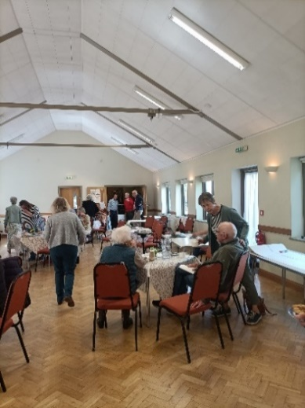
- created a new service pattern which we are currently trialling. If it’s successful, we hope the pattern will allow you to lead worship, to get to know us and still be able to worship yourself without feeling the need to rush from place to place on Sundays;
- and the four PCCs are currently exploring the Benefice Council model of governance which we hope will simplify things and enable us to work more closely as parishes and, hopefully, will reduce the number of meetings you would have to go to.
- we have also had fun socialising!
This work of coming together has been facilitated by our part-time Benefice Development Priest who was appointed by the Diocese for this specific task and whose time-limited role comes to an end in December 2026. The 2026 Vision Day
Could the Holy Spirit be calling you to be with us?
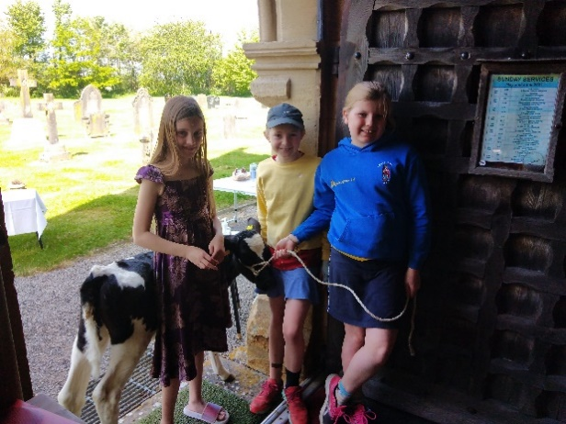
We’re praying that our new priest will be loving and passionate about multi-parish ministry, and that they will bring their own gifts and ideas knowing that in their heart they are called to join us on this wonderful new part of our shared journey of faith. That they will: Pet Service – was it a sheep or a goat?
- embrace and celebrate this new benefice;
- help us to develop the confidence and skill to herald the good news of Jesus Christ in our communities;
- teach the Bible with love and faithfulness;
- be intentional about developing our churches further as places of welcome and spiritual encouragement to people of all ages including children and young people;
- develop pastoral care, welcome and outreach;
- be accepting of the wide range of services and styles of worship already present, and continue to support and develop them further;
- be strong but pastorally sensitive – an encourager able to see possibilities and to encourage the gifts of others;
- be a friendly team player with a good sense of humour, imagination, creativity and resourcefulness;
- monitor and maintain good governance and communication across the benefice
- want us to join in with their vision

Florence thinks you
could look like this (and hopes that there will still be biscuits at church)!

‘The body is a unit, though it is made up of many parts; and though all its parts are many, they form one body …’ 1 Corinthians 12:12

We want you to feel well-supported!
We can offer you the support of a team that wants you, and those you love, to feel at
home, and to flourish and be happy in your ministry here, and would like to work
alongside you as members of the same Body of Christ:

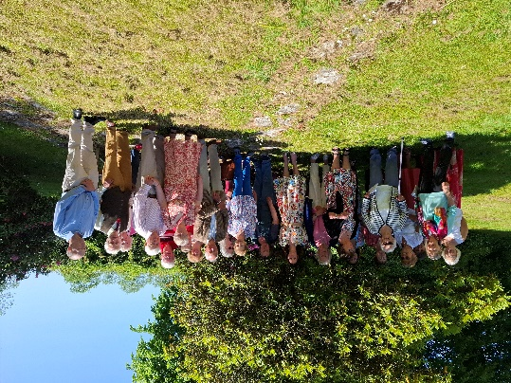
Some of the Team
- Churchwardens* (see next page)
- An embryonic Benefice Council and four PCCs
- A small group of Parish Reps who are happy to meet regularly to support you
- A part-time Benefice Administrator for 15 hours each week in the Wincanton-based Benefice Office
The four PCCs

- Two Readers
- Three Commissioned Lay ministers for Worship

- Three active retired members of Clergy each with permission to officiate

- A Safeguarding Officer in every parish – all working together as a safeguarding ‘Hub’

For Services:
- Four accomplished Organists
- A Church Choir (Wincanton)
- Intercessors, Bible readers, chalice assistants, Sidesmen and women, active bellringers
- Technical support with microphones, recorded music, screen projection, where the use of tech is possible
- Others who are great at providing hospitality
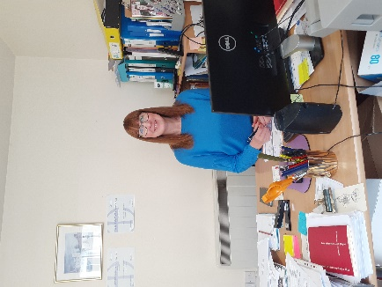
The churches also have:
- A branch of the Mothers’ Union
- Active fundraising and social committees
- Flower and cleaning teams
Our Benefice Administrator
And we have a rented Benefice Office in central Wincanton, funded by the four parishes.

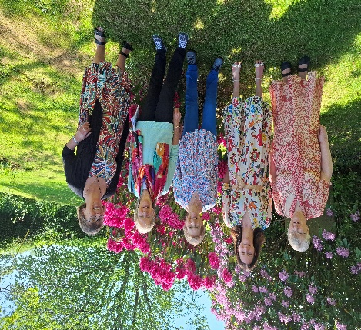
*At present the church in Wincanton has no Churchwardens, however two PCC members act as a point of contact for the church and community, and every PCC member has taken on responsibility for two ‘Churchwarden’ tasks and are effective in ensuring there are no gaps in jobs to be done.

*Charlton Musgrove is in a similar position where dedicated people ensure that the needs of the church and the pastoral needs of the local community can still be met.

Parish Safeguarding Officers working in a newly-formed
Benefice Safeguarding hub

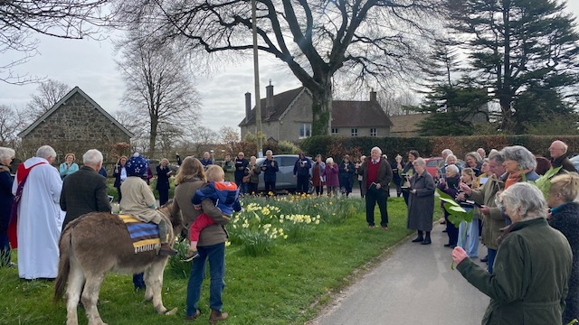
Palm Sunday blessing under Wesley’s preaching tree, Pen Selwood
Our Worship life
As churches, we cherish the wide diversity of worship already offered here, and hope that you’ll enjoy developing it further. The services offered in the Monarch’s Way Benefice currently range from the traditional to the less formal, from the Book of Common Prayer to Café Church, the Rise and Shine family service, Morning Worship, Praise services, and Iona-style services – we also have strong links to Bruton Filling Station. We enjoy worshipping together at the Benefice Service every month.

As you’d expect from a country town and rural villages, we also offer a range of Services that reflect our national life and rural heritage, these include Services of Remembrance, Rogation, Lammas, Harvest, Pet Services, Nativity Services, Christingle and Carol services, Lent courses, Agape meals, a Palm Sunday donkey procession, to name but a few. Sometimes services happen in Church, sometimes in the open air, and occasionally on a local farm! Additionally, there are Prayer Chains and an online Prayer group.

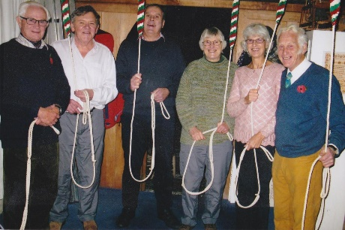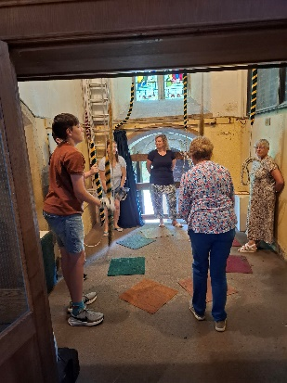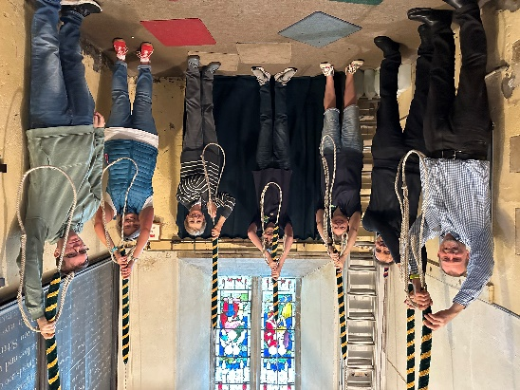
“I love being part of Wincanton Bellringers. It’s great fun and good exercise too! I also look forward to going to the church coffee mornings with my family.” Ollie, Age 13.
The Bellringers of Wincanton and Pen Selwood ringing before every Service

The Services
Since the Benefice began to work together, a trial Service pattern has been devised and used by the Benefice. It has been designed in a way that allows us to worship together once, sometimes twice, every month, and at Pentecost. We hope that this pattern will enable you to take two services each week and to be well-supported by the team of Lay Readers, Worship Lay Ministers, and active retired priests with permission to officiate. As allocated and agreed in the Deanery Plan, we also look forward to appointing a House for Duty colleague to join you.

Enjoying the Crib Service
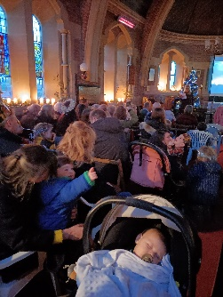

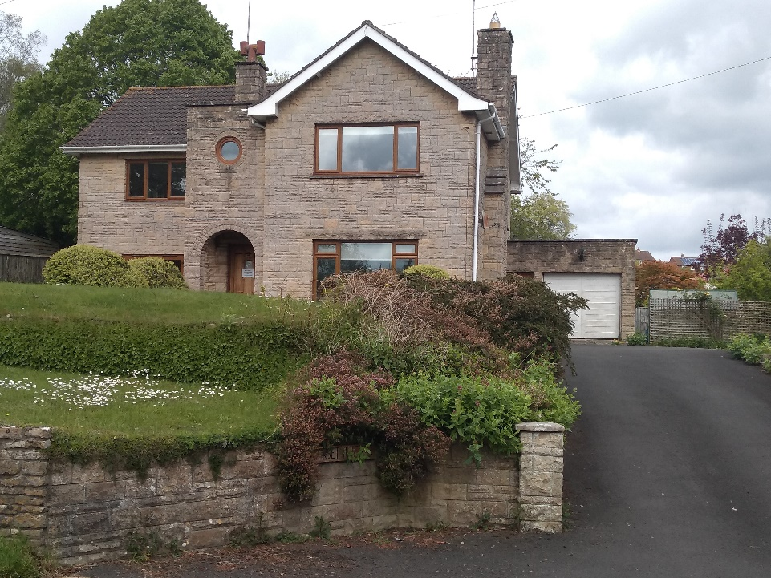

The Rectory – your new home
The Rectory is a beautiful four-bedroom home situated in a quiet road within walking distance of Wincanton town Centre, the church and local schools and other amenities. It boasts two en-suite, plus family, bathrooms, with study, prayer room and extensive gardens. If you would like a floor plan and estate agents details for the Rectory, please do get in touch and we’ll be happy to send them to you.

A little more about the individual churches in the (proposed) Monarch’s Way Benefice …

CHARLTON MUSGROVE – St Stephen’s and St John’s churches
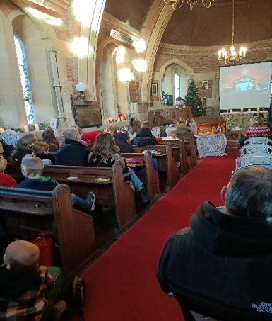
The parish of Charlton Musgrove extends from the edge of the Stourhead estate in the east across to Wincanton Racecourse in the west and is blessed with two churches.
St Stephen’s is situated at the edge of the village and is open every day for private prayer. The congregation values Common Worship Services and, like others in the group, many members have welcomed the monthly Benefice service. The church has recently been restored with a new roof, new electrics, a servery, toilet, and has a small area for children’s activities. The churchyard has a wildflower area created by the children with the help of a churchwarden and local enthusiast. Walking groups are sometimes hosted by the church. People have said that they love the sense of history they feel when in the church and the care that is taken of the building and churchyard. Some have also said that they love the fact that the church has a secret door!

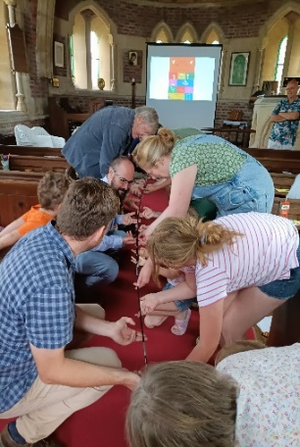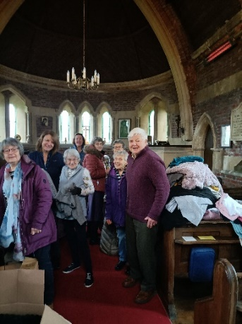
Café Christingle Café Church Ukraine-aid collection

All-age Christmas Tree decorating Weekly Coffee, Cake and Chat
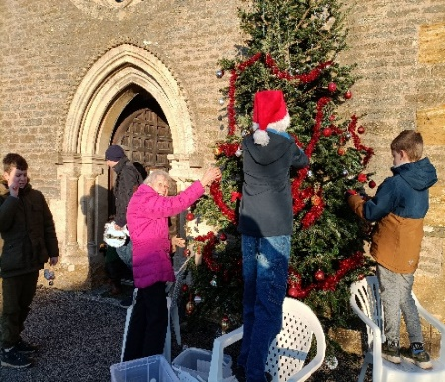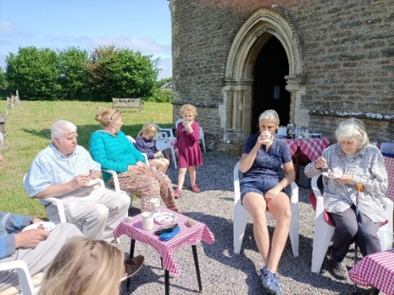

St John's chapel of ease is sited in the most populated part of the village and is particularly valued as a place of lively worship by an increasing number of families and young people of upwards of 40 people. Café Church and Morning Praise are much-loved here. As with St Stephen’s, the chapel is open every day and there are resources available for children’s activities during services. The chapel is also the venue for the popular weekly ‘Coffee, Cake and Chat’ hosted by an all-age team. The chapel has been described as having a simple beauty and very interesting modern stained-glass windows telling the stories of the lives of villagers. It’s valued for its rural location and for the peace it offers.
Coronation tea Worshipping on the farm Helping with National Garden Open Gardens
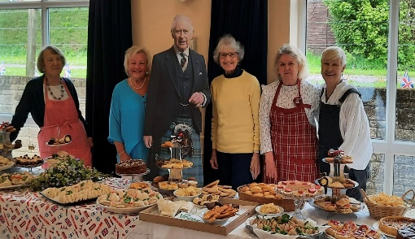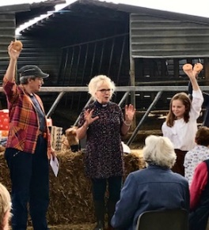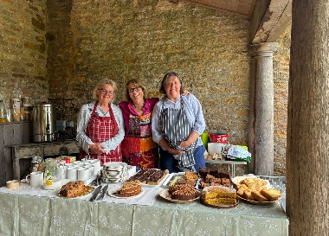
CUCKLINGTON and STOKE TRISTER with BAYFORD – St Lawrence’s church and St Andrew’s church
This Parish is known for its hospitality and community spirit is strong in its three villages - people look out
for each other here. The two churches work together and offer monthly events that are well attended and
include: coffee mornings; lunch clubs; film nights; scrabble; a pop-up pub; a book club; annual Flower
Show; churchyard BBQ; a Harvest meal; Christmas Bazaar; Christmas Tree festival; and a 100 Club.

St Lawrence’s, Cucklington is set in a tranquil position on the side of a hill in the quiet and peaceful village. The view of the Blackmore Vale from the churchyard is stunning!
The small congregation values the simplicity of traditional Holy Communion and Evensong here. The church is open to visitors and for private prayer every day and has a small number of resources for children. For centuries water from the nearby St Barbara’s well has been used for baptisms here. The small congregation says that it particularly loves the view, the carvings and the stained-glass windows to be found here. The church and churchyard are well maintained and cared for by volunteer cleaners, flower arrangers, and people who lock/unlock the church every day.

St Andrew’s Stoke Trister serves Stoke Trister and Bayford. These days it holds a bi-monthly service of Evensong. It also hosts most of the extraordinary services like royal occasions. The Church is well-supported and cared for by the community. It is greatly valued for its brightness and for the quiet space it offers every day for those who wish to use it. The churchyard offers a beautiful view, and from a distance the church reveals a beacon on the hill.

PEN SELWOOD – St Michael’s church
The village has a strong sense of community and friendliness; and the church is valued as central to village life by a supportive community, including those who do not attend regularly.
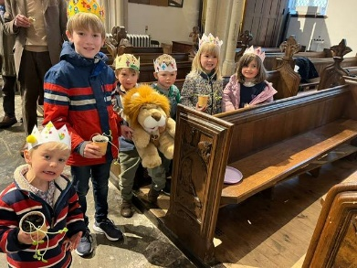 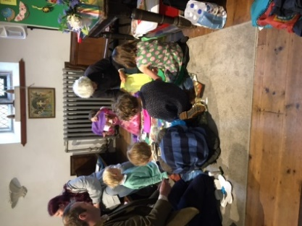 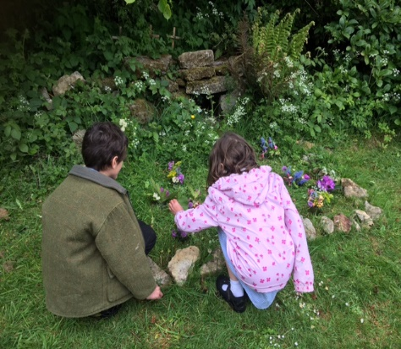 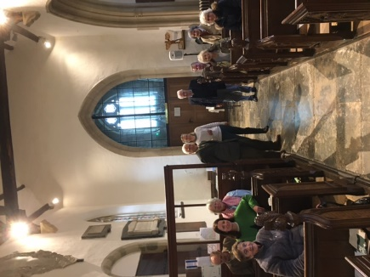The six kings (and queens) and, is it Aslan? Rise and Shine The Easter Garden Pen Selwood’s APCM
St Michael’s values quiet prayer and contemplation and the companionship of fellow worshipers. The children greatly enjoy ‘Rise and Shine’, the people in the church, the singing, and the biscuits! The congregation says that it loves learning and singing new songs as well as old favourites . The church is open daily for quiet reflection and prayer. Innovative ways are often found to draw more villagers into church activities and events, and Pen Selwood Village Community Association (PCA) are actively helping by holding popular monthly ‘pop-up’ pub nights, and fortnightly coffee mornings. The Church is involved in the annual village fete which draws people from miles around and raises substantial sums. With others in the village, the Church helps to sponsor a community bus project around Wincanton, supports the Balsam Centre (a ‘healthy living’ centre) in Wincanton, and the local Food Bank. Church members are active in other village clubs and groups within the village.
Church members love many things about the church building including the carved depiction of the Archangel Gabriel and a hidden ‘Green Man’ – to discover the other things that are loved, please take a look at Appendix 1 Vision Day Analysis

Pen Selwood Fete - circus skills and parachute play
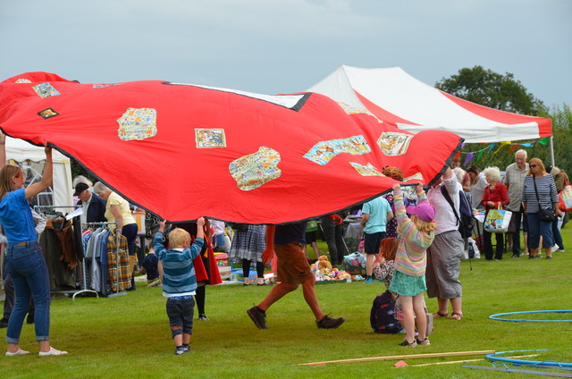

“Vibrant, relevant, teaching and worship for both young folk and parents” – the hopes of a parent

WINCANTON – the church of St Peter and St Paul
“Someone who is fun” – a child’s hope of you

Wincanton is a small, but growing country town and is the largest parish within the group.
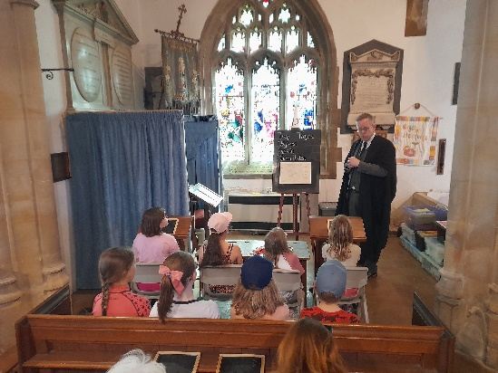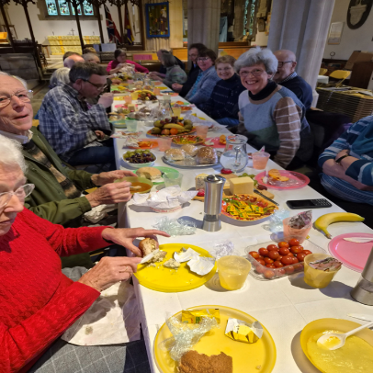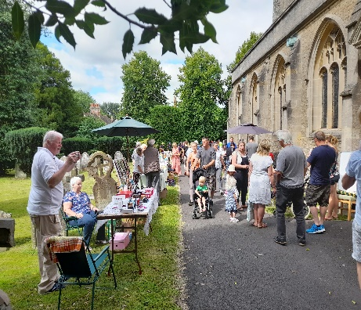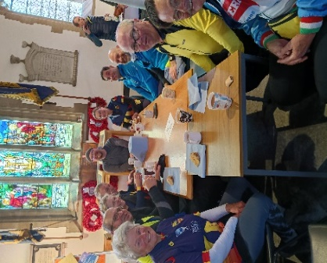
Wincanton Museum and History Day Wincanton Lent Lunch Wincanton Church Fete Wincanton Wheelers

The congregation, of about thirty worshippers, loves singing both traditional and new hymns (as long as there aren’t too many all at once). It has fully embraced changes in the service pattern that have enabled the congregation to experience and enjoy Iona-style Morning Worship as well as Common Worship Communion, with some sung responses. From time to time the Church hosts high profile services in the town, including the annual Service of Remembrance attended by members of the armed forces. Like the other churches in the benefice, it is open for private prayer and reflection on five days each week and we hope that eventually this will be increased to seven.
There is a good two-way relationship with the town’s local authority Primary School where clergy, a Reader and a local representative of the Children’s Society are sometimes invited to lead Collective Worship and support faith-based lessons. The school takes an active part in the Church fete and in other church-based town events.
There is a large, well-resourced, children’s area which is popular with small children attending Sunday Services, Baptisms, Weddings and by the younger siblings of pupils during School Services.
The Reader is active in the spiritual care of those living in the local Elroi nursing home and takes Home Communion to those who are unwell and unable to come to church. We would like to develop these relationships further.
In 2025, the Church took part in ‘Churches Count on Nature’ with ‘One Planet Wincanton’, and are working with them to create a natural area in the churchyard to protect orchids that were discovered during the 2025 Count.
New housing presents exciting mission and outreach opportunities within the town, and we want to explore these opportunities further and to find new ways of welcoming new residents, families and worshippers.
At present, there is a popular well-attended monthly coffee morning with book and cake sales.
Ecumenical relationships are good within all of the town churches and discipleship courses and events are often shared.
There are plans to offer a more versatile building to the community by the installation of a toilet and meeting rooms, in the church. However, a recent lead theft has meant that plans were set back as repairs needed to be paid for. The Church is now beginning to get back on track.
There is much that is loved in this church, including the font where many of the congregation were baptised – to find out more, please look at Appendix 1 - the Vision Day Analysis
As you see, the individual congregations value different styles of worship to support their spiritual lives. They also say that they look forward to and enjoy the monthly services (usually Common Worship) that enable them to worship together
“You let us join in when you talk about the Bible”- a child’s hope of you

If you would like more information about the Church architecture, please visit our pages on achurchnearyou.com or the individual websites listed a little later on in this Profile. More about our love for the individual churches, please take a look at the Vision Day analysis, Appendix 1

So this is us!
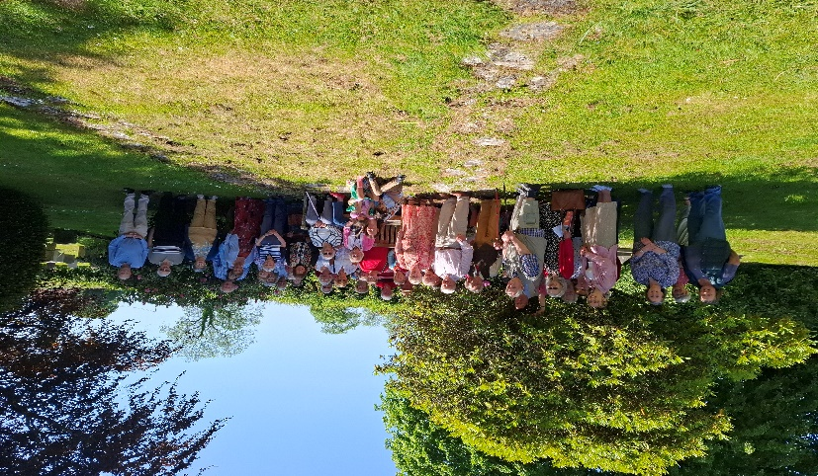

We aspire to live and tell the story of Jesus through loving and serving our communities and keeping Him at the centre of our lives, and to become a light to the whole benefice as we serve God and our community and become closer as we serve the Lord by:

- Growing spiritually;
- Prayerfully growing and welcoming newcomers and returners;
- Embracing new ideas and becoming more relevant for today;
- Becoming listening churches;
- Caring for and encouraging young, old and everyone in between, as they become confident in their journey of faith;
- Bringing our new benefice closer and celebrating, supporting and protecting both our rural life, our farming communities and our small and growing country town, and all that live, work and learn within them;
- Recognising, celebrating and encouraging the gifts we have been given as we move forward together with our new priest!

We are committed to God, our churches, our communities and to each other as we follow Jesus Christ. We strive to be welcoming to all, but please don’t think we’ve got it all sorted! For more ideas of where we think we may need help and how we plan to go about meeting some of our challenges, please look at the Vision Day Analysis in Appendix 1

We have great opportunities to:

- develop our ministry to, and the participation of, people of all ages, in particular families and people within the 20 to 50 age categories;
- get to know and find ways to serve those who are moving into the new housing developments in Wincanton and the villages;
- further our relationship with the schools and residential and nursing homes;
- reach out to those who may be lonely or unwell by developing pastoral care across the benefice;
- with your help, become more confident so that we can share what we do, and why we do it, with the wider community;
- make our churches more accessible for those with disabilities, both visible and invisible;
- fundraise and provide facilities that will enable us to use our churches more missionally

“You have imagination and what you say means something” – a child’s hope of you

And now, some facts and figures …

The trial Service pattern – for review once you have settled in
1st Sunday
9.00 Rise and Shine – Pen Selwood (LL)
9.00 Holy Communion – Cucklington (BCP/CW)
10.00 Café Church – Charlton Musgrove (St J) (LL)
10.30 Holy Communion – Wincanton (C/W)

2nd Sunday
9.00 Holy Communion – Pen Selwood (BCP)
9.00 Holy Communion – Charlton Musgrove (St S) (C/W)
10.30 Morning Worship – Wincanton (LL)
6.30 Evensong – alternating between Cucklington and Stoke Trister and between
sung and said liturgy (LL) (BCP)

3rd Sunday
9.00 Holy Communion – Cucklington (BCP)
9.00 A morning Service – Pen Selwood (LL)
10. 30 Morning Praise – Charlton Musgrove (St J) (LL)
10.30 Holy Communion – Wincanton (C/W)

4th Sunday
10.30 Benefice Sunday Service of Holy Communion – in order: Charlton Musgrove; Pen Selwood; Wincanton; Stoke Trister; Cucklington (C/W)
5th Sunday
10.30 Benefice Service of Morning Worship with a seasonal theme following the above
church order (LL)

LL = Lay Led; CW=Common Worship; BCP = Book of Common Prayer

Life event Services in 2025
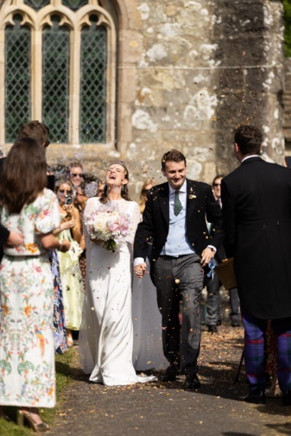

The number of ‘Life event’ services is largely influenced by the size of the communities within the benefice, which range from about 173 people in Cucklington to roughly 6,740 in Wincanton. To give an idea of what the Services might look like over a year, the following figures are what happened in 2025, but every year is different!
Church  (listed building grade) | Baptism | Wedding | Funeral/Memorial | Interment of ashes
St Peter and St Paul, Wincanton (Grade 2 *) | 8 | 0 | 28 | Closed Churchyard
St Michael, Pen Selwood (Grade 2) | 0 | 0 | 1 | 2
St Lawrence, Cucklington (Grade 2) | 1 | 1 | 3 | 2
St Andrew, Stoke Trister with Bayford (Grade 2) | 0 | 0 | 2 | 0
St Stephen, Charlton Musgrove (Grade 2) | 0 | 0 | 1 | Closed Churchyard
St John, Charlton Musgrove | 0 | 0 | 0 | 0

Finance including Parish Share 2025 (2026 request) …
This brief breakdown of finances includes the Parish Share requested from each church. It’s an area that some of our congregations are finding increasingly challenging and something we’d value your wisdom and guidance to address.

Parish |  | Charlton Musgrove | Cucklington, & Stoke Trister with Bayford combined | Pen Selwood | Wincanton
Parish Share 2025 (2026 request) |  | £12, 041 (£12,907) | £16,949  (£15, 316 with vacancy reduction £7,658.04) | £10, 050 (£9,839 with vacancy reduction £8,696) | £36, 698 (£44,726 with vacancy reduction £36, 197.69)
Parish Share paid 2025 |  | £10,535(Vacancy discount applied) | £11,299.36 | £4,030 (plus late payment £3,900) | £21,600
Total Income |  | £22,242 | £31,490 | £25,797.00 | £78,099.10
Total Expenditure | £20,118 |  | £26,625 | £20,667.00 | £96,435.28
Restricted and Designated Reserves | £5,8705 |  | £8,1976 | £1,724.00 | £60,656.30
Electoral Roll  (approximate population) | 40  (457) |  | 65  (173 + 318 respectively) | 27  (273) | 52  (6,740)
If you would like to see more detail about our finances, please let us know and we’ll be happy to email the 2025 Financial Reports to you.

Some helpful contacts:

www.achurchnearyou.com www.wincantonparishchurch.co.uk

www.penselwood.ning www.charltonmusgrove.org

www.wincantonprimaryschool.co.uk www.kingarthurs.org.uk

www.balsamcentre.org.uk www.wincantonwheelers.co.uk

“For I know the plans I have for you,” declares the Lord, “plans to prosper you and not to harm you, plans to give you hope and a future.” (Jeremiah 29:11)

Could this be you?
We would love to welcome and work alongside you, hoping and praying that together we will grow and flourish as we wholeheartedly serve God in this beautiful part of Somerset. We are eager to welcome you, and to work together alongside you, as you lead us into what we believe will be a new, exciting and much blessed future following the true Monarch’s way.

But should you decide we’re not for you, we pray that you will soon be blessed as you continue your search …

Welcome to the Diocese of Bath and Wells

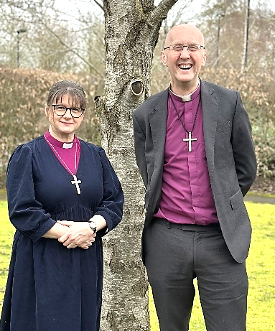
We are delighted that you are considering whether this post of Priest in Charge of the proposed Benefice of the Monarch’s Way in the Diocese of Bath and Wells might be right for you. To help your prayerful discernment we want to share with you our diocesan vision for growth and transformation, within which we hope your own ministry might flourish.
A vision for growth and transformation
In light of the challenges and opportunities we face, our aim across all our parishes is growing our churches, within and beyond our church buildings, in both numbers and depth of faith, so that we can better work for the transforming of our communities and the life of God’s Kingdom amongst us.
Our shared priorities
To help us pursue this aim, we invite churches across our diocese to focus on five particular areas of our ministry together. We ask all incumbents in our diocese to make these their priorities, understanding that what they look like in practice will vary in each place.
To value, cherish and develop the people and resources we already have | We love and affirm our churches and congregations, aiming to ensure each person is well supported and equipped as a follower of Jesus Christ and for any ministries they are called to undertake.
To develop new Christian worshipping communities | Whether through new forms of worship, church revitalisations or church plants, we seek to offer people in our communities opportunities to connect with the good news of Jesus
To share in ministry and leadership | We are committed to a model of shared local ministry: raising up and equipping lay and ordained leaders able to share together in leading the church and serving God’s world.
To deepen and grow faith | We long to see children, young people and young adults, having more opportunities to discover, explore and grow in faith and for people of all ages to deepen and grow in faith
To transform communities | We seek to work in partnership with our communities to serve the common good and to pursue the transformation of society, by God’s grace, to reflect the Kingdom.

Our challenge to you
When he talks about his own ministry in 1 Corinthians, Paul captures the dynamic we are seeking to achieve. “I planted,” he says, “Apollos watered, but God gave the growth” (1 Cor 3: 6). We know that our churches will only flourish and grow as a result of God’s action among us – it is God who gives the growth.
But Paul is also clear that we have a part to play too – in watering and planting, in doing the things that enable the conditions for God’s growth to be supported. So our challenge to each benefice is to see what it would take to growth by one adult and one child net during the coming year?

Our support for you
We aim to be a diocese that offers high support to help you meet these challenges and opportunities. We have an outstanding diocesan team who are focussed on parish support, offering specialist advice in both practical and missional areas. Clergy wellbeing is a priority for us and our confidential Counselling and Wellbeing Service is available at no cost to you and your family. We model collegiate working in every area of the diocese, including deaneries, where working together is encouraged and supported. The Bishops and Archdeacons carry out a regular programme of benefice visits to learn about the life of local churches, and your MDR is conducted within the context of these visits.

Your ministry in this Diocese
In summary, we are looking and praying for clergy who will:
- be committed to praying and intentionally seeking the growth and flourishing of the benefices in their care.
- relish and expect to work in an environment that offers high challenge and high support.
- work joyfully and collaboratively with those who share with them locally in ministry and leadership, with their congregations and with others in their locality, to identify ways to grow and develop their churches with the grain of local priorities, resources, skills and passions.
- enjoy working in partnership with deanery and diocesan colleagues.
We hope that you’d like to join us on the adventure and course we’ve set for our next ten years. We’re praying that God will send us the right labourers for the harvest that God has set before us. Might this be you?



Bishop Michael Bishop Fiona Acting Archdeacon of Wells
Deanery Statement

Bruton and Cary Deanery

Bruton and Cary Deanery, in the Archdeaconry of Wells, is served by seven incumbent status appointments. These posts cover 41 mainly rural parishes, which are run in a variety of benefice formats. In 2024 a new Deanery Plan was drawn up. As a result of this, Charlton Musgrove, Cucklington and Stoke Trister with Bayford joined with Pen-Selwood and Wincanton. They have worked hard together during vacancy and as The Monarch’s Way Benefice are now developing as a united benefice under the support of a part time Benefice Development Priest (BDP). The BDP was an intentional appointment approved by the Diocese specifically to support our rural parishes as they go through change and has been a great success.
We are a Deanery that is looking to seek ways to enable rural ministry to flourish. We aim to do this by helping larger groupings of parishes to develop ways of working together and pooling their resources and expertise, whilst also enabling the growth of lay ministry. We have an active Chapter group of Clergy and Chaplains which meets once a month, for prayer, food and fellowship. At this meeting we seek to prayerfully listen to each other and to God, share good practice and support one another in the roles that we have, as we seek to be labourers together in the building of God’s Kingdom.
Revd Caroline Walker
Interim Minister Vale of Camelot Churches, Area Dean Bruton and Cary carolinehwalker@btinternet.com
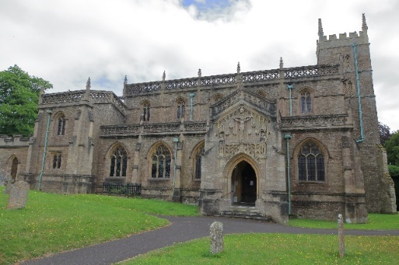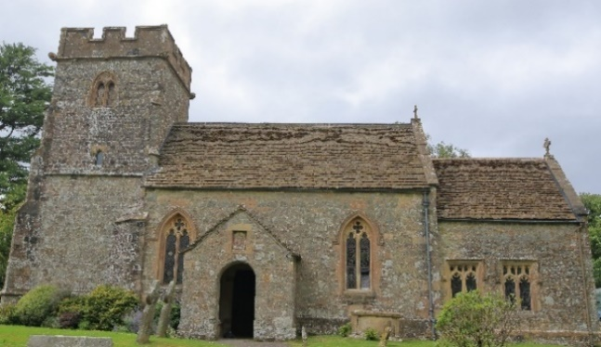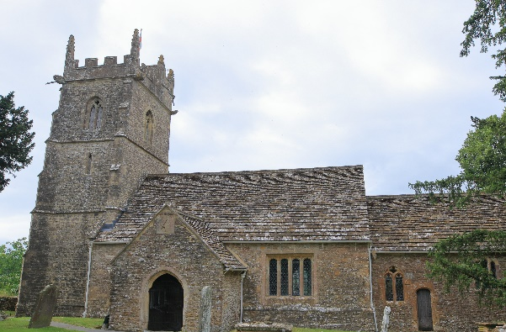
St Peter and St Paul, Wincanton St Michael, Pen Selwood St Stephen, Charlton Musgrove

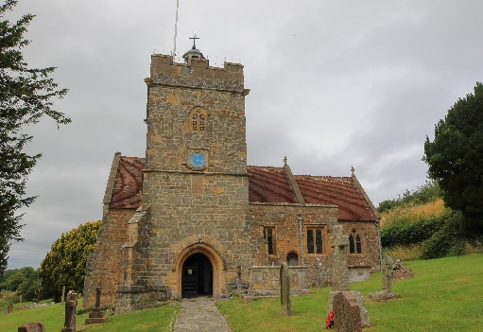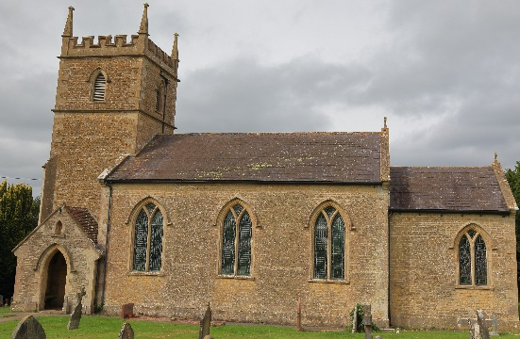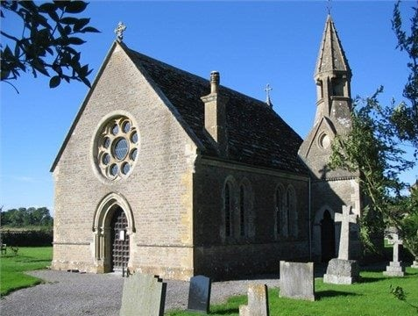
St Lawrence, Cucklington St Andrew, Stoke Trister St John Chapel of Ease, Charlton
Musgrove


Appendix 1
Vision Day Analysis
for the (proposed) Church of England Benefice
of
The Monarch’s Way
Created by members of the churches of St Stephen’s Church and St John’s Church, Charlton Musgrove; St Lawrence’s Church and St Andrew’s Church, Cucklington with Stoke Trister and Bayford; St Michael’s, Pen Selwood and St Peter’s and St Paul’s, Wincanton. Thank you to everyone who contributed to this document at the Benefice Vision Day in April 2026

- Key Texts page 2

- Church Memory page 2

- What we love about our churches page 2

- feel we do well enough and where we feel we need help page 5

- Looking back to 2026 from 2030 page 7

- Possible goals for our parishes and our benefice page 8

- The Angel of our Benefice page 8
Monarch’s Way Benefice Vision Day April 2026
Key texts for the Vision Day: John 15:1-17; Revelation 1:20-3:22; 1 Corinthians 12:12-13:13
Church Memory
In April 2026, we spent some time remembering past events – personal and shared across all six churches. Our memories included, baptisms, our weddings and those of our children and grandchildren, spiritual renewal, the establishment of key outreach initiatives, social and important spiritual events, church re-organisations and re-ordering, the coming and going of different rectors and lay leaders and some of their special gifts. We recognised, too, times of pain and of sorrow as we remembered family members and friends who have died or moved away; lead theft; the diminishing number of worshippers, the challenge of attracting younger people, and services and initiatives that eventually came to an end. As we discussed these memories it was possible to see how much the history of our church communities has shaped us in the present; to give thanks for the past; taking the best with us as we move on into the future.
What we love about our churches
Each of the churches within the Benefice is special, each has it’s own unique architecture and character. Many generations of villagers and townspeople have worshipped in them and have connected with them in a personal way. The current generation of worshippers are no different. When asked what they particularly love about their church buildings the following is what was discovered:
Church building | Church members say they love:
St Peter and St Paul, Wincanton | Its location  Its accessibility  Its churchyard  The stained-glass windows  The Lady Chapel  The lovely wide nave  The font  The clerestory windows  The organ  The flowers  The church bells  The pillars  The brasses  The choir stalls  The view from the church tower  The ‘Holy space’
St Michael’s, Pen Selwood | The undressed altar  Carvings on the pew ends  The stained-glass windows  The location  The peaceful atmosphere  The pulpit  The flower arrangements  The sound of bells  The beautiful tiles  The wooden angel St Michael  The green man
St Stephen’s Church, Charlton Musgrove | Its beauty  The sense of history  The way its cared for  The new roof  The toilet  The secret door
St John’s Church, Charlton Musgrove | The sense of those who went before  Its simple beauty  The lit candles*  The stained-glass windows  Its central location  The shape of the roof  The churchyard  *this features elsewhere as an identified challenge
St Lawrence’s, Cucklington | Its entrenched in history as far back at 1300  The view of the beautiful countryside from the churchyard  The carvings  The stained-glass windows  It’s a beautiful traditional church
St Andrew’s, Stoke Trister | The space and quiet it offers  It’s bright  Its glass screen  The view  It’s a beacon on the hill

Our churches vary in age but we have already seen that we each carry history with us – so we are not green field sites but rather scenes of mission that connect us with the past and future including past, current and future gifts given by God to enable us to proclaim the Gospel in our own time. We are not perfect churches, but we strive to be good enough to do the tasks we are given and be the people we are called to be. We are also not called to do it all by ourselves in our own strength – to do what God wants us to do will need help.
What we think we do well and where we feel we need some help
Each Church group was asked to consider what it does well and where it could do with some help or support
Church | We think we do well with this | Help/support needed
St Peter & St Paul, Wincanton | - Being welcoming  - Including new people in what we’re doing  - Choir  - Bellringing  - Music during services  - Coffee after church  - Monthly coffee morning  - Supporting one another  - Fundraising  - Collective worship in the local school  - Taking communion to the local residential care home  - Being open for private prayer during the working week | - Encouraging families  - Developing home groups  - Further developing our relationship with the school  - Creating a pastoral care team  - Having a children and youth worker  - Increasing the congregation  - Building a toilet  - Increasing our fundraising so we can pay our parish share and build the toilet  - Opening the Church at the weekend
St Michael’s, Pen Selwood | - Fundraising  - Special events  - Welcoming people  - The ‘Rise and Shine’ service  - Bell ringing  - Refreshments  - Flower arrangements  - Being open for private prayer daily | - Bringing in more people, especially younger people  - Modernising our music  - Making safeguarding training more accessible
St Stephen’s, Charlton Musgrove | - Being a church  - Being open for private prayer every day | - Finding a new priest
St John’s, Charlton Musgrove | - Loving Jesus, following the Holy Spirit and having a gospel focus  - Scripture-based teaching  - Welcoming people  - Encouraging families  - Coping without a priest  - Fellowship and friendship  - The presence of children and young people  - Worship  - Flowers  - Being up to date and open every day  - Refreshments  - Café church  - Weekly community coffee morning | - Raising money to install a toilet  - Having lit candles*  - Having a Communion together at St John’s  *this features in another place as something that is loved
St Lawrence’s Church, Cucklington | - Looking after our church  - Making people welcome  - Entertaining  - Being open daily | - encouraging new worshippers
St Andrew’s Cucklington | - Being kind and inclusive  - Our Christmas and Easter traditions that remind us of the reason for the seasons  - Being open outside services | - Using the church more  - Telling people why we meet  - Sharing the good news

Working together as one benefice, we then transported ourselves forward to 2030 and looked back to the 2026. Our 2030 selves were asked to identify things we were pleased that we had continued from 2026, things we were glad we further developed, and things we were glad we’d stopped and others we were glad we began at that time:
Looking back to 2026 from 2030
We’re glad we stopped | - Only going to our own church and not going to another one if there isn’t a service in our own parish  - Division between the churches  - Demanding that things only be done in our way  - Worshipping alone  - Some of the sung responses  - Worrying about running the church on our own  - Worrying about finance  - Worrying about the parish share  - Over-relying on the same faithful people
We’re glad we continued | - Meeting, worshipping and sharing meals together  - Going to joint benefice services  - Regular morning worship  - Serving teams (and developing them further)  - Welcoming children and developing this  - The ‘Rise and Shine’ service  - Café church  - Supporting the food banks  - The choir (Wincanton)  - Bell ringing  - Laughing together  - Having a Parish administrator  - Sunday news sheet  - Village news  - Meeting at all the coffee mornings  - Offering coffee mornings as outreach  - Having refreshments after the services  - Music in our worship  - Our Safeguarding Officers meeting together as a ‘hub’
We’re glad we started/ explored | - Having a pastoral care team to bring outreach and home communion to older or unwell people at home  - Toilet projects where needed  - Home groups to explore the Bible and our faith  - A music group  - Ensured all churches had hearing loops  - Created a booklet to make the BCP liturgy and the ‘red’ books easier to access when unfamiliar with it (the need to skip between pages in the traditional books can be confusing)  - putting Café Church and Rise and Shine on different Sundays in order to make it possible for families to have two rather than one service that might attract them in a month  - Having a pastoral role in secondary schools and starting a Christian Union  - Exploring the possibility of a café/meeting place in Wincanton High Street

Through the work done during the April Vision Day, several areas were identified for possible development and appear to fall into one or two of several areas:
- Worship
- Fellowship
- Mission
- Facilities
- The wider community
- Safeguarding

Possible Goals for the next three years
Area | Goal/action to be taken | When | By whom
Worship | - Create service booklets to help the services become more accessible to those who are unfamiliar with the BCP and ‘red’ Holy Communion books
Worship | - Review music to ensure that new as well as more traditional music can be experienced and used in our worship lives
Worship | - Explore the possibility of a music group
Worship | - Occasionally offer Holy Communion at St John’s
Worship | - Ensure that resources are well cared for and readily available in the churches to welcome children and young families
Worship | - Advertise in ways that will reach people of all ages
Worship | - Consider putting Rise and Shine and Café Church on different Sundays so that there are two accessible family-friendly services each month should families want to come to them
Worship | - Provide hearing loops in every church
Worship | - Finding a new priest
Fellowship | - Establish home groups for Bible Study and faith discussions
Fellowship | - Explore ways of using our churches outside Sundays
Fellowship | - Continue to share worship, social activities and other events
Mission | - Ensure that the coffee mornings have information about our activities and service available
Mission | - Explore ways to interest of people of all ages
Mission | - Tell people what we do and why we do it and advertise in a way that will reach the greatest number of people
Mission | - Explore the possibility of opening the church at the weekend (Wincanton)
Mission | - Continue to support the Food banks
Mission | - Doing more events together
Accessibility | - Provide hearing loops in every church
Accessibility | - Fundraise and further plan for a toilet in churches where one is needed
Community | - Further develop the relationship with the primary school (Wincanton)
Community | - Explore establishing a relationship with the secondary schools, including creating a Christian Union
Community | - Join in with what our communities are doing
Safeguarding | - Explore the possibility of Safeguarding training being delivered locally (Safeguarding Officers)
Part of the work of the proposed Benefice Council, with the ratification of the PCCs, will be to decide the order in which any of the above goals will be addressed and by whom. It’s expected that some will be addressed together, others separately and that some may not apply to a particular PCC.

The Angel of our benefice
During the Vision Day church members were able to begin to discern that God will send our churches someone who will:
- herald the good news and bring light into the darkness;
- show us that we need to trust that God is in control and that we need to be obedient to Him;
- will bring a new beginning in which children and the next generation of people will be important;
- will be caring and bring more people into the churches of the benefice;
- will be welcoming and encourage us to work alongside them – with a message that says ‘come with me’;
- (may) be musical;
- bring a big fanfare to celebrate the new benefice
- be cheeky!
The discernment process will continue further in the Benefice Council

