SUNDAY MORNING READING SHEET 23rd August 12th Sunday after Trinity

A reading from Paul’s letter to the Romans

I appeal to you therefore, brothers and sisters, by the mercies of God, to present your bodies as a living sacrifice, holy and acceptable to God, which is your spiritual worship. Do not be conformed to this world, but be transformed by the renewing of your minds, so that you may discern what is the will of God—what is good and acceptable and perfect.
For by the grace given to me I say to everyone among you not to think of yourself more highly than you ought to think, but to think with sober judgement, each according to the measure of faith that God has assigned. For as in one body we have many members, and not all the members have the same function, so we, who are many, are one body in Christ, and individually we are members one of another. We have gifts that differ according to the grace given to us: prophecy, in proportion to faith; ministry, in ministering; the teacher, in teaching; the exhorter, in exhortation; the giver, in generosity; the leader, in diligence; the compassionate, in cheerfulness. Romans 12:1-8

GOSPEL

Now when Jesus came into the district of Caesarea Philippi, he asked his disciples, ‘Who do people say that the Son of Man is?’ And they said, ‘Some say John the Baptist, but others Elijah, and still others Jeremiah or one of the prophets.’ He said to them, ‘But who do you say that I am?’ Simon Peter answered, ‘You are the Messiah, the Son of the living God.’ And Jesus answered him, ‘Blessed are you, Simon son of Jonah! For flesh and blood has not revealed this to you, but my Father in heaven. And I tell you, you are Peter, and on this rock I will build my church, and the gates of Hades will not prevail against it. I will give you the keys of the kingdom of heaven, and whatever you bind on earth will be bound in heaven, and whatever you loose on earth will be loosed in heaven.’ Then he sternly ordered the disciples not to tell anyone that he was the Messiah. Matthew 16:13-20

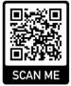
If you wish to make a donation to the church, then please hold Your phone’s camera over this image then touch the link that appears:

Royston Parish Church
Where all are welcome and God’s love is shared
Sunday 23rd August 2026 –12th Sunday after Trinity

If you would like regular copies of the Notice Sheet emailed to you please email the
Parish Office at admin@roystonparishchurch.org.uk

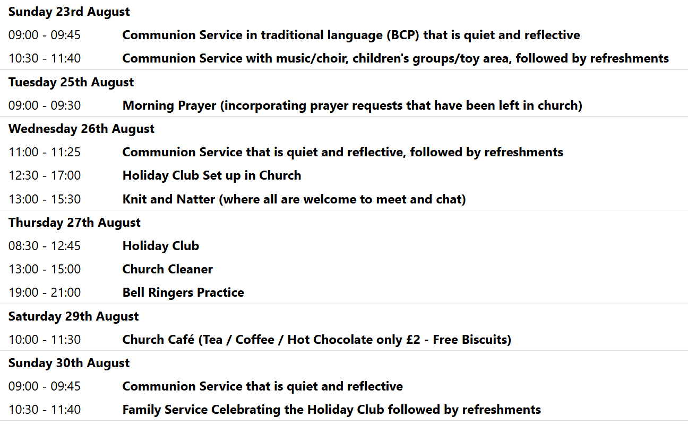

We pray for all Christians worldwide:
For all Christians in Liberia, Sierra Leone
For all who worship at Royston Catholic Church: Fr. Philip Knights
For the work of our mission partners: GenR8
Pray for the community of Royston:
For our local health centres
For all our local Royston Foodbank, for those who volunteer and make use of it

We pray for our world and ECO projects:
19th August is International Orang Utan Day - we pray that action may be taken to save this amazing species whose habitat is being destroyed by the growth of the palm oil industry (look at the ingredients of foodstuffs in your larder to see how prevalent this ingredient is nowadays). See #OrangutanDay

We pray for the sick and suffering:
2nd August | 9th August | 16th August | 23rd/30th August
Emma Thompson | Pat Tidey | Val Brown | Peter Coates
Jackson Herbert | Mike Brown | Angie & Ken Rushall | Sandra Cornwell
Marion |  | Paula Walker | Peter Foster
Peggy Dawes | Max Elliott | Clare Rice | Keith & Elaine Edwards

We pray for those who have died in the faith of Christ:
Deceased Bereaved
Baby David Family and friends

We pray for those whose anniversaries fall at this time:
Steven Law, Cliff Atkins

NOTICES

A DAY OUT IN NORFOLK Jilly Hall, a former member of our congregation who has recently moved to Norfolk, has invited us to share in a day she is organising on Wednesday September 23rd. called "Celebrating God's Creation on Massingham Heath". The morning will be a walk in the beautiful countryside, followed by lunch, then an afternoon of creative work : drawing, painting, writing, photography. All materials provided, no expertise necessary, the day and the lunch are free.
Massingham is about an hour-and-a-half to reach by car. The day starts at 10.30. If interested, please contact Duncan Rodgers for further details.
duncanstuartrodgers@gmail.com

SAVE THE DATES: We have a HERITAGE OPEN DAY in Church on Saturday 12th September 10 am – 4 pm. Free entry. Join us for a day of discovery about where we live. The Royston Tapestry on full display at the Parish Church, as well as demonstration of the organ and bells and tours of the church and refreshments. Donations welcome on the day.


ALSO : FRIDAY 25TH SEPTEMBER 7.30 PM – 9 PM, ARTS FESTIVAL ORGAN RECITAL: in Church, with Steven Sivyer playing the Organ. Tickets in advance are £10 for adults or £3 for under 18s in advance at https://bit.ly/ArtsFestivalOrgan or scan the QR code
Doors open from 7 pm, refreshments will be served.

AND; SATURDAY 26TH SEPTEMBER 10 AM TO 4 PM, ARTS FESTIVAL BOOK FAYRE: in Church,

HELP WANTED! We have 2 events coming up during September, for which we'd like donations of cakes, and help to serve refreshments. We have the Heritage Open Day on Saturday 12th, and the Arts Festival is running a book fayre in our church building on Saturday 26th, during which we'll be selling refreshments, the proceeds of which will go to church funds. If you're able to spare an hour or more to help, or can make a cake or batch of scones for either event, please can you sign up on the sheets at the back of church. Thank you from the Events Committee.

BEDS & HERTS HISTORIC CHURCHES TRUST SPONSORED BIKE ‘N HIKE - SATURDAY 12TH SEPTEMBER 2026: Last year we in Royston we raised over £ 2,000 which was divided between BHHCT and our own parish funds. This earned us a Gold Certificate and we were one of only 11 churches that raised more than £ 2,000. We hope to do just as well or better this year. Select your own route for cycling or hiking between the churches – there are over 600 churches to choose from so make it as long or as short as you wish. Most churches will be open on the day. The Sponsorship Packs are now available and if you would like a sponsor form, please go online www.bedshertshct.org.uk or contact Mike Maze (245606 or mikefmaze@aol.com) There is always the easier option which is to sponsor one of the participants using their Sponsor form or if online giving suits you best, please visit:- Sponsor Rodney & Matt Dyer or Sponsor Mike Maze

CHILDREN’S CHURCH: During the school holidays, there will be no Children’s Church but activity sheets will be left for them on the red tables by the Toy Area. Please ensure you supervise your children. Thank you

WE HAVE A NEW BATCH OF CHURCH MUGS FOR SALE, at £10 each, sales go towards church funds. Available at Saturday coffee, or after church services.

