Into his Courts
with Praise...

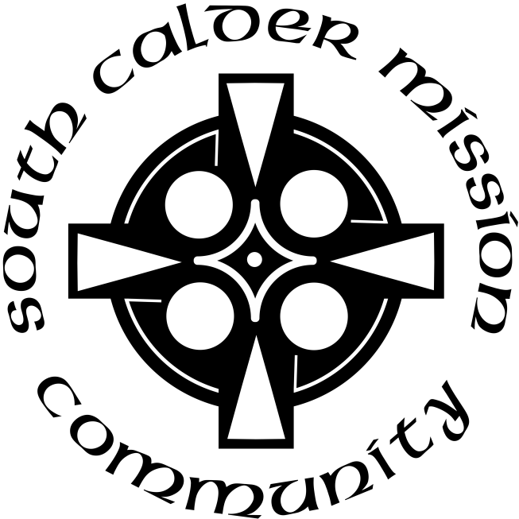

A Service of the Word
for
Sunday 9 August 2026
Tenth Sunday after Trinity.

A Service of the Word for Sunday morning

This service is taken from A Service of the Word,
Morning and Evening Prayer, Night Prayer,
which is copyright (c) The Archbishops' Council, 2000,
with permitted variations.

INTRODUCTION

“And those in the boat worshipped him, saying, ‘Truly you are the Son of God.’”
Matthew 14:33.
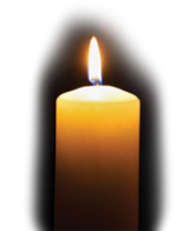

THE CONFESSION
The grace of God has dawned upon the world with healing for all. Though we have grieved him, yet he will heal us if we confess our sins in penitence and faith.

Almighty God,
I confess that I have sinned against you
in thought, word and deed;
I have not loved you with all my heart;
I have not loved my neighbours as myself.
Have mercy upon me,
cleanse me from my sins,
and help me to overcome my faults,
through Jesus Christ our Lord. Amen.

Receive God’s forgiveness
May the Father forgive us
By the death of His Son
And strengthen us
To live in the power of the Spirit
All our days. Amen.

PRAISE
O Lord, open my lips...
and my mouth shall proclaim your praise.
Give me the joy of your saving help...
and sustain me with your life-giving Spirit.

THE COLLECT
Lord of heaven and earth, as Jesus taught his disciples to be persistent in prayer, give us patience and courage never to lose hope, but always to bring our prayers before you; through Jesus Christ our Lord.
Amen.

Suggested hymn to sing or read I heard the voice of Jesus say.

THE WORD OF GOD.
1 Kings 19 : 9-18.

At that place Elijah came to a cave, and spent the night there.

Then the word of the Lord came to him, saying, ‘What are you doing here, Elijah?’ He answered, ‘I have been very zealous for the Lord, the God of hosts; for the Israelites have forsaken your covenant, thrown down your altars, and killed your prophets with the sword. I alone am left, and they are seeking my life, to take it away.’

He said, ‘Go out and stand on the mountain before the Lord, for the Lord is about to pass by.’ Now there was a great wind, so strong that it was splitting mountains and breaking rocks in pieces before the Lord, but the Lord was not in the wind; and after the wind an earthquake, but the Lord was not in the earthquake; and after the earthquake a fire, but the Lord was not in the fire; and after the fire a sound of sheer silence. When Elijah heard it, he wrapped his face in his mantle and went out and stood at the entrance of the cave. Then there came a voice to him that said, ‘What are you doing here, Elijah?’ He answered, ‘I have been very zealous for the Lord, the God of hosts; for the Israelites have forsaken your covenant, thrown down your altars, and killed your prophets with the sword. I alone am left, and they are seeking my life, to take it away.’ Then the Lord said to him, ‘Go, return on your way to the wilderness of Damascus; when you arrive, you shall anoint Hazael as king over Aram. Also you shall anoint Jehu son of Nimshi as king over Israel; and you shall anoint Elisha son of Shaphat of Abel-meholah as prophet in your place. Whoever escapes from the sword of Hazael, Jehu shall kill; and whoever escapes from the sword of Jehu, Elisha shall kill. Yet I will leave seven thousand in Israel, all the knees that have not bowed to Baal, and every mouth that has not kissed him.’

Psalm 85:8-13.

I will listen to what the Lord God will say, ♦︎
for he shall speak peace to his people and to the faithful,
that they turn not again to folly.
Truly, his salvation is near to those who fear him, ♦︎
that his glory may dwell in our land.
Mercy and truth are met together, ♦︎
righteousness and peace have kissed each other;
Truth shall spring up from the earth ♦︎
and righteousness look down from heaven.
The Lord will indeed give all that is good, ♦︎
and our land will yield its increase.
Righteousness shall go before him ♦︎
and direct his steps in the way.

Romans 10:5-15.

Moses writes concerning the righteousness that comes from the law, that ‘the person who does these things will live by them.’ But the righteousness that comes from faith says, ‘Do not say in your heart, “Who will ascend into heaven?” ’ (that is, to bring Christ down) ‘or “Who will descend into the abyss?” ’ (that is, to bring Christ up from the dead). But what does it say?
‘The word is near you,
on your lips and in your heart’
(that is, the word of faith that we proclaim); because if you confess with your lips that Jesus is Lord and believe in your heart that God raised him from the dead, you will be saved.
For one believes with the heart and so is justified, and one confesses with the mouth and so is saved. The scripture says, ‘No one who believes in him will be put to shame.’ For there is no distinction between Jew and Greek; the same Lord is Lord of all and is generous to all who call on him. For, ‘Everyone who calls on the name of the Lord shall be saved.’

But how are they to call on one in whom they have not believed? And how are they to believe in one of whom they have never heard? And how are they to hear without someone to proclaim him? And how are they to proclaim him unless they are sent? As it is written, ‘How beautiful are the feet of those who bring good news!’

Suggested hymn to sing or read Jesus is Lord.

GOSPEL
Matthew 14:22-33.

Immediately he made the disciples get into the boat and go on ahead to the other side, while he dismissed the crowds. And after he had dismissed the crowds, he went up the mountain by himself to pray. When evening came, he was there alone, but by this time the boat, battered by the waves, was far from the land, for the wind was against them. And early in the morning he came walking towards them on the lake. But when the disciples saw him walking on the lake, they were terrified, saying, ‘It is a ghost!’ And they cried out in fear. But immediately Jesus spoke to them and said, ‘Take heart, it is I; do not be afraid.’

Peter answered him, ‘Lord, if it is you, command me to come to you on the water.’ He said, ‘Come.’ So Peter got out of the boat, started walking on the water, and came towards Jesus. But when he noticed the strong wind, he became frightened, and beginning to sink, he cried out, ‘Lord, save me!’ Jesus immediately reached out his hand and caught him, saying to him, ‘You of little faith, why did you doubt?’ When they got into the boat, the wind ceased. And those in the boat worshipped him, saying, ‘Truly you are the Son of God.’

REFLECTION – Can you speak up please?

Charles Haddon Spurgeon (1834-92) was a Baptist minister and notable preacher. He must have been exceptional, because he began preaching at the age of 16 and at 18 was appointed pastor of a church in Waterbeach, Cambridgeshire. When he was 20 he moved to a church in Southwark, London, where he drew such congregations that they had to build a bigger church!

A story is told of Spurgeon, that one day, travelling in a train, he got into conversation with another passenger, who was clearly involved in his local church.
'Yes,' said Spurgeon, 'but are you a 'Say so' Christian?'
The other man was offended, thinking the question meant, did he just say he was a Christian without living out that faith? Spurgeon quickly corrected this, saying that it was a reference to Psalm 107 verse 2:
'Let the redeemed of the Lord say so.'
Or as we might find it in more modern versions,
'Let those the Lord has redeemed of tell their story,' or
'Those whom the Lord has saved must talk about him.'
In other words, if you are a Christian, are you willing to admit it? Are you ready to talk about your faith? Are you a 'Say so' Christian?

With this introduction in mind, we shall pick up some points from today's reading from the Letter to the Romans, chapter 10. First, a familiar theme of Paul's, the Jewish Law as given to Moses has never saved anybody, because it has to be kept in its entirety – pass mark 100% – one broken rule, and hope is gone. So the Law teaches us what sin is, but doesn't help to save us. The next bit (verses 6-8) tells us that the righteousness which comes by faith, rather than law, is not difficult to find: no need to ascend to heaven or descend to the world of the dead; the word is close to you all the while. So how do we access this righteousness, this putting right with God the Father? Verses 9-10 tell us,
'If you declare with your mouth, 'Jesus is Lord,' and believe in your heart that God raised him from the dead, you will be saved.' Simple! In fact, before the early Councils of the Church set out the creeds, such as the Nicene Creed and the Apostles' Creed, the basic creed of the Church was to affirm 'Jesus is Lord.' I have sometimes seen evangelistic cards or leaflets intended to be given to anyone who enquires about the Christian faith, explaining the basics of our belief, and often including a short prayer of commitment, acknowledging Jesus as Lord. They often conclude, 'Say this prayer aloud, and you will be saved.'

This section of the letter ends with the conclusion that as no-one is saved by the Jewish Law, then both Jews and Gentiles are on a level playing field: the same Lord is Lord of all, and anyone who calls on the name of the Lord will be saved (verses 12-13).

Before moving on to the last section, it is worth noting that for Paul the death and resurrection of Jesus are in effect one event, for which he often uses the shorthand 'The Cross', or as in this passage, 'God raised him from the dead.' The death of Jesus pays the price for sin; his rising from the dead is his vindication, and also the proof we need that his death was, in fact, his victory over sin. So they cannot be separated, and together form the event which achieves salvation for us.

Verses 14-15 raise four logical questions:
How can they call on one they have not believed in?
How can they believe in one of whom they have not heard?
How can they hear unless someone proclaims the message?
How can anyone proclaim unless they are sent out?

All reasonable questions. The Scottish theologian AM Hunter, in his much respected commentary on the Letter to the Romans, argues that 'people today don't have the excuse that they have not heard the gospel. They have all been taught it.' That might have been true when it was written in 1955, but 70 years on it is certainly not so today. We practise our faith, we begin our proclamation, in a time when in wider society there is a general lack of knowledge or understanding of Christianity, making Paul's four questions even more relevant.

The writer of the First Letter of Peter tells us,
'Always be ready to give an answer to everyone who asks you to give the reason for the hope you have.' (1 Peter 3: 15) – though he goes on to say,
'but do this with gentleness and respect.'
I do realise that being open about our faith can be daunting:
- We might be afraid that trying to impose our beliefs will put people off. Better to keep quiet and win their friendship?
- What if they take offence, reject us?
- What if they ask a question to which we don't have the answer, making us feel inadequate?
- What if we rely on our way of living, in the view that actions speak louder than words?

But remember, what we have to offer is the greatest possible treasure on earth: life-giving faith in Jesus Christ. If people won't listen, that is their problem, they are the ones missing out. If they have a question we can't answer, be honest, offer to try to find someone who can give an answer. And yes, how we live can be the greatest possible witness to our faith – but in the end, we also have to talk about it, or people won't realise why we live that way.

Remember Paul's four questions:
How can they call…..believe…..hear…..how can anyone proclaim?
Which brings us back to Charles Spurgeon's question, addressed this time to us:
'Are you a 'Say so' Christian?'

Jonathan Falkner.

Suggested hymn to sing or read Firmly I believe and truly.

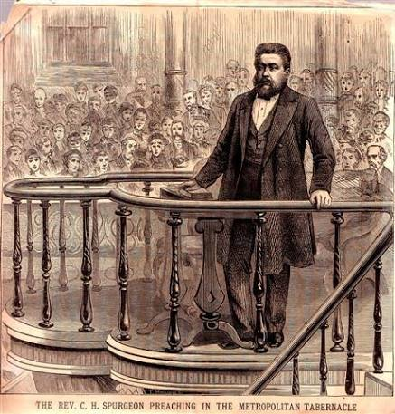

THE PRAYERS
A time of quiet prayer for
• The universal Church - Bishops, synods and all leaders church
• The leaders of the nations
• The natural world and the resources of the earth

Lord Jesus, you are the Prince of Peace.
Look upon our divided world
to be with those who are victims of violence.
We pray for the people of Ukraine
and all who have been subjected to the cruelty of others.
Help us to know the gift of your peace
in the power of your Spirit and
we ask you to soften the hearts
of those who can stop the fighting.
Creator God, we ask for your aid as your children of light
living in the darkness of our world.
Amen.
Cumbria Ecumenical Spirituality Group.

Finishing with the South Calder Mission Community prayer...
Heavenly Father we thank you for the life of your Church
in this place, and in all the villages of the South Calder Mission Community;
for all who have served and worshipped you in years gone by,
for all who make up your family in our churches today,
for the faith we have in common, and for the people and traditions which make each church unique.
By your Spirit, guide and equip us,
that together we might find new ways
to reach out to our local community,
to show your love to our neighbours,
and to encourage them
to follow the Lord Jesus in their lives.
Father, we offer ourselves to your service,
In the unity of the Holy Spirit,
And in the name of Jesus Christ our Lord. Amen

and the Lord’s prayer...
Our Father, who art in heaven,
hallowed be thy name; thy kingdom come;
thy will be done; on earth as it is in heaven.
Give us this day our daily bread.
And forgive us our trespasses,
as we forgive those who trespass against us.
And lead us not into temptation;
but deliver us from evil.
For thine is the kingdom,
the power and the glory,
for ever and ever. Amen.

THE CONCLUSION

Suggested hymn to sing or read Go forth and tell.

The following prayer is said
Be with me, Lord, as I finish my prayer today.
May my lips always speak the truth;
may my eyes which have read your word
see only what is good;
and may my life as well as my worship
be always pleasing in your sight,
for the glory of your name. Amen.

And now may the Lord who brought us to birth by his Spirit,
strengthen us for the Christian life.
May the Lord who provides for all our needs
sustain us day by day.
May the Lord whose steadfast love is constant as a mother's care,
send us out to live and work for others.
And the blessing of God Almighty.
the Father, the Son, and the Holy Spirit,
be with us and remain with us always.
Amen.

So now may I go in peace to love and serve the Lord.
In the name of Christ. Amen.

Links for the hymns

I heard the voice of Jesus say.

https://youtu.be/yYqgBMrmeZA

Jesus is Lord.

https://youtu.be/8HHYt40whHQ

Firmly I believe and truly.

https://youtu.be/9kPzfqy4RIo

Go forth and tell.

https://youtu.be/QkDD4GiqUEM

