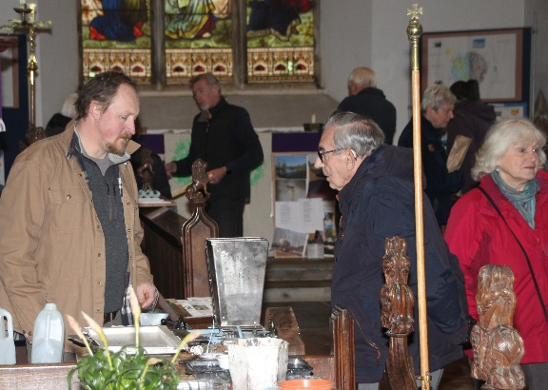
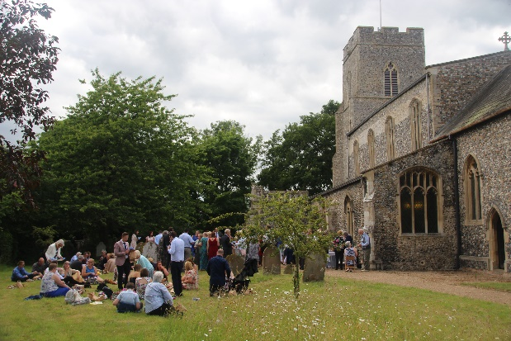
Supportive Evidence for Eco-church Gold from All Saints, Mendham
Our Environmental Principles
St Edmundsbury and Ipswich diocese encourages the pursuit of ‘eco-church’ and our eco-church journey began has a result of a presentation at a deanery synod by an advisor in 2019. The diocesan website summarizes, ‘The environment is God’s gift to everyone and we have a responsibility towards each other to protect it. We cannot think of ourselves as isolated from others or from creation.’ This idea was integrated into the faith and life of All Saints, Mendham before it appeared on the website as laity influenced care of the environment in worship, cultivation of the churchyard for wildlife, and the selling of local produce in a churchyard market from the start of the century.

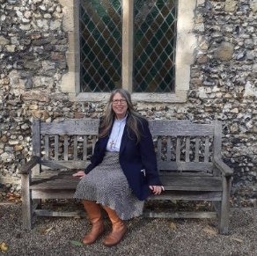
Pursuit of an eco-church award was boosted when a curate in the benefice who had previously worshipped at All Saints was employed as a local minister. Care for creation was not only important in her personal lifestyle but central to her theology. Whilst an ordinand she organized a successful Green Fair in the church. It was a distinguishing feature of the parish to work on as part of her role, whilst fitting with her own passions. The interview with Diane on Mendham attaining Bronze remains the first article under eco-church on the diocesan website and is in appendix 1.

During Covid lockdowns, much use was made of outdoor areas for worship and meetings and it became apparent that being in natural surroundings could draw new people to church so came to form an important part of the church’s mission plans under the diocesan strategy for growth called

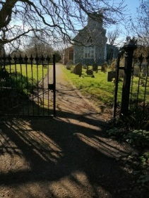
a photo from a Zoom Good
Friday service with a virtual walk- through the churchyard, now used on church
posters

The listening phase included the local minister visiting all homes to build relationships and to hear how the church could fit better into the life of the local community. ‘Members of the community were surprised that the church was interested in the environment… It wasn’t seen as the church doing something on their own, but as the church getting involved in the community.’ All three priorities chosen link with eco church:
- Connecting and serving the local community
- Welcoming people into the life of the church – making the step into church life low and easy
- Focusing on eco-church.
The plan was to:
- offer services and opportunities for reflection outdoors which are accessible to all, in the churchyard for example

- develop a local response to eco-church, and the eco awards working with the local school in this regard and in any other ways that can be identified. (The primary school (not a church school) had been greatly involved with the Green Fair and Live Lent: care for God’s Creation was used in assemblies and children from the school described what they were doing at the accompanying service).
- Setting up a community larder green fair symbol Our diocese funded the spring 2023 project.

Consideration of the environment at All Saints was broadened from a local to a global focus by the diocesan link with Kagera and the connected Bishops’ Lent Appeals directly relating to the effects of climate change there. The national perspective came in when Bishop Martin grew a tree for every parish for Queen Elizabeth II’s Platinum Jubilee. Indeed, as our Eco journey has progressed, environmental concerns globally, nationally and in the church have become more mainstream – our first green fair avoided the term climate change to be inclusive to as many as possible, a non- belief in climate change is more unusual in our area now. There has also been a motivation to preserve the legacy of two past congregation members with a passion for environmental concerns.
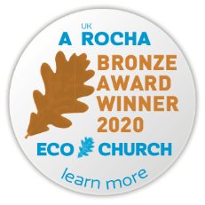
After achieving Bronze, other churches became interested in what we were doing and the curate was asked to consider being a deanery champion (a formal role that training prohibited but did not prevent her informal encouragement of others). With a town church nearby with a gold award, we were spurred on to continue the work to achieve silver although lockdowns meant it took longer than expected. Recently Eco-church has become a seam-less part of the church’s work, its inclusion no longer questioned or to be abandoned despite the challenges as well as opportunities. It is now trusted that it will not be used to stigmatise for example the local beef farm and individuals help within their own area of interest rather than its leadership restricted to a small team.
Worship and Teaching Work prior to 2000 gave the church a gold in this area when the bronze award overall was achieved but more continued to be done. The newly designed monthly village services on the local leader’s appointment have included many environmental themes eg the use of clover on farms linked to the trinity, of which this is a service snap-shot:

Our Bible reading: Matthew 28: 16-end Clover leaf: a reflective script from ‘Seasonal Worship from the Countryside’ (The Staffordshire Seven SPCK) A farming note: ‘Clover is a remarkable plant in that it can fix nitrogen from the air. Farmers with low fertilizer usage can obtain all the nitrogen needing through sowing clover in the sward, resulting in lower costs and improved pasture.’ 2003 quote from book above. Diane leads discussion: How does the clover leaf help us to understand God, Father, Son and Holy Spirit?
An interesting discussion with an arable farmer resulted. Sheets from services often contain useful environmental information on the back page used as an information leaflet in church and the pub afterwards as we are mindful of the use of paper.
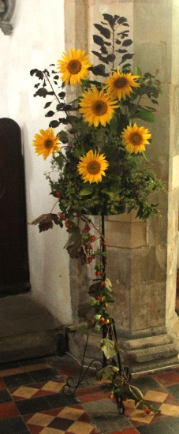
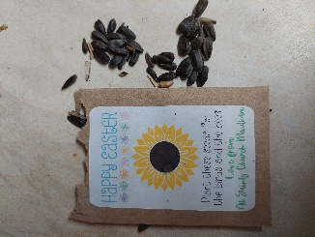
Since achieving our silver award overall, the church has celebrated creation-tide for the first time, beginning with an outdoor service celebrating all God’s creatures (a more inclusive name, than calling it a pets’ service) attended by nine dogs and a rabbit including a traditional farmers’ harvest service and ending with a service on St Francis of Assisi, focusing on living simply. As a result of our choosing sunflower seeds to encourage insects in environmentally friendly packets as a gift to all villagers for Easter rather than the usual primulas in plastic pots with wrapping, harvest arrangements were full of sunflowers. We were also given photos of the sunflowers as they grew and the bees attracted to show the school children.
Assemblies with the children at the school prior to their harvest service link with caring for God’s earth and it is always a part of their service with parents in the church. At Easter, new life is also linked with understanding the seasons and Easter gardens have been made that were then displayed in the church. The school has produced recycled plastic poppy wreaths for Remembrance Sunday and is currently contacting a local ‘maker’ who demonstrated a machine to recycle plastic at the green fair (see title picture) to work with them as part of their ‘Inventions’ project.
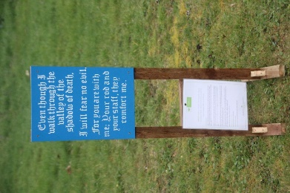
Hand painted verses of psalm 23 were gradually put out around the churchyard in Lent with accompanying reflections on creation from the Bible Society whilst reflections on aspects such as water and trees provided content for the rogation service. Rogation readings and hymns have always related to the wild flowers in the churchyard and the river. Weekly prayers as well as village services regularly employ Wild Goose materials from the Iona Community with its focus on creation and global care. The local minister and (in the past a lay elder) have joined an Iona diocesan weekly group for worship on Zoom.
We tried hard to get a local gold eco church leader to speak at a service but he was unable to do it because of the vulnerability of his family to Covid and our limited availability of service dates however we did get a couple who had seen the effects of climate change in Kagera for themselves, to present. We hope to get an ex- villager who has just completed studies with the University of East Anglia, to speak about her work with tribes in the Amazon rainforest.
Two new people from the village drawn to our outside services now play guitar at village services regularly, another sings. Some people often with dogs (which incidentally are welcome in the building) choose to come to outdoor services only. One of the guitarists who is Romany and lived in their traditional lifestyle created the nativity figures (seen later) and Psalm 23 signs, rewriting verses for a hymn for the God’s creatures service and hosting a Lenten group. This Lent his group is to use The John Ray Initiative biblical studies on the environment, we accessed when we achieved Bronze.
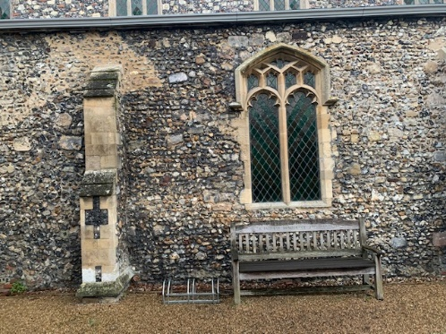
Building The ‘Building’ aspect of Eco-church was always the one we felt might be the most difficult to raise to Gold status. Firstly, this was because of the listed status of the church building with the accompanying cost, complexities and period of time required to make any changes. The parish does not contain a church hall, office or vicarage - the self-supporting local minister works from her own home. The building of a church toilet, in the planning from 2000, began after our Bronze award and lots of problems with this occurred. The committee responsible for the building always saw reasons why further changes linked to being environmentally friendly might be difficult. However, despite all this we altered those things we could!
The Green Fair and its emphasis on the environment meant that when the treasurer had to negotiate a new electricity contract, without being asked he looked for one, linked to 100% renewable electricity which we then publicised. After talk about the requirement for a faculty we managed to install a cycle rack as a temporary feature in a place in the church yard that was approved and attached to a bench. Whilst renting a porta-loo parochial church meetings debated the merits of different makes of recycled toilet paper for one day when we had a choice (the porta-loo company, just like the benefice photocopier hire company, paper was bought for, would not allow recycled products!)
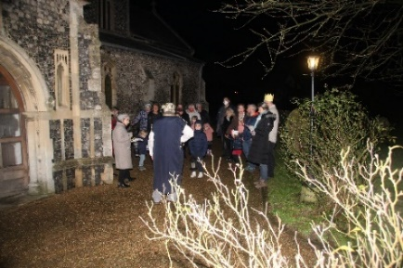
Then after achieving Silver overall, the toilet building was finally completed. Immediately we had a choice about toilet paper. The constant eco discussion meant that without debate, all cleaning products bought were environmentally friendly and at this point we ensured that any other products the church provides for volunteer cleaners also were satisfactory in this regard, removing any products brought and left that were not suitable, without losing any of our small group of volunteers. Then came a disappointment – the disabled toilet had no dual flush button (an inherited anomaly with water usage meant this was not considered a problem but it was a problem for the local minister who had seen what a precious resource water is in Kenya). A simple water-saving device was fitted. Options for additional water collection from this building need to be explored in the future, as does a better positioning of the water butt for collection of water for churchyard users.
The PCC agreed the limited lighting around the church was part of our environmental drive with a timer even restricting this use. Light bulbs although low energy, were not all LED so the churchwarden with help arranged for this to be done, giving much brighter lights for reading and cheering the place up.
Aims of BREEAM • To reduce the environmental impact of development. • To enable development to be recognized according to their environmental benefits . • To provide a creditable, environment label for building. • To stimulate demand for environmentally sustainable building.
Our work in the village for the environment attracted the attention of a BREEAM consultant who lives here and he gave a presentation to the PCC about the concept of BREEAM that persuaded them to agree this would be considered with future building work. Our BREEAM consultant is willing to work to explain the concept to other churches and try to gain funding to conduct a survey for BREEAM in-use.
Carbon footprint The carbon footprint for 2021 was calculated using the Carbon 360 website. This was shared with the congregation who talked about ways this might be reduced. The local minister without access to data inputting for Church of England at that point explained the importance of inputting energy bills on this website within the timescale in future to aid calculation of the footprint. The PCC agreed to target initially reducing the footprint year on year as they did not have detailed figures to compare and that funds acquired for the church’s ‘green’ work could be used to pay to offset the carbon footprint where changes could not be made. With tree planting being carried out by congregation members, the local minister was shocked to find how little this offset and how impact needed to be in particular areas of the world in an intensive way so a donation of 30 pounds was made calculated to offset 2021’s amount to Climate Stewards.
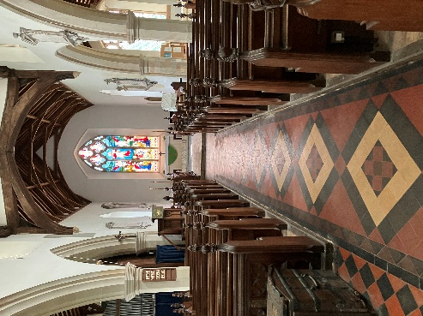
Energy bills and building data was entered for 2022 calculating a carbon footprint on the Church of England website. The total annual emissions for 2021 1.41 tonnes were more than the gross emissions for 2022 of 1.3 tonnes (net emissions 0.1 tonnes). This was despite the energy used increasing almost 400% due to an increased use of building after Covid and the start of building work using electricity and causing many draughts as there was a gap under an outside door. It is difficult to compare details as the two footprints are calculated differently. Travel expenses for work in Mendham is not claimed by the self-supporting minister who was able to lead most services in 2022 so no travel consideration is made in the data. The church is open but empty most of the time and only service hours were in 2021 footprint. The 2023 data has not yet been input but contractors for energy have been changed because of costs (still 100% renewable) building work continued and there was additional use for a children’s choir weekly from September.
The next green fair should provide more funds to offset but we want to continue to reduce the footprint. The new toilet building has heating and lighting that only comes on when in use. Faulty under pew heaters are being checked and only these heaters are put on in advance. Lighting is only put on when in use. We have not yet had a year to see the difference in energy use of all LED bulbs. Water for hot drinks is kept warm in thermos flasks but there is washing up as we do not use disposables to be environmentally friendly – the elderly congregation do not bring their own mugs. Blankets are provided and heated cushions were investigated but considered too costly. A balance has to be provided with heating the building to protect the elderly and encourage its use with the young children at the school. The calculations for attendance need to be compared in the same way and with the church being in 0-10% church usage adjusted percentile band (the 10-20% band for weather adjusted energy efficiency and emissions/sq metre adjusted percentile band) we might find it better to use the carbon 360 option as well the Church of Engand data in the future.
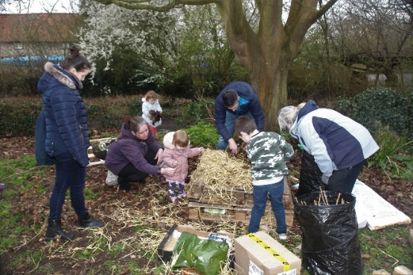
Land From the beginning of this century consideration had been given to encouraging wild flowers and insects in the churchyard, especially leaving some areas unmown, doing counts of what plants and insects were there. At this stage there was not a systematic approach to the whole churchyard, with conflicts due to what was considered respectful by some villagers for graves, the methods of an employed gardener and some others who were negative to environmentally friendly forms of gardening.
The Green Fair had the Waveney Trust helping families to building a bug hotel and after an exhibit about encouraging hedgehogs a hedgehog box in was placed in the churchyard. People also began to understand more about the bats which came into the church.
As we worked towards the Silver award, working with the Suffolk Wildlife Trust enabled us to establish a land management plan and mowing regimes in order to preserve the rare grasses that had been considered so important but may not be given a second glance by visitors more interested in birds, insects and wild flowers. There were differences of opinion linked to the regular use of power tools with noise pollution and energy use and wedding couples who wanted mown grass for high heels and no chance of snagging clothes and neat background for photos. There were also problems in finding funds for new equipment and manual hours and the gardener taking orders from different people. We wanted to use old fashioned methods like scything but had no able volunteers (and could attract no volunteers) to do it.
Then during a time when the churchyard was not able to be monitored so closely because of Covid, the management plan was not kept to, areas were left unmown and the problem seemed unsurmountable. More consultations with Suffolk Wildlife Trust and the deanery Eco champion were made. It was only due to the persistent work of one of our original Eco team and his contacts with various organisations of volunteers with machines that we got back to a position where we could generally reestablish the plan. The land management plan is on permanent display at the back of the church. The most recent of our Suffolk Wildlife reports which relates to the plan is in the appendix 6 and is also on display in the church. We now need to reestablish counts of wildlife, maybe look into panels to help people identify wildlife, work with the children from the school on this or have an open day.
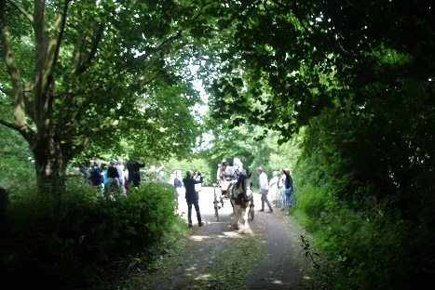
We were also frustrated by the fact that we wanted to plant more trees but this is not practical – we do have links with people who will plant elsewhere locally if anyone requests it and managed to plant saplings (including the bishop’s trees to become part of hedging. We do not have a pond or wetland area because our churchyard is right next to the River Waveney so we get dragonflies etc because of that.
As we have worked towards gold overall a congregation member has developed an interest in looking after the birdfeeders as part of her therapy. (We just need to monitor this with problems in the village linked to rodents because of the river.) She was lucky enough to observe a hedgehog whilst locking up. The gardener now seems to understand the importance of keeping to the plan and a change in his leadership seems to have gone smoothly. An area disturbed by the building of a toilet has been successfully sown with wild flowers.
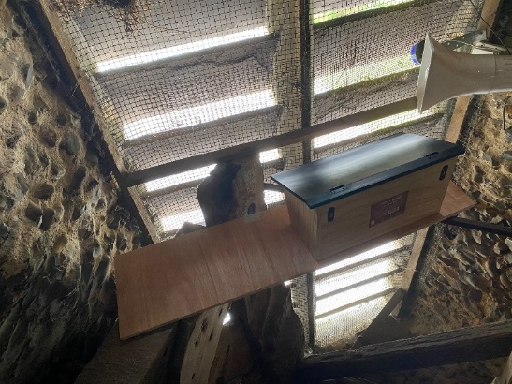
We have finally after a number of years working with a local swift organisation, been granted a faculty for electrical work to install equipment to link with the installation of swift boxes. This was after securing a grant from The Round Table in the nearby town where there is a swift project underway. We had to persuade the PCC that the birds would not get into church and liaise with the bell ringing guild to establish that the sound of bell -ringing will not be impacted because of the unusual position of our bells.
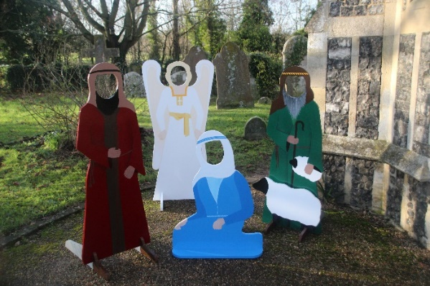
The opportunity for teaching about Christian festivals outdoors has involved crosses erected for a family-friendly Good Friday service with the pillbox becoming the tomb on that day and Easter Sunday, large cut-out figures built up into a nativity scene, one put out each week of Advent. We also undertook the ancient ‘clypping’ tradition. Our service refreshments are outside on fine days.
Many people walk through the churchyard, sit on the benches for a packed lunch and we encourage dog walkers, although this does mean some of our congregation are involved in clearing up after other people’s dogs despite our pleas and a dog toilet not far away!
Community and global engagement Some of these aspects were well-established before Eco-church status was considered. Through congregation members’ personal work, the church had good working relationships with The River Waveney Trust, Suffolk Wildlife Trust, Save our Swifts. Members have been involved in clean-up projects. The church has always been involved with the Historic Churches Ride and stride and organised rogation walks. It contains information on footpaths for walkers and has hosted talks on the church for a rambling group. Members have always shared car- rides to events whenever possible. Meals provided by the church always included food that is locally grown and a vegetarian option with an eye to reducing food waste.
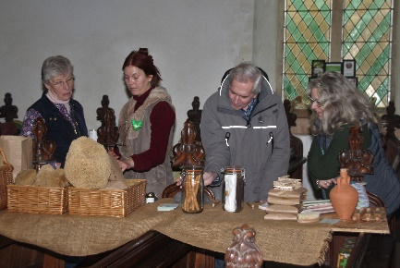
From the appointment of the local minister, All Saints worked closely with a chair of the parish council interested in environmental matters. He is working with a local town on an environmental project and plans to involve us in the future supporting our events with his poetry. The local leader now reports on church progress at an annual parish council meeting. The parish council has increased their donation to the upkeep of the churchyard. The Green Fair showcased local produce (photo shows natural soaps) and raised awareness of many environmental issues including recycling and Fairtrade products. The fair planned for this year will do the same.
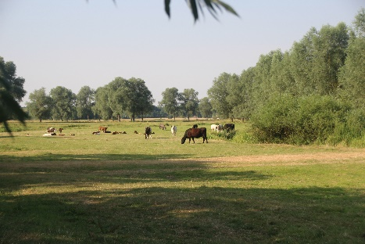
Our church supports local small family farmers in using their products and our pub/hotel which provides meals of them. Farmers attend our church and we are aware of the difficulties they are facing (our nearest dairy farm has given up his herd) – we serve them and recognise they are also trying to be more environmentally free in their practices. One of the reasons why fairtrade sugar was purchased last was we bought local sugar from sugar beet. Beef reared on the marshes (a SSI area) with reduced farm to fork miles but not labelled organic is another product. The green fair managed to advertise meat, local dairy and vegan products as well as advertise British Hen Welfare Trust. This is a difficult balance but one we believe is essential in working together as one community, respecting differences. Food may be provided by individuals for free and we use what is offered. Congregation members sell or give away excess vegetables fruit and plants grown in their gardens at the end of services in the summer.
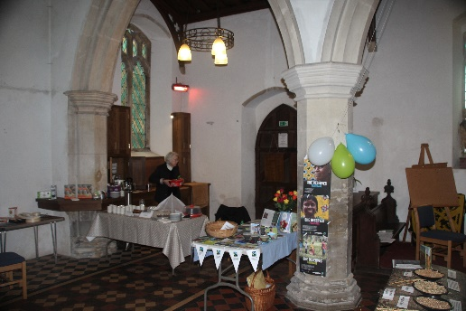
A congregation member who has died since we began our eco journey headed up our Fairtrade work and was passionate about petitioning politically about global environmental campaigns and encouraging us all to join in. However, pursuing eco-church status has kept the use of fairtrade products prominent, so now Fairtrade is purchased for Advent calendars, Easter eggs and wine and all refreshments are fairtrade as the congregation has agreed taste is no longer compromised. Fairtrade status has recently been achieved. Members ask the local Co-op about stocking specific fairtrade items.
Since achieving Silver award overall, the church promoted plastic free July in the parish, working with the school (who produced poems displayed in the church) and encouraged other parishes in the benefice to take this up, following it up in a benefice family service the following month. This connected with the emphasis of the local river conservation group and a national interest in clean rivers and reduction of plastic pollution.

The new toilet has been e-twinned with Uganda and there is framed photo of this in the toilet and this was all organised for us by a congregation member. The church prays for the work done to support our link diocese in Kagera, Tanzania with climate change, with a substantial funds raised for this last Lent, and a person there prayed for in morning prayer every weekday, said by the local priest with the bishops on-line.
A plan for someone from the local green council to speak has not been actioned at the moment due to a green MP standing at elections and the church not wanting to seem to side with one political party in an election year.
Lifestyle The installation of the cycle rack allowed us to promote again walking or cycling to church and there is limited car parking around the church however the lack of mobility of many of our elderly members and the way that our village is spread out over country lanes with no footpaths can be preventative. Members always car share when possible. Travel came up in discussion around the carbon 360 church footprint. Showing the church carbon footprint enabled us to suggest doing a personal carbon footprint, writing personal pledges linked to environment and making a verbal care for creation pledge. The local minister has referred to a holiday In Malta going overland and sea rather than flying and a parishioner who has a son who is a pilot has described to the prayer group a project in the county with a plane fuelled by green energy.
Issues with rising costs of heating and worries about keeping warm enabled us to tackle the topic of reducing personal energy consumption also saving money. There needed to be a balance to this as elderly people can worry about fuel bills and reduce heating to the detriment of their health. The local minister advertises that parishioners can join her in the pub with a hot drink and has people go in there to keep warm.
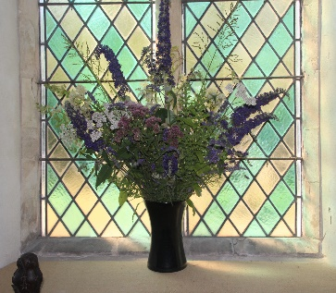
The church contains a food and household larder for people to take what they need, given by those who can, which is regularly being used, including by families. This saves the petrol consumption of deliveries from a foodbank a number of miles away. Those giving have tailored what is there to what is needed which is advertised. Dog food is included. Clothes for recycling have been taken to a scheme at the local school (and in the past crisp packets). Christian books can be placed in the church and other books are swapped through shelves in village pub. Recycling for example of glass is available in the village car park for the benefit of the village. The first green fair demonstrated a place in the benefice where all sorts of unusual items could be recycled. The local minister re-uses cardboard, foil items, calendar pictures etc when making items to use for children, for prayer corner, thank-you cards and avoids the use of envelopes or recycles them using special labels. Since our silver award, there have been schemes set up for recycling by re-using Christmas cards and we have supported recycling of Christmas trees in parish to be eaten by goats. Presents exchanged have wrappings that can be reused and recycled. Congregation members use flowers from gardens where possible and where flowers are ordered where they come from and how they are wrapped can be considered by individuals.
Moving away from a benefice website we are now beginning to develop our parish website although there is no help with this, broadband reception in the village is not good and there are people who do not have access to the internet. The benefice magazine delivered free now has an A5 newsletter Mendham Message for the village and this is where environment tips are included. Since achieving Bronze, a large board at the back is updated with Eco work and is frequently looked at by visitors. Loaf has been advertised with questions on this board.
The church's ethical investment enabled the priest to speak and display about the principles of CAF bank as part of a sermon about how we live our lives (it also included e-twinning.) A congregation member in another village has purchased large amounts of environmentally friendly household products that means containers can be refilled. Ordering together for Fairtrade chocolate eggs and Advent calendars have been made possible. It is hoped to offer a communal Easter card in the future as since Covid we have found how much Christmas cards are appreciated.
The future All Saints is working hard to organise another Green Fair in March of this year and it feels it has gone full circle although this time a different focus is needed as local people are much better informed. Eco-church has been fitted to our work, is much more than a set of criteria to fulfil and we have been keen to ensure that it has been inclusive. The action is integrated and does not relate to one aspect of Eco-church at a time. We keep positive using David Attenborough’s example – accentuating what we can all do rather than what we cannot and ensuring people want to take the steps chosen so they are more likely to be sustained. However there will always be more still to be done in the parish and the benefice and the rest of Suffolk awaits!

Appendix 1: Diocesan website article

Suffolk church goes for gold in eco-friendly boost
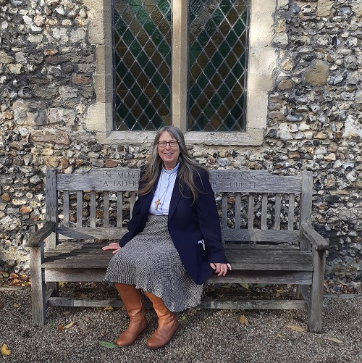
The Revd Diane Ekins is overseeing an eco-revolution at All Saints’ Church in Mendham, where she is now local minister after being ordained last year.
The church has a vision to achieve Gold Eco Church status from the 'A Rocha' charity scheme, after achieving bronze before the initial coronavirus lockdown. 'A Rocha' is a charity that recognises churches which have gone above and beyond to help the environment, with caring for God's creation a fundamental part of Christian faith.
Diane was first inspired to live an eco-friendly lifestyle after working in Kenya in the 1990s with her husband Granville, where they had to live without the benefits of constant running water and a stable electricity supply. Diane said: “When we came back to England, we felt there was just no way we could return to living life the way we did before. We wanted to live life like the stars of The Good Life – we aimed to become as self-sufficient as we could, we grew our own food, recycled our own water. Nowadays we only spend around £1 a week on water bills.”
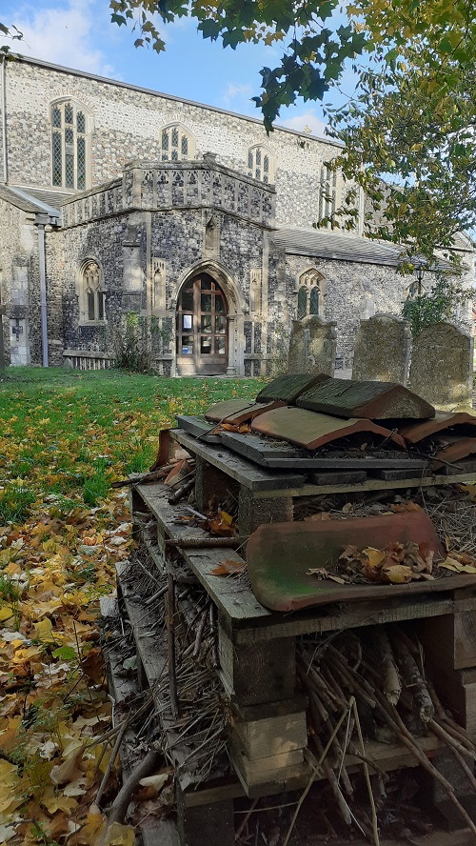
In 2020 an exhibition was hosted at the church prior to it being awarded bronze status, as part of Diane’s ministerial training. It taught local people the benefits of recycling and shopping from local or Fairtrade farmers. The churchyard has since become a haven for residents and visitors alike to walk in and watch the birds, with plans in place to install new swift boxes. Local primary school children also helped create a bug and hedgehog hotel on the church grounds, as well as putting up bird feeders. The church has also subseqently switched to eco-friendly electricity tariffs.
But Diane and the local parish now have a plan in place to make the churchyard even more eco-friendly – and go for gold status.
Diane said: “This has become part of our life, how we live and what we are passionate about. We were so pleased to find out other members of the parish shared our love for the environment. I thank God that we were able to achieve bronze status just before the pandemic hit. We are now heading towards silver and planning what else we need to do. I am confident we can do it and go on for gold.”
Diane also worked as a headteacher at Ranelagh Primary School in Ipswich before becoming a member of the clergy, teaching children there to be eco-friendly. Diane thanked the local community in Mendham for coming together in support of the church. She said: “The reaction in the community has been fantastic. Everyone needs to do their little bit to help the environment.”
More information on the Eco Church scheme can be found here.

Appendix 2: Back page from service sheet on hope in creation Mendham All Saints Church supports Fairtrade
Fairtrade Fortnight runs from 21st February until 7th March in 2022.


Activate more hope for the world!

Did you know that:
- Fairtrade means farmers and workers have more resources to adapt to the changing climate and invest in sustainable farming techniques.
- The eco-friendly Fairtrade Standards help tackle climate change and its effects through reducing carbon emissions, preventing soil erosion and deforestation, and promoting environmentally sustainable farming techniques.
Appendix 3: Service sheet for care for creation service


Celebrating all God’s creatures
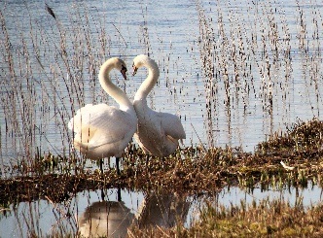
All Saints Church, Mendham 3rd Sept 2023
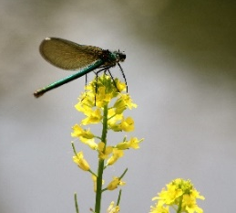

Welcome and introduction to Creation tide
The Lord of all Creation be with you
And also with you.

We will praise God on dog walks, and in the countryside.

We will praise God in gardens, paddocks and pasture.
Yes, we will praise God!
We will praise God in aquariums and all sorts of animal houses.
We will praise God with all animals who share our home.
Yes, we praise the God of all creatures!

We sing:
All things bright and beautiful 1. Each little flow’r that opens
All creatures great and small, Each little bird that sings All things wise and wonderful: He made their glowing colors The Lord God made them all. He made their tiny wings

2.The purple-headed mountain, 3.The cold wind in the winter,
The river running by, The pleasant summer sun, The sunset and the morning The ripe fruits in the garden,
That brightens up the sky. He made them every one.
Saying sorry to God for our failure to care for other creatures We confess to you the times when we have not been good stewards of creation, Forgive us Lord.
We confess that we have not always respected the ways in which we and other creatures are interconnected, Forgive us Lord.
We confess to you our selfishness or ungratefulness in the gifts you have provided. Forgive us Lord.
God’s forgiveness assured: May the God of love bring us back to himself, forgive us and assure us of his eternal love in Jesus Christ our Lord. Amen.
We sing:
Think of a world without any flowers,
Think of a world without any trees,
Think of a sky without any sunshine,
Think of the air without any breeze.
We thank you, Lord, for flowers and trees and sunshine, We thank you, Lord, and praise your holy name.
Think of a world without any animals,
Think of a field without any herd, . Think of a stream without any fishes,
Think of a dawn without any bird.
We thank you, Lord, for all your living creatures,
We thank you Lord, and praise your holy name.
We listen to a poem: ‘No wonder he wags his tail’
We listen to some words of Jesus from Matthew 10:29-31.
Diane reflects briefly on these words.
We pray: Divine Creator, we thank you for the sheer delight of all the beautiful creatures you have made and placed here to share this planet with us. Lord of life, hear our prayer.
We thank you for all the animals who have helped and comforted humans in the past and those who do so today. We ask for compassion in humans looking after animals. Lord of life, hear our prayer.
Lord of all, giver of all, open our eyes to the richness of creation and to everything you would say to us through it. Lord of life hear our prayer. Amen.
We sing: He's got the whole world in his hands x3 He's got the whole world in his hands
2) He's got all those of the wild in his hands x3
He's got them all held in his hands

3) He's got all our feathered friends in his hands x3
He's got them all held in his hands

4) He's got the fishes in the sea in his hands x3
He's got them all held in his hands

5) He's got all our pets at home in his hands x3
He's got them all held in his hands
Blessing: May God bless the sun that is above us, The earth than is below us The creatures all around us and lead us into his peace.
Thank you to Joe and Graeme, the guitarists who invite you now to join them singing: Me and You and a dog named Boo, travelling and living off the land. Please stay for refreshments. An offering plate for church’s work inside the church. 17th Sept Communion 10.30am. 24th Sept Harvest 6.30pm 1st Oct Next Village Service Simple life (St Francis) with guitarists. Refreshments from 10.15am to start 10.30am.
Appendix 4: carbon footprint 2021
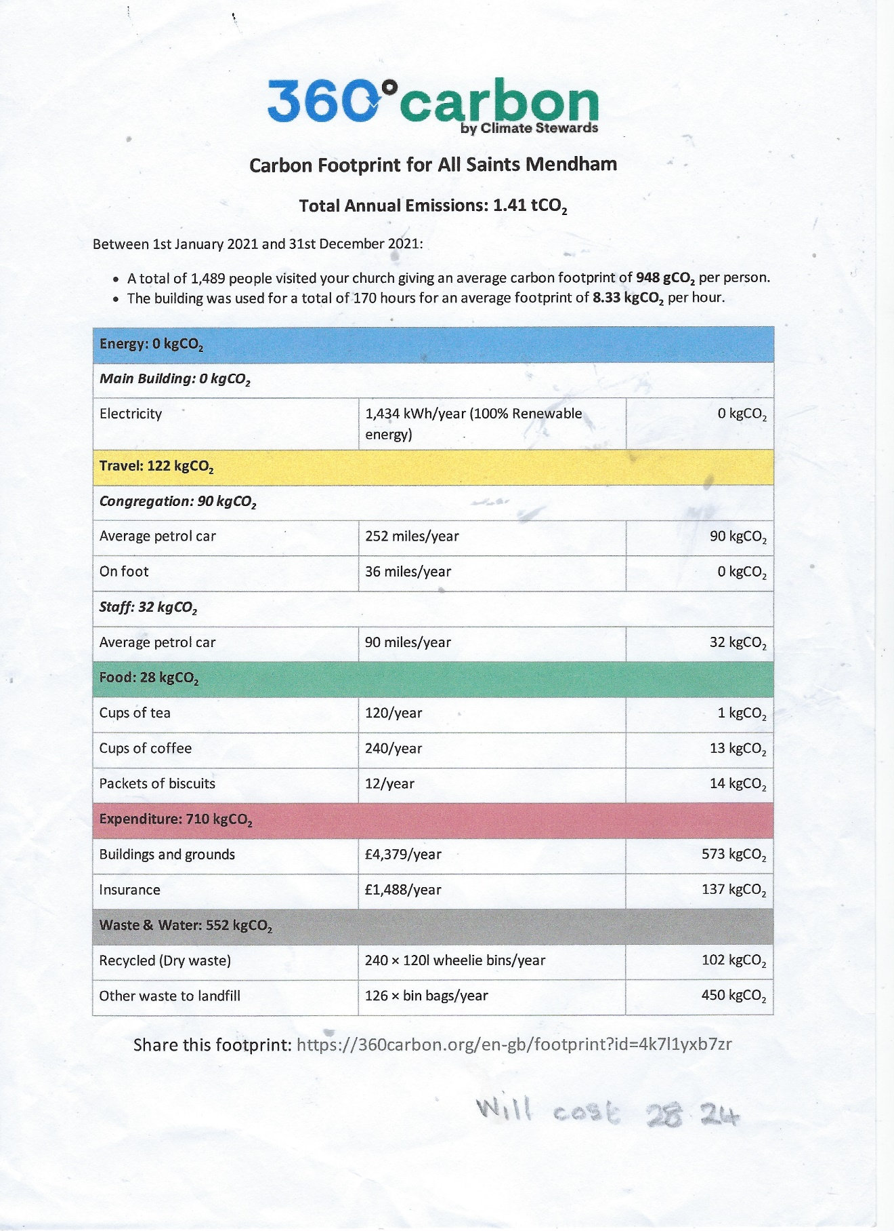
Appendix 5: Carbon footprint 2022
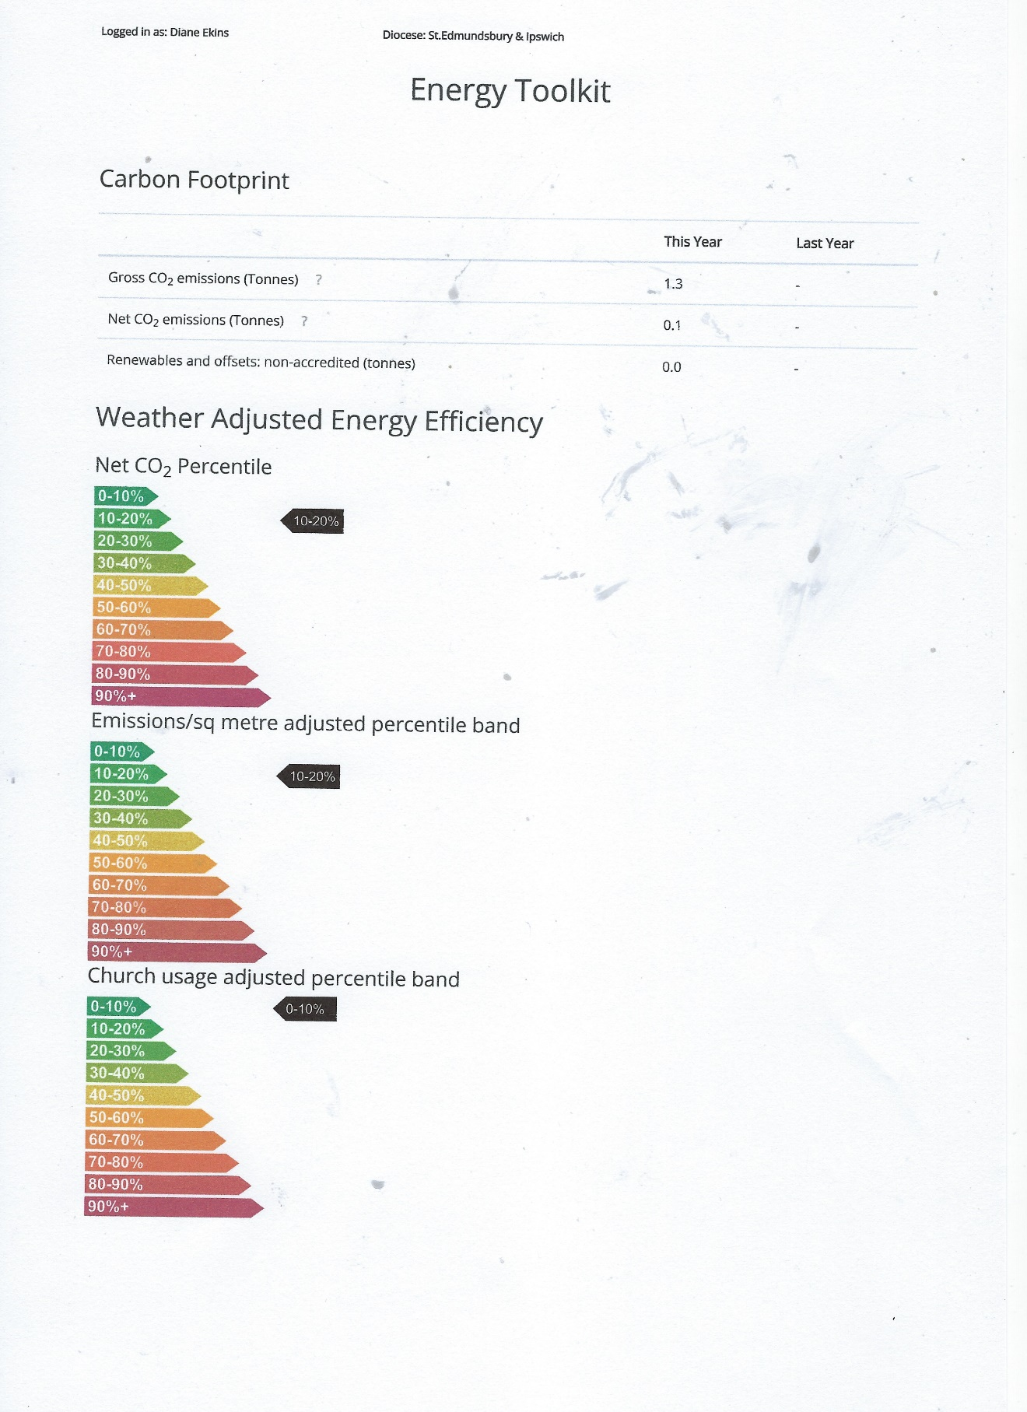
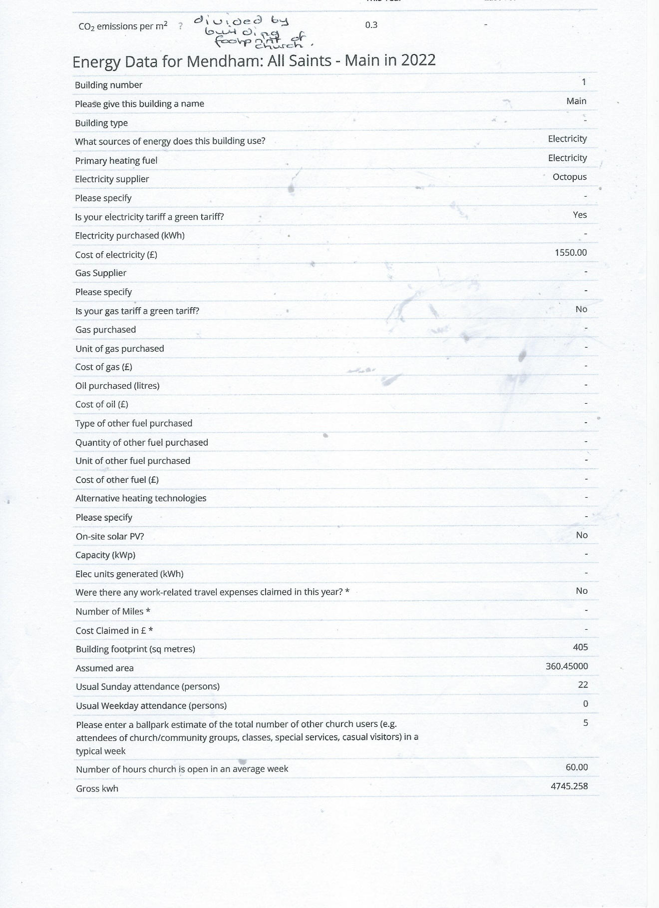

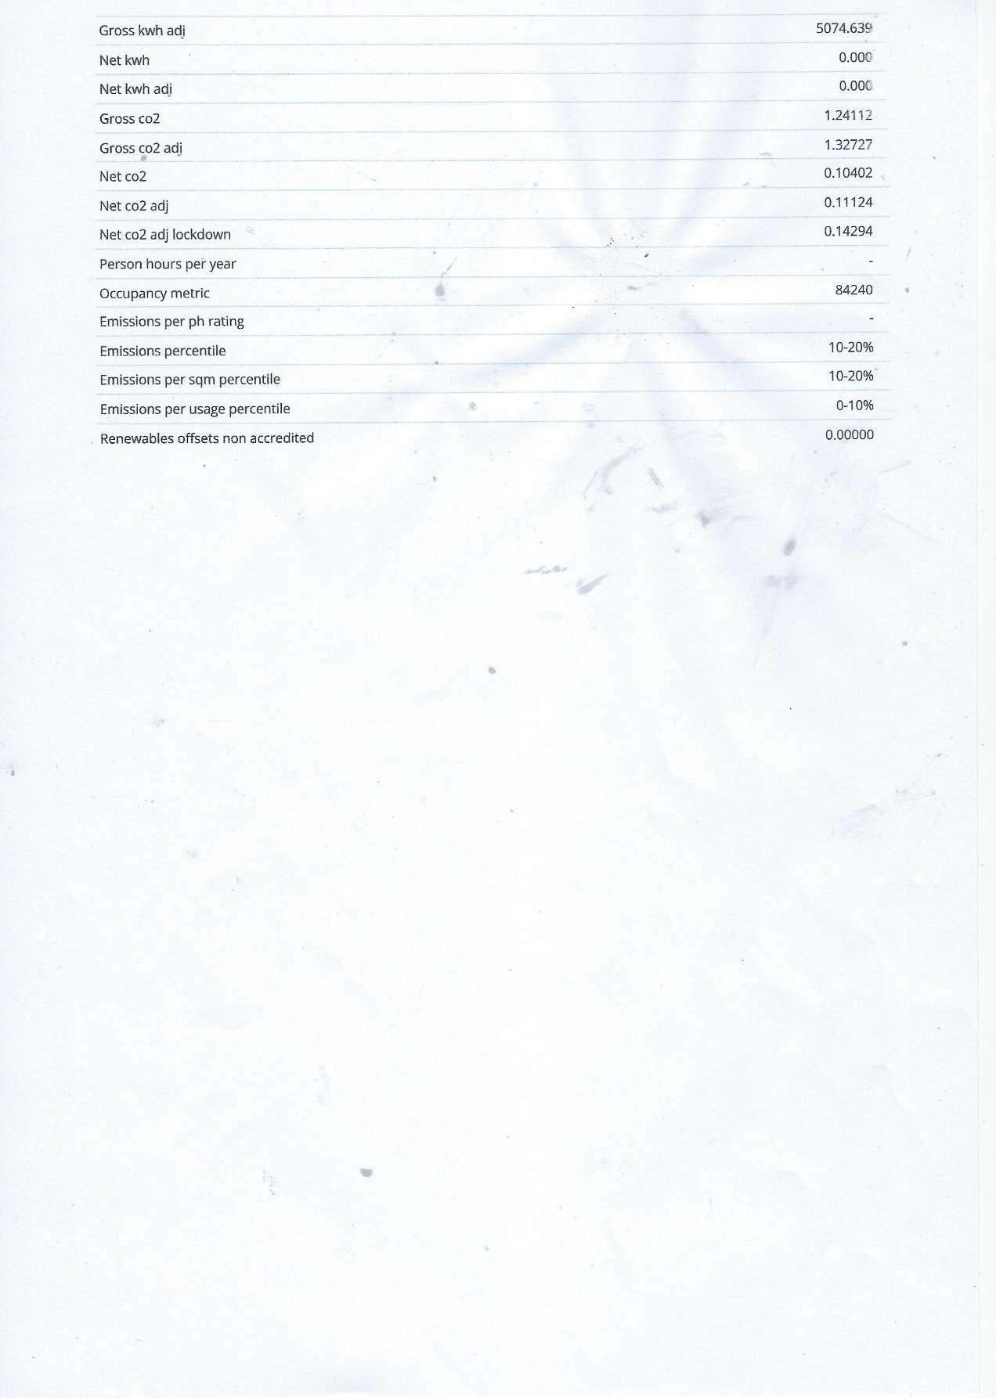
Appendix 6: land Management Plan
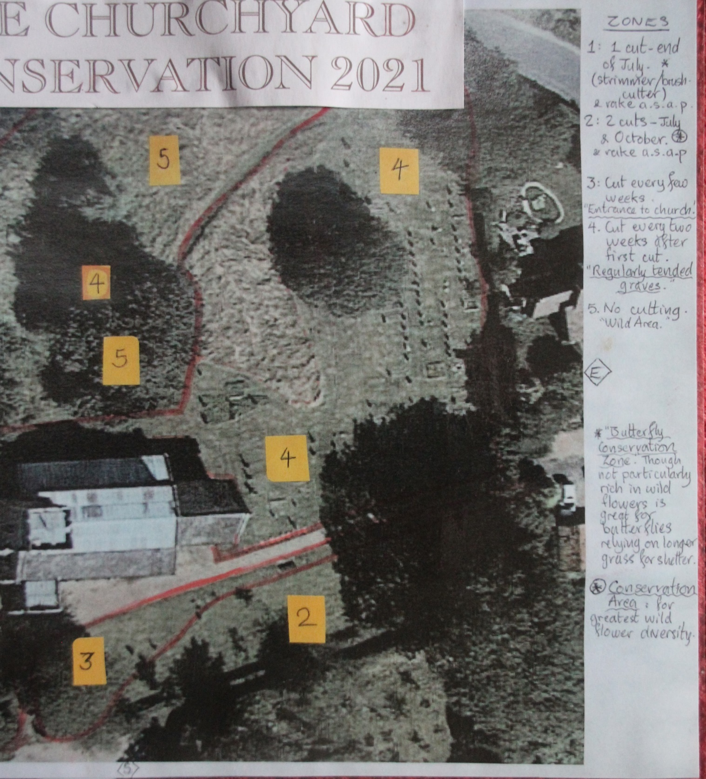

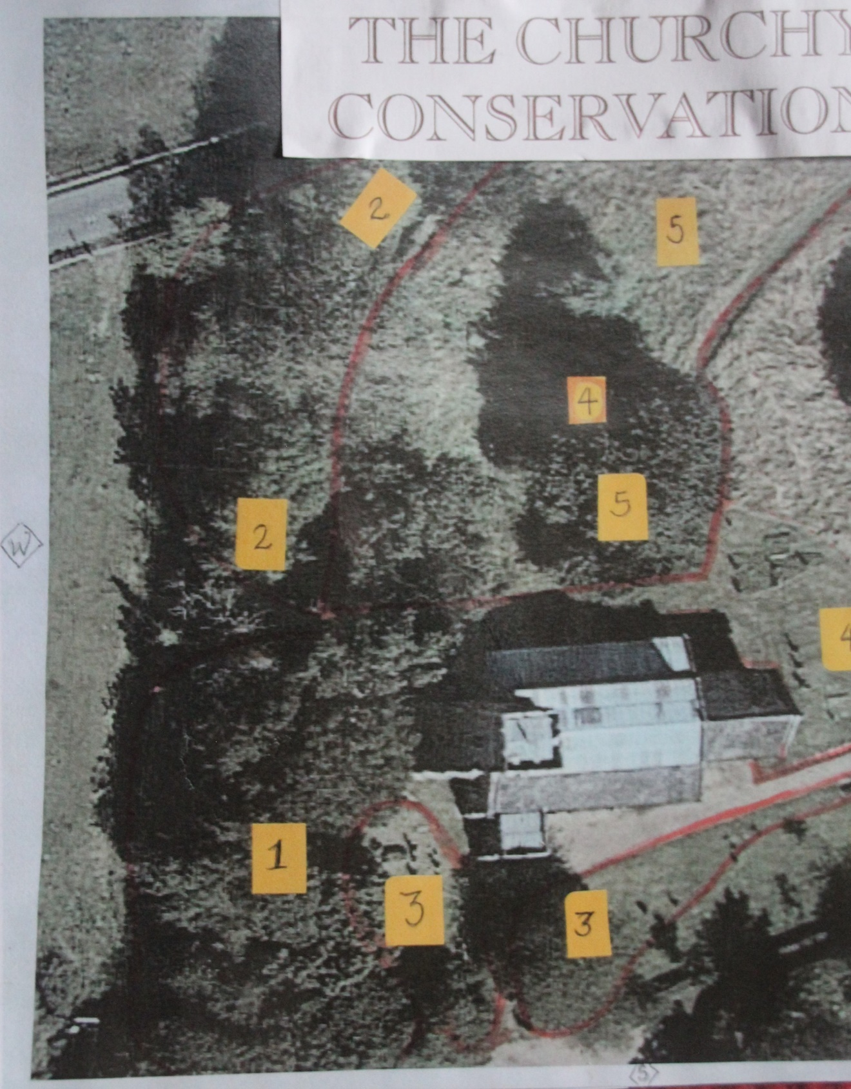
Appendix 7 : CONSERVATION ADVISOR SITE VISIT REPORT - All Saints Mendham Advisor’s Name: Cathy Smith, Community Wildlife Advisor Tel. 01473 890089 Date of visit: 23rd July 2021 Name of Project leader: Gordon Lascelles Email: gordon.lascelles@googlemail.com Location of site: IP20 0NH Grid Reference: TM269829
Enquiry How can we make best use of the different areas within the churchyard ? • a very wild area we cannot cut • an area of deposits of earth from freshly dug graves (new wildflower planting?) • a fenced-off area where the grave/monuments are unsafe (hedgehog hibernation house already installed) • a large “compost” area that is removed annually • an area for education for the local primary school children (we have put some covers down that can be peeled back to show bug habitats, some stumps (for sitting on and rolling back for investigation) and a bug hotel, as well as the usual bird boxes etc • other features on the site, like a well built pill box. • Map showing areas under different management provided.
Summary of the site Churchyards can often be rare remnants of a species rich grassland habitat that was once common in Suffolk. It is understood that during the 1970’s, some of the headstones were moved to their current position, along the western perimeter. The management of the churchyard has been carefully thought with mowing aimed at meeting the needs of different user groups as well as wildlife. The mown grassland, headstones, pathways, mature trees and shrubs, wall and church building itself all provide vital habitat opportunities for a wide range of species. Species noted: A full botanical survey was not undertaken, these plants were noted at the time of the visit: Yarrow, Achillea millefolium Black Medick Medicago lupulina Common Ragwort Senecio jacoboea Field bindweed Convolvulus arvensis Common knapweed Centaurea nigra agg. Catsear Hypochaeris radicata
Management recommendations: 1. Continue to mow either side of the path and to the frequently visited parts of the burial ground on a regular basis. This will help balance the needs of different user groups and demonstrate that the management is purposeful and the churchyard well-kept and cared for. It also creates a mosaic of sward length which benefits a greater number of species.
2. The hedge on the north and west boundary is kept well-trimmed to facilitate good road visibility. A path at the base of the hedge has been mown to allow for hedge cutting and supports a neater look along roadside aspect. Some suckering into the grass sward has occurred, widening the mown strip would help to get this under control.
3. Area 1, the southwest corner near the sheds, is shown for an end of July brush cutter cut. To avoid disturbance to any late nesting birds, cutting would be better delayed until September.
4. September is also the best time to clear excess from the compost/brash heap, before hedgehogs are likely to use it as a potential hibernation site.
5. Tree stumps or a log pile could be reinstated. Habitat piles can provide important opportunities for hedgehogs, lizards, and slow worms as well as a host of invertebrates. This project could also include building solitary bee homes to place in a sunny part of the churchyard.
6. Areas 2 are scheduled to be cut in July and October and raked up. This management is working well for the block to the south of the main path with modest grass growth and a mix of wildflowers within the sward. It is important to continue to rake off and remove clippings – if left on, they smother delicate plants, and increase fertility which encourages rank growth at the expense of wildflowers. If possible, the arisings should be left for a few days to allow the seed to fall then raked off and removed.
7. The second block identified as area 2, lies along the boundary to the west adjacent to a native hedge. Here, some hedge species have suckered and in places are encroaching on the headstones. Careful removal will be required to protect the monument stones and will also benefit lichens by restoring light levels.
8. As Suffolk is a county with very little habitat containing large areas of stone, the headstones in our churchyards provide a valuable surface for lichens to develop undisturbed. Lichens can take over 100 years to grow only a few centimetres and should not be removed from gravestones unless necessary. The British Lichen Society is a good source of information.
9. Area 3 is cut every few weeks which together with the rose bushes provides a welcoming and attractive entrance to the churchyard.
10. Area 4 encompasses the more regularly tended graves and is mown every two weeks after the first cut in the spring. This seems a sympathetic and appropriate approach.
11. Area 5 includes a fenced-off area where the grave/monuments are unsafe. A hedgehog box has been placed within the fenced area. There is a large sycamore tree and yew tree as well as some small suckering elm. The latter could coppiced, cut to the ground, on a seven year rotation to maintain it but it may ultimately be shaded out by the sycamore tree.
12. Also within the no cutting wild areas is a large swathe of nettles, set aside for butterflies. Nettles are the food plant caterpillars of the Vanessid species which includes the comma, peacock and small tortoiseshell butterflies. They favour fresh growth and those nettles in a sunny patch. There is a small amount of scrub establishment within this area, occasional late mowing will help prevent natural succession to scrub occurring. The optimum time for Vanessid caterpillars would be early April, July and September, accepting that the red admiral will use nettles across these windows. A double width path would help keep the nettles from encroaching on the walkway after heavy rain. Should you wish to reduce the area of nettles to diversify the vegetation, then repeated cutting, especially in the spring should weaken the growth. More information can be found on Butterfly Conservation website, there is also a downloadable guide on the Wildlife Trusts website.
13. Additional bird boxes could be installed on some of the larger trees. They will complement the other natural habitat opportunities already present in and around the churchyard. It is good practice to clean out bird boxes between 1st September-31st July (outside the breeding season).
14. Bats are known to be using the church building and no doubt benefitting from the mature trees and shrubs which provide hunting and additional roosting opportunities. The Bats in Churches project, have run and recorded several online webinars which you may find of interest, see below.
15. Swifts have been seen in Mendham although non seen flying overhead at the time of the visit. The bells are hung half way up the church tower, below the belfry so there is the possibility of installing swift boxes with call system, SOS swifts from Suffolk Bird Group are happy to advise.
Community Engagement Encourage the church community and local residents to record their sightings of wildlife through the Suffolk Biological Records website or through the i-record platform. The i-record platform allows for groups to set up their own space for collective records and has a process for verification. Biological records will help inform the management and identify the effects of any changes made. Important considerations • Any tree surgery carried out to the mature trees should follow the guidelines from the Bat Conservation Trust. You may also need archdeacon approval. • Hedgehogs make daytime nests in long grass during summer months. To reduce the chance of injuring a hedgehog when cutting long grass, a high cut followed by a lower one is recommended.
Appendix 8: Information from service sheet on sharing God’s energy
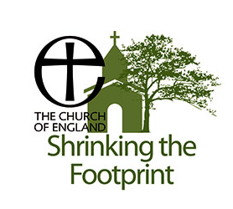
Reducing your Carbon footprint with a personal lifestyle audit
can also save you money!

Did you Know?
Keeping your home, a constant temperature helps you save energy. Less than 30% households bleed radiators.

For carbon footprint any items bought secondhand do not count.

An average household spends 55 pounds a year, powering appliances on standby, (not switched off at the plug.)

¾ of us admit we at least occasionally, boil the kettle with more water than we are going to use. Use a thermos or take care!

12% energy use in gas households is to heat water for showers, baths or hot water taps. Heating water accounts for 5% total CO2 emission. If you run the tap for hot water do not waste the cold that comes off first. Use cold water if you do not need hot eg rinsing. A tap running for 95 secs fills a washing bowl!

Any water use contributes to both energy bills and carbon emission.
Most underestimate energy water companies need to treat and pump water into homes - Scottish Water is the largest user of electricity in Scotland.
Facts from https://energysavingtrust.org.uk Calculate your footprint at https://climatestewards.org
Appendix 9: Mendham Message visit news sheet
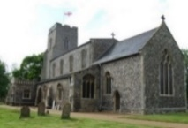
January Mendham
Message
All Saints Church Open 9am-dusk daily.
Church Larder provides food & household essentials for anyone to take if needed.


Sun 7th Jan 10.30am Village Service celebrating arrival of Wise Men with carols. Refreshments from 10.15am.

Sun 21st Jan 10.30am Common Worship Holy Communion.

Wed. Prayers for Village in pub 10am. Join us for prayers, send a request or join Diane from 10.30am in a hot drink.

Recycling: Christmas cards: box in church for Diane to reuse Christmas trees: contact
Mark at pub for trees to be eaten by goats!

In event of flooding or a crisis all are welcome to use All Saints Church as a refuge with hot drinks, blankets & a toilet.
Thursdays 7-8pm My Choir Rocks 5-16 yrs in church Contact myrockchoir@gmail.com
Begins again 11th Jan. Join newcomers.

Sat 20th January Coffee Morning at Mendham and Withersdale Village Hall.

Sir Alfred Munnings Hotel booking for:
31st Dec: New Year’s Eve menu.
Fri 26th, Sat 27th January: Burns nights.

Thank you to Daniel of Rich-Gray funerals Harleston for donation of church Christmas tree and to everybody who helps festivities.

Advance notice: Reserve the dates…
Spring Fayre to celebrate local community & area products in church on Mar 2nd. To exhibit or help contact Revd Diane 01986788750 diane1961erica@gmail.com

Sun Mar 3rd morning Mendham VIP visit. Bishop Martin who sits in House of Lords, coming to celebrate our local community.
Come and meet him over coffee!

Quotes for press release leading to article in Appendix 1
Appendix 2 shows back page of service sheet on hope in creation
Appendix 3 Service sheet for God’s creatures’ service
See the summary of footprint 2021 in appendix 4
See the summary of footprint 2022 in appendix 5
See appendix 6 for land management plan
See appendix 7 for information sheet on back of service sheet on Sharing God’s energy
A sample Mendham Message is included in appendix 8

