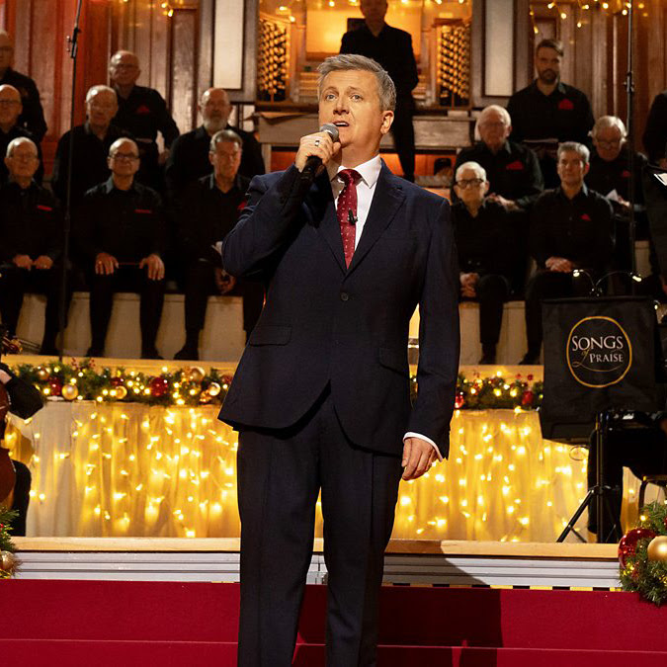

A CHRISTMAS CELEBRATION FROM THE GLASSHOUSE INTERNATIONAL CENTRE FOR MUSIC
A Songs of Praise Special Event.
Join Aled Jones and some very special guests at the iconic Glasshouse for a spectacular Christmas concert. Bring your singing voice and Christmas jumper for an evening of classic carols and traditional hymns.
WHEN:
Tuesday 6th October 2026 – start at 19:00
Doors open at 18:00
Age restriction: there is no minimum age for entry, all ages are warmly welcomed, but children aged 17 and under should be supervised by a responsible adult at all times.
WHERE:
The Glasshouse International Centre for Music, St Mary's Square, Gateshead Quays, Gateshead, NE8 2JR
BOOK HERE

