Crispian Steele-Perkins is an internationally acclaimed classical trumpeter having performed with the Royal Philarmonic Orchestra and accompanied some of the world’s greatest singers, including Kiri Te Kanawa. He has also played in numerous film scores including Jaws, Gandhi, Star Wars and six Bond films and played the theme tune to Antiques Roadshow

Ian leGrice is one of London’s most distinguished organists, giving recitals as well as performing with symphony orchestras and choirs. He has held teaching posts at the Royal College of Music, London, Trinity College of Music and Reading University. Since 2005 he has collaborated with trumpeter Crispian Steele-Perkins. In their highly varied programmes, they share their enthusiasm for and love of music in an informal setting.

We are always fundraising to keep our beautiful church watertight and open to all. If you would like to make a donation you can at any time to Morston PCC Building Account, 53-50-73, 59503513
THE TRUMPET SHALL SOUND
an evening with internationally acclaimed trumpeter
CRISPIAN
STEELE-PERKINS
with accompanist Ian leGrice

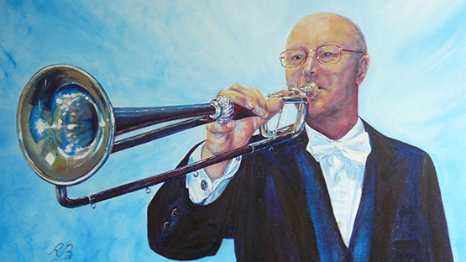

Presenting the illustrated history of the trumpet from ancient Egypt to the modern film studio

Friday 15th May 2026
All Saints Church, Morston 6pm

Proceeds in aid of All Saints PCC

Doors open 5.30pm
Bar open and canapes served
Concert starts 6pm

Interval 6.45pm

Bar open and canapes served
Concert resumes 7.15pm
End 8pm

W Boyce, a Set of Voluntaries
GF Handel, Trumpet Overture in 3 Parts
H Goodall, Shackleton’s Cross demonstration of the evolution of the trumpet
WA Mozart, Posthorn Serenade

INTERVAL

FJ Haydn, Divertimento
Sir A Sullivan, Echoes of the Savoy
G Gershwin, Someone to Watch Over Me
H Mancini, Hollywood Medley

