Into his Courts
with Praise...



A Service of the Word
for
Sunday 23 August 2026
Twelfth Sunday after Trinity.

A Service of the Word for Sunday morning

This service is taken from A Service of the Word,
Morning and Evening Prayer, Night Prayer,
which is copyright (c) The Archbishops' Council, 2000,
with permitted variations.

INTRODUCTION

“I will give thanks to you, O Lord, with my whole heart; ♦︎
before the gods will I sing praise to you.”
Psalm 186:1.
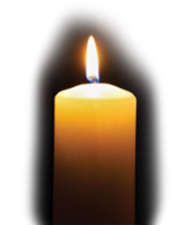

THE CONFESSION
The grace of God has dawned upon the world with healing for all. Though we have grieved him, yet he will heal us if we confess our sins in penitence and faith.

Almighty God,
I confess that I have sinned against you
in thought, word and deed;
I have not loved you with all my heart;
I have not loved my neighbours as myself.
Have mercy upon me,
cleanse me from my sins,
and help me to overcome my faults,
through Jesus Christ our Lord. Amen.

Receive God’s forgiveness
May the Father forgive us
By the death of His Son
And strengthen us
To live in the power of the Spirit
All our days. Amen.

PRAISE
O Lord, open my lips...
and my mouth shall proclaim your praise.
Give me the joy of your saving help...
and sustain me with your life-giving Spirit.

THE COLLECT
God of constant mercy, who sent your Son to save us:
remind us of your goodness, increase your grace within us,
that our thankfulness may grow, through Jesus Christ our Lord.
Amen.

Suggested hymn to sing or read Hear the call of the kingdom.

THE WORD OF GOD.
Isaiah 51 : 1-6.

Listen to me, you that pursue righteousness,
you that seek the Lord.
Look to the rock from which you were hewn,
and to the quarry from which you were dug.
Look to Abraham your father
and to Sarah who bore you;
for he was but one when I called him,
but I blessed him and made him many.
For the Lord will comfort Zion;
he will comfort all her waste places,
and will make her wilderness like Eden,
her desert like the garden of the Lord;
joy and gladness will be found in her,
thanksgiving and the voice of song.

Listen to me, my people,
and give heed to me, my nation;
for a teaching will go out from me,
and my justice for a light to the peoples.
I will bring near my deliverance swiftly,
my salvation has gone out
and my arms will rule the peoples;
the coastlands wait for me,
and for my arm they hope.
Lift up your eyes to the heavens,
and look at the earth beneath;
for the heavens will vanish like smoke,
the earth will wear out like a garment,
and those who live on it will die like gnats;
but my salvation will be for ever,
and my deliverance will never be ended.

Psalm 138.

I will give thanks to you, O Lord, with my whole heart; ♦︎
before the gods will I sing praise to you.
I will bow down towards your holy temple and praise your name,
because of your love and faithfulness; ♦︎
for you have glorified your name
and your word above all things.
In the day that I called to you, you answered me; ♦︎
you put new strength in my soul.
All the kings of the earth shall praise you, O Lord, ♦︎
for they have heard the words of your mouth.
They shall sing of the ways of the Lord, ♦︎
that great is the glory of the Lord.
Though the Lord be high, he watches over the lowly; ♦︎
as for the proud, he regards them from afar.
Though I walk in the midst of trouble,
you will preserve me; ♦︎
you will stretch forth your hand against the fury of my enemies;
your right hand will save me.
The Lord shall make good his purpose for me; ♦︎
your loving-kindness, O Lord, endures for ever;
forsake not the work of your hands.

Romans 12 :1-8.

I appeal to you therefore, brothers and sisters, by the mercies of God, to present your bodies as a living sacrifice, holy and acceptable to God, which is your spiritual worship. Do not be conformed to this world, but be transformed by the renewing of your minds, so that you may discern what is the will of God—what is good and acceptable and perfect.

For by the grace given to me I say to everyone among you not to think of yourself more highly than you ought to think, but to think with sober judgement, each according to the measure of faith that God has assigned. For as in one body we have many members, and not all the members have the same function, so we, who are many, are one body in Christ, and individually we are members one of another. We have gifts that differ according to the grace given to us: prophecy, in proportion to faith; ministry, in ministering; the teacher, in teaching; the exhorter, in exhortation; the giver, in generosity; the leader, in diligence; the compassionate, in cheerfulness.

Suggested hymn to sing or read O God, you search me and you know me.

GOSPEL
Matthew 16:13-20.

Now when Jesus came into the district of Caesarea Philippi, he asked his disciples, ‘Who do people say that the Son of Man is?’ And they said, ‘Some say John the Baptist, but others Elijah, and still others Jeremiah or one of the prophets.’ He said to them, ‘But who do you say that I am?’ Simon Peter answered, ‘You are the Messiah, the Son of the living God.’ And Jesus answered him, ‘Blessed are you, Simon son of Jonah! For flesh and blood has not revealed this to you, but my Father in heaven. And I tell you, you are Peter, and on this rock I will build my church, and the gates of Hades will not prevail against it. I will give you the keys of the kingdom of heaven, and whatever you bind on earth will be bound in heaven, and whatever you loose on earth will be loosed in heaven.’ Then he sternly ordered the disciples not to tell anyone that he was the Messiah.

REFLECTION – Scary Romans.

I have mentioned before that in my second year at theological college, we were given a choice between studying the Letter to the Romans in English or the Letter to the Colossians in Greek. All but one of our year group chose Colossians (including me), partly because it is shorter, but mainly through the fear that Romans is difficult. Since then, I have come to love and value Romans, but wouldn’t deny that it takes some working at.

St Paul’s Letter to the Romans is one of his later works, and unlike some of his other letters, he was not writing to correct a specific problem or dispute in that church. He had long wanted to visit Rome – when he eventually got there, it was under arrest! – but in this letter he was saying, ‘This is the Gospel as I understand it: I hope, when I arrive, to find that this is what you believe too. (You’d better!)’ So this letter is his most complete and thought-out statement of the Christian faith, so much so that it has sometimes been called, ‘The Gospel according to St Paul.’

Scottish theologian AM Hunter, in his commentary on Romans, says that it falls into two parts: chapters 1 – 11 on Believing and 12 – 16 on Behaving. In other words, the first part deals with the person and work of Jesus, the significance of the cross, where this leaves both Jews and Gentiles, and the coming of the Holy Spirit. The Behaving part deals with how we should live as Christians in the light of our Believing. Today’s reading from chapter 12 is the start of the Behaving section.

Now we should not expect to find here a long list of rules: Paul has already demonstrated, in earlier chapters, that the Jewish Law, which was a long list of rules, never saved anyone, because it was impossible to keep in its entirety. Instead, Christian ethics flow from the belief that God the Father loves and values every person, and because of our faith in Jesus as our Saviour, he forgives us when we fail. This in turn ought to shape the way we live, and the value we put on every other person. Paul describes this way of living as ‘Offering yourselves as a living sacrifice.’ This might have caused his first readers to stop and think, because they were well used to the idea of sacrifice, in all the pagan religions of their day as well as in Judaism, but in all those cases the sacrifice was dead. What could he mean by a ‘living sacrifice?’ To put it simply, we go on living, but every part of our life: our work, our family life, our social life, all are under his authority, and might be required to further his kingdom.

The next verse reinforces this new way of looking at the world and at our own lives: ‘No longer conform to the pattern of this world, but be transformed;’ see things from God’s point of view, and act accordingly.
To guide us in this, we have the help of the Holy Spirit: see chapter 8, where Paul has dealt thoroughly with the difference it makes to have the Holy Spirit dwelling in us. AM Hunter, whom I mentioned earlier, likens this to ‘a compass rather than a map.’ We are not given every little detail, with a line to follow at every step; rather, we are given the direction in which to step out in faith, and if necessary, adjustments to our course as we go along.

Now we come to a further aspect of our life as Christians: how we serve and relate to our fellow-Christians in the Church. And here I want to take a little detour to today’s gospel reading, and Simon Peter’s reply to Jesus’ question: ‘Who do you say I am?’
‘You are the Christ, the Son of the living God.’ And Jesus’ response:
‘Blessed are you, Simon son of Jonah. I tell you, you are Peter, and on this rock I will build my Church.’ (Peter would be Cephas in Aramaic or Petros in Greek.)
Of course, the Aramaic word cepha and the Greek petra both mean ‘rock.’ The use of words like ‘build’ and ‘rock’ might make us think of actual buildings, made of stone, so it is important to see these as parables, and to remember that the word Jesus uses for ‘church’ actually means an assembly of people. (See the illustration below.) And although Peter was clearly a leader and spokesman among the apostles, it is not his leadership which is the ‘rock’ but his statement of who Jesus is: the Church is built upon Peter’s statement,
‘You are the Christ, the Son of the living God.’

So remembering that the Church is built up of people who believe that Jesus is the Christ, the Messiah, we go back to the Letter to the Romans and the familiar image of the Church as the ‘Body of Christ,’ which also figures in chapter 12 of the First Letter to the Corinthians. Two things to note here:
1. It implies relatedness to one another and to Jesus. The many and varied parts of the body only function when they remain connected. Detach them from the body and they can no longer play their part. Years ago, there was a member of the Franciscan brotherhood who used to hitch-hike up and down the country, talking about faith to the people who gave him lifts – and seeing him at the side of the road in his habit, plenty of people did offer lifts. Someone once referred to him as ‘a Lone Ranger of the Gospel.’
‘Oh no,’ he said. ‘Members of my brotherhood are praying for me while I am on the road, and people in churches are ready to offer me hospitality at the end of the journey. I could not do this mission without other parts of the Body of Christ.’
2. The image of the body implies different functions for the various parts. In other words, we all have something to contribute, and we should be encouraging one another to discern and use our particular gifts. Although some specific functions are listed in Romans and 1 Corinthians, and indeed throughout the New Testament, the important thing to note is that the gifts are many and varied, and no-one who has faith will be lacking in some kind of gift, for the benefit of the whole church, its life and its mission.

So then, in conclusion, don’t be afraid of the Letter to the Romans, there is a lot of good stuff in there. And from today’s passage in particular, believing in Jesus will have a direct impact upon the way we live, and how we play our own special part in the life of his body, the Church.

Jonathan Falkner.



Suggested hymn to sing or read Holy Spirit, living breath of God.

THE CREED

All I believe in God the Father,
whose loving care is the pattern for family life.
I believe in Jesus, the Son of God,
who lives in my heart through faith,
and fills me with his love.
I believe in God the Holy Spirit,
who strengthens me with power from on high.
I believe in one God;
Father, Son and Holy Spirit. Amen.

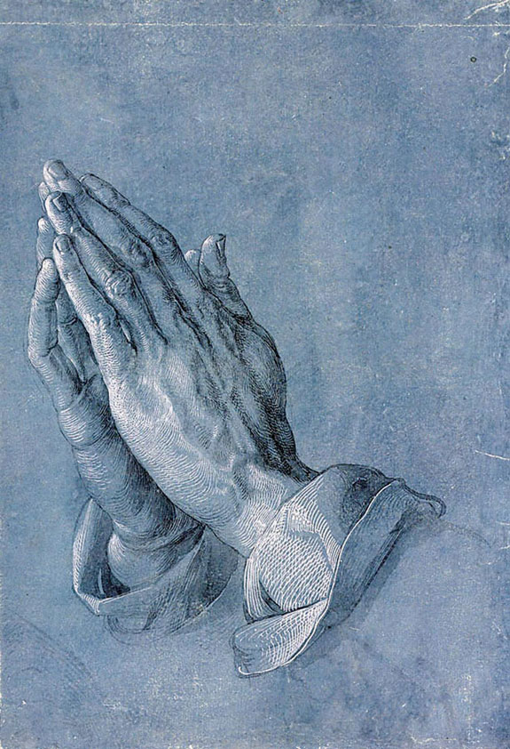

THE PRAYERS
A time of quiet prayer for
• The universal Church - Bishops, synods and all leaders church
• The leaders of the nations
• The natural world and the resources of the earth

Lord Jesus, you are the Prince of Peace.
Look upon our divided world
to be with those who are victims of violence.
We pray fall who have been subjected to violence and cruelty.
Help us to know the gift of your peace
in the power of your Spirit and
we ask you to soften the hearts
of those who can stop the fighting.
Creator God, we ask for your aid as your children of light
living in the darkness of our world.
Amen.
Cumbria Ecumenical Spirituality Group.

Finishing with the South Calder Mission Community prayer...
Heavenly Father we thank you for the life of your Church
in this place, and in all the villages of the South Calder Mission Community;
for all who have served and worshipped you in years gone by,
for all who make up your family in our churches today,
for the faith we have in common, and for the people and traditions which make each church unique.
By your Spirit, guide and equip us,
that together we might find new ways
to reach out to our local community,
to show your love to our neighbours,
and to encourage them
to follow the Lord Jesus in their lives.
Father, we offer ourselves to your service,
In the unity of the Holy Spirit,
And in the name of Jesus Christ our Lord. Amen

and the Lord’s prayer...
Our Father, who art in heaven,
hallowed be thy name; thy kingdom come;
thy will be done; on earth as it is in heaven.
Give us this day our daily bread.
And forgive us our trespasses,
as we forgive those who trespass against us.
And lead us not into temptation;
but deliver us from evil.
For thine is the kingdom,
the power and the glory,
for ever and ever. Amen.

THE CONCLUSION

Suggested hymn to sing or read Forth in thy name O Lord I go.

The following prayer is said
Be with me, Lord, as I finish my prayer today.
May my lips always speak the truth;
may my eyes which have read your word
see only what is good;
and may my life as well as my worship
be always pleasing in your sight,
for the glory of your name. Amen.

And now may the Lord who brought us to birth by his Spirit,
strengthen us for the Christian life.
May the Lord who provides for all our needs
sustain us day by day.
May the Lord whose steadfast love is constant as a mother's care,
send us out to live and work for others.
And the blessing of God Almighty.
the Father, the Son, and the Holy Spirit,
be with us and remain with us always.
Amen.

So now may I go in peace to love and serve the Lord.
In the name of Christ. Amen.

Links for the hymns

Hear the call of the kingdom.

https://youtu.be/rlPxUNOrTYU

O God, you search me and you know me.

https://youtu.be/XST5DCIHh6c

Holy Spirit, living breath of God.

https://youtu.be/YrN0PNWT_QE

Forth in thy name.

https://youtu.be/AUVAbXgJyqQ

