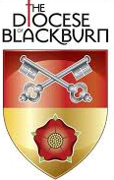
St Anne’s Parish Church Greenlands

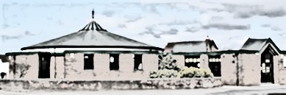

Holy Communion
According to the Book of Common Prayer

Please join in with the words printed in bold

Please stand when the Sacristy Bell rings
The Priest standing at the Table shall say Collect for Purity, the people kneeling.
ALMIGHTY God, unto whom all hearts be open, all desires known, and from whom no secrets are hid: Cleanse the thoughts of our hearts by the inspiration of thy Holy Spirit, that we may perfectly love thee, and worthily magnify thy holy Name; through Christ our Lord. Amen.
Then shall the Priest, turning to the people, rehearse distinctly the Summary of the Law:
Minister. OUR Lord Jesus Christ said: Hear, O Israel, the Lord our God is one Lord; and thou shalt love the Lord thy God with all thy heart, and with all thy soul, and with all thy mind, and with all thy strength. This is the first commandment. And the second is like, namely this: Thou shalt love thy neighbour as thyself. There is none other commandment greater than these. On these two commandments hang all the law and the prophets.

People. Lord, have mercy upon us, and incline our hearts to keep this law.

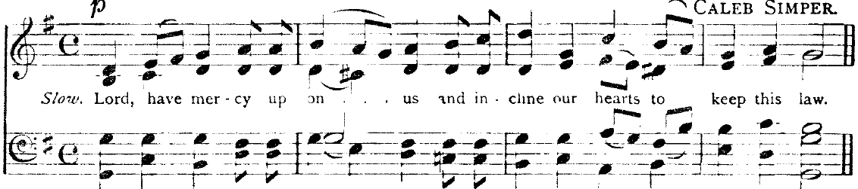
Then shall follow the Collect for the King, the Priest standing as before, and saying,

Let us pray.
ALMIGHTY and everlasting God, we are taught by thy holy Word, that the hearts of Kings are in thy rule and governance, and that thou dost dispose and turn them as it seemeth best to thy godly wisdom: We humbly beseech thee so to dispose and govern the heart of CHARLES thy servant, our King and Governor, that in all his thoughts, words, and works, he may ever seek thy honour and glory, and study to preserve thy people committed to his charge, in wealth, peace and godliness: Grant this, O merciful Father, for thy dear Son's sake, Jesus Christ our Lord. Amen.

Then shall be said the Collect of the Day.

And immediately after the Collect the Epistle shall be read, saying,

THE Epistle is written in the ____Chapter of ____ beginning at the ____ Verse.

And the Epistle ended, he shall say, Here endeth the Epistle.

Then shall the minister read the Gospel (the people all standing up) saying,

THE holy Gospel is written in the ____ Chapter of ____ beginning at the ____ Verse.

All: Glory be to Thee, O Lord

At the end: This is the Gospel of the Lord.

All: Thanks be unto Thee, O God.

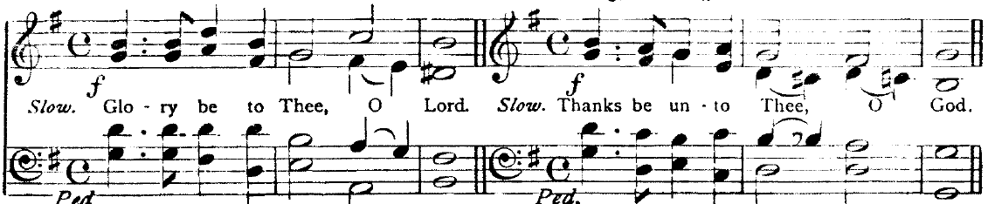

Then shall the Priest return to the Lord's Table, and begin the Offertory, saying these Sentences following,
LET your light so shine before men, that they may see your good works, and glorify your Father which is in heaven. St. Matthew 5.

LAY not up for yourselves treasure upon the earth; where the rust and moth doth corrupt, and where thieves break through and steal: but lay up for yourselves treasures in heaven; where neither rust nor moth doth corrupt, and where thieves do not break through and steal. St. Matthew 6.
Stand to sing the Offertory Hymn
The Priest shall then place upon the Table so much Bread and Wine as he shall think sufficient. After which done, the Priest shall say the Prayers of Intercession. We pray for the Church, our world, those who are sick and the departed.
Then shall the Priest say to them that come to receive the Holy Communion,
YE that do truly and earnestly repent you of your sins, and are in love and charity with your neighbours, and intend to lead a new life, following the commandments of God, and walking from henceforth in his holy ways: Draw near with faith, and take this holy Sacrament to your comfort; and make your humble confession to Almighty God, meekly kneeling upon your knees.

Then shall this general Confession be made, in the name of all those that are minded to receive the Holy Communion, by one of the Ministers: both he and all the people kneeling humbly upon their knees and saying,

ALMIGHTY God, Father of our Lord Jesus Christ, Maker of all things, Judge of all men: We acknowledge and bewail our manifold sins and wickedness, Which we from time to time most grievously have committed, By thought, word, and deed, Against thy Divine Majesty, Provoking most justly thy wrath and indignation against us. We do earnestly repent, And are heartily sorry for these our misdoings; The remembrance of them is grievous unto us; The burden of them is intolerable. Have mercy upon us, Have mercy upon us, most merciful Father; For thy Son our Lord Jesus Christ's sake, Forgive us all that is past; And grant that we may ever hereafter Serve and please thee In newness of life, To the honour and glory of thy Name; Through Jesus Christ our Lord. Amen.

Then shall the Priest stand up, and turning himself to the people, pronounce this Absolution

ALMIGHTY God, our heavenly Father, who of his great mercy hath promised forgiveness of sins to all them that with hearty repentance and true faith turn unto him; Have mercy upon you; pardon and deliver you from all your sins; confirm and strengthen you in all goodness; and bring you to everlasting life; through Jesus Christ our Lord. Amen.
Then shall the Priest say,
Hear what comfortable words our Saviour Christ saith unto all that truly turn to him.

COME unto me all that travail and are heavy laden, and I will refresh you. St. Matthew 11.28

So God loved the world, that he gave his only-begotten Son, to the end that all that believe in him should not perish, but have everlasting life. St. John 3.16

Hear also what Saint Paul saith.

This is a true saying, and worthy of all men to be received, that Christ Jesus came into the world to save sinners. 1 St. Timothy 1.15

Hear also what Saint John saith.

If any man sin, we have an Advocate with the Father, Jesus Christ the righteous; and he is the propitiation for our sins. 1 St. John 2.1

After which the Priest shall proceed, saying,
Priest. Lift up your hearts.
Answer. We lift them up unto the Lord.
Priest. Let us give thanks unto our Lord God.
Answer. It is meet and right so to do.

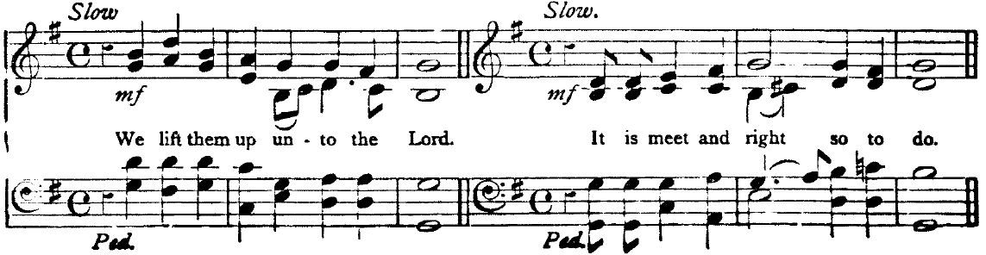
Then shall the Priest turn to the Lord's Table and say,

IT is very meet, right, and our bounden duty, that we should at all times, and in all places, give thanks unto thee, O Lord, Holy Father, Almighty, Everlasting God.

Here shall follow the proper Preface, according to the time, if there be any specially appointed: or else immediately shall follow,

Therefore with Angels and Archangels, and with all the company of heaven, we laud and magnify thy glorious Name; evermore praising thee, and saying:

Holy, holy, holy, Lord God of hosts, heaven and earth are full of thy glory: Glory be to thee, O Lord most High. Amen.

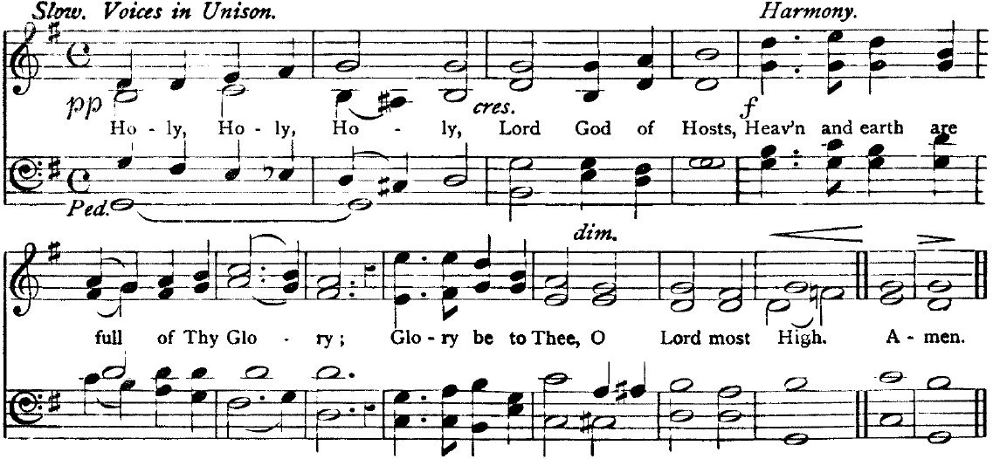

Then shall the Priest, kneeling down at the Lord's Table, say in the name of all them that shall receive the Communion this Prayer following.

WE do not presume to come to this thy Table, O merciful Lord, trusting in our own righteousness, but in thy manifold and great mercies. We are not worthy so much as to gather up the crumbs under thy Table. But thou art the same Lord, whose property is always to have mercy: Grant us therefore, gracious Lord, so to eat the flesh of thy dear Son Jesus Christ, and to drink his blood, that our sinful bodies may be made clean by his body, and our souls washed through his most precious blood, and that we may evermore dwell in him, and he in us. Amen.
When the Priest, standing before the Table, hath so ordered the Bread and Wine, that he may with the more readiness and decency break the Bread before the people, and take the Cup into his hands, he shall say the Prayer of Consecration, as followeth.
ALMIGHTY God, our heavenly Father, who of thy tender mercy didst give thine only Son Jesus Christ to suffer death upon the Cross for our redemption; who made there (by his one oblation of himself once offered) a full, perfect, and sufficient sacrifice, oblation, and satisfaction, for the sins of the whole world; and did institute, and in his holy Gospel command us to continue, a perpetual memory of that his precious death, until his coming again: Hear us, O merciful Father, we most humbly beseech thee; and grant that we receiving these thy creatures of bread and wine, according to thy Son our Saviour Jesus Christ's holy institution, in remembrance of his death and passion, may be partakers of his most blessed Body and Blood: who, in the same night that he was betrayed, took Bread; and, when he had given thanks, he brake it, and gave it to his disciples, saying, Take, eat; this is my Body which is given for you: Do this in remembrance of me. Likewise after supper he took the Cup; and, when he had given thanks, he gave it to them, saying, Drink ye all of this; for this is my Blood of the New Testament, which is shed for you and for many for the remission of sins: Do this, as oft as ye shall drink it, in remembrance of me. Amen.
Then shall the Minister first receive the Communion in both kinds himself, and then proceed to deliver the same to people also in order, into their hands, all meekly kneeling.
When all have communicated, the Minister shall return to the Lord's Table, and reverently place upon it what remaineth of the consecrated Elements, covering the same with a fair linen cloth.
Then shall the Priest say the Lord's Prayer, the people repeating after him every petition.
OUR Father, which art in heaven, Hallowed be thy Name, Thy kingdom come, Thy will be done, in earth as it is in heaven. Give us this day our daily bread; And forgive us our trespasses, As we forgive them that trespass against us; And lead us not into temptation, But deliver us from evil. For thine is the kingdom, the power, and the glory, For ever and ever. Amen.
After shall be said as followeth.
O LORD and heavenly Father, we thy humble servants entirely desire thy fatherly goodness mercifully to accept this our sacrifice of praise and thanksgiving; most humbly beseeching thee to grant, that by the merits and death of thy Son Jesus Christ, and through faith in his blood, we and all thy whole Church may obtain remission of our sins, and all other benefits of his passion. And here we offer and present unto thee, O Lord, ourselves, our souls and bodies, to be a reasonable, holy, and lively sacrifice unto thee; humbly beseeching thee, that all we, who are partakers of this holy Communion, may be fulfilled with thy grace and heavenly benediction. And although we be unworthy, through our manifold sins, to offer unto thee any sacrifice, yet we beseech thee to accept this our bounden duty and service; not weighing our merits, but pardoning our offences, through Jesus Christ our Lord; by whom, and with whom, in the unity of the Holy Ghost, all honour and glory be unto thee, O Father Almighty, world without end. Amen.

Then shall be said or sung,

GLORY be to God on high, and in earth peace, good will towards men. We praise thee, we bless thee, we worship thee, we glorify thee, we give thanks to thee for thy great glory, O Lord God, heavenly King, God the Father Almighty.

O Lord, the only-begotten Son, Jesu Christ; O Lord God, Lamb of God, Son of the Father, that takest away the sins of the world, have mercy upon us. Thou that takest away the sins of the world, have mercy upon us. Thou that takest away the sins of the world, receive our prayer. Thou that sittest at the right hand of God the Father, have mercy upon us.

For thou only art holy; thou only art the Lord; thou only, O Christ, with the Holy Ghost, art most high in the glory of God the Father. Amen.
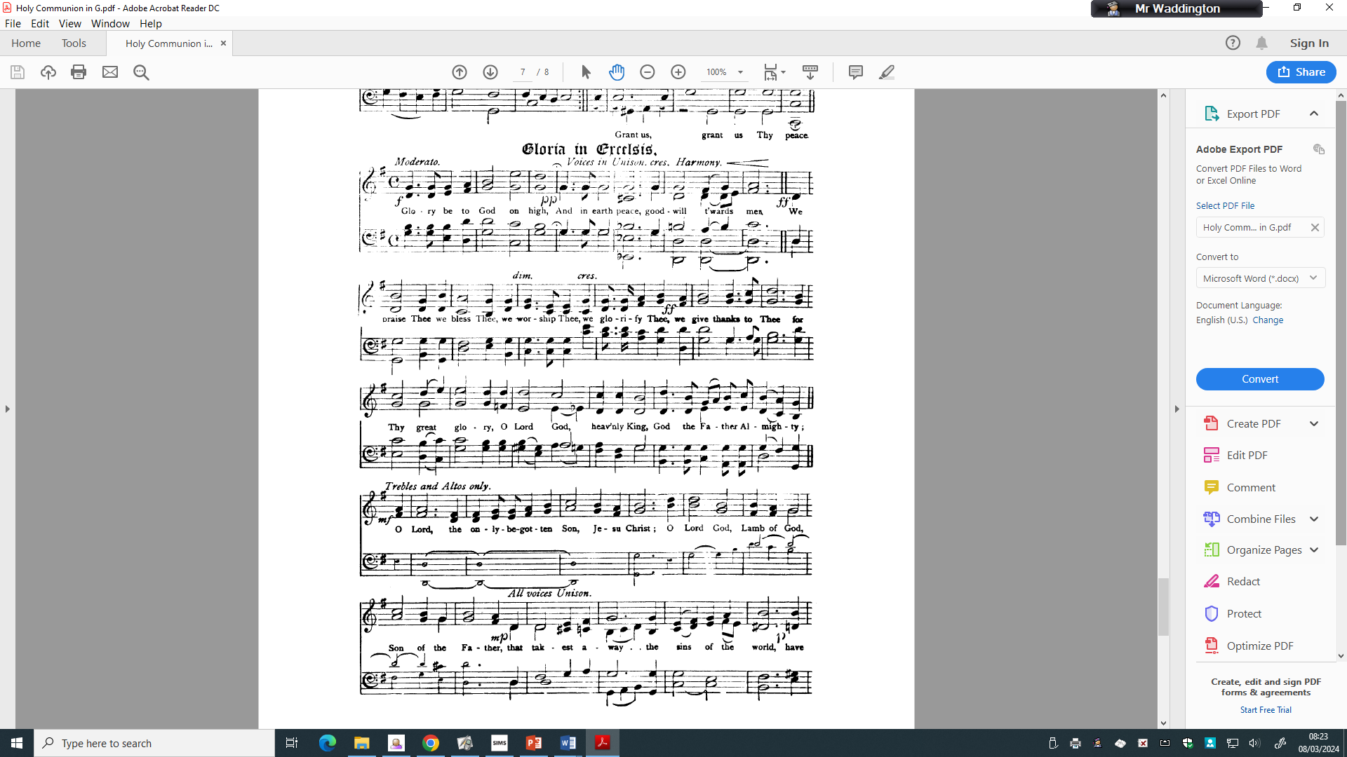

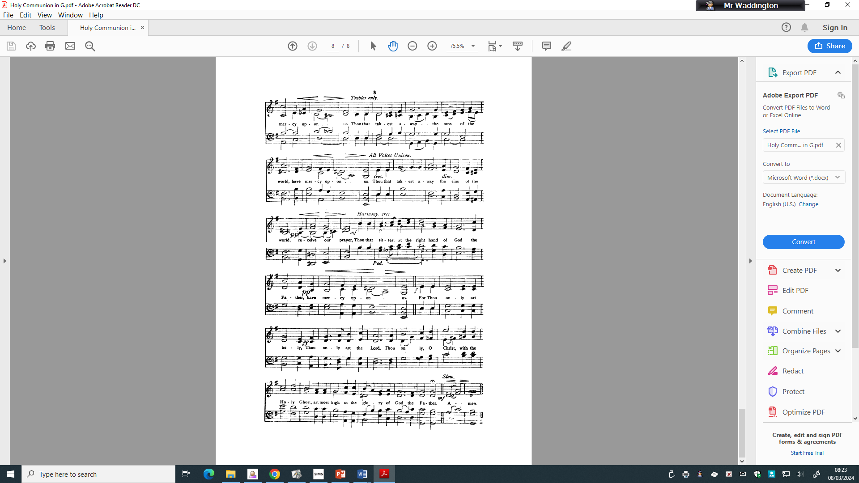
Then the Priest shall let them depart with this Blessing.

THE peace of God, which passeth all understanding, keep your hearts and minds in the knowledge and love of God, and of his Son Jesus Christ our Lord: And the blessing of God Almighty, the Father, the Son, and the Holy Ghost, be amongst you and remain with you always. Amen.

The Ministers and people depart.

