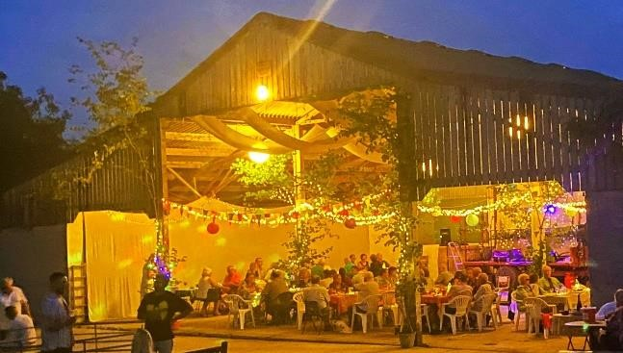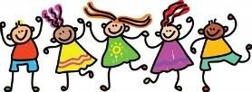
Local Band Redwing will be playing their joyful and infectious music and there will be a caller. So dance if you wish, or just enjoy listening and watching along with wine or beer, a buffet supper, and chatting with friends old and new.

In aid of

LEZANT PARISH CHURCH & CHILDREN’S HOSPICE SW

a
t

FRIDAY SEPTEMBER 4TH at 7.00pm

Delicious food, live music, dancing and good company.

Tickets £20 (to include food and first drink)

Children under 12 are free

EAST PENREST FARM (PL15 9NR)

Tickets from:
Jo & James Rider 01579 370186
07976551578
Bridget Pentreath 07802177803
Christine Stone 01579 370436

BARN DANCE

