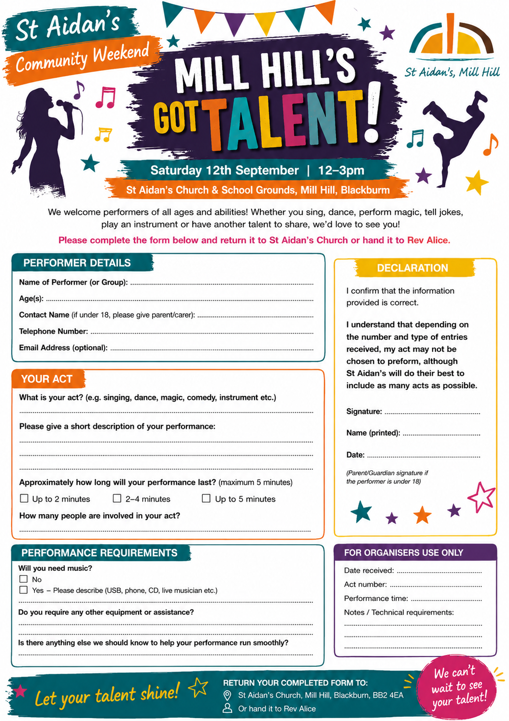

Performer Details
Name of Performer (or Group):

Age(s):

Contact Name (if under 18, please give parent/carer):

Telephone Number:

Email Address (optional):

Your Act
What is your act?

Please give a short description of your performance:

Approximately how long will your performance last?
☐ Up to 2 minutes ☐ 2–4 minutes ☐ Up to 5 minutes
How many people are involved in your act? _________________________________

Performance Requirements
Will you need music?
☐ No
☐ Yes – Please describe (USB, phone, etc.)

Additional Information
Is there anything else we should know to help your performance run smoothly? E.g. power socket.

Declaration
I confirm that the information provided is correct. I understand that depending on the number and type of entries received, my act may not be chosen to preform, although St Aidan’s will do their best to include as many acts as possible.
Signature: _______________________________
Date: ___________________
(Parent/Guardian signature if the performer is under 18)

Please return your completed form to:
St Aidan's Vicarage, 170 St Aidan’s Avenue, Mill Hill
Or email it to Rev Alice (rev.alicecole@gmail.com)
Applications should be received by Friday 28th August and you will be notified by Monday 7th September if your performance has been selected.
We can't wait to see your talent!

