SUNDAY MORNING READING SHEET 26th July 2026 8th Sunday after Trinity

A reading of Psalm 128

Happy is everyone who fears the Lord,
who walks in his ways.
You shall eat the fruit of the labour of your hands;
you shall be happy, and it shall go well with you.
Your wife will be like a fruitful vine
within your house;
your children will be like olive shoots
around your table.
Thus shall the man be blessed
who fears the Lord.
The Lord bless you from Zion.
May you see the prosperity of Jerusalem
all the days of your life.
May you see your children’s children.
Peace be upon Israel! Psalm 128

GOSPEL

Jesus put before them another parable: “The kingdom of heaven is like a mustard seed that someone took and sowed in his field; it is the smallest of all the seeds, but when it has grown it is the greatest of shrubs and becomes a tree, so that the birds of the air come and make nests in its branches.” He told them another parable: “The kingdom of heaven is like yeast that a woman took and mixed in with three measures of flour until all of it was leavened.” “The kingdom of heaven is like treasure hidden in a field, which a man found and reburied; then in his joy he goes and sells all that he has and buys that field. “Again, the kingdom of heaven is like a merchant in search of fine pearls; on finding one pearl of great value, he went and sold all that he had and bought it. “Again, the kingdom of heaven is like a net that was thrown into the sea and caught fish of every kind; when it was full, they drew it ashore, sat down, and put the good into baskets but threw out the bad. So it will be at the end of the age. The angels will come out and separate the evil from the righteous and throw them into the furnace of fire, where there will be weeping and gnashing of teeth. “Have you understood all this?” They answered, “Yes.” And he said to them, “Therefore every scribe who has become a disciple in the kingdom of heaven is like the master of a household who brings out of his treasure what is new and what is old.” Matthew 13:31-33,44-52


If you wish to make a donation to the church, then please hold Your phone’s camera over this image then touch the link that appears:

Royston Parish Church
Where all are welcome and God’s love is shared
Sunday 26th July 2026 – 8th Sunday after Trinity

If you would like regular copies of the Notice Sheet emailed to you please email the
Parish Office at admin@roystonparishchurch.org.uk

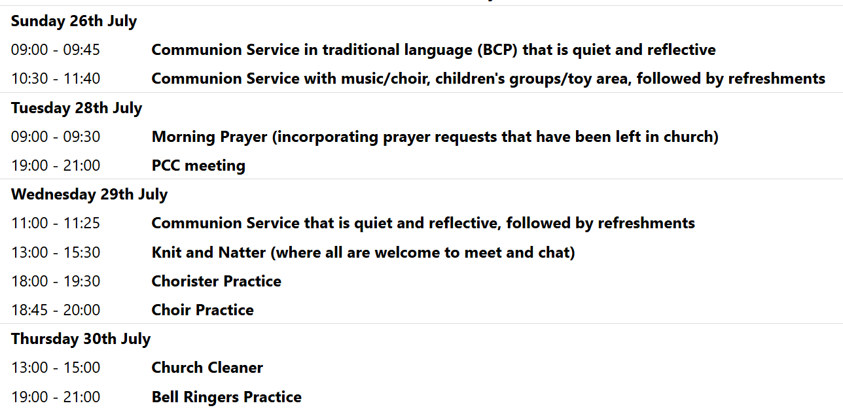
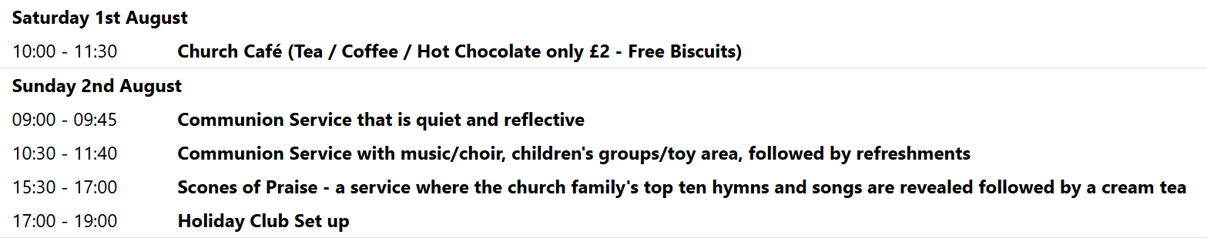

We pray for all Christians worldwide:
For all Christians in Burundi, Democratic Republic of Congo, Rwanda
For all who worship at Royston Methodist Church: Revd. Charity Nzegwu
For the work of our mission partners: Church Mission Society (CMS)
Pray for the community of Royston:
For our local health centres
For all our local Industrial estate workers
For all our young people revising and waiting for exam results at this present time
We pray for our world and ECO projects:
As the campaign "Plastic Free July" continues, we pray that we can move to world without single use plastics and have cleaner streets, oceans and communities.
We pray for the sick and suffering:
5th July | 12th July | 19th July | 26th July
Emma Thompson | Pat Tidey | Val Brown | Peter Coates
Jackson Herbert | Mike Brown | Angie & Ken Rushall | Mike Askew
Marion |  | Paula Walker | Peter Foster
Peggy Dawes | Max Elliott | Laura O’nyamul  (On-Ya-Mul) | Keith & Elaine Edwards

We pray for those who have died in the faith of Christ:
Deceased Bereaved
Revd. Anne Abok Family and friends
Katie Family and friends
Ted Rayment Family and friends

We pray for those whose anniversaries fall at this time:
Janet Henderson, Ken Law
NOTICES

BEDS & HERTS HISTORIC CHURCHES TRUST SPONSORED BIKE ‘N HIKE - SATURDAY 12TH SEPTEMBER 2026: Last year we in Royston we raised over £ 2,000 which was divided between BHHCT and our own parish funds. This earned us a Gold Certificate and we were one of only 11 churches that raised more than £ 2,000. We hope to do just as well or better this year. Select your own route for cycling or hiking between the churches – there are over 600 churches to choose from so make it as long or as short as you wish. Most churches will be open on the day. The Sponsorship Packs are now available and if you would like a sponsor form, please go online www.bedshertshct.org.uk or contact Mike Maze (245606 or mikefmaze@aol.com) There is always the easier option which is to sponsor one of the participants using their Sponsor form or if online giving suits you best, please visit:-
Sponsor Rodney & Matt Dyer or Sponsor Mike Maze

MUSIC QUESTIONNAIRE: There is a Music Questionnaire for everyone to take part it. Please take enough copies for each member of your household that comes to church and put completed questionnaires in the box provided in church by Sunday 26th July. There will then be a Scones of Praise on Sunday 2nd August at 3.30pm where the accumulative results of our church family’s top ten hymns and songs will be revealed.
It will be a free event (donations welcomed) but we ask you to get a free ticket so we know how many people to cater for. Please obtain your ticket from this link:
https://tickets.myiknowchurch.co.uk/gb/NzcwMi0zNQ/t
Or scan this QR code:



CHILDREN’S CHURCH: During the school holidays, there will be no Children’s Church but activity sheets will be left for them on the red tables by the Toy Area. Please ensure you supervise your children. Thank you

VENEZUELA EARTHQUAKE APPEAL: The recent earthquake in Venezuela killed at least 1,700, people, thousands were injured and many more are still missing. Our mission partner Tearfund is responding by supplying emergency food and shelter to the countless people who have lost their homes and livelihoods, bringing medical care to the injured, and providing post-traumatic stress support to the survivors. As a church we are making a donation from our missions budget. If you would like to add to this by making an individual donation, simply do so via the Tearfund website. THANK YOU

WE HAVE A NEW BATCH OF CHURCH MUGS FOR SALE, at £10 each, sales go towards church funds. Available at Saturday coffee, or after church services.

HOLIDAY CLUB 2026 this August would appreciate any boxes you may have, the children love building with them. Please leave them in the creche area in the corner. If the boxes are large, we are happy to come and pick them up. Please see Yvonne.

