SUNDAY MORNING READING SHEET 12th July 2026 6TH Sunday after Trinity

A reading from Paul’s Letter to the Romans

There is therefore now no condemnation for those who are in Christ Jesus. For the law of the Spirit of life in Christ Jesus has set you free from the law of sin and of death. For God has done what the law, weakened by the flesh, could not do: by sending his own Son in the likeness of sinful flesh, and to deal with sin, he condemned sin in the flesh, so that the just requirement of the law might be fulfilled in us, who walk not according to the flesh but according to the Spirit. For those who live according to the flesh set their minds on the things of the flesh, but those who live according to the Spirit set their minds on the things of the Spirit. To set the mind on the flesh is death, but to set the mind on the Spirit is life and peace. For this reason the mind that is set on the flesh is hostile to God; it does not submit to God’s law—indeed it cannot, and those who are in the flesh cannot please God. But you are not in the flesh; you are in the Spirit, since the Spirit of God dwells in you. Anyone who does not have the Spirit of Christ does not belong to him. But if Christ is in you, though the body is dead because of sin, the Spirit is life because of righteousness. If the Spirit of him who raised Jesus from the dead dwells in you, he who raised Christ from the dead will give life to your mortal bodies also through his Spirit that dwells in you. Romans 8:1-11

GOSPEL

That same day Jesus went out of the house and sat beside the lake. Such great crowds gathered around him that he got into a boat and sat there, while the whole crowd stood on the beach. And he told them many things in parables, saying: ‘Listen! A sower went out to sow. And as he sowed, some seeds fell on the path, and the birds came and ate them up. Other seeds fell on rocky ground, where they did not have much soil, and they sprang up quickly, since they had no depth of soil. But when the sun rose, they were scorched; and since they had no root, they withered away. Other seeds fell among thorns, and the thorns grew up and choked them. Other seeds fell on good soil and brought forth grain, some a hundredfold, some sixty, some thirty. Let anyone with ears listen!’ ‘Hear then the parable of the sower. When anyone hears the word of the kingdom and does not understand it, the evil one comes and snatches away what is sown in the heart; this is what was sown on the path. As for what was sown on rocky ground, this is the one who hears the word and immediately receives it with joy; yet such a person has no root, but endures only for a while, and when trouble or persecution arises on account of the word, that person immediately falls away. As for what was sown among thorns, this is the one who hears the word, but the cares of the world and the lure of wealth choke the word, and it yields nothing. But as for what was sown on good soil, this is the one who hears the word and understands it, who indeed bears fruit and yields, in one case a hundredfold, in another sixty, and in another thirty.’ Matthew 13:1-9, 18-23


If you wish to make a donation to the church, then please hold Your phone’s camera over this image then touch the link that appears:

Royston Parish Church
Where all are welcome and God’s love is shared
Sunday 12th July 2026 – 6th Sunday after Trinity

If you would like regular copies of the Notice Sheet emailed to you please email the
Parish Office at admin@roystonparishchurch.org.uk

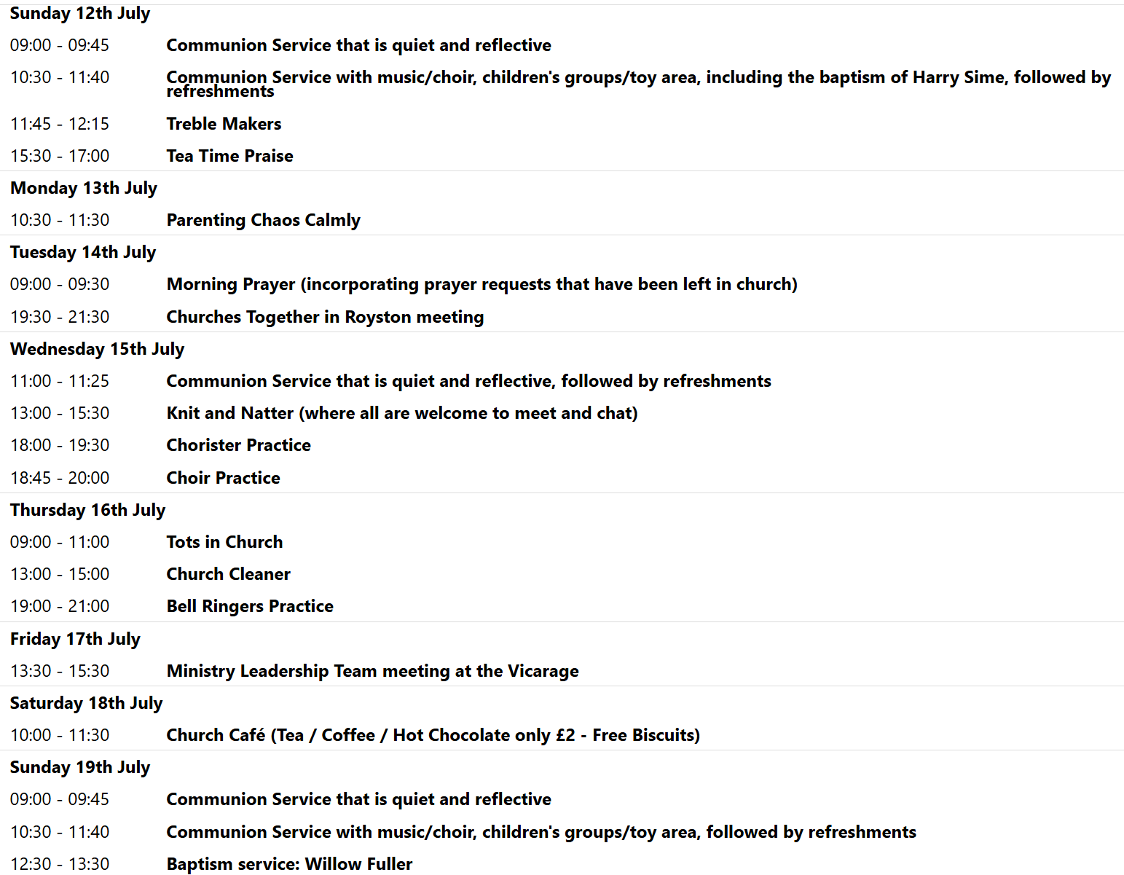

We pray for all Christians worldwide:
For all Christians in Eritrea, Ethiopia
For all who worship at Kneesworth House Hospital: Ged McHale
For the work of our mission partners: Royston Home Start
Pray for the community of Royston:
For our local health centres
For all who volunteer and make use of Royson Community Transport
For all our young people revising and waiting for exam results at this present time
We pray for our world and ECO projects:
World Population Day is on 11th July. As our world becomes increasingly over-populated, we pray that we can find more sustainable ways of living.
We pray for the sick and suffering:
5th July | 12th July | 19th July | 26th July
Emma Thompson | Ted Rayment | Val Brown | Peter Coates
Jackson Herbert | Pat Tidey | Angie & Ken Rushall | Mike Askew
Marion | Mike Brown | Paula Walker | Peter Foster
Peggy Dawes |  | Laura O’nyamul  (On-Ya-Mul) | Keith & Elaine Edwards
Katie | Max Elliott |  | Susan Bowles

We pray for those who have died in the faith of Christ:
Deceased Bereaved
Revd. Anne Abok Family and friends

We pray for those whose anniversaries fall at this time:
Ken Charles, Emma Harrison, Rita Woor
NOTICES

A BIG THANK YOU: I would like to say a heartfelt thank you to everyone for the many cards, gifts, kind messages, and prayers that I received for my ordination as priest on Saturday at St Albans Cathedral. Your love, encouragement, and support meant so much to me and made the occasion even more special. A special thank you also goes to everyone who worked so hard behind the scenes to organise the coach, enabling so many people to share in the service at the cathedral. It was wonderful to have such a strong presence from our church family on such an important day. Finally, thank you to everyone who helped organise, prepare, and contribute to the bring-and-share lunch after my first service on Sunday. It was a joy to celebrate together, and I am so grateful for the generosity, fellowship, and care that made the day so memorable.
I feel truly blessed to be part of such a loving and supportive church family, and I look forward to continuing this journey of ministry with you all.
With grateful thanks, Jaime
BEDS & HERTS HISTORIC CHURCHES TRUST SPONSORED BIKE ‘N HIKE - SATURDAY 12TH SEPTEMBER 2025 Last year we in Royston raised £ 2,157 which was divided between BHHCT and our own parish funds. Only 11 churches in the two counties received the gold certificate awarded for exceeding £ 2,000, and we need both participants and sponsors this year to help us achieve another record Bike ‘n Hike total. Select your own route for cycling or hiking between the churches – there are over 600 churches to choose from, so make it as long or as short as you wish. Most churches will be open on the day. Sponsorship forms are now available online www.bedshertsct.org.uk or can be supplied by Mike Maze (245606 / mikefmaze@aol.com)

VENEZUELA EARTHQUAKE APPEAL: The recent earthquake in Venezuela killed at least 1,700, people, thousands were injured and many more are still missing. Our mission partner Tearfund is responding by supplying emergency food and shelter to the countless people who have lost their homes and livelihoods, bringing medical care to the injured, and providing post-traumatic stress support to the survivors. As a church we are making a donation from our missions budget. If you would like to add to this by making an individual donation, simply do so via the Tearfund website. THANK YOU

MUSIC QUESTIONNAIRE: There is a Music Questionnaire for everyone to take part it. Please take enough copies for each member of your household that comes to church and put completed questionnaires in the box provided in church by Sunday 26th July. There will then be a Scones of Praise on Sunday 2nd August at 3.30pm where the accumulative results of our church family’s top ten hymns and songs will be revealed.

CHURCH AT HOME (SCHOOL YEARS 7 UP): Our final event of the year will be a barbecue at Beth and Andy's on 12th July for young people and their parents. We would also like to invite any young people who will be in year 7 from September 2026 to come along to the barbecue with their parent(s) to meet the group. (Of course any young people who are in school years 7 to 12 and currently aren't part of the group would also be very welcome). To find out more, please email youth@roystonparishchurch.org.uk or speak to Reg, Beth or Andy on a Sunday.

WE HAVE A NEW BATCH OF CHURCH MUGS FOR SALE, at £10 each, sales go towards church funds. Available at Saturday coffee, or after church services.

HOLIDAY CLUB 2026 this August would appreciate any boxes you may have, the children love building with them. Please leave them in the creche area in the corner. If the boxes are large, we are happy to come and pick them up. Please see Yvonne.

