CHURCH SERVICES IN CLIFTON, THE SHELSLEYS AND LOWER SAPEY (HARPLEY)
August 2026
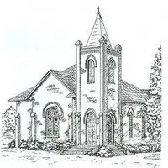

Sunday 2nd August
10.30am: Morning Service, St Bartholomew, Harpley
10.30am: Morning Prayer, St Kenelm’s, Clifton

Sunday 9th August
8.00am: Morning Prayer Service, (Midland Automobile Club) MAC Service, St Andrew’s, Shelsley Walsh
10.30am: Holy Communion, All Saints, Shelsley Beauchamp

Sunday 16th August
10.00am: Praise 4 All, St Kenelm’s Clifton

Wednesday 19th August
10.30am: Holy Communion, St Andrews, Shelsley Walsh

Saturday 22nd August
4.00pm: Welly Church, St Kenelm’s, Clifton

Sunday 23rd August
6.30pm: Evensong, St Kenelm’s, Clifton

Saturday 29th August
11.30am: The Evans Story @ St Bartholomew, Harpley

Sunday 30th August
3.00pm: Thanksgiving Service Old Bartholomew, Lower Sapey

