THE BRIXHAM MISSION COMMUNITY
ALL SAINTS’ SEA WEEK 2026: July 12-19

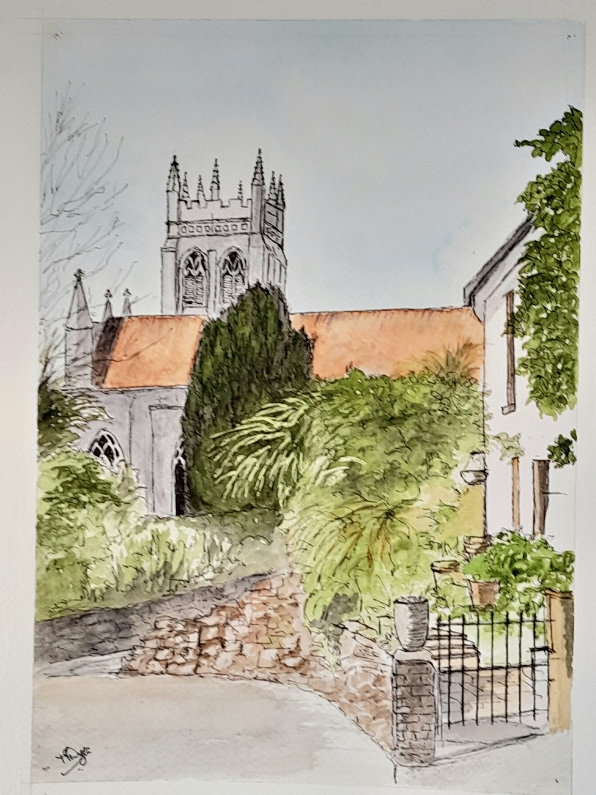
Our Festival of Heritage, Refreshment and Entertainment
Full programme inside
Photo: Painting kindly donated by Margaret, to raise funds for All Saints’

Issue 34 July 2026
Magazine free to take Suggested donation £1
Brixham Mission Community Services July 2026
2026 | Week 1 | Week 2 | Week 3 | Week 4 | Week 5
Sunday | Trinity 5 Proper 9 | Trinity 6 Proper 10 | Trinity 7 Proper 11 | St James Apostle
July | 5th | 12th | 19th | 26th
All Saints'  Lower Brixham | 09:30  Eucharist | 09:30  Eucharist Sea Sunday | 09:30  Worship for All | 09:30  Eucharist
St Mary’s  Brixham | 08:45  No service | 08:45  Eucharist | 08:45  No service | 08:45  Eucharist
 | 11:00  Eucharist | 11:00  W.A.L.K* | 11:00  Eucharist | 11:00  Morning worship
SMVC  Churston | 10.00  Eucharist | 10:00  Morning Worship | 10:00 Eucharist | 10:00  Service of the Word
STCK  Kingswear | 10:30  Morning worship | 10:30  Eucharist | 10:30  Morning worship | 10:30  Eucharist
CGSG  Galmpton | 08:45  Eucharist | 08:45  Morning worship | 08:45  Morning worship | 08:45  Eucharist
Mid-week | Sunday 19 July | 6pm for 6.30pm | All Saints’ | Harvest of the Sea
All Saints'  Lower Brixham 10.00 |  | 7th  Communion by ext. | Wed 15th  St Swithun Eucharist | 21st  Communion by ext. | 28th Eucharist
St Mary’s  Brixham 10.30 | 1st Eucharist | 8th  Eucharist | 15th  Eucharist | 22nd Eucharist | 29th Eucharist
* W.A.L.K Worship, Ask, Love, Know: a fresh expression of worship Brixham Mission Community Churches welcome you!
Welcome to the month of July
Welcome all residents and visitors to the season of summer, sun and sea!
I know it sounds cheesy, but I can’t resist the sizzle of a little bit of alliteration. There’s plenty going on around Brixham Mission Community for everyone.
At the Trawler Event on 20 June I was aware how every trawler depends on the teamwork of fishermen together, doing dangerous work in difficult and challenging conditions. Listening to the live music, I was struck by Maggie Duffy’s beautiful rendition of Sting’s How fragile we are:
On and on, the rain will fall
Like tears from a star, like tears from a star
On and on, the rain will say
How fragile we are, how fragile we are
How fragile we are, how fragile we are.
We live in a world of meritocracy when what we have and achieve seems to count for more than who we are. Have you ever wondered why humankind seems to find it so hard to admit individual or community fragility? Sting’s song was written in the 1980’s as a social comment that acts of violence achieve nothing while humanity stubbornly refuses to acknowledge vulnerability. Perhaps that also resonates for you in today’s world where conflict continues and peace is fragile. I had the privilege last week of listening to Archbishop Hosam Naoum, the Archbishop of the Province of Jerusalem and the Gulf States. Fragility, vulnerability and conflict are constant in his context. He owns his vulnerability with courage, speaks into the vulnerability of the people around him and urges all people of all faiths and none to hold on the sure and certain hope of God with us all. Here’s a soundbite from Archbishop Hosam for you to think about:
Going by yourself you can go fast,
but going with your community you can go far.
We all need one another. ‘How fragile we are’ but, like the trawler teams, we can be so much stronger if we recognise and uphold our need for one another. Be brave in your vulnerability and keep firm in your hope.
Philippa Bellows

Holy Walkies
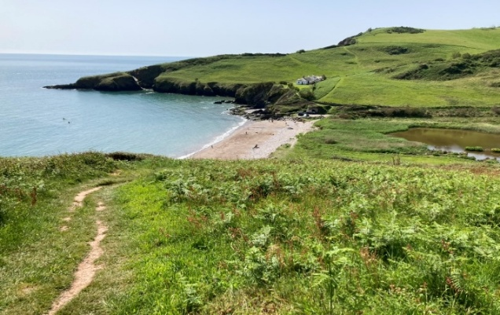
The tradition of pilgrimage is deeply rooted in almost all world religions. It’s a physical journey, often taken on foot, that enables spiritual reflection and experience. Brixham Mission Community is the home of many pilgrim places. Some of these may be familiar to you. I have included a bible verse that sprang to mind on my recent wanderings with Zip.
Mansands
‘The Lord is my shepherd; I shall lack nothing. He makes me lie down in green pastures, he leads me beside quiet waters, he refreshes my soul.’ (Psalm 23: 1-2)

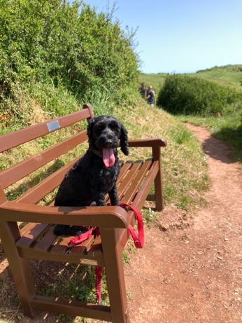
Approaching Sharkham
‘Yes, my soul shall find rest in God,
my hope comes from him.’
(Psalm 62:5)

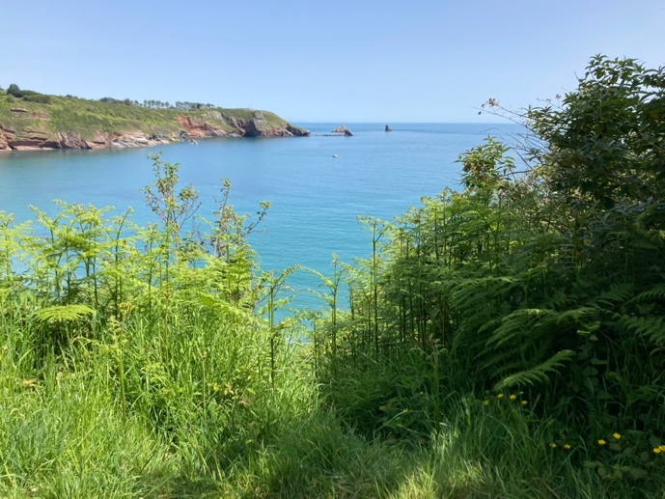
Overlooking St Mary’s Bay
‘He is the maker of the heaven and earth, the sea, and everything in them – he remains faithful forever.’
(Psalm 146:6)

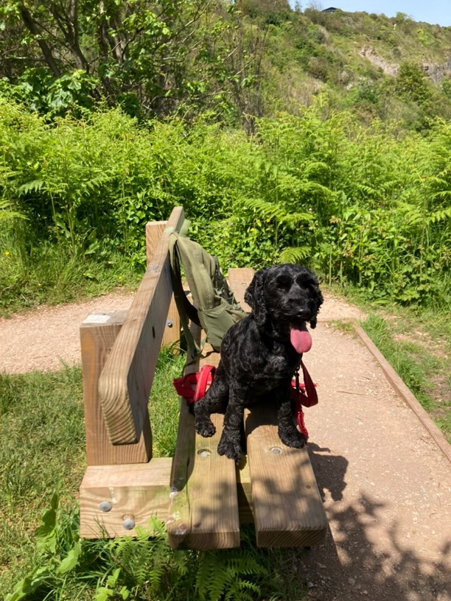
‘Come to me all who are weary and burdened, and I will give you rest. ‘
(Matthew 22:28)

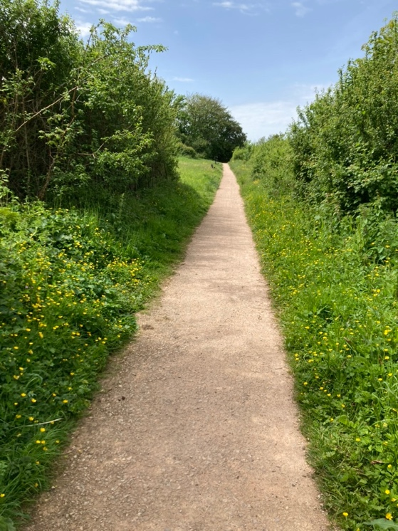

Wishings Field

‘In all your ways submit to him and he will make your paths straight.’
(Proverbs 3:6)
Philippa Bellows and Zip

Bishop James’ Pilgrimage
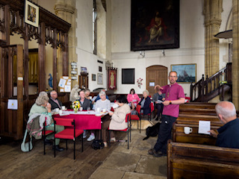
A group of people and dogs accompanied Bishop James from Churston to All Saints’ Lower Brixham, where lunch and prayers were shared before the bishop set off for Kingswear.

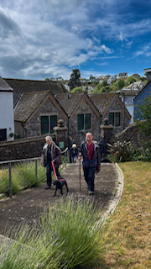
He was greeted by a group at St Thomas of Canterbury, Kingswear for tea, cake and prayers.
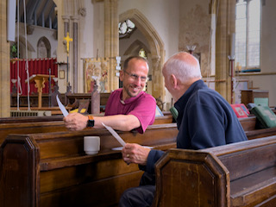

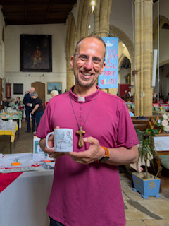
Visiting three churches in Brixham Mission Community was part of Bishop James’ four-day pilgrimage where he visited churches, schools and colleges for prayer and pastoral conversations.
Photos: Cassie Long, Exeter Diocesan Comms Team

Booted into the Parish! by Revd John Calvert
Last month I reminisced about my time working as Children’s Officer in Gloucester Diocese. However after eight years it was time to think of a move. I knew our Bishop (John Went) well, so I contacted him. ‘Have a look at South Cerney’, he suggested. I knew that the PCC had already turned down two of the bishop’s suggestions, so I felt God was opening a door for me and we moved into South Cerney Vicarage in autumn 1987.
The parish comprised South Cerney, the largest village in Gloucestershire, the hamlet of Cerney Wick and Down Ampney. This small village is the birthplace of my favourite composer, Ralph Vaughan Williams, who wrote the tune we sing to Come down O Love Divine, called Down Ampney. Apart from a couple of minor hiccups we spent twenty very happy years there. With God’s help I hope I provided an ‘all round’ ministry to the parish, but my focus was work with children and families, the large church school, music, new forms of liturgy, and the building up of a ministry team.
I retired to Brixham in 2007, but God had more in store. Travelling back from visiting Gill’s sister in the Algarve, I noticed an advert in the Portugal News for a locum Anglican priest. I applied, was accepted and there followed several years of dividing our lives between Brixham and the Algarve serving a dedicated and enthusiastic ex-pat community.
Back here, over the years I have also helped at St Mary’s, Brixham, and St John’s, Paignton.
Having responded to God’s call to the priesthood in 1967, I cannot pretend that it has always been an easy ride but, along with the hard work, the opportunities to serve God have been varied and exciting, and Gill and I give thanks for that. Revd John Calvert

Apple Cake for the Algarve by Gill Calvert
I expect that many older home cooks have a file of tatty bits of paper containing recipes collected over the years. One of my most dog-eared is an apple cake recipe by ‘national treasure’ Mary Berry.
Whilst Revd John and I were ministering in an Anglican church in the Algarve I came to realise that it was very important for the ex-pats to meet, other than in church. So I devised ‘Soup and Sweet’ as an easy way of entertaining groups of our congregation.
This very easy apple cake recipe was a favourite ‘sweet’.
Ingredients:
225g self-raising flour
1 level tsp baking powder
225g caster sugar
2 large eggs
150g melted butter
Half tsp almond extract
250g peeled, cored and thickly sliced cooking apples
25g flaked almonds.
Method:
Preheat oven to 160°C or 140°C fan. Grease a 20cm deep, loose-bottomed tin.
Mix well all the ingredients except the apple slices. Then beat for a minute.
Spread half the mixture into the tin and top with the apple slices, piling more towards the centre than the edge.
Spoon on the remaining mixture, making sure that all the apple slices are well covered.
Sprinkle with the flaked almonds.
Bake for 1¼ - 1½ hours until golden and coming away from the sides of the tin.
A great cake for entertaining, served either cold or warm as a pudding. Thank you Mary!
NB: I usually make 1½ times the recipe and cook for slightly longer.
Gill Calvert

Prayer Boots

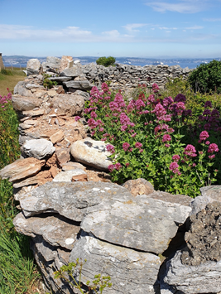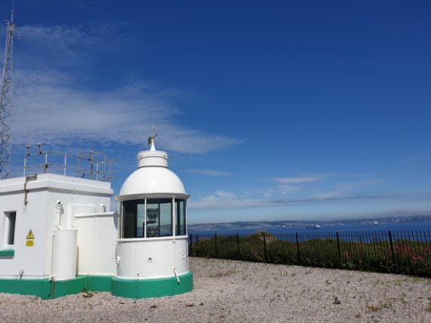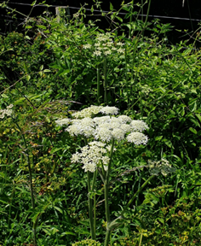

‘To everything there is a season,
and a time to every purpose under the heaven.’

Deciding what to select and write about is a real joy and blessing and needs much thought and consideration. A key part of my prayer time and my preparation includes time with my ‘Prayer Boots’; thinking, praying and listening to God as I walk along. One such walk found me up at Berry Head and I have shared some photos which I hope that you will enjoy too.


As I looked out over the Bay, truly a stunning view on a beautiful sunny day, words from scripture came to mind:

‘But I trust in you, Lord. I say “You are my God. My times are in your hands.”’
(Psalm 31: 14-15 NIV)

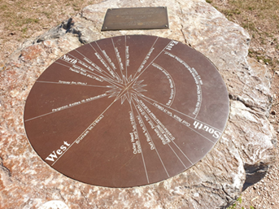
Christ of the seven directions is with me:
Christ above me to uplift me
Christ beneath me to support me
Christ before me to guide me
Christ behind me to protect me
Christ on my left to meet me
Christ on my right to greet me
Christ within me to strengthen me.
David Adam ‘The Open Gate’
On my walk I was reminded of the words of David Adam, that relaxation is one of the best preparations for prayer: ‘We need to learn to be still in body, mind and spirit, to let go of the tensions of our lives. We need to heed the words “Be still and know that I am God.” It is only by relaxing into His presence that we make room for God to work, make room for His peace, His love, His joy to flow into us and through us to others.’

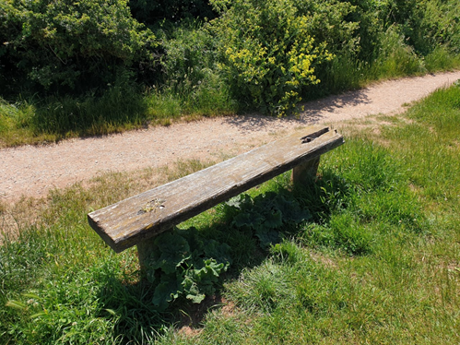
The Father of many resting places grant you rest,
The Christ who stilled the storm grant you calm,
The spirit who fills all things grant you peace,
God’s light be your light,
God’s love be your love,
God’s way be your way.
Amen
David Adam ‘The Open Gate’.

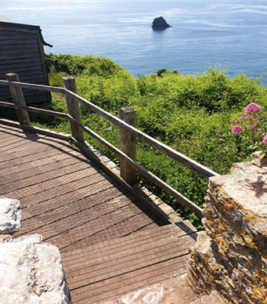
Living, loving God,
help me to set times and spaces apart this day for me to meet with You.
And in between those times
be the breath behind my words,
the impulse behind my actions
and the reason behind my thoughts.
Amen

God above.
God around.
God within.
Amen
‘The Way Within’ People of the Way

Until next time, I hope that you can enjoy moments of peace and stillness too, hopefully with sunshine as well. Travel gently. May the Lord bless you and keep you safe.
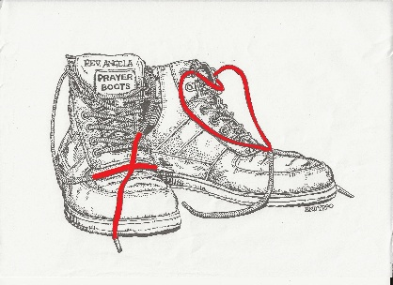
Footnote: (no pun intended!)
This Prayer Boots article is the one that started my Prayer Boots journey or 'Pilgrimage', a few years ago in Covid time.
You could call it 'Angela's Armchair Pilgrimage'; as you read it you don't even have to go outdoors.
The intention is to collect some of the pilgrimage writing into a booklet, which is in process now.
Revd Angela


Some of you came with me in July 2025 to pray on top of Berry Head over the whole of Torbay.
We were joining many prayer stations all round the South West Coast Path to encompass the South West peninsula with prayer.
This year I have once again bagged a spot on top of Berry Head, by the signpost along the tarmac path that leads from the car park.

Come and join us on 11 July at 10.30am
in this amazing wave of prayer.
M Pickthorne
CARING FOR GOD’S CREATION: ECOCHURCH

2025 marked the hottest summer on record in the UK (Met Office). Climate Change is impacting on us locally and globally, destroying homes, infrastructure and habitats, affecting crop production and reducing biodiversity. Those least responsible are often affected first and worst.
Acting on this issue is to show solidarity with our neighbours and care for God’s world.

The UK was the first major economy to set legally binding targets to reach net zero by 2050 - a goal now shared with the EU and many other nations. The Church of England has its own net zero target by 2030 (approved 2022), and there is a three yearly update to General Synod on progress.

Helping us on the way is a charity called A Rocha UK. The name means ‘The Rock’ in Portuguese. Conservation work undertaken in Portugal, out of the conviction to care for God’s Creation, was the inspiration behind the founding of the charity, which is celebrating its 25th anniversary this summer.

The focus of A Rocha UK is to help churches to understand the Climate and Nature Crises, and to respond through faith and action. Their Scheme is called ECOCHURCH, and there are Bronze, Silver and Gold awards to work towards. I have taken on the hat for Churston.

We consider many aspects of church life: from Worship and Teaching to Land and Nature, to Lifestyle, to Buildings and Energy, to Community and Global engagement, to Confirmation. By caring for creation and taking action to address the Climate and Nature Crisis, we live out our Christian Faith.

After making a start, examples of actions are:
- Buying ‘ethical’ supplies of tea and coffee eg Fairly Traded, Organic, Women’s Cooperative.
- Trying to get to church by foot, bike, bus or car share.
- Enjoying some outdoor services during the summer, surrounded by creation, feeling more informal.
- Undertaking a Nature Survey in the churchyard.
- Creating a Pilgrimage to be hosted by our churches on 15 and 16 August 2026. This ‘Good Shepherd’s Way’ will start at the Barn Chapel of the Good Shepherd on Saturday 15 August and go via St Mary the Virgin, Churston, then All Saints’, Lower Brixham, ending on the first day at St Mary’s, Brixham with a picnic lunch. We can do all or just some of the stages, and experience nature, peace, friendship and welcome as we travel from church to church. Children are most welcome on this first day.

The second day will start early at St Mary’s Brixham on 16 August and we will walk first to the SW Coast Path and around to St Thomas of Canterbury, Kingswear. This stage is demanding, so it is only suitable for the very fit. It is expected that most joining on day 2 will choose to depart from St Thomas of Canterbury in the afternoon, rather than risk the challenges of the SW Coast Path in the morning! We will undertake the final walk back to the Barn Chapel, alongside the steam engine line and riverside path, then through Long Wood near Greenway, ending up with a well-deserved tea at The Barn Chapel, Galmpton.

Do tell your friends, family and walking enthusiasts about it. Everyone is welcome. We can’t wait to share in this journey and experience community and the beauty of our land and places of worship. If you can’t walk far, try and be at one of the churches on the day to greet us and share in the occasion. Details are due on the BMC website soon.

Deb Avery



We believe in life before death
Thank you all for your continued generosity. We enjoyed our annual summer afternoon tea in Roger and Lindsay's beautiful garden, raising the amazing amount of £1,178.00. Thanks to our marvellous hosts and all the hard-working crew in the kitchen; also, the waitresses who worked non-stop serving tea, coffee, sandwiches and a wonderful array of cakes and, of course, the makers of said cakes and sandwiches. There were great plants, cakes, and bric-a-brac for sale and of course a raffle! It was a big team.
We are now looking forward to Marie's pizza party which starts at 12 noon and runs till late on Saturday 18 July. It’s just great to be able to make and cook your own pizza. Our next event in the Christian Community Centre will be our Harvest celebration on 12 September but there will be some garden get-togethers in August so just watch out.
It is very sad that all the government foreign aid, that we fought so hard to get, is now going on weapons to defend ourselves. What an upside-down world and, of course, it means we all must give more, and charities have to work harder.
‘Whoever is kind to the poor lends to the Lord and will be repaid in full.’ (Proverbs 19:17)
Marie, Lindsay, Mary
Australian Visitors share service at All Saints’
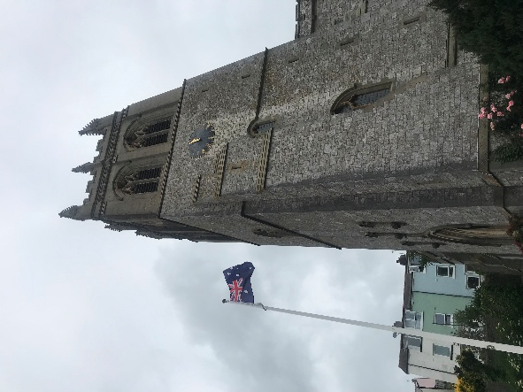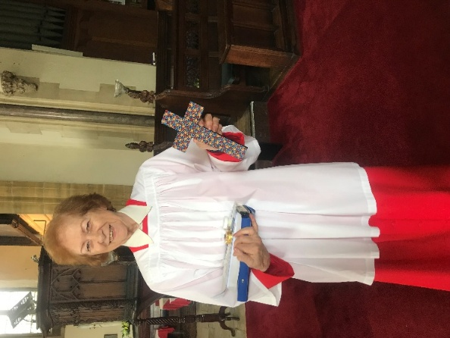
The Australian Flag flies proudly over All Saints’, and a gift from the Australian party, an Aboriginal cross
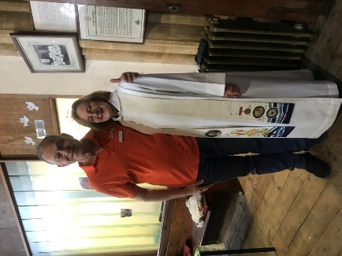
Our own Angela, with the leader of the Australian party and, below, the Henry Francis Lyte chapel
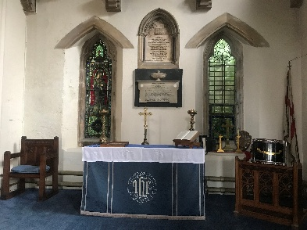

The party were visiting locations associated with their favourite hymns, one of which is Abide with Me. All Saints’ resounded with a rousing rendition of Waltzing Matilda, after a service led by Rev’d Angela.
Galmpton Open Gardens 2026
The Galmpton Festival Association held its annual Open Gardens event on Sunday 14 June. There were 13 gardens and other points of interest open for visitors to admire and enjoy. The ten ‘feature gardens’ were all outstanding, displaying a wide variety of sizes, landscaping and planting.
The students at the Primary School presented an outstanding display of their artwork in the school hall, all with a floral theme. Katy Burns, head teacher, and her team had pulled out all the stops to put this presentation together.
The Barn Chapel was open throughout the day, with Deb Avery and Debbie Perret on duty outside, welcoming visitors and promoting the work of the Mission Community. Over 130 people visited the chapel during the day. School children showed their families and many others commented that they had never been inside the chapel before.
The tea and cakes in the institute did a roaring trade all day! The final financial outcome has yet to be confirmed but it was certainly another very successful event drawing the community together.
The next Festival Association event is the annual Autumn Festival on Sunday 13 September. Entry forms for the wide spectrum of categories (arts and crafts, flowers, fruit and veg, cookery and children’s categories) are available now from the Manor Inn.
As a footnote don’t forget the annual Galmpton Gooseberry Pie Fair taking place on the common on Sunday 5 July from 11.00am.
Jonathan Bye
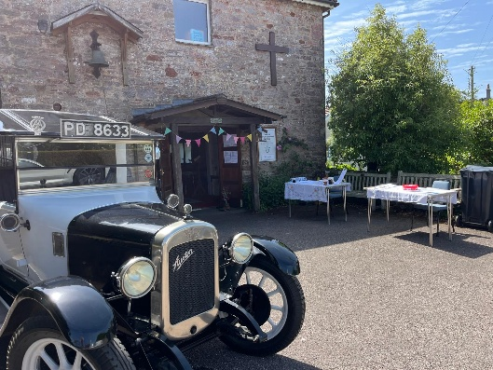
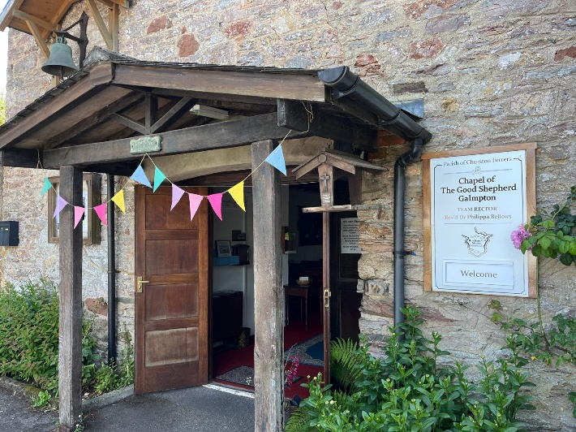
A place of welcome and rest. The Barn Chapel with Deb Avery’s Pilgrimage Boot, and flowers.

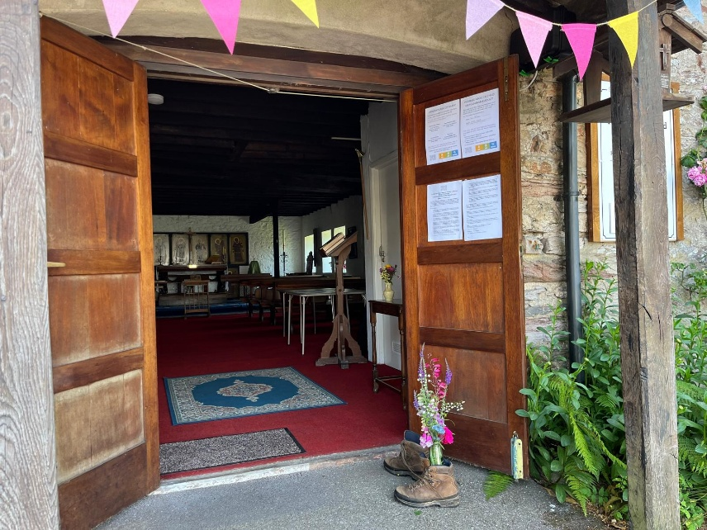

ALL SAINTS SEA WEEK 2026: 12-19July
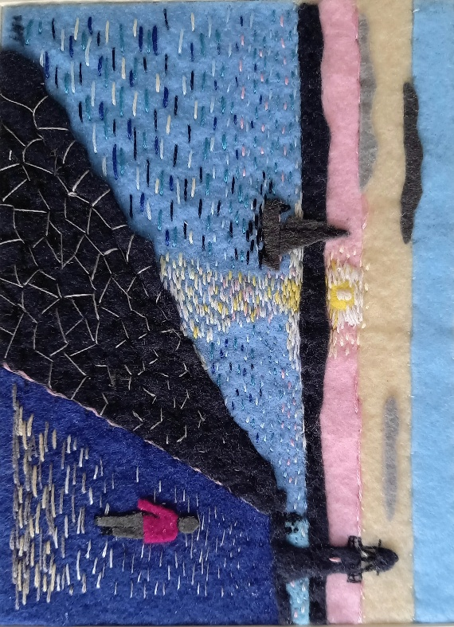
Photo: Brixham Breakwater, embroidery kindly donated by Marion, to raise funds for All Saints’

Daily Exhibition

The Great Storm of 1866 to the Lifeboats of Torbay
Monday 13th – Saturday 18th July
10:00am – 4:00pm daily
Brixham Baptist Church
Free Entry
Discover the dramatic story of the Great Storm of 1866 and explore how maritime disasters helped shape the development of the lifeboat services we know today.
Featuring photographs, historical information and fascinating stories from Brixham’s maritime past, this exhibition offers a unique insight into the courage, resilience and community spirit that continue to define our coastal town.
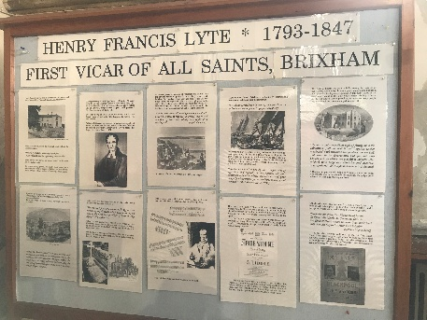
Sunday 12th July

Sea Sunday Service

9:30am
All Saints’ Church

Sea Week begins with our special Sea Sunday Service.
Join us as we celebrate Brixham’s connection to the sea, remember those who work on and around our waters, and give thanks for the communities that have grown around our harbour.
Refreshments will be served after the service.
Everyone is welcome.

Monday 13th July

School Visits
9:30am
All Saints’ Church
We are delighted to welcome pupils from Brixham Church of England Primary School and Furzeham Primary School for a morning of learning and discovery.
Topics include:
- Where does your fish supper come from?
- Staying Safe in the Water with the RNLI
Helping younger generations connect with Brixham’s maritime heritage is an important part of Sea Week.
Photo: Cassie Long, Exeter Diocese Communications Team

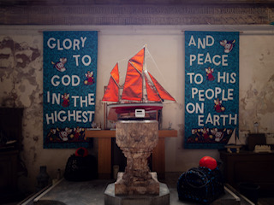

Tuesday 14th July

Fish Quay Market
10:00am – 2:00pm
Brixham Fish Quay
Visit our Sea Week stall at the Fish Quay Market.
Learn more about All Saints’ Church, Sea Week activities and our fundraising campaign to support the future of the church.
We’ll also have information about our Fish and Chip Supper and Quality Auction.

Cream Tea with Music
3:00pm – 5:00pm
All Saints’ Church
Enjoy a traditional cream tea while listening to live music from local favourites:
- Missin' Tackle
- Fish Hawkers Tale
Tickets: £5 per person
A relaxed afternoon of music, refreshments and community spirit in the heart of Lower Brixham.

Wednesday 15th July

Midweek Service and Refreshments
10:00am – 11:00am
All Saints’ Church
Take time to pause and reflect during Sea Week.
Join us for a short midweek service followed by refreshments and the opportunity to visit the Sea Week exhibition.
Everyone is welcome.
Thursday 16th July

Coffee Morning
10:00am – 12:00pm
All Saints’ Church
Enjoy coffee, homemade refreshments and friendly conversation.
This is a wonderful opportunity to meet members of the church community and find out more about the role All Saints’ continues to play in the life of Lower Brixham.
Visitors are also encouraged to visit the Sea Week exhibition.

Friday 17th July

Fish and Chip Supper, Music and Quality Auction
7:00pm
All Saints’ Church
One of the highlights of Sea Week.
Enjoy:
- Fresh fish and chips
- Live music
- Community fellowship
- Quality charity auction
Auction prizes include generously donated items and experiences from local businesses, artists and supporters. A wine bar will also be available through the evening.
Funds raised from the evening will help support the future of All Saints’ Church and our campaign to raise £10,000 by Christmas 2026.
Tickets: £10
Please contact Jayne Carter jvacarter@yahoo.co,uk tel contact 07790 940552, to book tickets, or see us at the Fish Quay Market (subject to availability).

Saturday 18th July

All Saints’ Open Day

10:00am – 4:00pm
All Saints’ Church

Step inside one of Brixham’s most iconic buildings.

Throughout the day you can:
- Explore the church
- Enjoy refreshments
- View the Sea Week exhibition
- Learn about the church’s history
- Spend time in our reflection space
- Meet members of the church community
Whether you are a regular visitor or have never stepped inside before, we would love to welcome you.

Sunday 19th July

Harvest of the Sea Civic Service

6:30pm
All Saints’ Church

Sea Week concludes with our Harvest of the Sea Service.

This special civic service brings together representatives from sea-related organisations, civic office holders and members of the local community to celebrate Brixham’s maritime heritage and give thanks for all those connected to the sea.

Everyone is warmly invited to attend.

Supporting the Future of All Saints Church

Sea Week 2026 forms part of our campaign to secure the future of All Saints’ Church. For more than 200 years, All Saints’ has stood above Brixham Harbour as a place of worship, community and heritage. Through fundraising events, community activities and the support of local people, we hope to ensure it continues serving future generations.
We are currently working towards a fundraising target of £10,000 by Christmas 2026. Thank you for supporting Sea Week and helping keep faith at the heart of Fishtown.

Come and join us – everyone is welcome.
A Sea Town

Nautical knots and splices
Exotic fruits and spices

Markets full to the brim
Of trinkets lace and scrim

And fish of course, salt sea fresh
Caught in nets, the right size mesh

Crabs and lobsters for the pot
Whatever you want we’ve got the lot

So take your time and look around
You’ll be surprised what can be found

Our town is like an open book
Waiting for you to take a look.

Stephen
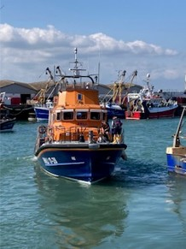

Quay Harmony

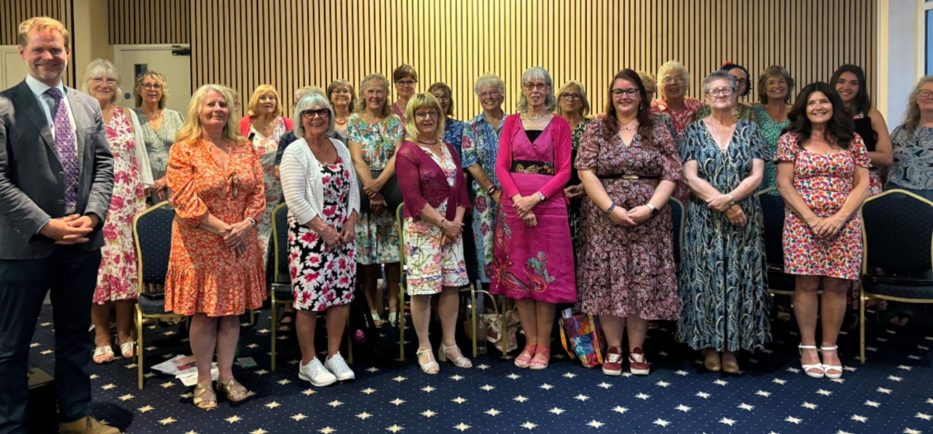
Quay Harmony’s Summer Concert, scheduled to take place at Churston church, took place instead at Churston Golf Club, due to repairs being carried out on the church roof.

The concert proved to be a big success and was well attended. The choir and soloists performed a wide selection of songs to a very appreciative audience, supported admirably by The Sea Hounds and The Galliard Recorder Trio who added musical variety. Jane Washington gave a vote of thanks to Musical Director, Jeremy Kenyon, their accompanist, Karen White and everyone involved. An enjoyable evening was had by all. The choir have been invited to hold their Christmas Concert at the church in December. Janet Bradley

Thank you
Thank you so much from Michael Perret, who wrote the article on leprosy research (June magazine). Michael has received several supportive comments. Special thanks to Brenda and Graham Eyre who welcomed Michael into their home and shared their wealth of experience and links with the Leprosy Mission.
All Saints’, Lower Brixham LYTE FINGERS – A GENTLE REMINDER
The Quayside Market is now only a few weeks away, and our table will be as usual stacked with crafted items for sale. We have virtually finished the final stocktake and pricing and are looking forward to a sunny day with lots of visitors to buy our items. Margaret Dyer and I also enjoy painting and will be displaying some of our work for sale too, along with three pictures to be included in the Auction at the Fish and Chip Supper (see details elsewhere).
We were pleased to receive Jonathan Parr’s interesting report regarding goods going to Ukraine, which arrived in time to be published in the last edition of Moving Forward Together. We send our thanks to Jonathan for that.
Revd Angela’s Flock of Sheep appeal has drawn a good deal of interest, and there seems to be a particular demand for black sheep! If you would like to have one of the pom-pom sheep, they are on display in All Saints’. Please make a generous donation.
This week, we will have our midsummer meeting where we will be relaxing with tea, coffee and cake, maybe in the garden if the weather is fine. With work for the market virtually complete, we shall also start to put our thoughts towards Christmas! Where is the year going? Finally, my “gentle reminder” is to ask that you visit our table at the ALL SAINTS’ QUAYSIDE MARKET ON TUESDAY 14 JULY from 10am. We look forward to seeing you there.
Marion Turner

St Mary’s, Brixham: June
What a wonderful start to the summer with one of the hottest half-term holidays we can remember! It has been a real joy to see families out and about, making the most of the break, which for many schools extended into the following week.
When Mummy & Me resumed after half-term more young mums joined the group, enjoying the friendship, chat and support that it offers each Thursday morning during term-time. This is a happy group who welcome all newcomers. Messy Church and Youth Group have seen new members too, all enjoying each other’s company and the activities offered.
Some of us, two-legged and four-legged, joined Bishop James on a section of his pilgrimage around the churches of the Brixham Mission Community, from St Mary’s, Churston to All Saints’, where the reception and refreshments were very welcome on a wet day.
Thanks go to our amazing team who served afternoon tea for all who supported the Christian Aid event at Hunter’s Moon. We were blessed with beautiful weather after a week of intermittent rain: great teamwork! It was lovely to welcome so many, from two months old to 92 years old. All enjoyed catching up with each other.
Our W-A-L-K service concentrated on A for Ask and how prayer may be ‘answered’ in different and unexpected ways.
Again, there were waffles on offer before the service which were greatly enjoyed by all. Our thanks to Eleanor and Paul, who then swapped waffle-maker for guitar to accompany the first hymn!
Thanks as always go to all who serve members of the congregation, by taking services, serving refreshments, welcoming and talking to visitors, preparing for services, tidying afterwards, taking Home Communion to those unable to attend any longer, delivering magazines and Grapevines to the housebound, cleaning the church, etc, much of which goes unnoticed! Thank you! LW

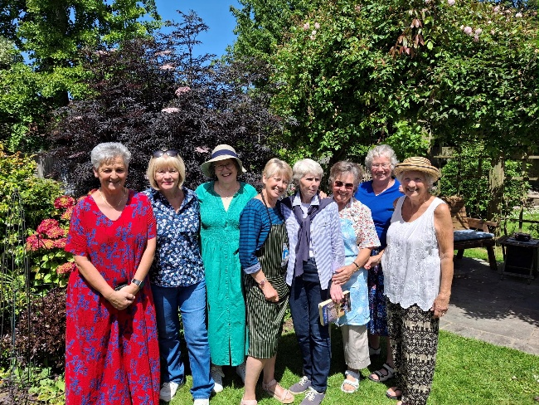
Christian Aid Tea...the kitchen team!

Messy Church, St Mary’s, Brixham
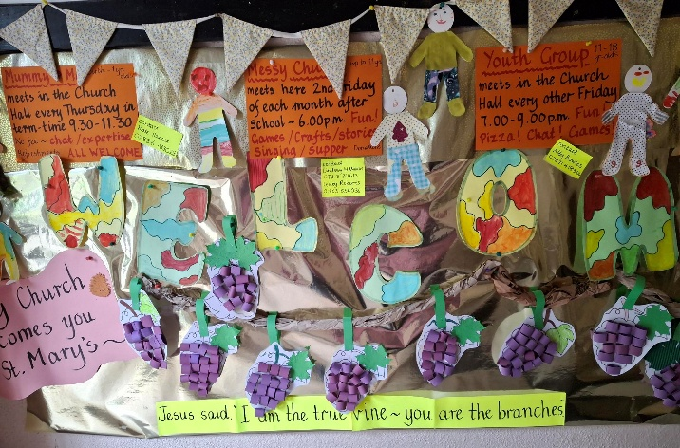
Messy Church St Mary’s, Brixham
The last of the ‘I am….’ sayings of Jesus for this term were ‘I am the true vine, and you are the branches…’ which was a good theme to include Pentecost and the coming of the Holy Spirit and Trinity Sunday. Both of these had occurred since the previous Messy Church. It was with some ingenuity on the part of our amazing team of helpers that we managed to incorporate these into one session. Upon arrival children made Pentecost streamers on sticks to wave, and curled paper bunches of grapes to hang on a vine.
We sang joyfully, ‘Father/Jesus/Spirit, we adore you…’

Activities then included:
- Placing a paper plate with red/yellow/orange paint dabbed on it into a salad-spinner to see the effect
- Making red/yellow/orange paper fans
- Choosing from three different ‘grape vine’ cards to make
- Making a friendship bracelet from three strands of thick wool
- Decorating savoury biscuits with small pieces of coloured vegetables.
Supper was pizzas with carrot and cucumber sticks, thanks to the wonderful kitchen team.
Do come and join us for the last Messy Church of the year on Friday 10 July, when we hope the weather will allow us to have games and a picnic at Hunter’s Moon, Horsepool Street. If wet we will be in church as usual.
For further information please contact Lesley 01803 854036 or Lindsay 07813 311613

St Mary the Virgin, Churston
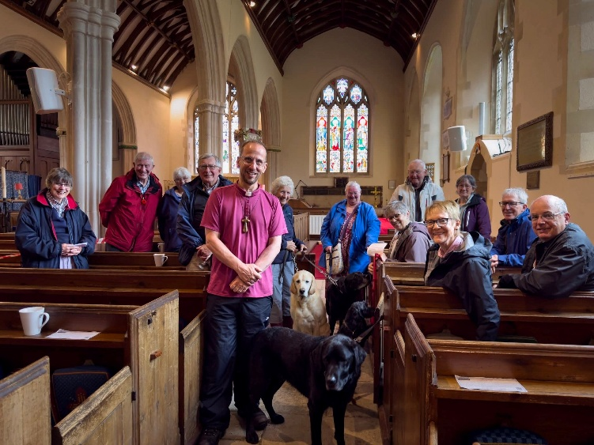
Thank you very much to everyone who came along to greet Bishop James as he did his walk around the Deanery on Wednesday 3 June. He was in good spirits and said some lovely prayers.
Philip read a passage from the bible (Matthew 28 16-20, the final verses of Matthew's Gospel), and Bishop James asked us all to pick out something from the text. The bit that I picked out was ‘And behold, I am with you always, to the end of the age.’ I always try to keep this in mind, especially when things are difficult.
I was listening to the radio while I was ironing yesterday and up popped Simon and Garfunkel’s Bridge over Troubled Water. Shamefully, as a teenager I thoroughly enjoyed the tune but never took much notice of the lyrics, and they are surely some of the best to come from that era: such a comforting reminder that God is always there when things aren't going the way you hoped (and he is also there joining in the fun when things are going well and we sometimes forget that too). So, it all fitted together this week. The lyrics are below:
‘When you're weary, feeling small,
When tears are in your eyes, I will dry them all;
I'm on your side. When times get rough
And friends just can't be found,
Like a bridge over troubled water
I will lay me down.
Like a bridge over troubled water
I will lay me down.
When you're down and out,
When you're on the street,
When evening falls so hard
I will comfort you.
I'll take your part.
When darkness comes
And pain is all around,
Like a bridge over troubled water
I will lay me down.
Like a bridge over troubled water
I will lay me down.
Sail on silver girl,
Sail on by.
Your time has come to shine.
All your dreams are on their way.
See how they shine.
If you need a friend
I'm sailing right behind.
Like a bridge over troubled water
I will ease your mind.
Like a bridge over troubled water
I will ease your mind.’
JaneWashington

Origami

Without any help from me
Flowers unfurl their buds
Without any help from me
Butterflies break free
Pump wings
And fly
Without any help from me
Perfume floats through forest
Gardens, sacred spaces
Without any help from me
Creation unfolds.

Stephen Bellows

Dates for your diary
JULY
Wednesday 1st 9.15am St Mary’s hall
Men’s breakfast
Sunday 5th 12noon Galmpton Gooseberry Pie Fair
Friday 10th St Mary’s Messy Church
Saturday 11th 10.30am Berry Head Southwest
prays
Sunday 12th-Sunday 19thALL SAINTS’ SEA WEEK:
Sunday 12th 9.30 All Saints’ Sea Service
Monday 13th All Saints’ schools’ visits
Tuesday 14th 10am-2pm Quayside Market
Tuesday 14th 3pm-5pm All Saints’ cream teas
Wednesday 15th 10am-11am All Saints’ service
Thursday 16th 10am-12pm All Saints’
Coffee Morning
Friday 17th 7pm All Saints’ Fish and Chip Supper
Saturday 18th 10am-4pm All Saints’ Open Day
Sunday 19th 6.30pm All Saints’
Harvest of the Sea Service
Saturday 18th 12noon Christian Aid Pizza
Saturday 18th 3pm St Mary the Virgin, Churston
Brixham Orpheus Male Voice Choir

FORTNIGHTLY in term time
Friday 7.00-9.00pm St Mary’s
Youth Group 11 -18s
WEEKLY in term time
Thursday 9.30-11.30am St Mary’s church hall
Mummy & me
Friday 9.15-11.15am Barn Chapel Stay & play

CONTRIBUTIONS FOR AUGUST MOVING FORWARD TOGETHER:
I would be grateful if you could send contributions
by Sunday 26th July, to Debbie Perret, BMC Administrator, at debbie.brixhammc@gmail.com

WHO WE ARE
Revd Dr Philippa Bellows, Team Rector rectorbrixhammc@gmail.com 01803 927797
Revd Angela Sumner, Associate Priest (SSM) 01803 853959
Debbie Perret, Administrator debbie.brixhammc@gmail.com 07790 104293
LICENSED LAY MINISTERS (LLMS)
Wendy Emlyn 07785 573145 Margaret Pickthorne 07969 474613
Martyn Hodge 01803 851302 Elaine Vestey 07930 815155
Hilary Hyde 01803 852323
-------------------------------------------------------------------------------------------------------------------------------
PARISH OFFICERS
ALL SAINTS', LOWER BRIXHAM
Warden: vacant
PCC Secretary: vacant
Organist: Mr R Thomas 01803 850125
Choir Director: Jean Aird (Mrs Jean Holman) jeanaird@aol.com 01803 858235
Treasurer: Mr I A Webb ianw@iawaccountancy.co.uk 01803 845961 Safeguarding: Martyn Hodge martynhodge47@gmail.com 01803 851302
-------------------------------------------------------------------------------------------------------------------------------------------
ST MARY'S, BRIXHAM
Wardens: Nichola Aldridge nicholawinstanley@live.com
Lindsay Williams ra_lawilliams@hotmail.com 07813 311613
PCC Secretary: Rachel Fox rachelpaul2506@outlook.com 07359 143257
Acting Organist/Dir. of Music: Michael Hackeson
Treasurer: Mr I A Webb ianw@iawaccountancy.co.uk 01803 845961
Safeguarding: Ferne Raybould ferne.rogers@nhs.net
-------------------------------------------------------------------------------------------------------------------------------------------
ST MARY THE VIRGIN, CHURSTON
Warden: vacant
Safeguarding: Philip Mantell philip.81mantell@btinternet.com 01803 844128
PCC Secretary: Debbie Perret deb.perrethome@gmail.com 07790 104293 Treasurer: Mr I A Webb ianw@iawaccountancy.co.uk 01803 845961
-------------------------------------------------------------------------------------------------------------------------------------------
ST THOMAS OF CANTERBURY, KINGSWEAR
Warden: Gary Lewis Gary.Lewis@a1plc.co.uk 07940 734721 contact via Carmen Lewis 07957 432993
PCC Secretary: vacant
Safeguarding: Sandra Barton Jayne sbartonjayne@outlook.com 07341 845462
Treasurer: Carolyn Williams carolynwilliams351@gmail.com 07801 847248
-------------------------------------------------------------------------------------------------------------------------------------------
CHURCH HALL BOOKINGS
St Mary’s Church hall Mrs M Seffert 01803 853525
Barn hall, Galmpton Lynn Milner 07305 788503
------------------------------------------------------------------------------------------------------------------------------------------
OTHER CONTACT DETAILS
BMC Treasurer: Mr I A Webb ianw@iawaccountancy.co.uk 01803 845961
Funerals: The Team Rector
Baptisms: The Team Rector/Administrator
Weddings: Rachel Fox rachelpaul2506@outlook.com 07359 143257

REMEMBER …….

ALL SAINTS’

SEA WEEK

12-19 JULY

