
CANALSIDE NEWS
for OCTOBER 2025

Thought from Chris

We have just coming to the end of Creationtide, which runs from the 1st of September to the 4th of October. This is a time in the church year specifically set aside to celebrate creation and the goodness of the world around us. That God created the world and made it good is something we say regularly in church as part of the Creed that starts “We believe in God, the creator, maker of heaven and earth and of all things, seen and unseen.” It’s something we have been particularly thinking about in the Benefice this year as we have celebrated Plough Sunday, Rogationtide, Lammas and will finish this particular season of Creationtide with our Harvest festival. (Harvest service at St Michael’s on Sunday 5th October; Harvest Supper at the Village Hall in Semington on Saturday 18th October, tickets available now!)

I’ve been learning a lot this year about the issues we face in trying to protect our environment and look after the world God has given us. Although there are still climate sceptics who believe there is no human-caused climate change and people who consider what changes we do see to be natural processes, the regular warming and cooling of the planet over millions of years, many others see the evidence as unequivocal. The burning of fossil fuels, as well as some other factors like increases in methane production, has caused the warming of the planet.

One of the effects we’re already seeing is that sea rise is causing devastation and loss of life. Sometimes this is obvious, like rising sea levels forcing communities to move, which impacts more people who are poor than it does people with more wealth. Sometimes it is less obvious: one of the factors in the terrible flooding seen earlier this year in Texas was because of the increased temperature in the seas around the Gulf of Mexico (or Gulf of America). Storms and hurricanes feed on higher temperatures and this contributed to the disaster.

What has any of this got to do with what we do in church? Well, through the services I’ve already mentioned and our reverence for God’s creation, we want to think about how to take care of our world. To preach, without apology, for action that promotes protection for the environment and to stop the harm that is still ongoing.


There are three things that I keep coming back to. Celebrating the beauty of the world around us; lamenting the harm that has been done to the natural world; acting as stewards of the earth, rather than seeking to exploit it. To me, this is part of a life of faith but is also crucial for all of us. Looking around us and being joyful at just how wonderful the world is; recognising the damage we’ve done; trying to do better.
In Loving Memory for All Souls

Our annual In Loving Memory Service will take place on Sunday 2nd November at St Michael’s at 3pm. This is a Benefice wide Service at which we remember those we have loved and lost, and all are very welcome to join us. The names of those whose funerals, memorial services or interments have taken place in the Benefice during the last three years will be read out during the service together with all those named in the Book of Remembrance at St Michael’s. If there are others that you would like us to name during the service, please write their names on the list which is at the back of church or let Michael know by Friday 31st October.
Used Postage Stamps

Thank you to all those who have passed on all their used postage stamps to Bill
and Marilyn Stubbs for the Bible Society. Please keep them coming and use
the Storehouse church porch containers for dropping them off from which Bill
will collect them.
Could you be the next Foundation Governor at Hilperton School?

As a Foundation Governor you represent the

Church to the school and the school to the
church and have a particular role
in maintaining the Christian ethos of the
school. The Hilperton School governing body
already has two excellent foundation
governors, so you would not be serving in
this role alone, but the PCC wish to appoint a
third, to replace Joy, who has completed her
term of office.

All school governors are volunteers and their role is threefold:
- to ensure the clarity of vision, ethos and strategic direction for the school;
- to hold the school accountable for the quality of education;
- to hold the school accountable for the use of finance and resources and make sure the money is well spent.

If you would be interested in the important and vital role, please speak with
either Chris or Joy for more information.
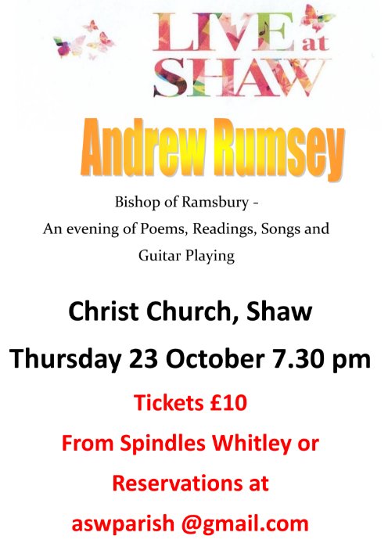
100 Club Winners

Congratulations to recent winners
of the 100 Club :
July: Jim Banks
August: Roger Emes.
Michael’s Phone Number

Please note I no longer have a landline
telephone so only use by
mobile number to contact me
07795400262. Thankyou
Advent Calendars

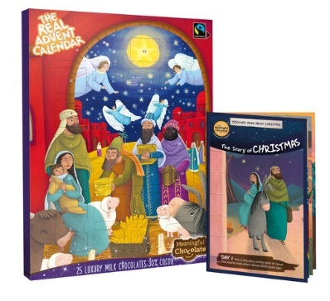
I will be ordering Real Advent Calendars again this year. This is the only one with Fairtrade chocolate and a copy of the Christmas story. It supports charitable projects, and sadly no supermarkets stock it. The cost - £4.95 each if we order 18 or more, otherwise £6.00. More details from https://meaningfulchocolate.co.uk
To ensure we have them for 1st December I will need orders by Sunday 2nd November please. Bev Woodward 01380 870784.


Tuesday’s Morning Prayer Number

On Tuesday 30th
September we will not
be meeting online for
Morning Prayer, but in
person in St. Michael’s
Church at 9.30am.

Going forward
we anticipate an in
person Morning Prayer
on the last Tuesday of
each month, and details
will be in the Newsletter
Diary.

On the other Tuesdays
Morning Prayer will
continue online as
before and the link is in the diary.

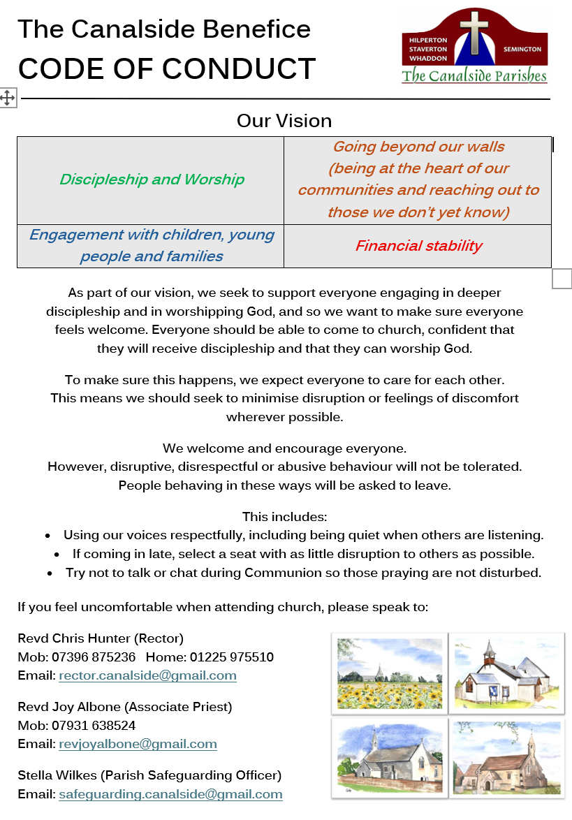


Prayer Requests

It is important that we pray for all who seek our support.
Please let Michael know of anyone who particularly needs our prayers. Do ensure that you have their permission.
This month we pray for..  + Alison Meader  + Amelia-Lily and  family  + Andrew Margetts  + Audrey Sheppard  + Barbara Tucker  + Bob Cradock  + Catherine  + Cathy and Ian  + Chloe Stevens  + Colin Jackson  + Collette Miyagawa  + Colston Carpenter | + Dave, Rosemary,  Matthew & Family  + Eve and Jim Banks  + Hannah, Ash, Oliver & baby Leo  + Heather  + Helen Thomas  + Hilary & Mark Heaton  + Irene Hicks  + Isabelle & Family  + Jeannette  + Joanna Martin  + Laurence & Family  + Maggie & Family | + Maureen Mitchell  + Mike Aldridge  + Ntombi and Family  + Richard Marshman  + Roger Emes  + Rosa Light  + Val, Phil and family  + Viv and Jan  

- We pray for all those who mourn at this time particularly the family and friends of Graham Baldwin and Daphne Peat.

- We pray for the people of Sudan at this time of conflict, including Archbishop Ezekiel as he leads the Anglican Church there.
Science and Faith in Pew and Pulpit

4th October 2025, 10am to 2pm. The Science and Religion Forum is hosting a half-day, online event, Science and Faith in Pew and Pulpit, looking at the importance of engaging with science in the church context and how we can introduce science, and the science-faith dialogue, into the life of our churches. Speakers are Dr Ruth Bancewicz, Church Engagement Director at the Faraday Institute for Science and Religion, and the Revd Dr Jennifer Brown, former Science Missioner in the Oxford Diocese and until recently Director of Training of the College of Preachers. The cost for the event is £15 for SRF members, £20 for non-members. Places can be booked by going to
https://www.srforum.org/anniversary-pew-pulpit.

Foodbanks Update


Together with many other Foodbanks across the country both Melksham and Trowbridge are desperate for more donations, as the demand is very high at present, so please give as generously as you are able.


HELP!
If you can donate any food or hygiene items PLEASE, pop them in our trolleys or come on down and bring them to us. If you are a little flush; you can do online shopping with ASDA as they will deliver to us on your behalf. Please drop into the building as we now do a breakfast for the homeless so eggs are always needed plus cheese, butter bacon etc as we have a fridge freezer, and fridge. Fruit and vegetables are always welcome but do not put in a trolley.
Please continue to donate to us so we can keep blessing the people of Trowbridge. Thank you all.
Please use the collection boxes in the porches of St Mary Magdalen’s and St Michael’s to drop off food donations etc. Bill Stubbs then very kindly collects everything up and drops it off at Storehouse. As always Bill thankyou so much for all you do on this.
If you prefer you can make a one off financial donation or support Trowbridge Storehouse regularly, please follow the link below and select storehouse. https://westwiltsvineyard.churchsuite.co.uk/donate/fund/zk54op3a Storehouse is always in need of carrier bags


Melksham Foodbank continue to need all items but in particular at the moment
require :
Packet Soup, Tinned Vegetables and Pulses Tinned Baked Beans, but all items are still urgently needed. The demand for support is very high (please ensure all items are well within the best before date). They can also take large bags of rice, tea bags, sugar & pasta as these can be decanted into smaller bags for distribution. Please take your donations to the porch at St George’s, Semington before 6pm on Wednesday.

Our continued support of Melksham FoodBank and Trowbridge StoreHouse is vital, and a part of our response to God’s generosity to us.
A Prayer for World Peace


Almighty God, from whom all thoughts of truth and peace proceed: kindle, we pray, in the hearts of all, the true love of peace and guide with your pure and peaceable wisdom those who take counsel for the nations of the earth that in tranquillity your kingdom may go forward, till the earth is filled with the knowledge of your love; through Jesus Christ your Son our Lord, who is alive and reigns with you, in the unity of the Holy Spirit, one God, now and for ever. Amen.

CANALSIDE DIARY
Please pray for all events taking place in the next few weeks

Day | Date | Time | Event details | Location
S E P T E M B E R 2 0 2 5
Tu | 30th | 0930 | Hilperton/Staverton Morning Prayer  (NOT online – see separate notice) | St Michael’s
Tu | 30th | 1300 | LWL/LPA Meeting | St Michael’s Room
O C T O B E R 2 0 2 5
W | 1st | 1000 | Midweek Morning Worship | St Michael’s
Th | 2nd | 0900 | Semington Morning Prayer  https://us06web.zoom.us/j/88553953942?pwd=1EHGGg18bBqqYKytMMRbYvZ5JZFZNm.1 | Online
F | 3rd | 0930-1100 | Toddlers@theTin | St Mary Magdalen’s
Tu | 7th | 0930 | Hilperton/Staverton Morning Prayer https://us06web.zoom.us/j/89678887943?pwd=IKy2vBYNviwibNcoWUpqTtf4hpwQTA.1 | Online
W | 8th | 1000 | Midweek Communion | St Michael’s
Th | 9th | 0900 | Semington Morning Prayer  Use link above | Online
Th | 9th | 1430-  1600 | Friendship Group | St Mary Magdalen’s
F | 10th | 0930-1100 | Toddlers@theTin | St Mary Magdalen’s
Tu | 14th | 0930 | Hilperton School’s Harvest Service | St Michael’s
Tu | 14th | 0930 | Hilperton/Staverton Morning Prayer  Use link above | Online
W | 15th | 1000 | Midweek Morning Worship | St Michael’s
W | 15th | 1030 | Harvest Service | Staverton House
Th | 16th | 0900 | Semington Morning Prayer  Use link above | Online
Th | 16th | 0930 | St George’s School Harvest Service | St George’s Church
Th | 16th | 1000-  1200 | Community Café | St Mary Magdalen’s
F | 17th | 0930-1100 | Toddlers@theTin | St Mary Magdalen’s
Sa | 18th | 1000-1200 | Autumn Coffee Morning | St Mary Magdalen’s
Sa | 18th | 1900 | Semington’s Harvest Supper | Village Hall
Tu | 21st | 0930 | Hilperton/Staverton Morning Prayer  Use link above | Online
Tu | 21st | 1430 | Staverton School’s Harvest Service | Staverton School
W | 22nd | 1000 | Midweek Communion | St Michael’s
Th | 23rd | 0900 | Semington Morning Prayer  Use link above | Online
F | 24th | 0930-1100 | Toddlers@theTin | St Mary Magdalen’s
Tu | 28th | 0930 | Hilperton/Staverton Morning Prayer  (NOT online – see separate notice) | St Michael’s
W | 29th | 1000 | Midweek Morning Worship | St Michael’s
Th | 30th | 0900 | Semington Morning Prayer  Use link above | Online
N O V E M B E R 2 0 2 5
Tu | 4th | 0930 | Hilperton/Staverton Morning Prayer  Use link above | Online
W | 5th | 1000 | Midweek Communion | St Michael’s
Th | 6th | 0900 | Semington Morning Prayer  Use link above | Online
F | 7th | 0930-1100 | Toddlers@theTin | St Mary Magdalen’s

Hello – I’m just a lonely little chair looking for a good home. My previous owners abandoned me recently at the Silent Auction. Although I put on a brave face for the auction no one put in a bid for me and it now looks like I’m heading for the tip. Please help me find a new home before it’s too late.
Contact Michael

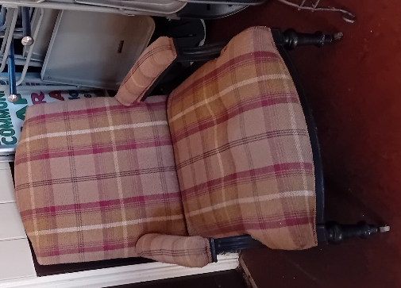

D A T E S F O R D I A R I E S

Month | Day | Date | Time | Event details | Location
OCTOBER | Sat | 18th | 1000-  1200 | AUTUMN COFFEE MORNING | St Mary Magdalen’s
OCTOBER | Sat | 18th | evening | SEMINGTON HARVEST SUPPER | Semington Village Hall
NOVEMBER | Sat | 8th | 1000-1200 | REMEMBRANCE COFFEE MORNING | Hilperton House
NOVEMBER | Sat | 22nd | TBD | CHRISTMAS FESTIVE FAYRE | St Mary’s Magdalen’s
NOVEMBER | Fri | 28th | 1900 | QUIZ NIGHT | St Mary Magdalen’s

CANALSIDE CONTACTS

Rector | Rev. Chris Hunter | 07396875236  01225 975510 | rector.canalside@gmail.com
Associate Priest | Rev. Joy Albone | 07931638524 | revjoyalbone@gmail.com
Office | Michael Gamble | 07795400262 | canalsideoffice@gmail.com
Churchwardens
Semington | David Wildsmith | c/o 01380 870784 | c/o jackbev.woodward@gmail.com
Hilperton and Staverton | James Newton | 07803904947 | jpnewton@churchmouse.org.uk
Hilperton and Staverton | Martyn Carpenter | 07831309377 | martyncarpenter55@gmail.com
Website | canalsidebenefice.org.uk
Facebook | https://www.facebook.com/canalsideparishes



CHURCH SERVICES in
CANALSIDE BENEFICE

 | HILPERTON  St Michael’s | HILPERTON  St Mary Magdalen’s | SEMINGTON  St George’s | WHADDON  St Mary the Virgin
28th September  Trinity 15  and  Michaelmas | 10.30am  ‘EXPLORE’ SERVICE  for MICHAELMAS | 4pm  TEA@theTIN
5th October  Trinity 16 and  Harvest | 10.30am  HOLY COMMUNION  for  HARVEST |  |  | 3pm  BCP  HOLY COMMUNION  for HARVEST
12th October  Trinity 17 |  | 10.30am  HOLY  COMMUNION | 9.15am  HOLY COMMUNION
19th October  Trinity 18 | 10.30am  HOLY COMMUNION |  | 9.15am  BREAKFAST CHURCH for HARVEST
26th October  Last Sunday After Trinity |  | 10.30am  ‘EXPLORE’ SERVICE
26th October  Last Sunday After Trinity |  | 4pm  TEA@theTIN
2nd November  Fourth Sunday Before Advent | 10.30am  HOLY COMMUNION
2nd November  Fourth Sunday Before Advent | 3pm  IN LOVING MEMORY SERVICE
Full details of upcoming services and events can be found on our website www.canalside.org.uk

