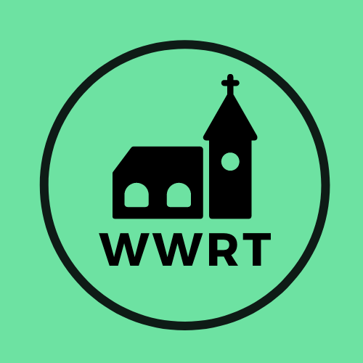
CHURCH SERVICES IN MARTLEY AND WICHENFORD
AUGUST 2026

Sunday 2nd August
Trinity 9
10.30am CW Holy Communion, St Peter, Martley

Sunday 9th August
Trinity 10
10.30am CW Holy Communion, St Laurence, Wichenford

Sunday 16th August
Trinity 11
10.00am Café Church, St Peter, Martley

Sunday 23rd August
Trinity 12
10.30am CW Holy Communion, St Peter, Martley

Sunday 30th August
Trinity 13
10.30am Benefice Family Service, St Leonard, Cotheridge

In August there will be Holy Communion at Heaton House, Martley on the 12th and 26th Wednesday at 10.15am and on the 1st and 3rd Wednesday via our YouTube channel -wwrtlive1.
All services and timings are subject to review and amendment – please check the website for updates: www.achurchnearyou.com

