Into his Courts
with Praise...



A Service of the Word
for
Sunday 28 June 2026
Fourth Sunday after Trinity.

A Service of the Word for Sunday morning

This service is taken from A Service of the Word,
Morning and Evening Prayer, Night Prayer,
which is copyright (c) The Archbishops' Council, 2000,
with permitted variations.

INTRODUCTION

“Whoever welcomes you welcomes me, and whoever welcomes me welcomes the one who sent me.”
Matthew 10:40.
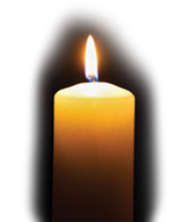

THE CONFESSION
The grace of God has dawned upon the world with healing for all. Though we have grieved him, yet he will heal us if we confess our sins in penitence and faith.

Almighty God,
I confess that I have sinned against you
in thought, word and deed;
I have not loved you with all my heart;
I have not loved my neighbours as myself.
Have mercy upon me,
cleanse me from my sins,
and help me to overcome my faults,
through Jesus Christ our Lord. Amen.

Receive God’s forgiveness
May the Father forgive us
By the death of His Son
And strengthen us
To live in the power of the Spirit
All our days. Amen.

PRAISE
O Lord, open my lips...
and my mouth shall proclaim your praise.
Give me the joy of your saving help...
and sustain me with your life-giving Spirit.

THE COLLECT
Gracious Father, by the obedience of Jesus
you brought salvation to our wayward world:
draw us into harmony with your will, that we may find all things restored in him, our Saviour Jesus Christ.

Amen.

Suggested hymn to sing or read Empty, broken, here I stand.

THE WORD OF GOD.
Jeremiah 28:5-9.

Then the prophet Jeremiah spoke to the prophet Hananiah in the presence of the priests and all the people who were standing in the house of the Lord; and the prophet Jeremiah said, ‘Amen! May the Lord do so; may the Lord fulfil the words that you have prophesied, and bring back to this place from Babylon the vessels of the house of the Lord, and all the exiles. But listen now to this word that I speak in your hearing and in the hearing of all the people. The prophets who preceded you and me from ancient times prophesied war, famine, and pestilence against many countries and great kingdoms. As for the prophet who prophesies peace, when the word of that prophet comes true, then it will be known that the Lord has truly sent the prophet.’

Psalm 89:8-18.

Who is like you, Lord God of hosts? ♦︎
Mighty Lord, your faithfulness is all around you.
You rule the raging of the sea; ♦︎
you still its waves when they arise.
You crushed Rahab with a deadly wound ♦︎
and scattered your enemies with your mighty arm.
Yours are the heavens; the earth also is yours; ♦︎
you established the world and all that fills it.
You created the north and the south; ♦︎
Tabor and Hermon rejoice in your name.
You have a mighty arm; ♦︎
strong is your hand and high is your right hand.
Righteousness and justice are the foundation of your throne; ♦︎
steadfast love and faithfulness go before your face.
Happy are the people who know the shout of triumph: ♦︎
they walk, O Lord, in the light of your countenance.
In your name they rejoice all the day long ♦︎
and are exalted in your righteousness.
For you are the glory of their strength, ♦︎
and in your favour you lift up our heads.
Truly the Lord is our shield; ♦︎
the Holy One of Israel is our king.

Romans 6: 12-end.

Therefore, do not let sin exercise dominion in your mortal bodies, to make you obey their passions. No longer present your members to sin as instruments of wickedness, but present yourselves to God as those who have been brought from death to life, and present your members to God as instruments of righteousness. For sin will have no dominion over you, since you are not under law but under grace.

What then? Should we sin because we are not under law but under grace? By no means! Do you not know that if you present yourselves to anyone as obedient slaves, you are slaves of the one whom you obey, either of sin, which leads to death, or of obedience, which leads to righteousness? But thanks be to God that you, having once been slaves of sin, have become obedient from the heart to the form of teaching to which you were entrusted, and that you, having been set free from sin, have become slaves of righteousness. I am speaking in human terms because of your natural limitations. For just as you once presented your members as slaves to impurity and to greater and greater iniquity, so now present your members as slaves to righteousness for sanctification.

When you were slaves of sin, you were free in regard to righteousness. So what advantage did you then get from the things of which you now are ashamed? The end of those things is death. But now that you have been freed from sin and enslaved to God, the advantage you get is sanctification. The end is eternal life. For the wages of sin is death, but the free gift of God is eternal life in Christ Jesus our Lord.

Suggested hymn to sing or read God has spoken by his prophets.

GOSPEL
Matthew 10:40-end.

‘Whoever welcomes you welcomes me, and whoever welcomes me welcomes the one who sent me. Whoever welcomes a prophet in the name of a prophet will receive a prophet’s reward; and whoever welcomes a righteous person in the name of a righteous person will receive the reward of the righteous; and whoever gives even a cup of cold water to one of these little ones in the name of a disciple—truly I tell you, none of these will lose their reward.’

REFLECTION – The price of grace.

This week we are looking at Paul’s letter to the Romans. This is the longest of the epistles and although perhaps not an easy read, is widely regarded as one of the most important books of the New Testament. Before we look at today’s passage it’s worth looking at the context in which Paul was writing, why it was written and to whom was it addressed.

Fairly obviously Paul’s intended audience was the Christian Church in Rome. Composed of Gentiles as well as Jews, this was a very large Christian group. As to the reason for writing it, Paul was probably seeking to address conflict between Gentile and Jewish Christians. In AD 49 the Emperor Claudius had expelled the Jews from Rome leading to Gentiles taking leading positions in the Church there.

When the Jews were allowed, by Nero, to return to Rome, many Gentiles argued that the Jews were no longer “God’s chosen people”. In writing the letter to the Romans Paul was seeking to bring encouragement and assurance to the Roman Church of the gifts that God has given them.

This is typical of much of Paul’s “problem solving” ministry. He helped the fledgling Church to overcome the arguments and differences which threatened to split it apart before it had a chance to grow to be the wonderful entity it is to this day.

This particular passage is typical of Paul’s “diatribe” style of writing. It was common enough at the time for writing to be set out as a series of arguments. Almost like dealing with an imaginary heckler. There’s always someone who asks a silly question. In Paul’s letter to the Romans it is the imaginary heckler who asks it, twice in Chapter 6. Our passage deals with the second instance;

What then? Should we sin because we are not under law but under grace?

It is worded differently from the question in Romans 6:1 but essentially it is the same question. If we are under God’s grace can we get away with sin? Paul gives the same answer albeit in a slightly different form.

Paul says, “By no means!”

Well, Paul would say that wouldn’t he? What he’s really saying is that through faith in Jesus we have been freed from the dominion, the slavery of sin. Having been granted that freedom we have the choice, to live free from sin in Jesus Christ or to turn back to the authority that sin had over us, to choose to be slaves in effect.

If we are living under grace rather than under law we are not deprived of free will, yes, we can still sin, we can do it but why would we? We have something greater in the Covenant with God, we have life eternal. God is in our life and that surely changes everything.

We now have access to the grace of God, that caring compassionate grace which brings freedom. But with freedom comes responsibility. As Christians we must follow the authority of God and Jesus our saviour.
This is the nature of true grace. The German theologian Dietrich Bonhoeffer wrote about the nature of grace and points out that there is cheap grace and costly grace. He explains cheap grace like this;

Cheap grace is the idea that "grace" did it all for me so I do not need to change my lifestyle. The believer who accepts the idea of "cheap grace" thinks he can continue to live like the rest of the world. Instead of following Christ in a radical way, the Christian lost in cheap grace thinks he can simply enjoy the consolations of his grace.

The alternative to cheap grace is costly grace, to quote Bonhoeffer once again;

Costly grace is the treasure hidden in the field; for the sake of it a man will gladly go and sell all he has. It is the pearl of great price to buy which the merchant will sell all his goods.

This seems to me to be exactly what Paul is saying in Romans 6:22-23;

But now that you have been freed from sin and enslaved to God, the advantage you get is sanctification. The end is eternal life. For the wages of sin is death, but the free gift of God is eternal life in Christ Jesus our Lord.

Bonhoeffer also answers the question posed in Romans 6:15 in a very succinct way;

The only man who has the right to say that he is justified by grace alone is the man who has left all to follow Christ.

So, accepting that sin is a part of life, in our age as it was in Jesus’ time, we can accept the costly grace of God, through the death and resurrection of Jesus Christ, to bring us to eternal life.
Amen.

Reference.
Dietrich Bonhoeffer (2015). “The Cost of Discipleship”, p.4, SCM Press

Brian Pateman.

Suggested hymn to sing or read Take my life and let it be.

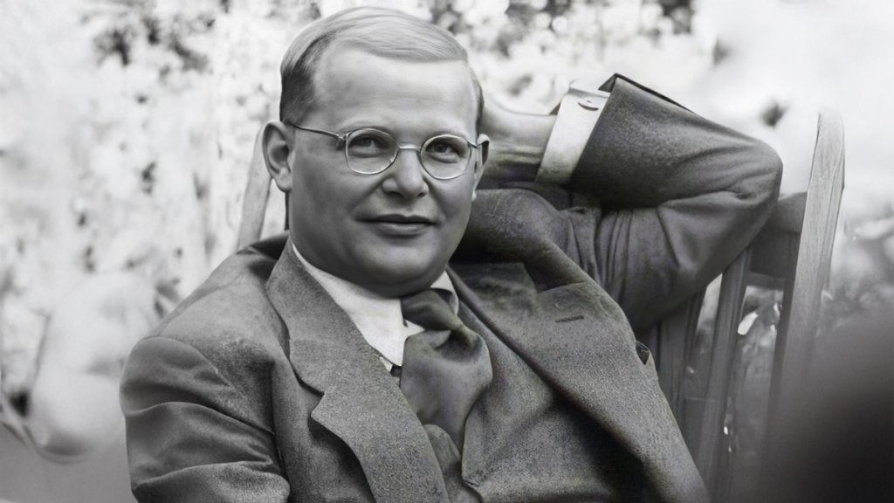

THE CREED

All I believe in God the Father,
whose loving care is the pattern for family life.
I believe in Jesus, the Son of God,
who lives in my heart through faith,
and fills me with his love.
I believe in God the Holy Spirit,
who strengthens me with power from on high.
I believe in one God;
Father, Son and Holy Spirit. Amen.

THE PRAYERS
A time of quiet prayer for
• The universal Church - Bishops, synods and all leaders church
• The leaders of the nations
• The natural world and the resources of the earth

Lord Jesus, you are the Prince of Peace.
Look upon our divided world
to be with those who are victims of violence.
We pray for the people of Ukraine
and all who have been subjected to the cruelty of others.
Help us to know the gift of your peace
in the power of your Spirit and
we ask you to soften the hearts
of those who can stop the fighting.
Creator God, we ask for your aid as your children of light
living in the darkness of our world.
Amen.
Cumbria Ecumenical Spirituality Group.

Finishing with the South Calder Mission Community prayer...
Heavenly Father we thank you for the life of your Church
in this place, and in all the villages of the South Calder Mission Community;
for all who have served and worshipped you in years gone by,
for all who make up your family in our churches today,
for the faith we have in common, and for the people and traditions which make each church unique.
By your Spirit, guide and equip us,
that together we might find new ways
to reach out to our local community,
to show your love to our neighbours,
and to encourage them
to follow the Lord Jesus in their lives.
Father, we offer ourselves to your service,
In the unity of the Holy Spirit,
And in the name of Jesus Christ our Lord. Amen

and the Lord’s prayer...
Our Father, who art in heaven,
hallowed be thy name; thy kingdom come;
thy will be done; on earth as it is in heaven.
Give us this day our daily bread.
And forgive us our trespasses,
as we forgive those who trespass against us.
And lead us not into temptation;
but deliver us from evil.
For thine is the kingdom,
the power and the glory,
for ever and ever. Amen.

THE CONCLUSION

Suggested hymn to sing or read Ye servants of God your master proclaim.

The following prayer is said
Be with me, Lord, as I finish my prayer today.
May my lips always speak the truth;
may my eyes which have read your word
see only what is good;
and may my life as well as my worship
be always pleasing in your sight,
for the glory of your name. Amen.

And now may the Lord who brought us to birth by his Spirit,
strengthen us for the Christian life.
May the Lord who provides for all our needs
sustain us day by day.
May the Lord whose steadfast love is constant as a mother's care,
send us out to live and work for others.
And the blessing of God Almighty.
the Father, the Son, and the Holy Spirit,
be with us and remain with us always.
Amen.

So now may I go in peace to love and serve the Lord.
In the name of Christ. Amen.

Links for the hymns

Empty, broken, here I stand.

https://youtu.be/pdl3F5N_Wdc

God has spoken by his prophets.

https://youtu.be/-rbR63VCTg4

Take my life and let it be.

https://youtu.be/Of4l5bTdZ8M

Ye servants of God your master proclaim.

https://youtu.be/ptLLr_WjCz8

