CHURCH SERVICES IN CLIFTON, THE SHELSLEYS AND LOWER SAPEY (HARPLEY)
July 2026
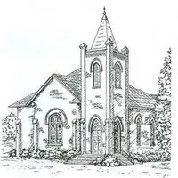

Sunday 5th July
10.30am: Holy Communion, St Kenelm’s, Clifton
3.00pm: NHS Celebration, St Bartholomew, Harpley
3.00pm: Deanery Outdoor Service, Ombersley

Sunday 12th July
10.30am: Holy Communion, All Saints, Shelsley Beauchamp
2.30pm: Rochford Fete

Wednesday 15th July
10.30am: Holy Communion, St Andrews, Shelsley Walsh

Sunday 19th July
10.00am: Praise 4 All, St Kenelm’s Clifton
2.00pm: Walking Church

Saturday 25th July
4.00pm: Welly Church, St Kenelm’s Clifton

Sunday 26th July
10.30am: Circle Service with Communion,
St Bartholomew, Harpley
3.00pm: Celebration of Popular Praise, St Kenelm’s Clifton
6.30pm: Patronal Evensong, St Kenelm’s, Clifton

