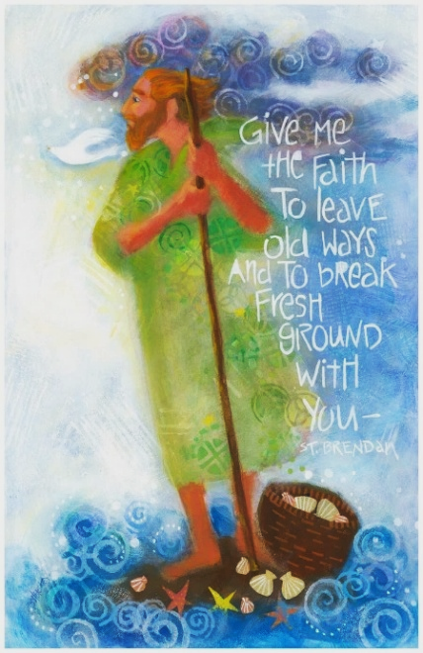  Further reading  You may enjoy the following books for further reading. All of these authors have written several others which would be good to explore.  St Brendan  David Adam  A desert in the ocean - God’s call to adventurous living  Fire of the North - The Life of St Cuthbert  The Path of Light - Meditations on prayers from the Celtic tradition.  David Cole  Celtic Lent - 40 days of devotions to Easter,  Celtic Saints - 40 days of devotional Readings (an introduction to 40 different Celtic Saints)  Celtic Advent - 40 days of devotions to Christmas  Michael Mitton  Restoring the woven cord-Strands of Celtic Christianity for the church today  Simon Reed  Followers of the Way-ancient discipleship for modern Christians includes practising a Way of Life.  Ray Simpson  New Celtic Monasticism for Everyday People  Prayer Rhythms for busy people  Celtic Rhythms of Life - Daily Prayer from the Community of Aidan and Hilda  Margaret Silf  Sacred Spaces: Stations of a Celtic Way  Wayfaring  Landmarks  At Sea with God |  | 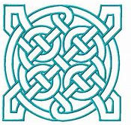  Celtic Christianity  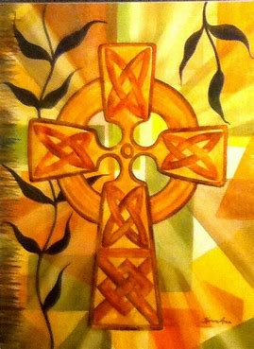  is an expression of Christianity from the 5th and 6th Century which has much wisdom and inspiration for us today. You may have heard of St Columba, St Patrick, St Brigid and St Aidan who were missionaries of the Celtic Church. Five characteristics of Celtic Christianity include: hospitality, a deep love and respect for the earth, honouring of women’s ministry, community and creativity. The spirituality of everyday life is important to Celtic Christianity and the sacredness of the ordinary, as is a recognition of the need for times of silence and meditation and pilgrimage.  We hold Celtic Encounters (Reflections) monthly and both in the Olive Garden at St Mary’s, Brighstone and at Porchfield Village Hall. We meet for these short times of worship and prayer for about 30 minutes. Themes are often seasonal, on creation or reflect special times in the church calendar such as Lent, Easter and Christmas. We enjoy refreshments afterwards and all are welcome.  Details of upcoming Celtic Encounters are available in Village Newsletters, Noticeboards and church bulletins.
Celtic Communities  There are three ecumenical communities inspired by Celtic Christianity based in the UK. They are mainly dispersed communities, offering printed and on-line resources, daily prayers and retreats. All communities encourage believers to follow a ‘Way or Rule of life’, following Christ’s example to lead an authentic Christian life.  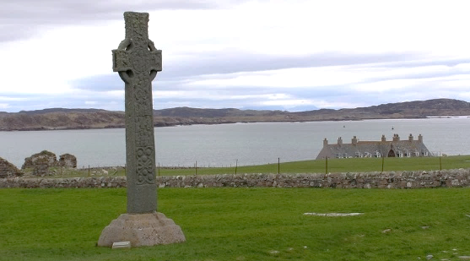  The Iona Community was founded in 1938 by Rev George Macleod who restored Iona Abbey. It is described as an “international, ecumenical Christian movement working for justice and peace, the rebuilding of community and the renewal of worship.” There is a residential community and a retreat centre on Iona for guests to explore Columba’s life and legacy, spirituality, worship and the arts. There is also on-line daily worship from the Abbey. See https://iona.org.uk/  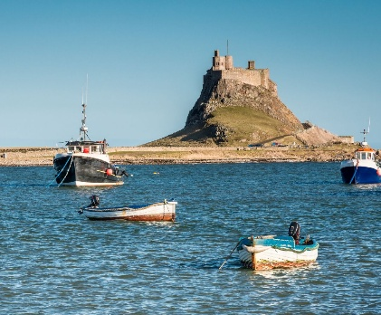  Northumbria Community was established 1992, centred in Northumbria where St Aidan built an Abbey on the island of Lindisfarne. There is a retreat centre and the  Community  embraces to living openly in a way that the life of God can be seen by others. There is a  regular cycle of daily prayers, ‘the daily office’ morning, midday, evening prayer and compline which constitutes the essential rhythm of prayer of life that all of the communities encourage. See https://www.northumbriacommunity.org/.  In the benefice, there is Northumbria  morning prayer in the Olive Garden,  St Mary’s Brighstone at 8 am every Thursday and at 8.30 on line every  Tuesday. Contact Paula:  bbmcsparishes@gmail.com for link. |  | 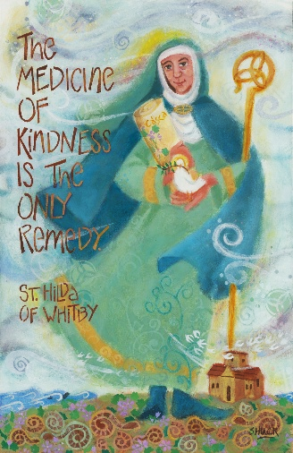  Community of Aidan and Hilda was founded in 1994 and seeks particular inspiration from St Aidan and St Hilda. It seeks to develop holistic Christian spirituality for today, to raise up renewed people who journey with God and heal broken people and fragmented communities. Daily Celtic Light prayer is available on line. See https://www.aidanandhilda.org.uk. The Community Aidan and Hilda have a regional group which meets for fellowship and prayer in Romsey, just north of the New Forest so is accessible for a day trip. There are also on-line meetings. For further information on meetings ask Gill or Alison.  Daily Prayer and Bible Reading Resources  It maybe that you would like to explore something new or to refresh your prayer and Bible reading habits. There are more traditional daily Bible reading notes that you may be familiar with and several resources mentioned in this leaflet. You may like to explore the following daily prayer apps (free to download) and the Northumbria website:  Northumbria Daily Celtic Prayer: https://www.northumbriacommunity.org/ The daily offices can be found by selecting ‘Who are we’ and ‘Daily Celtic Prayer’. See opposite for description.  Lectio 365 app - helps you meditate on God’s word praying three times a day following the ancient rhythm of Jesus and his followers. It is developed by the 24-7 international prayer movement.  Pray as you Go app - is based on the spirituality of St Ignatius of Loyola and is written and produced by the Jesuits. It often encourages you to enter into a Bible passage using your imagination as if you were there.

