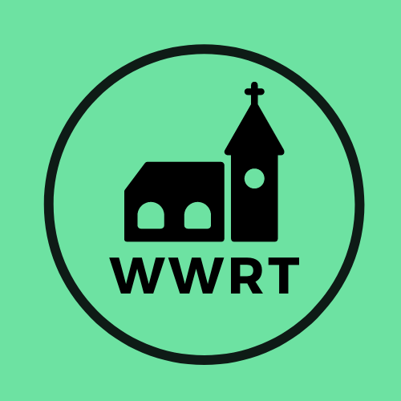
CHURCH SERVICES IN MARTLEY AND WICHENFORD
JULY 2026

Sunday 5th July
Trinity 5
10.30am All Age, St Mary Magdalene, Broadwas
10.30am CW Holy Communion, St Peter, Martley

Saturday 11th July
3.30pm Café Church BBQ, St Peter, Martley

Sunday 12th July
Trinity 6
10.30am CW Holy Communion, St Laurence, Wichenford

Sunday 26th July
Trinity 8
10.30am CW Holy Communion, St Peter, Martley

In July there will be Holy Communion at Heaton House, Martley on the 2nd and 4th Wednesday at 10.15am and on the 1st and 3rd Wednesday via our YouTube channel -wwrtlive1.
All services and timings are subject to review and amendment – please check the website for updates: www.achurchnearyou.com

