St. Mary’s, Great Parndon.
JUNE 2026 News.

Priest in charge – Revd Richard Attew –Tel 01279 315044.

Services - Sunday – 11:00am Holy Communion/ morning worship.
Wednesday – 9:30am Morning Prayer.
Thursday – 9:30am Morning Prayer.

Monthly Coffee Morning -Thursday 4th June. Come and join us for tea, coffee, and a chat.10:30am to 12noon at St Mary’s church.
All are welcome. For further details contact Alison on 01279 418699.

Christian Aid Week. May 10 – 16.
So far, we have raised £75 from the Christian Aid envelopes. Many thanks to those who donated by this method and to those who donated directly

New Safeguarding campaign from the Church of England, 1st to 14th June.
“It’s not just policy, it’s personal” is a Church of England campaign to raise awareness of how to recognise and report safeguarding concerns. Resources have been produced to build confidence in responding and taking appropriate action. The resources are designed to be flexible and can be used in any way that suits your setting, whether digitally, in print or as a part of local conversations. Further details are available on the Church of England website, under safeguarding or please speak to Janet.

Paul’s Licensing Service – Thursday 25th June, 7:30 pm at St Mary’s church.
The Reverend Paul Bartlett is to be licensed as Self-Supporting Minister, Associate Priest – to be known as Priest Missioner – in the Parishes of St. Mary's, Great Parndon, All Saints' with St. Giles', Nazeing, and St. Peter's, Roydon. Please come and support Paul at this important service for him. We will be serving refreshments after the service.

PCC Meeting.
Our next PCC Meeting will take place on Monday 6th July, 7:30pm at St Mary’s church.
Please give thanks and pray for Yemi who has kindly agreed to take the minutes of our PCC meetings.

Leading your church into growth (LYCiG) conference – 17th and 18th October in Chelmsford.
The LYCiG team has a track record in encouraging and equipping local church communities in mission from across the different traditions within the Church of England. It’s for up to 8 people per parish and the aim is to get a group working together to explore the principles and practicalities of church growth. Although there is a small cost involved, the PCC will subsidise this for anyone interested. Please see Ray if you would like to take part as we need to give numbers by the end of this month.

Eco tip.
Blister packs can now be recycled at Boots in Harlow Town Centre. You can gain extra Boots Advantage
points by scanning the relevant link on the Boots website, which entails photographing the blister packs on
your smartphone and downloading them on the app. Otherwise just place in the box provided.

Foodbank. Peter Button is happy to take donated items from St Mary’s to the Foodbank each week. Please leave items in the usual place next to the font. Note that the Foodbank is dealing with rising demand and is now short of many items, such as tinned meat, tinned fish (tuna), sponge pudding, tinned vegetables, tinned fruit, long life fruit juices and small jars of coffee.
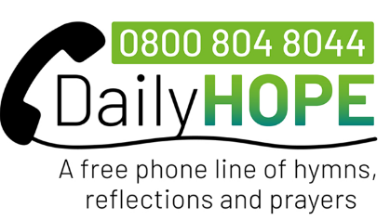
For help: The Church of England has a free 24-hour phone line,
Daily Hope, offering hymns, prayers & reflections (0800 804 8044).
Email; https://www.churchofengland.org/resources/coronavirus-covid-19-guidance/sleep-well-dailyhope

