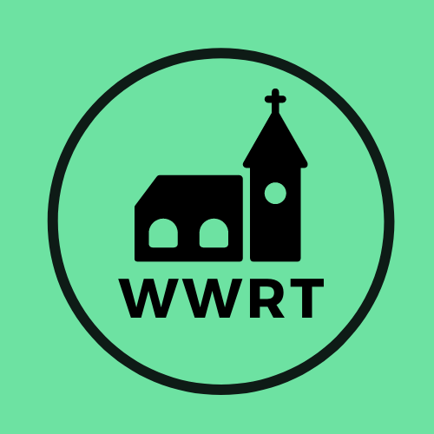

CHURCH SERVICES IN THE LOWER TEME VALLEY JULY 2026

Sunday 5th July
Trinity 5
9.00 am BCP Holy Communion, St Leonard, Cotheridge
10.30am All Age, St Mary Magdalene, Broadwas

Sunday 12th July
Trinity 6
3.00pm Evening Worship, Knightwick Chapel

Sunday 19th July
Trinity 7
10.30am CW Holy Communion, St Mary Magdalene, Broadwas

Sunday 26th July
Trinity 8
10.30am Morning Worship, St Mary Magdalene, Broadwas

In July there will be Holy Communion at Heaton House, Martley on 2nd and 4th Wednesday at 10.15am and on the 1st and 3rd Wednesday via our YouTube channel -wwrtlive1.
All services and timings are subject to review and amendment – please check the website for updates: www.achurchnearyou.com

All services and timings are subject to review and amendment in accordance with Covid lockdown easing – please contact the Rectory or check the website for updates.
01886 888664
www.achurchnearyou.com

