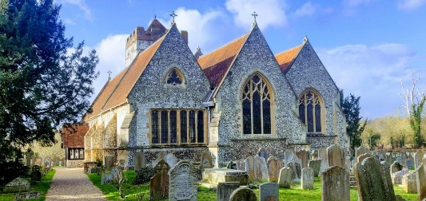
BISHAM TOGETHER
The Monthly Newsletter
from All Saints Bisham
June 2026

June is one of those months when everything seems to be growing at once — the grass, the flowers, the weeds, and possibly the list of things we meant to do before the summer holidays arrive! It is a month of longer days, lighter evenings, and hopefully a few more chances to pause, chat, and enjoy being part of this lovely community.
At All Saints, we are always reminded that church life is not just about Sundays, but about the many ways we share life together — through friendship, worship, coffee, conversation, service, and care for one another. This month’s newsletter gives a glimpse of some of those things: what has been happening, what is coming up, and how we can continue to grow together as a community.
So, whether you are reading this with a cup of tea in the garden, in between jobs, or while wondering where May disappeared to, we hope you enjoy this month’s Bisham Together.
Carol
Team Vicar

🕍 Church Life
Worship & Events:
• Every Sunday: 9.30am Holy Communion at All Saints Bisham
• First Sunday of every month: 8am Book of Common Prayer Service
- Next BCP service: 7th June

29th June – Supporters’ Evening: 6-9pm at All Saints Bisham
- Come and find out how you can partner with us and be a part of our future!
Sundays at All Saints…
This month we are continuing our sermon series exploring the story of Joseph. For many of us, Joseph may bring to mind Andrew Lloyd Webber, a Technicolor Dreamcoat, and perhaps a few songs that are almost impossible not to hum once mentioned! But behind the colour and music is one of the most powerful and very human stories in the Old Testament.
Joseph’s story has it all: family tension, favouritism, jealousy, betrayal, false accusation, dreams, disappointment, forgiveness, and reconciliation. It is a story about what happens when life takes unexpected turns, when relationships become strained, and when the future looks very different from anything we had imagined.
And yet, running through all the twists and turns is the steady faithfulness of God. Joseph’s story reminds us that God is at work not only in the joyful and obvious moments, but also in the confusing, painful, and complicated parts of life. Even when Joseph cannot see the bigger picture, God is quietly weaving hope and restoration through it all.
We would love you to join us as we journey through this remarkable story together and discover what Joseph’s life might have to say to our own lives, our families, our community, and our faith today.

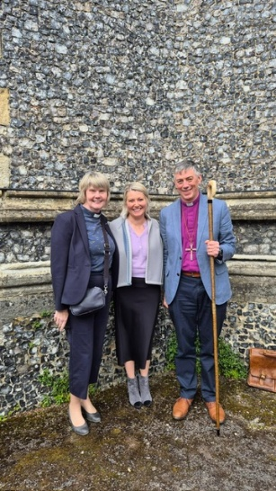
…And in other news this month:

✨ Confirmed in Faith
It was lovely to be at St Paul’s, Wooburn Green, as Rebecca Seaton was confirmed alongside 15 other candidates from across the Deanery. Bishop Dave Bull led the service, and the church was packed for a joyful and uplifting celebration. There was lively worship from a band — even including a harpist! — and a real sense of encouragement as people of all ages took this important step in faith.
Afterwards, everyone had the chance to catch up over cakes and refreshments, which was a very fitting way to continue the celebration.

📝 Looking Back, Looking Ahead
Our recent ACCM, held at All Saints Bisham on 10th May, gave us a good opportunity to look back over the past year and reflect on all that has happened in the life of the church. There was much to celebrate, including a more secure financial position, strong support from Bisham Church Friends, growing links with Bisham CofE Academy, well-supported community events, and the appointment of Carol as permanent Team Vicar for Bisham.
We were delighted that Mark Garrad was affirmed as Churchwarden for another year, as were members of the BCC, and we are very grateful to all of them for the hard work and dedication they show in looking after our church.
We also recognised some of the challenges ahead, including ongoing care of the church building, the churchyard, and future planning for our worship, mission and community life.
The APCM then brought together the wider picture from across the Benefice, with reports from each church. There is still plenty to do, but we all have much to be thankful for, and we look ahead with hope as we continue to seek God’s guidance for the future of the Parish and wider team.

⛵ A New Jetty at All Saints Bisham
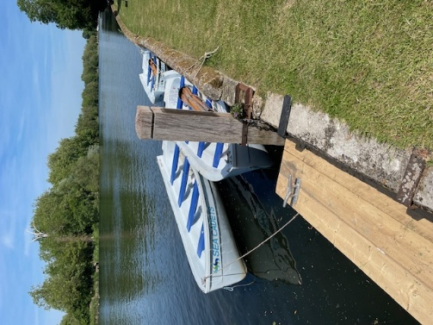
One of the very special features of All Saints Bisham is our beautiful position beside the river, and we know that many people love to sit in the churchyard and enjoy the peace and view by the water.
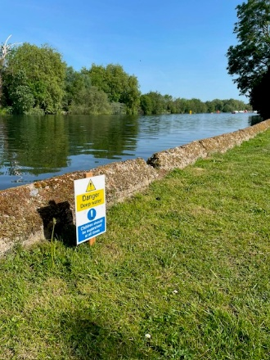
We are also fortunate enough to have a jetty, which some of our wedding couples have used in the past to leave the church by boat. We are delighted to say that a new jetty has now been installed at the bottom of the churchyard, helping to make access to the river safer for those who use it, and we are very grateful to Tim Folley for all his work in arranging this. It also enables the Sea Cadets to continue using the jetty for their training.
Being so close to the river does mean that we all need to take care, especially around the water’s edge, and new riverside safety signs have now been put up as a reminder to everyone to be cautious and sensible near the river. Our thanks also go to Hamish Hunter for kindly installing them for us.

🗑️ Helping to Keep the Churchyard Tidy

We are very grateful to everyone who helps to keep our churchyard looking cared for and welcoming. Recently, however, we have had a few occasions where the wrong rubbish has been placed in the wrong bin, which means the bin collectors are unable to empty them — and the contents then have to be sorted by hand.
To help us avoid this, please could everyone take a moment to use the correct bin. The blue bin is for recycling, the black bin is for general waste, and we have now ordered a green bin for green waste. We also have a compost heap, but this is only for natural compostable material. Any plastic, wire, ribbon, oasis, or other artificial pieces from wreaths or flower arrangements must go in the black general waste bin, not on the compost heap, or in either of the other bins.
Thank you for helping us to look after the churchyard and keep it tidy, safe and pleasant for everyone who visits.

☕ Coffee, Cake and the 21st Century
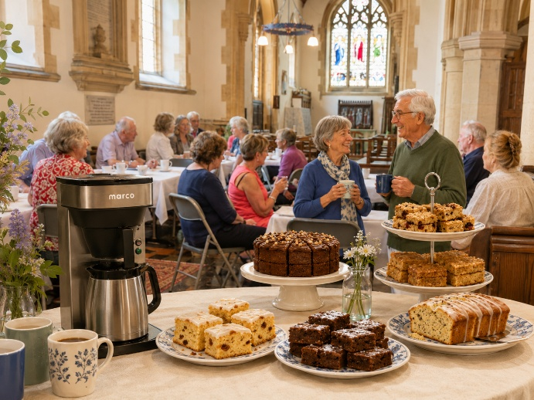
We are delighted to report that All Saints has taken a bold step into the 21st century with the arrival of a new coffee machine! While we cannot promise artisan latte art or complicated ordering systems, we can promise a very welcome cup of coffee at church events and gatherings.
Of course, good coffee is only half the story. We remain enormously grateful to the wonderful cake makers from our church community and Bisham Church Friends, whose baking continues to be such an important part of our hospitality.
Whether it is a coffee morning, a special event, or refreshments after a service, the combination of coffee, cake and conversation is one of the ways we welcome people and enjoy being together.
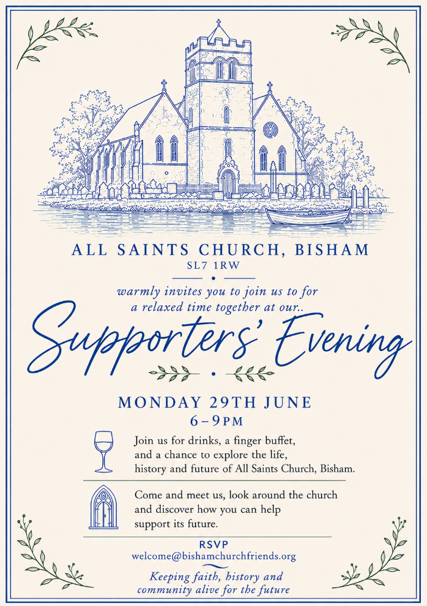
💙🌿 Supporters' Evening at All Saints Bisham
For centuries, All Saints has been a place of prayer, celebration, comfort and community at the heart of Bisham. On Monday 29th June, we are inviting friends, neighbours and supporters to join us for a special evening as we celebrate the story of our church, explore its life and ministry today, and look ahead to its future.
The evening will be an opportunity to enjoy refreshments, look around our beautiful church, hear something of its rich history, and discover more about what happens here week by week.
Most importantly, we will be sharing our hopes for the future of All Saints and inviting people to consider how they might partner with us in sustaining this special place for generations to come — whether through practical support, financial giving and worship.

Many people feel a connection with All Saints, even if they are not with us every Sunday. If that sounds like you, we would love to welcome you for what promises to be a relaxed, friendly and inspiring evening.

🫶 Bisham Church Friends
☕ Community Connections at All Saints Bisham
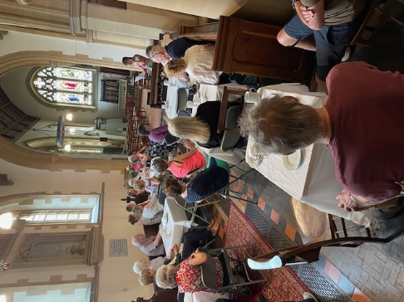
We have enjoyed two wonderful community events recently, both of which brought people together over coffee, cake and conversation.
Our monthly History Coffee Morning continues to be very well supported, with 38 visitors joining us this time to hear Sheila’s fascinating talk, and nearly £100 raised in donations.
We were also delighted to welcome the Marlow Riders back to All Saints on one of their regular visits, which raised an amazing £600 for the church.
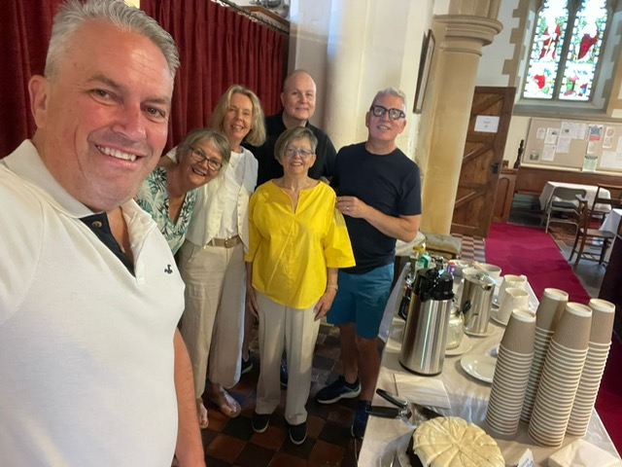
We are hugely grateful to everyone who helped serve coffee — with the new machine being put through its paces! — as well as all those who baked and provided cakes for both events.
Particular thanks go to the Marlow Riders for their generosity. These occasions are not only enjoyable in themselves but also make a real difference in supporting the life and work of the church, and remind us how much we value the friendships and connections we share across the wider community.

🏫 Bisham CofE Academy
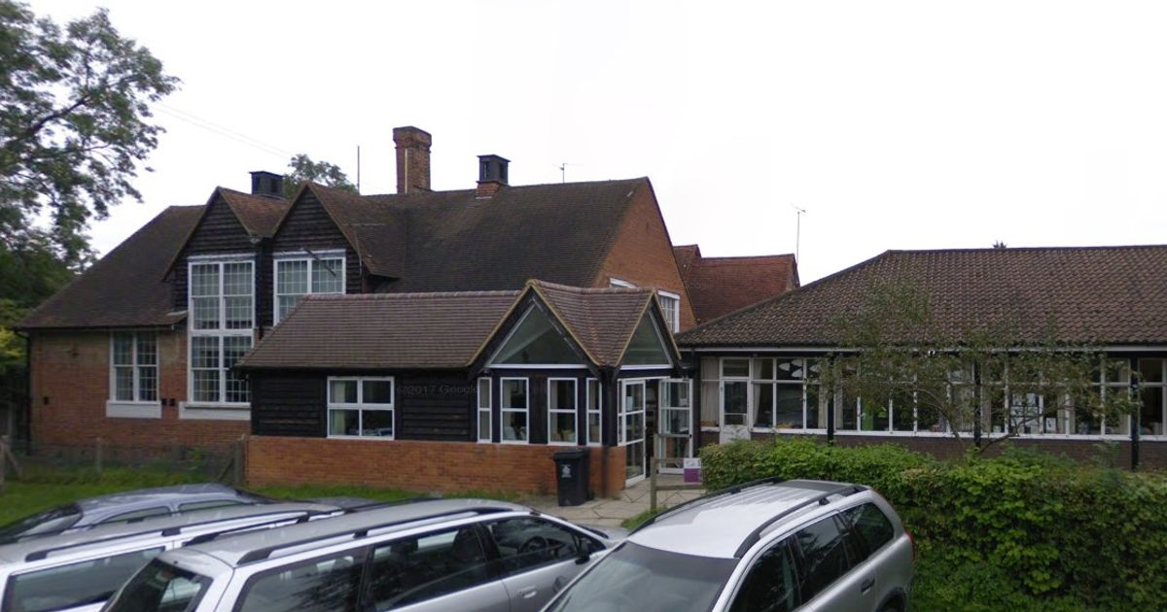
💛Bisham Academy: Back Together Again

Many of you will know that Bisham Academy recently experienced a serious flood and a small fire, which meant the school had to close temporarily due to the loss of water and electricity.
Parents have been kept fully informed by the school, and we are very grateful for the calm and determined way Emma Brookman and the whole staff team have responded.
A great deal of work has taken place behind the scenes to make the building safe and ready for pupils to return, including some re-jigging of classrooms so that everyone can be welcomed back as soon as possible.
The school was able to reopen only a few days after half term, which is a real testament to the hard work and commitment of Emma and her team. The church is helping where we can, and if the wider community would like to add their support, a simple but much-appreciated gesture would be to drop off some treats for the staffroom, as the staff continue to manage the practical challenges of the coming weeks.

Community Notices
Upcoming Dates:
- 25th June History Coffee Morning 10am-12noon
- 27th June Open Church Tour
      - please visit website for booking details.
https://www.bishamchurchfriends.org/
- 29th June Supporters Evening 6pm-9pm

Contact us:

Parish Office (Marlow) | 01628 481806 | parish.office@4u-team.org
Rev Carol Cooper | 07774 061944 | carol.cooper@4u-team.org
Mark Garrad (Churchwarden) | 07738 029086 | garrad.mark@gmail.com
Daphne Dru (Safeguarding) | 07717 441437 | Daphne.dru@4u-team.org

📸 Community Gallery
A few moments from the life of our church and community this month…..
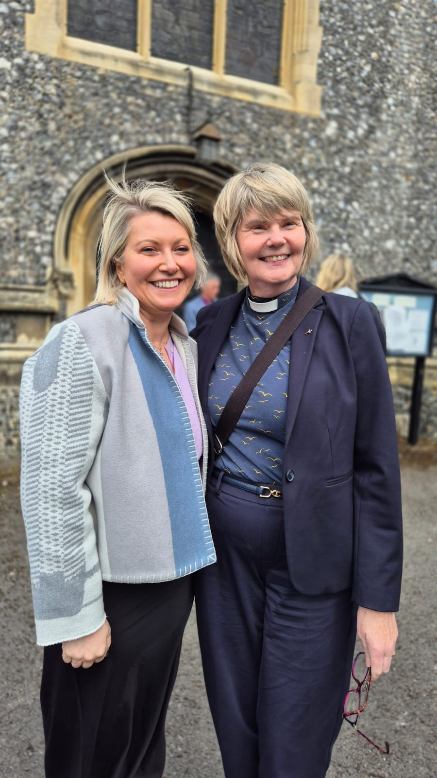
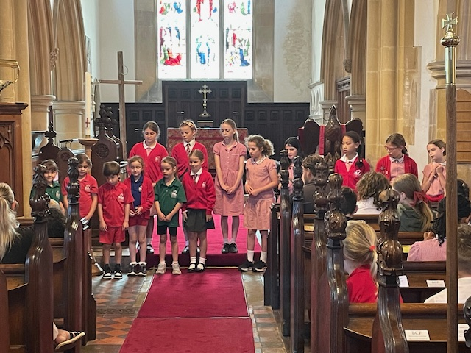

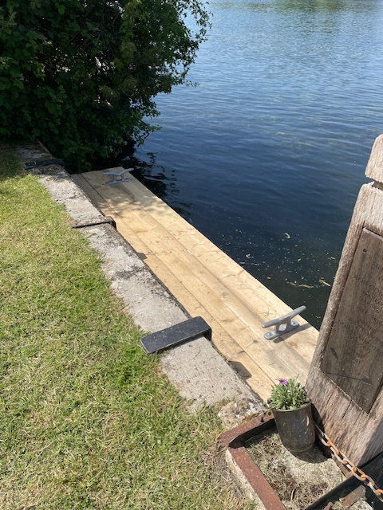
The school did their assembly on Mental Health
and Wellbeing at the Church on 22nd May.
Rebecca and Carol

The new jetty!

