Into his Courts
with Praise...



A Service of the Word
for
Sunday14 June 2026
Second Sunday after Trinity.

A Service of the Word for Sunday morning

This service is taken from A Service of the Word,
Morning and Evening Prayer, Night Prayer,
which is copyright (c) The Archbishops' Council, 2000,
with permitted variations.

INTRODUCTION

“As you go, proclaim the good news, The kingdom of heaven has come near.”
Matthew 10:7.


THE CONFESSION
The grace of God has dawned upon the world with healing for all. Though we have grieved him, yet he will heal us if we confess our sins in penitence and faith.

Almighty God,
I confess that I have sinned against you
in thought, word and deed;
I have not loved you with all my heart;
I have not loved my neighbours as myself.
Have mercy upon me,
cleanse me from my sins,
and help me to overcome my faults,
through Jesus Christ our Lord. Amen.

Receive God’s forgiveness
May the Father forgive us
By the death of His Son
And strengthen us
To live in the power of the Spirit
All our days. Amen.

PRAISE
O Lord, open my lips...
and my mouth shall proclaim your praise.
Give me the joy of your saving help...
and sustain me with your life-giving Spirit.

THE COLLECT
For the Second Sunday after Trinity.
Faithful Creator, whose mercy never fails:
deepen our faithfulness to you and to your living Word,
Jesus Christ our Lord.

Amen.

Suggested hymn to sing or read God of grace and God of glory.

THE WORD OF GOD.
Exodus 19:2-8a.

They had journeyed from Rephidim, entered the wilderness of Sinai, and camped in the wilderness; Israel camped there in front of the mountain. Then Moses went up to God; the Lord called to him from the mountain, saying, ‘Thus you shall say to the house of Jacob, and tell the Israelites: You have seen what I did to the Egyptians, and how I bore you on eagles’ wings and brought you to myself. Now therefore, if you obey my voice and keep my covenant, you shall be my treasured possession out of all the peoples. Indeed, the whole earth is mine, but you shall be for me a priestly kingdom and a holy nation. These are the words that you shall speak to the Israelites.’

So Moses came, summoned the elders of the people, and set before them all these words that the Lord had commanded him. The people all answered as one: ‘Everything that the Lord has spoken we will do.’ Moses reported the words of the people to the Lord.

Psalm 100.

Make a joyful noise to the Lord, all the earth.
Worship the Lord with gladness;
come into his presence with singing.

Know that the Lord is God.
It is he that made us, and we are his;
we are his people, and the sheep of his pasture.

Enter his gates with thanksgiving,
and his courts with praise.
Give thanks to him, bless his name.

For the Lord is good;
his steadfast love endures for ever,
and his faithfulness to all generations.

Romans 5:1-8.

Since we are justified by faith, we have peace with God through our Lord Jesus Christ, through whom we have obtained access to this grace in which we stand; and we boast in our hope of sharing the glory of God. And not only that, but we also boast in our sufferings, knowing that suffering produces endurance, and endurance produces character, and character produces hope, and hope does not disappoint us, because God’s love has been poured into our hearts through the Holy Spirit that has been given to us.

For while we were still weak, at the right time Christ died for the ungodly. Indeed, rarely will anyone die for a righteous person—though perhaps for a good person someone might actually dare to die. But God proves his love for us in that while we still were sinners Christ died for us.

Suggested hymn to sing or read There’s a spirit in the air.

GOSPEL
Matthew 9:35-10:8.

Jesus went about all the cities and villages, teaching in their synagogues, and proclaiming the good news of the kingdom, and curing every disease and every sickness. When he saw the crowds, he had compassion for them, because they were harassed and helpless, like sheep without a shepherd. Then he said to his disciples, ‘The harvest is plentiful, but the labourers are few; therefore ask the Lord of the harvest to send out labourers into his harvest.’

Then Jesus summoned his twelve disciples and gave them authority over unclean spirits, to cast them out, and to cure every disease and every sickness. These are the names of the twelve apostles: first, Simon, also known as Peter, and his brother Andrew; James son of Zebedee, and his brother John; Philip and Bartholomew; Thomas and Matthew the tax-collector; James son of Alphaeus, and Thaddaeus; Simon the Cananaean, and Judas Iscariot, the one who betrayed him.

These twelve Jesus sent out with the following instructions: ‘Go nowhere among the Gentiles, and enter no town of the Samaritans, but go rather to the lost sheep of the house of Israel. As you go, proclaim the good news, “The kingdom of heaven has come near.” Cure the sick, raise the dead, cleanse the lepers, cast out demons. You received without payment; give without payment.

REFLECTION – Strange way to start a revolution.

Is Jesus feeling out of his comfort zone? As we read the beginning of today’s Gospel passage, it might seem so. Here he is;

Proclaiming the good news of the kingdom, and curing every disease and every sickness.

But he sees the crowds, “harassed and helpless like sheep without a shepherd.”

I’m sure we all feel like that at times, I know that I do. That feeling that it’s all getting too much, that you need a helping hand to see what to do next.

Jesus is the one that everybody looked to for direction, for that sign to the correct path, avoiding the snares and pitfalls which lie in wait for the unwary. Certainly that was one of the many things expected of him.

There were also those who, hearing the words;

“The kingdom of heaven has come near.”

might have expected something else. After all didn’t this mean that this Jesus, this Messiah, was going to lead an uprising and drive the Romans out of Palestine, bringing freedom for all? They had spent generations living under the control of occupying forces, first the Greeks and now the Romans. After all the scriptures hailed this Messiah as the descendant of King David. He must be the one who would bring an uprising, a revolution, even if that meant bloodshed.

That’s what many were hoping for, some of the disciples too, Simon of Cyrene also known as Simon the Zealot for example. But it was what the authorities were afraid of. They saw Jesus as a dangerous revolutionary, if the people listened to him there would be fighting in the streets. They had a problem, how could they silence him? If they arrested him it might make the situation worse. It might bring about the end of their empire.

The religious authorities were also concerned. Wouldn’t he bring an end to their positions of power and privilege?

But what was this feared revolutionary doing?

Well he was talking a lot, about the Kingdom to come, but what was he actually doing?

He was “curing every disease and every sickness” and he had compassion for the people, “like sheep without a shepherd”.

A strange way to start a revolution!

Well that’s what he was doing, starting a revolution in the strangest way possible. A revolution where the participants were encouraged to love their enemies, to care for and heal people.

What happens next in this story is that Jesus recognises the size of the task and the sense of urgency that now is the time to begin the mission in earnest.

The harvest is plentiful, but the labourers are few; therefore ask the Lord of the harvest to send out labourers into his harvest.

Jesus commissions the twelve Apostles, named here for the first time in Matthew’s Gospel - indeed the only time he uses the word - and gives them the power to do his work.

Let’s look at them in a little more detail, these men who were commissioned to do the work of the Lord.

The first of them, Simon known as Peter, impetuous and hot headed, also in need of guidance. He would deny Jesus three times when the going got tough. And the last named, Judas who would lead the authorities to come and arrest him. Betraying him to his brutal death. Then in between, Matthew, a tax collector who worked for the establishment and the other Simon, the zealot who was almost certainly working against the occupiers.

This group of disparate individuals were empowered to do the work of the Kingdom. To spread the news and do works of healing. They are to fulfil their tasks in the same way that Jesus does. The Apostles are the interface between the “Kingdom” and the “World” there to bring the two together. And it was never going to be, nor intended to be, an easy task.

They are not on their own, however. Jesus gives them the words along with the commission and he empowers them. He is with them and they work through his power. Later on in Matthew’s Gospel Jesus tell them;

“I am with you always, even to the end of the age” (Matthew 28:20).

That’s why this revolution of the Messiah is a strange one. It is a revolution based on love and care, healing and forgiveness. Perhaps the only successful revolution ever to take place. After all it is still going on and we, like the Apostles, are part of it.

In our present turbulent world, we see “Christianity” used as an excuse for excluding people who are not approved by the regime, depriving the poor of the means for a dignified life, making profit from people who are in need of care and healing. I would suggest that we, as followers of our healing, compassionate revolutionary should take a stand against the abuse of Christianity by reminding those who wish to use it for their own ends just who Jesus the Prince of Peace is and what he stands for.
Brian Pateman.

Suggested hymn to sing or read Jesus, the name high over all.

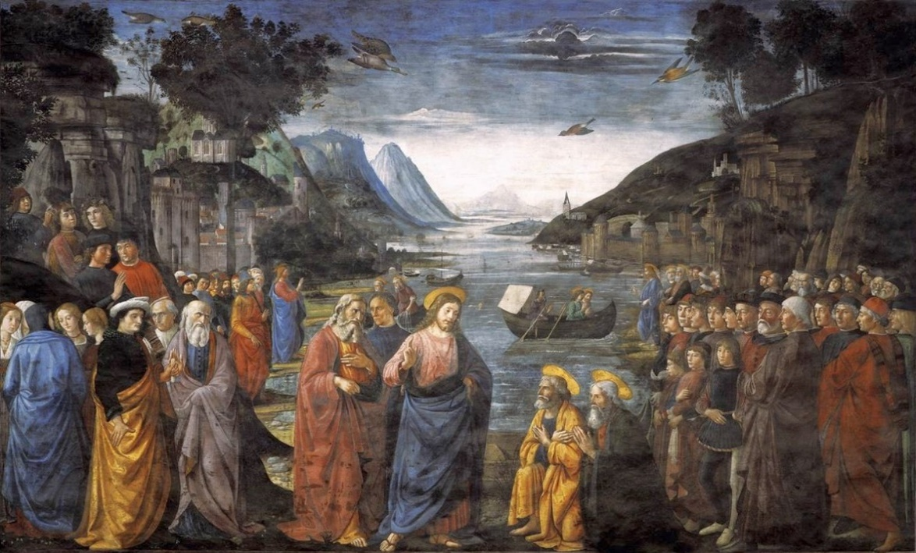

Vocation of the Apostles, Domenico Ghirlandaio 1481-82

THE CREED

All I believe in God the Father,
whose loving care is the pattern for family life.
I believe in Jesus, the Son of God,
who lives in my heart through faith,
and fills me with his love.
I believe in God the Holy Spirit,
who strengthens me with power from on high.
I believe in one God;
Father, Son and Holy Spirit. Amen.

THE PRAYERS
A time of quiet prayer for
• The universal Church - Bishops, synods and all leaders church
• The leaders of the nations
• The natural world and the resources of the earth
Lord Jesus, you are the Prince of Peace.
Look upon our divided world
to be with those who are victims of violence.
We pray for all people who are subject to the cruelty of others.
We bring to you all who are deprived and disadvantaged.
Help us to know the gift of your peace
in the power of your Spirit and
we ask you to soften the hearts
of those who use religion falsely and selfishly.
Creator God, we ask for your aid as your children of light
living in the darkness of our world.
Amen.

Finishing with the South Calder Mission Community prayer...
Heavenly Father we thank you for the life of your Church
in this place, and in all the villages of the South Calder Mission Community;
for all who have served and worshipped you in years gone by,
for all who make up your family in our churches today,
for the faith we have in common, and for the people and traditions which make each church unique.
By your Spirit, guide and equip us,
that together we might find new ways
to reach out to our local community,
to show your love to our neighbours,
and to encourage them
to follow the Lord Jesus in their lives.
Father, we offer ourselves to your service,
In the unity of the Holy Spirit,
And in the name of Jesus Christ our Lord. Amen

and the Lord’s prayer...
Our Father, who art in heaven,
hallowed be thy name; thy kingdom come;
thy will be done; on earth as it is in heaven.
Give us this day our daily bread.
And forgive us our trespasses,
as we forgive those who trespass against us.
And lead us not into temptation;
but deliver us from evil.
For thine is the kingdom,
the power and the glory,
for ever and ever. Amen.

THE CONCLUSION

Suggested hymn to sing or read Hear the call of the Kingdom.

The following prayer is said
Be with me, Lord, as I finish my prayer today.
May my lips always speak the truth;
may my eyes which have read your word
see only what is good;
and may my life as well as my worship
be always pleasing in your sight,
for the glory of your name. Amen.

And now may the Lord who brought us to birth by his Spirit,
strengthen us for the Christian life.
May the Lord who provides for all our needs
sustain us day by day.
May the Lord whose steadfast love is constant as a mother's care,
send us out to live and work for others.
And the blessing of God Almighty.
the Father, the Son, and the Holy Spirit,
be with us and remain with us always.
Amen.

So now may I go in peace to love and serve the Lord.
In the name of Christ. Amen.

Links for the hymns

God of grace and God of glory.

https://youtu.be/6Y9rBrtuZg0

There’s a spirit in the air.

https://youtu.be/YsvUXGnPck4

Jesus, the name high over all.

https://youtu.be/y3Jpx0Rnmmo

Hear the call of the Kingdom.

https://youtu.be/rlPxUNOrTYU

