HOLY TRINITY CHURCH BOTTISHAM
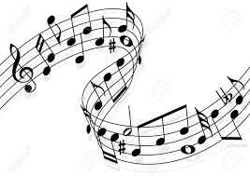

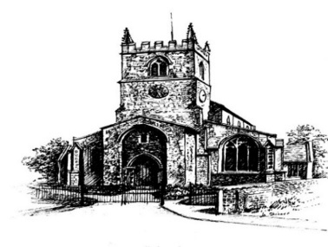
Coffee & Cake Concert
SATURDAY 27TH JUNE 10.30 AM
SHORT ORGAN RECITAL BY JAMES CHENG
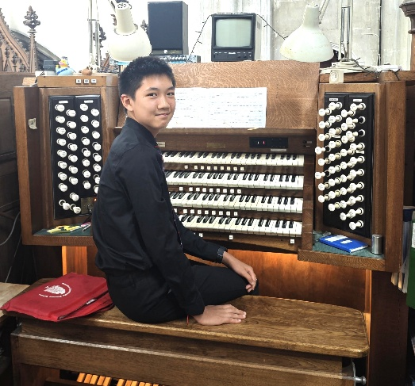
James is a Year 10 student at the Perse School, lives in Bottisham, usually practises in our church and achieved Grade 8 Distinction in his organ examination. He has received prizes in recent organ competitions in London and Leicester.
Enjoy a coffee (tea or juice) & cake, served from 10.15am and then the concert which will last around 40 minutes
Suggested donation £5, in aid of the church building fund – children free
