SUNDAY MORNING READING SHEET 28th June 2026 4th Sunday after Trinity

A reading from Paul’s letter to the Romans
Therefore, do not let sin exercise dominion in your mortal bodies, to make you obey their passions. No longer present your members to sin as instruments of wickedness, but present yourselves to God as those who have been brought from death to life, and present your members to God as instruments of righteousness. For sin will have no dominion over you, since you are not under law but under grace.
What then? Should we sin because we are not under law but under grace? By no means! Do you not know that if you present yourselves to anyone as obedient slaves, you are slaves of the one whom you obey, either of sin, which leads to death, or of obedience, which leads to righteousness? But thanks be to God that you, having once been slaves of sin, have become obedient from the heart to the form of teaching to which you were entrusted, and that you, having been set free from sin, have become slaves of righteousness. I am speaking in human terms because of your natural limitations. For just as you once presented your members as slaves to impurity and to greater and greater iniquity, so now present your members as slaves to righteousness for sanctification.
When you were slaves of sin, you were free in regard to righteousness. So what advantage did you then get from the things of which you now are ashamed? The end of those things is death. But now that you have been freed from sin and enslaved to God, the advantage you get is sanctification. The end is eternal life. For the wages of sin is death, but the free gift of God is eternal life in Christ Jesus our Lord. Romans 6:12-23

GOSPEL
‘Whoever welcomes you welcomes me, and whoever welcomes me welcomes the one who sent me. Whoever welcomes a prophet in the name of a prophet will receive a prophet’s reward; and whoever welcomes a righteous person in the name of a righteous person will receive the reward of the righteous; and whoever gives even a cup of cold water to one of these little ones in the name of a disciple—truly I tell you, none of these will lose their reward.’ Matthew 10:40-42

WE HAVE A NEW BATCH OF CHURCH MUGS FOR SALE, at £10 each, sales go towards church funds. Available at Saturday coffee, or after church services.

HOLIDAY CLUB 2026 this August would appreciate any boxes you may have, the children love building with them. Please leave them in the creche area in the corner. If the boxes are large, we are happy to come and pick them up. Please see Yvonne.


If you wish to make a donation to the church, then please hold Your phone’s camera over this image then touch the link that appears:

Royston Parish Church
Where all are welcome and God’s love is shared
Sunday 28th June 2026 - 4th Sunday after Trinity
If you would like regular copies of the Notice Sheet emailed to you please email the
Parish Office at admin@roystonparishchurch.org.uk

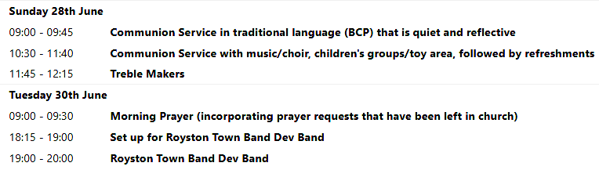
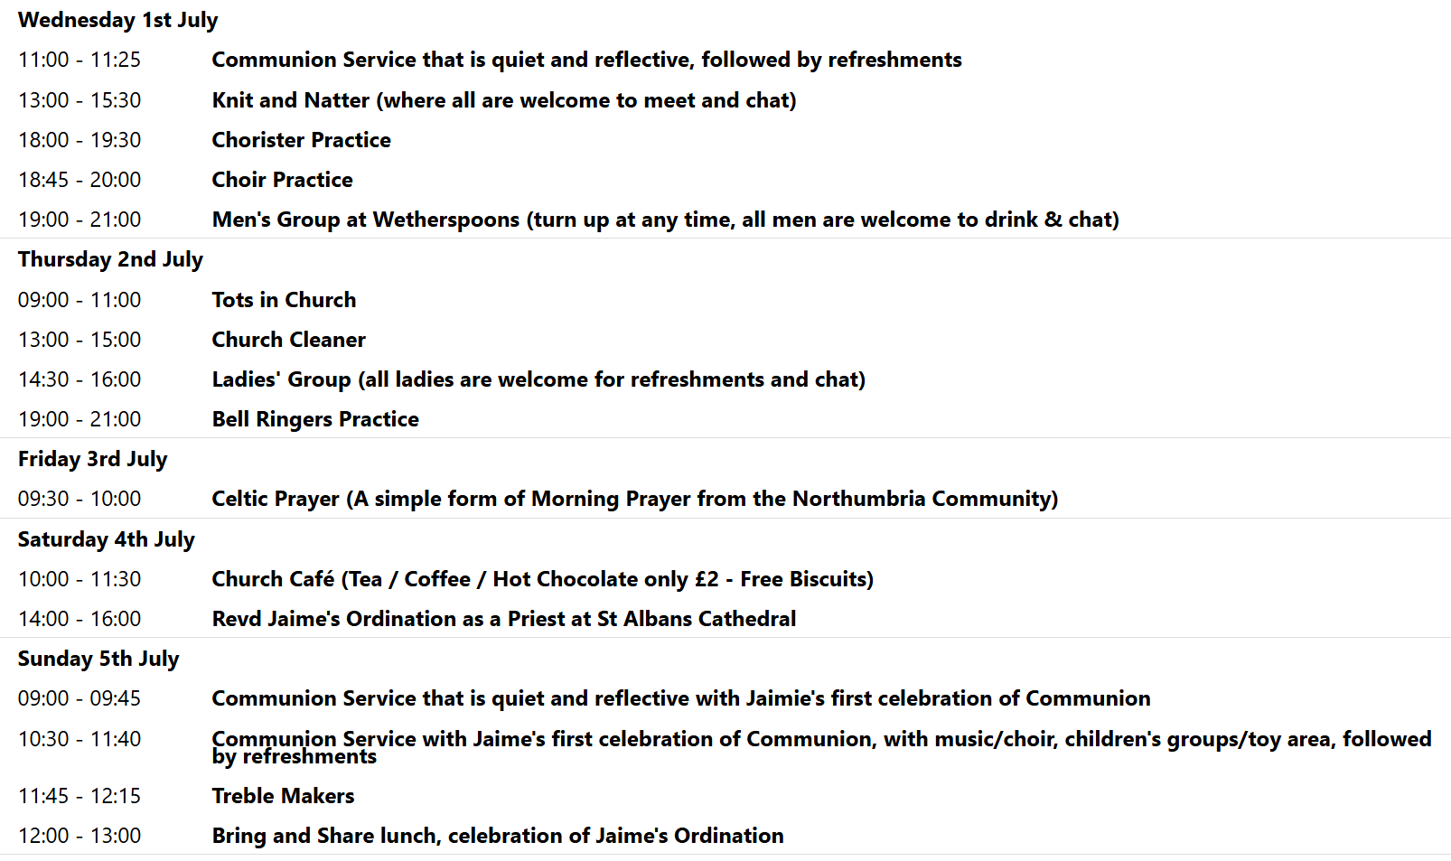

We pray for all Christians worldwide:
For all Christians in Kenya, Tanzania
For all who worship at Therfield Chapel: Paul Dutton
For the work of our mission partners: GenR8
Pray for the community of Royston:
For our local health centres
For all our local Royston Civic amenity centre and sewage plant
For all our young people revising for exams at this present time
Those being confirmed and received into Holy Communion during the Patronal Festival service
We pray for our world and ECO projects:
As the campaign "Plastic Free July" begins, we pray that we pray that we can move to world without single use plastics and have cleaner streets, oceans and communities.
We pray for the sick and suffering:
7th June | 14th June | 21st June | 28th June
Emma Thompson | Ted Rayment | Val Brown | Peter Coates
Jackson Herbert | Pat Tidey | Angie & Ken Rushall | Mike Askew
Marion | Mike Brown | Paula Walker | Peter Foster
Peggy Dawes |  | Laura O’nyamul  (On-Ya-Mul) | Keith & Elaine Edwards
Katie | Max Elliott | Revd. Anne Abok | Susan Bowles

We pray for those who have died in the faith of Christ:
Deceased Bereaved
Margaret Green Neal, family and friends

We pray for those whose anniversaries fall at this time:
No anniversaries this week
NOTICES

THE FUNERAL FOR THE LATE MARGARET GREEN: Margaret’s funeral will take place on Tuesday 30th June, 11.30am at Cam Valley Crematorium near Great Chesterford. If you would like to go but would need a lift or are going and could offer a lift could you please let Joanne know. The funeral will be followed by a wake at The Old Bull. The family have kindly said that you can go to this even if you cannot make the funeral but they would need to know the numbers, so please let Joanne know if you would like to attend the wake.

JAIME’S ORDINATION: We are offering a coach to take people to Jaime’s Ordination on Saturday 4th July in St. Alban’s Abbey. To help towards the cost a charge of £15 will be made. Please sign up on the list at the back of church, and pay either Kay or Richard.
SUNDAY 5TH JULY 9 AM AND 10.30 AM: Jaime will be celebrating her first Communion Service with us at both services, after her Ordination as Priest on Saturday 4th July. We will follow the 10.30 am with a Bring and Share lunch, so please bring an item of food to share

PATRONAL FESTIVAL Thank you to everyone who played a part in helping to make our Patronal Festival run smoothly and be so enjoyable, particularly to Emma for the art work, Lynda who ran the raffle and to members of the Events Committee who purchased, prepared and served refreshments. Overall we managed to raise £1520.13 for the mission and ministry of the church.

JULIAN PRAYER – JULY: The July meeting will be on Thursday July 9th at 7pm. At 11 Middle Drift. If it's not raining , we will do a prayer walk around the garden with chairs to sit and pray and a prayer prompt , or you can just wander around in silence. The side gate will be open, do just come through. If it rains, I will lead the meeting.
As usual, there will not be a meeting in August.

MUSIC QUESTIONNAIRE: There is a Music Questionnaire for everyone to take part it. Please take enough copies for each member of your household that comes to church and put completed questionnaires in the box provided in church by Sunday 26th July. There will then be a Scones of Praise on Sunday 2nd August at 3.30pm where the accumulative results of our church family’s top ten hymns and songs will be revealed.

CLIMATE EMERGENCY BRIEFING & DISCUSSION: You are warmly invited to an important and thought-provoking evening on Tuesday 7th July at 7:30pm, as Royston St John the Baptist Parish Church Sustainable Living Committee joins with the Royston Environmental Group to host a screening of the National Climate Emergency Briefing.
This event is an opportunity to come together as a community to better understand the challenges facing our world today, and to reflect on what they mean for us locally and personally. The briefing will be followed by an open, friendly discussion, where everyone is welcome to share thoughts, ask questions, and listen to different perspectives. Entry is free but please book your place via https://tickets.myiknowchurch.co.uk/gb/NzcwMi0zNA/t

CHURCH AT HOME (SCHOOL YEARS 7 UP): Our final event of the year will be a barbecue at Beth and Andy's on 12th July for young people and their parents. We would also like to invite any young people who will be in year 7 from September 2026 to come along to the barbecue with their parent(s) to meet the group. (Of course any young people who are in school years 7 to 12 and currently aren't part of the group would also be very welcome). To find out more, please email youth@roystonparishchurch.org.uk or speak to Reg, Beth or Andy on a Sunday.

