A summary of what we are permitted to allow on graves
The design of memorials is covered by the Diocese of Chelmsford Churchyard Handbook. This covers the shapes, kinds of stone and inscriptions for headstones and all other permissions for memorials.
Maximum height: for full-sized (burial) headstones: 27 inches
Maximum height for ashes headstones: 21 inches.
Kerbs, chippings, enclosures or ornaments are not permitted.
The process for approvals is as follows:
Approvals for memorials are made on form CR1. This can be found on the Chelmsford Diocese website. Forms should be sent to the incumbent priest, Canon Lee Francis Dehqani, Bishopscourt, Margaretting CM4 0HD.

St Margarets Church, Margaretting
Churchyard Guidance
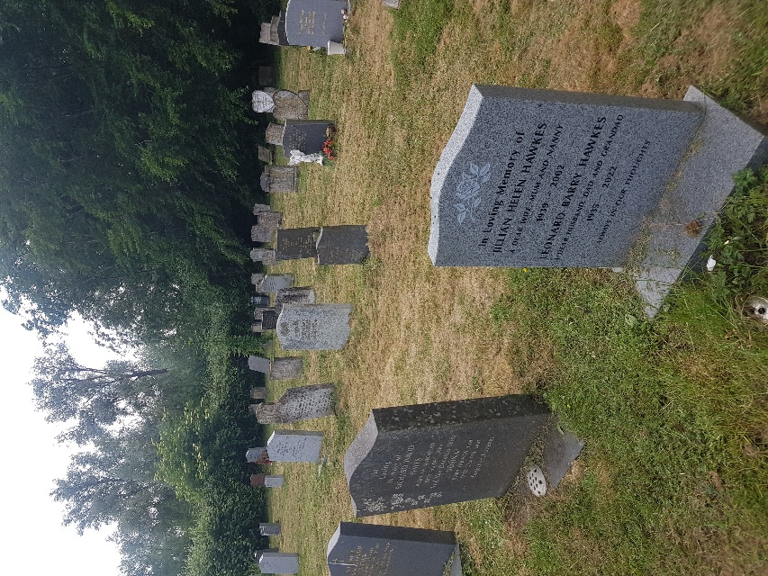
Guidance for graves and headstones
Introduction
This leaflet has been put together by members of Margaretting Parochial Church Council (PCC), that is, people who worship at this church and are the trustees of the church and churchyard in accordance with Charity Law. This contains guidance for the churchyard, developed from the Diocese of Chelmsford Churchyard Handbook* with additional specific references for this churchyard. .
Burials are a sensitive issue and we would like to make sure that-
- Families are able to tend graves in ways that help express your grief and love. The churchyard is consecrated (blessed) and will always be treated as a sacred space for your loved ones.
- Once your family’s headstone has been put up we need to ensure that it is not overshadowed by another family’s. This is about respect to others, and handing on a proper legacy to the future. The maximum sizes and styles that are allowed are covered in the above Churchyard Handbook.
- As this churchyard is consecrated ground, the Handbook also covers appropriate inscriptions; as it a historic place we also need to also be mindful with inscriptions of our legacy to history.
- Headstones are covered on the back page. The process is as follows. Funeral directors and stonemasons request permission for headstone design from the incumbent priest before putting it up. The priest then checks the proposed design against the Churchyard Handbook and authorises the request if all is in order. He/she can refer non-standard designs to the Diocesan Chancellor for a final decision. After permission has been obtained, the headstone can go up.
- The main area in the churchyard is for full burials with full-sized headstones, up to 27 inches high. The south-east corner is for ashes: in this area the maximum height for headstones should be 21 inches.
- People mowing the churchyard need to be able to mow the grass. For this reason, such things as kerbs (grave surrounds), common in the 19th century are no longer allowed, nor are chippings or plant cages. We would like the grave to be able to revert to level grass within five years, so it can then be mowed.
- We request that natural flowers only are placed on graves (with the exception of Remembrance items in the season).. Our long term aim is to have a churchyard in keeping with its natural setting.
Maintenance of the churchyard
Ongoing maintenance of this churchyard rests with Margaretting PCC who look after the costs of mowing; also with the Margaretting Church Support Group, a group of local volunteers, who keep the churchyard tidy. As they get older there is a need for more able-bodied people to join them. If you can help please contact Michael Scott (michael.john.scott@me.com).
Wildlife areas
The PCC has designated the older areas of the churchyard, ‘wildlife areas’. These have become a haven for bees, butterflies, beetles and small mammals. With this in mind, we leave these areas unmowed so wildlife can flourish there undisturbed. You may also see that grass in the newer area is at times a bit longer: this is when wildflowers are out.
As the churchyard is a wildlife area, we request that you take home things that won’t compost, like plastic or polythene; otherwise getting rid of this will just become another job for our churchyard volunteers.
A final word
The care of graves in the churchyard is a sensitive issue. We do recognise that the first few years of mourning are very difficult; families need to be allowed to properly remember loved ones. In compiling this guidance we have tried to balance the needs of bereaved families and keeping this churchyard a beautiful place for everyone for the future.
On behalf of the Priest-in-Charge, Focal Minister, Margaretting Parochial Church Council and Margaretting Church Support Group

*You can find the Diocesan Handbook by searching on line for Diocese of Chelmsford, Churchyard Handbook.

