THE UPDATE #320 (31 May 2026) for the Forest of Galtres Benefice.
Trinity Sunday 2026
Welcome to this week’s update. We have a video reflection the Archdeacon of the East Riding. There is the Hymns and Pimm’s Service in Stillington. There are more details on the Quiet Day at St Mary’s, Marton. We continue to pray for the Holy Land as well as Ukraine, prayers below.
What’s On for Benefice Services in June is attached separately.
From me:. This Sunday afternoon gives our benefice churches an opportunity to meet as one church and enjoy singing, fellowship and refreshments together – you will notice that this is the only service in the benefice as it is a 5th Sunday in the month – Hymns and Pimm’s Service in Stillington at 4pm.
Do have a think and a pray about the Quiet day taking place on the 20th of June – details below.
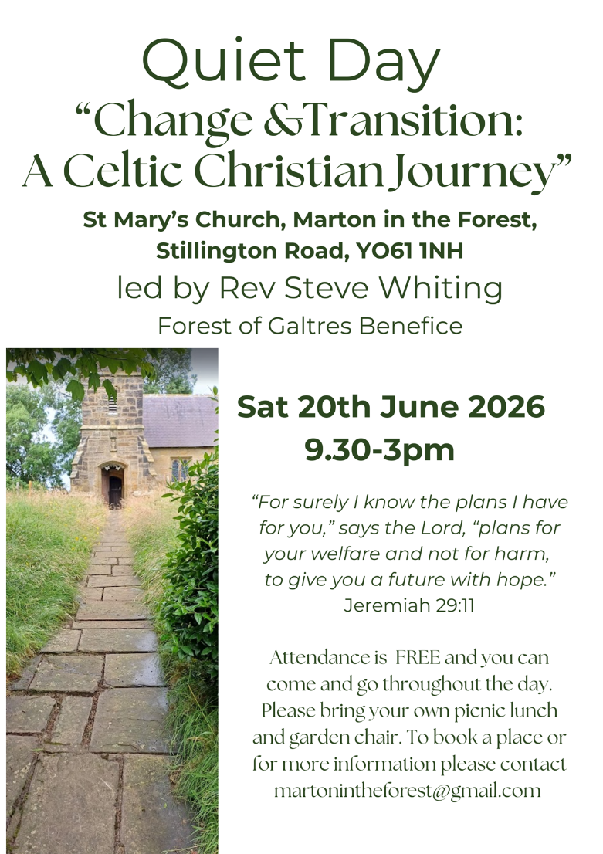
With every blessing,
Rev Steve
Trinity Sunday
Trinity Sunday reminds us that God is not distant or solitary, but a living communion of love: Father, Son and Holy Spirit. This weekend, as our five churches gather together for our Hymns and Pimm’s service, we celebrate not only our shared faith, but also the joy of belonging to one another. Singing familiar hymns in good company can lift the heart and strengthen the spirit, reminding us that worship is something we offer together. In a world that often feels divided or weary, occasions like these are gifts of fellowship, thanksgiving and hope. May this special afternoon encourage us all in faith, friendship and the love of God that surrounds us always.

The Ven Andy Broom, Archdeacon of the East Riding, reflects on Trinity Sunday, 31st May. Ctrl & click here à https://vimeo.com/1195998668
Coming to church this week 4.00pm Churches Together at Stillington
31 May On the 5th Sunday of the month all five churches come Trinity Sunday together for one benefice service, this month it will be Hymns & Pimm’s, a celebration of hymns and fellowship.

Coming to church next week 10.00am Holy Communion at Sutton
07 June 10.00am Morning Worship at Stillington
6.00pm Celtic Communion at Marton.

A Prayer for the Holy Land:

O God of all justice and peace
we cry out to you in the midst of the pain and trauma
of violence and fear which prevails in the Holy Land.
Be with those who need you in these days of suffering;
we pray for people of all faiths – Jews, Muslims and Christians and for all people of the land.
While we pray to you, O Lord, for an end to violence and the establishment of peace,
we also call for you to bring justice and equity to the peoples.
Guide us into your kingdom
where all people are treated with dignity and honour as your children
for, to all of us, you are our Heavenly Father.
In Jesus’ name we pray. Amen.

A Prayer for Ukraine:
God of all peoples and nations,
Who created all things alive and breathing,
United and whole,
Show us the way of peace that is your overwhelming presence.
We hold before you the peoples of Ukraine and Russia,
Every child and every adult.
We long for the time
When weapons of war are beaten into ploughshares
When nations no longer lift up sword against nation.
We cry out to you for peace;
Protect those who only desire and deserve to live in security and safety
Comfort those who fear for their lives and the lives of their loved ones
Be with those who are bereaved.
Change the hearts of those set on violence and aggression
And fill leaders with the wisdom that leads to peace.
Kindle again in us a love of our neighbour,
And a passion for justice to prevail
and a renewed recognition that we all play a part in peace.
Creator of all hear our prayer
And bring us peace. Make us whole. Amen.

