A WARM WELCOME AWAITS YOU AT

ALL SAINTS’
THURCASTON WITH CROPSTON
PARISH CHURCH
Anstey Lane, Thurcaston LE7 7JB

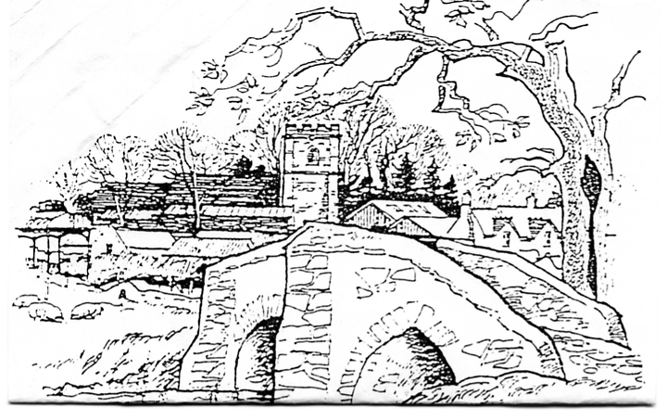

CHURCH AND WIDER PARISH ACTIVITIES
Activity | Day & time | Venue
Bell ringers | Wednesday 7.45pm | Church Bell Tower
Brownies | Wednesday 6pm | Harrison Room
Choir | Thursday 7.15 to 8.15pm | Church
Coffee Morning | 1st Sat 10 to 12 noon | Cropston Chapel
CROPSTON FELLOWSHIP | 2nd Wednesday 11 to 12 noon | Hind Sisters Homes
Garden Club | 2nd Wednesday 7.45pm | Thurcaston Memorial Hall
Hand Bell Ringers | Thursday 9.30am | Harrison Room
History Society | 3rd Tuesday 7.30pm | Thurcaston Memorial Hall
Latimer Players | Christine Deavin Sec. | Tel. 0116 2376855
Monday Club | 2nd Monday 2.15pm | Cropston Chapel
WEDNESDAY HUB  Chat/ Games in the warm | Wednesday 2 to 4 pm | Harrison Room
W. I. | 2nd Wednesday 7.30pm | Jubilee Hall, Stadon Rd Anstey

Church events and services can also be found at www.achurchnearyou.com/church/5502/service-and-events/
www.stmarysandallsaints.co.uk

PARISH SERVICES
Day in calendar month | Time | Service or Activity
1st Sunday | 8.30am | Holy Communion (said) Thurcaston
 | 10am | Fresh Start Morning Praise Thurcaston
 | 10am | Parish Communion (sung) Anstey
2nd Sunday | 10am | Family All Age Service Anstey
 | 10am | Parish Communion (sung) Thurcaston
3rd Sunday | 8.30am | Holy Communion (said) Thurcaston
 | 10am | Parish Communion (sung) Anstey
4th Sunday | 10am | Parish Communion (sung) Thurcaston
 | 10am | Fresh Start Morning Praise Anstey
5th Sunday | 10am | Parish Communion (sung) Anstey & Thurcaston alternately
Every Wednesday | 9.30am | Holy Communion (said) Anstey

In June and July 2026 there is a trial of changed service pattern. Please see calendar on website.

You are welcome to contact the Rector:
Rev. Matthew Gough
Mob. 07754961997
email: revgough@gmail.com
05/2026

