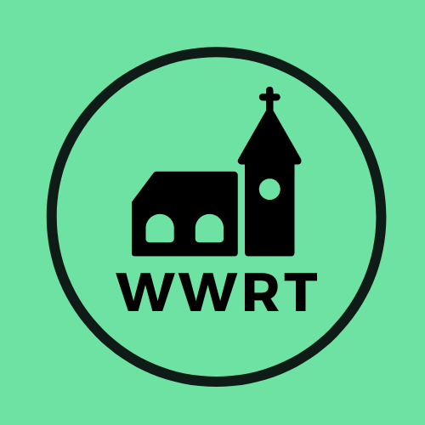
CHURCH SERVICES IN MARTLEY AND WICHENFORD
MAY 2026

Sunday 3rd May
Easter Five
10.30am Worship for All, St Mary Magdalene, Broadwas
10.30am CW Holy Communion, St Peter, Martley

Sunday 10th May
Easter Six/Rogation
11.00am Rogation Service, St Laurence, Wichenford

Sunday 17th May
Easter Seven
10.00am Café Church, St Peter, Martley

Sunday 24th May
Pentecost
10.30am CW Holy Communion, St Peter, Martley

Sunday 31st May
Trinity Sunday
10.30am Benefice Service, Pewcroft Farm

In May there will be Holy Communion at Heaton House, Martley on the 2nd and 4th Wednesday at 10.15am and on the 1st and 3rd Wednesday via our YouTube channel -wwrtlive1.
All services and timings are subject to review and amendment – please check the website for updates: www.achurchnearyou.com

