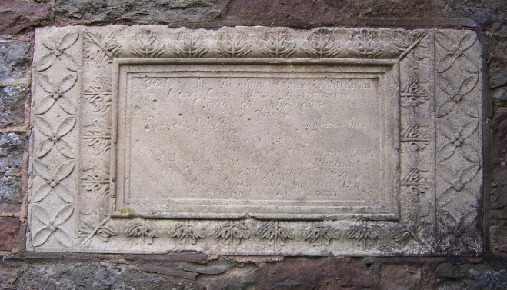
ST. JOHN THE BAPTIST, YARKHILL
Save our Monument!

Can YOU help to preserve this aged memorial to Francis Stedman before constant weathering causes its wording to disappear for ever?
The Reverend Francis Stedman was the incumbent here for 47 years in the 17th Century and his son Fabian, ‘The Father of Change Ringing’ was baptised at St John the Baptist Yarkhill in 1640.
In 1712 the antiquarian, James Hill, visited Yarkhill and recorded ‘In the Churchyard stands a handsome freestone altar monument in memory of Francis Stedman Minister of this parish, thus inscribed…
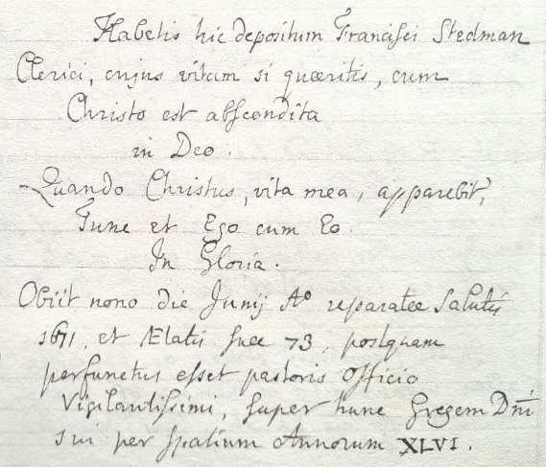
Translated:
Here lie the mortal remains of Francis Stedman whose life, if you seek it, is hid with Christ in God “When Christ my life shall appear then I, too, will appear with him in glory.”
He died on the ninth of June in the year of salvation 1671, aged 73, after most watchfully carrying out his duty as shepherd of the Lord’s flock for 46 years.

When the church was rebuilt in 1862 it stood in the way of the proposed new vestry. The altar tomb was dismantled, but the plaque with its inscription was saved, and set in the north wall on the exterior of the new vestry.
Yarkhill PCC is raising funds to enable the repair and preservation of this historic monument, a significant record of the history of Yarkhill and its connection to the founding of the art of ‘change ringing’.
We have a detailed conservator’s report and architect’s plans for the restoration project and have received quotations in the region of £15,000.00 (Fifteen thousand pounds). We are seeking grants to help with this but will not be able to fully meet the cost without help.
Francis’s time as Rector saw the installation of the current ring of four bells.
In 2012 the church installed eight new bells dedicated to the legacy of Fabian Stedman.
The old four bells have been preserved as they hang in the old 17th Century bell frame. The new bells have been rung regularly. Visting towers are encouraged to ring these bells.
For further information or to find out how to make a donation please contact:
Bell Tower Captain: Mr. Ashley Fortey tel. 07894 728762 e. ashleycfortey5040@gmail.com
Treasurer & Secretary: Mrs Julia Savagar tel. 07890 82144 e. juliasavagar@gmail.com

