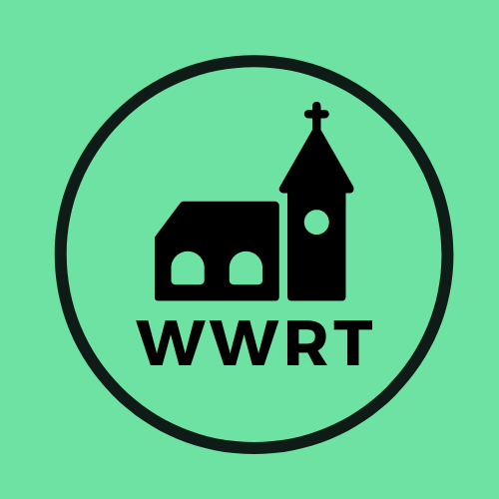

CHURCH SERVICES IN THE LOWER TEME VALLEY MAY 2026

Sunday 3rd May
Easter Five
9.00am BCP Holy Communion, St Leonard, Cotheridge
10.30am Worship for all, St Mary Magdalene, Broadwas

Sunday 10th May
Easter Six/Rogation
3.00pm Evening Worship, Knightwick Chapel

Sunday 17th May
Easter Seven
10.30am CW Holy Communion, St Mary Magdalene, Broadwas

Sunday 24th May
Pentecost
10.30am Morning Worship, St Mary Magdalene, Broadwas

Sunday 31th May
Trinity Sunday
10.30am Benefice Service, Pewcroft Farm

In May there will be Holy Communion at Heaton House, Martley on the 2nd and 4th Wednesday at 10.15am and on the 1st and 3rd Wednesday via our YouTube channel -wwrtlive1.
All services and timings are subject to review and amendment – please check the website for updates: www.achurchnearyou.com

All services and timings are subject to review and amendment in accordance with Covid lockdown easing – please contact the Rectory or check the website for updates.
01886 888664
www.achurchnearyou.com

