

We’re coming to improve your area and need your help.

When and where we’ll be working
Where can you find information?
Please refer to the yellow signboards on your street to see the exact dates, timings and permit number, including any date changes. You can also visit One.Network online.

Do you need a hand?
If you have any special access requirements, please contact Eurovia on 07703 796403 hcc.comms@eurovia.co.uk or the Customer Service Centre on 0300 123 4047 or email us at cschighways@Hertfordshire.gov.uk or Aroads@Hertfordshire.gov.uk

What: Carriageway Resurfacing Works
Where: Watling Street, St Albans
From the junction of St Stephen’s Hill to the junction of Park Street Roundabout
Dates and times:
09 June 2026 to 16 June 2026 between 8pm – 5am (Resurfacing Works)
And
03 July 2026 to 04 July 2026, between 8pm – 5am (High Friction Surfacing Reinstatement)
How: Full Road Closure (Refer to diversion route below)
How does this affect you?
Parking and access: To allow us to come and do these improvement works we’ll need to restrict parking temporarily. If you need to use your vehicle, please move it outside the works area shown on this letter, at least 30 minutes before we are due to start working.

Vehicles may not be allowed access during the works, except for emergency vehicles. Please speak to the on-site team on the day who will be able to advise on access or contact the contractor Eurovia 07703 796403.

Weather: Works are weather dependent and may be postponed. We apologise if works don’t start on time in these instances.

Affected bus services: Details of any disruptions to bus services can be found at www.intalink.org.uk/timetables (search for your service). If you're unable to find this information, please call our customer service centre on 0300 123 4047.

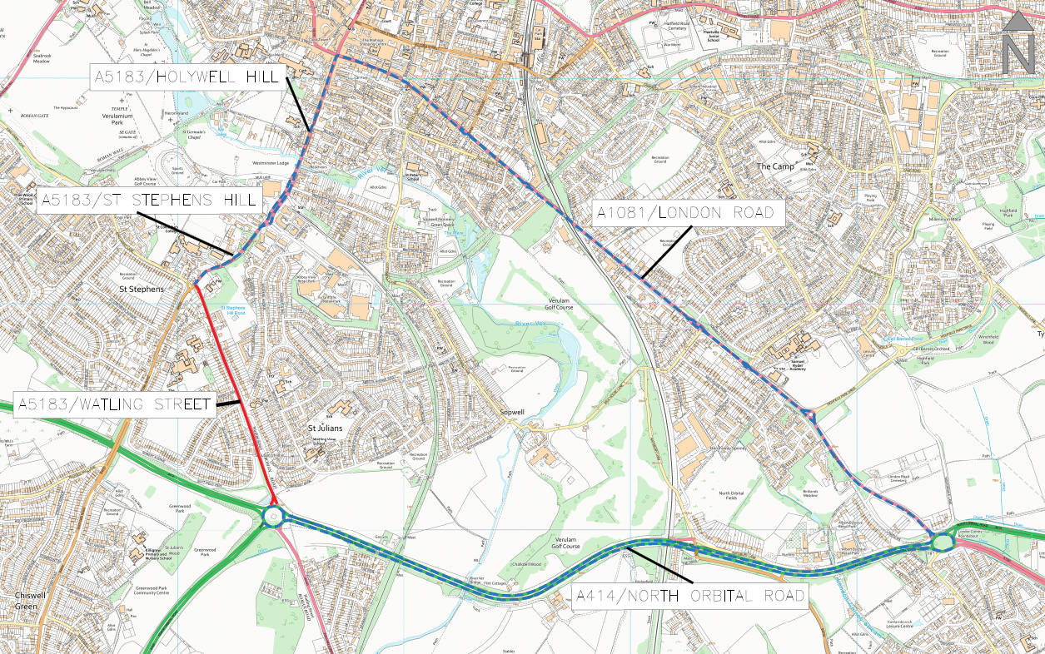
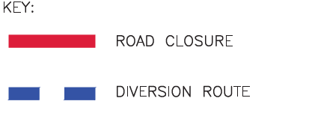
Works Permit Number: FM30257076501-01 (Resurfacing Works) & FM30228398977-01 (High Friction Surfacing Reinstatement). You can use this permit number on One.Network.

© Crown copyright and database rights 2025 OS AC0000849954

Map of the area we are working in

