SUNDAY MORNING READING SHEET 26th April 2026 4th Sunday of Easter
GOSPEL
Jesus said: ‘If you love me, you will keep my commandments. And I will ask the Father, and he will give you another Advocate, to be with you for ever. This is the Spirit of truth, whom the world cannot receive, because it neither sees him nor knows him. You know him, because he abides with you, and he will be in you. ‘I will not leave you orphaned; I am coming to you. In a little while the world will no longer see me, but you will see me; because I live, you also will live. On that day you will know that I am in my Father, and you in me, and I in you. They who have my commandments and keep them are those who love me; and those who love me will be loved by my Father, and I will love them and reveal myself to them.’ John 14:15-21

PRAYER WALK ON THERFIELD HEATH, 9TH MAY A morning's walk on the Heath and its surroundings, stopping for short prayers for the local community. Meets at 10.30am at St John the Baptist Parish Church, finishes at about noon at the Old Bull for optional lunch. Just turn up at the church.

CHRISTIAN AID WEEK: 10th – 16th May 2026. Envelopes are now ready at the back of church for your donations. Please either return envelope to the black safe on the wall, or bring to church and hand in on Sunday. Thank you

WE HAVE A NEW BATCH OF CHURCH MUGS FOR SALE, at £10 each, sales go towards church funds. Available at Saturday coffee, or after church services.

Events coming up:
14th May 8 pm - Ascension Day Evensong
Julian Prayer meeting Thursday 21st May at 7pm at 11 Middle Drift.
19th June 7.30 pm - Hymns and PIMM’ s
20th June 7.30 pm - An evening with Faversham Musical Theatre Choir
21st June 10.30 am - Patronal Festival Service with the Bishop if Hertford
21st June 5 pm - Come and Sing Vivaldi’s Gloria
With a rehearsal for those who wish to sing from 2.30 pm


If you wish to make a donation to the church, then please hold Your phone’s camera over this image then touch the link that appears:

Royston Parish Church
Where all are welcome and God’s love is shared
Sunday 10th May - 6th Sunday of Easter
Sunday 17th May - 7th Sunday of Easter

If you would like regular copies of the Notice Sheet emailed to you please email the
Parish Office at admin@roystonparishchurch.org.uk

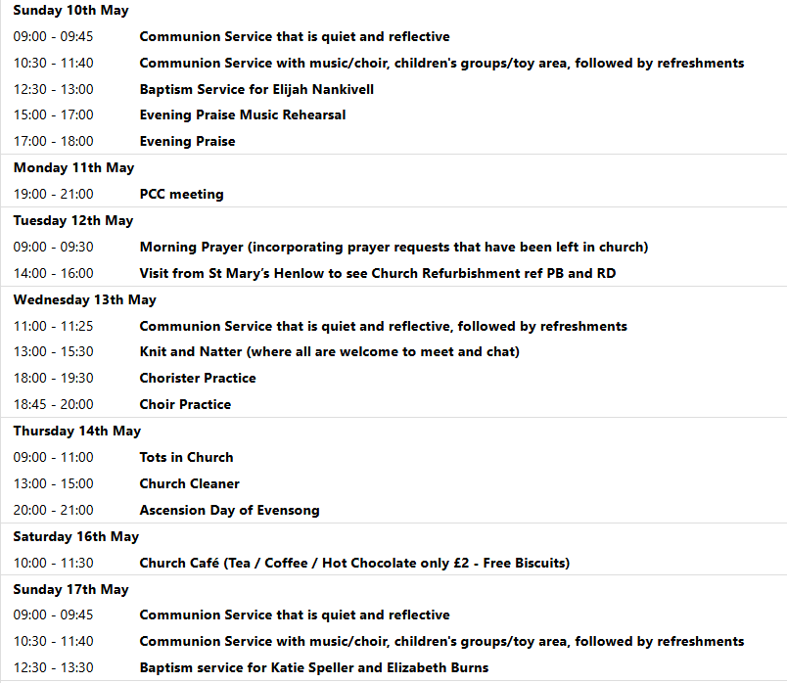
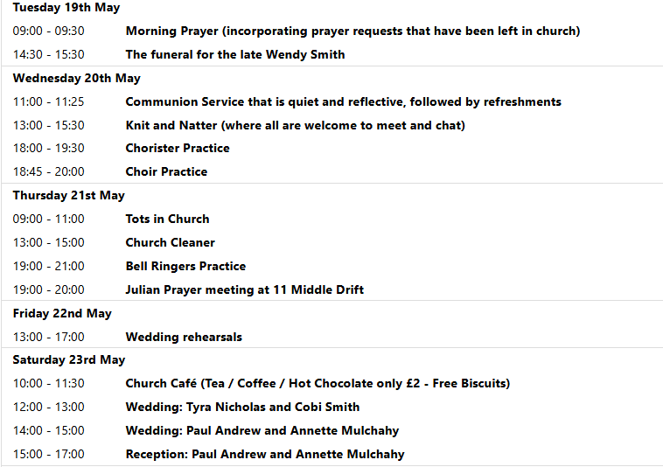
PENTECOST
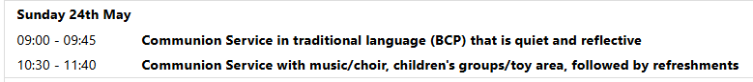

We pray for all Christians worldwide:
For all Christians in India, Pakistan, Sri Lanka
For all who worship at Royston Evangelical Church: Jonathan Scott
For the work of our mission partners: The Bible Society

Pray for the community of Royston:
For our local health centres
For all who work on our Industrial estates
For all our young people revising for exams at this present time

We pray for our world and ECO projects:
People participating in "No Mow May" to encourage wildlife

We pray for the sick and suffering:
3rd May | 10th May | 17th May | 24/31 May
Emma Thompson | Ted Rayment | Val Brown | Peter Coates
Jackson Herbert | Pat Tidey | Angie & Ken Rushall | Margaret Green
Marion | Mike Brown | Paula Walker | Peter Foster
Peggy Dawes | Cobi Smith | Laura O’nyamul  (On-Ya-Mul) | Keith & Elaine Edwards
George N | Max Elliott | William, Ruth & baby | Susan Bowles
Katie

We pray for those who have died in the faith of Christ:
Deceased Bereaved
Doris Neale Family and friends
Wendy Smith Sue Canon, family and friends
We pray for those whose anniversaries fall at this time:
David Ellis
NOTICES

CONFIRMATION: Bishop Jane will be leading our Patronal Festival at 10.30 am on Sunday 21st June. If you are interested in being confirmed or to receive communion for the first time please speak to Steven.

A BIG THANK YOU to everyone who contributed to the book fayre in any way. The event drew lots of people into the church building for hospitality, and raised £1762 for church funds.
Raffle tickets for our Patronal Festival draw are now on sale at £1 a ticket.
We are seeking donations of items for the luxury hamper that will be 2nd prize in our Patronal Festival raffle. Please leave items in the kitchen when it is open or leave with Joanne in the vestry. Thank you in advance from the Events committee.

ON SATURDAY MAY 30TH at 10-30am we plan to have a good clear up in the Churchyard outside the church. The tombs and graves are getting covered in Ivy which is causing a lot of damage. Please come along with gardening tools, shears and gloves and lend a hand. We could make a huge improvement with lots of help, even if you can only stay for an hour. Many thanks Kay & Richard

WEDDING INVITATION. Two members of our Church, Annette and Paul, are getting married here at 2pm on Saturday 23rd May. They would really like it if members of the Church could join in their celebration and stay for refreshments before they go off to their reception.

