Into his Courts
with Praise...

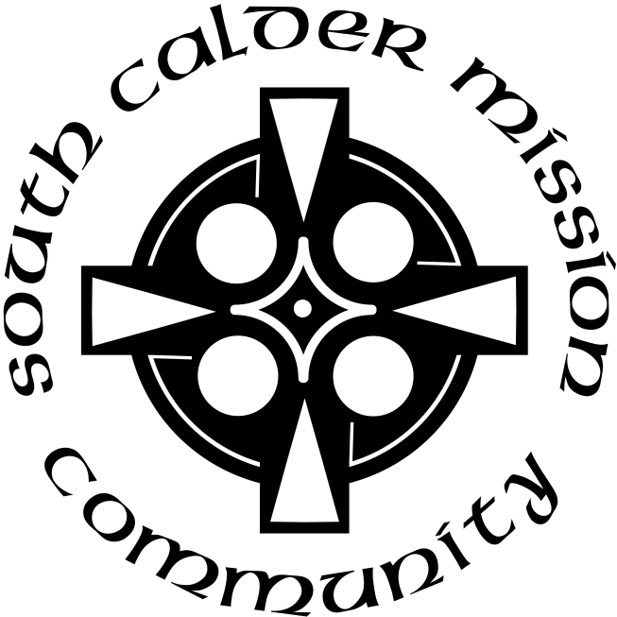

A Service of the Word
for
Sunday 24 May 2026
Pentecost.

A Service of the Word for Sunday morning

This service is taken from A Service of the Word,
Morning and Evening Prayer, Night Prayer,
which is copyright (c) The Archbishops' Council, 2000,
with permitted variations.

INTRODUCTION

“Everyone who calls on the name of the Lord shall be saved.”
Acts 2:21.
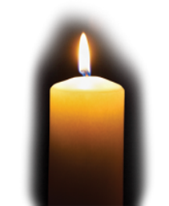

THE CONFESSION
The grace of God has dawned upon the world with healing for all. Though we have grieved him, yet he will heal us if we confess our sins in penitence and faith.

Almighty God,
I confess that I have sinned against you
in thought, word and deed;
I have not loved you with all my heart;
I have not loved my neighbours as myself.
Have mercy upon me,
cleanse me from my sins,
and help me to overcome my faults,
through Jesus Christ our Lord. Amen.

Receive God’s forgiveness
May the Father forgive us
By the death of His Son
And strengthen us
To live in the power of the Spirit
All our days. Amen.

PRAISE
O Lord, open my lips...
and my mouth shall proclaim your praise.
Give me the joy of your saving help...
and sustain me with your life-giving Spirit.

THE COLLECT
Holy Spirit, sent by the Father, ignite in us your holy fire;
strengthen your children with the gift of faith, revive your Church with the breath of love, and renew the face of the earth,
through Jesus Christ our Lord.

Amen.

Suggested hymn to sing or read Come down, O Love divine.

THE WORD OF GOD.
Acts 2:1-21.

When the day of Pentecost had come, they were all together in one place. And suddenly from heaven there came a sound like the rush of a violent wind, and it filled the entire house where they were sitting. Divided tongues, as of fire, appeared among them, and a tongue rested on each of them. All of them were filled with the Holy Spirit and began to speak in other languages, as the Spirit gave them ability.

Now there were devout Jews from every nation under heaven living in Jerusalem. And at this sound the crowd gathered and was bewildered, because each one heard them speaking in the native language of each. Amazed and astonished, they asked, ‘Are not all these who are speaking Galileans? And how is it that we hear, each of us, in our own native language? Parthians, Medes, Elamites, and residents of Mesopotamia, Judea and Cappadocia, Pontus and Asia, Phrygia and Pamphylia, Egypt and the parts of Libya belonging to Cyrene, and visitors from Rome, both Jews and proselytes, Cretans and Arabs—in our own languages we hear them speaking about God’s deeds of power.’ All were amazed and perplexed, saying to one another, ‘What does this mean?’ But others sneered and said, ‘They are filled with new wine.’

But Peter, standing with the eleven, raised his voice and addressed them: ‘Men of Judea and all who live in Jerusalem, let this be known to you, and listen to what I say. Indeed, these are not drunk, as you suppose, for it is only nine o’clock in the morning. No, this is what was spoken through the prophet Joel:
“In the last days it will be, God declares,
that I will pour out my Spirit upon all flesh,
and your sons and your daughters shall prophesy,
and your young men shall see visions,
and your old men shall dream dreams.
Even upon my slaves, both men and women,
in those days I will pour out my Spirit;
and they shall prophesy.
And I will show portents in the heaven above
and signs on the earth below,
blood, and fire, and smoky mist.
The sun shall be turned to darkness
and the moon to blood,
before the coming of the Lord’s great and glorious day.
Then everyone who calls on the name of the Lord shall be saved.”

Psalm 104:26-37.

O Lord, how manifold are your works! ♦︎
In wisdom you have made them all;
the earth is full of your creatures.
There is the sea, spread far and wide, ♦︎
and there move creatures beyond number, both small and great.
There go the ships, and there is that Leviathan ♦︎
which you have made to play in the deep.
All of these look to you ♦︎
to give them their food in due season.
When you give it them, they gather it; ♦︎
you open your hand and they are filled with good.
When you hide your face they are troubled; ♦︎
when you take away their breath,
they die and return again to the dust.
When you send forth your spirit, they are created, ♦︎
and you renew the face of the earth.
May the glory of the Lord endure for ever; ♦︎
may the Lord rejoice in his works;
He looks on the earth and it trembles; ♦︎
he touches the mountains and they smoke.
I will sing to the Lord as long as I live; ♦︎
I will make music to my God while I have my being.
So shall my song please him ♦︎
while I rejoice in the Lord.
Let sinners be consumed out of the earth
and the wicked be no more. ♦︎
Bless the Lord, O my soul.
Alleluia.

1 Corinthians 12:3b-13.

Therefore I want you to understand that no one speaking by the Spirit of God ever says ‘Let Jesus be cursed!’ and no one can say ‘Jesus is Lord’ except by the Holy Spirit.

Now there are varieties of gifts, but the same Spirit; and there are varieties of services, but the same Lord; and there are varieties of activities, but it is the same God who activates all of them in everyone. To each is given the manifestation of the Spirit for the common good. To one is given through the Spirit the utterance of wisdom, and to another the utterance of knowledge according to the same Spirit, to another faith by the same Spirit, to another gifts of healing by the one Spirit, to another the working of miracles, to another prophecy, to another the discernment of spirits, to another various kinds of tongues, to another the interpretation of tongues. All these are activated by one and the same Spirit, who allots to each one individually just as the Spirit chooses.

For just as the body is one and has many members, and all the members of the body, though many, are one body, so it is with Christ. For in the one Spirit we were all baptized into one body—Jews or Greeks, slaves or free—and we were all made to drink of one Spirit.

Suggested hymn to sing or read Breathe on me, breath of God.

GOSPEL
John 20:19-23.

When it was evening on that day, the first day of the week, and the doors of the house where the disciples had met were locked for fear of the Jews, Jesus came and stood among them and said, ‘Peace be with you.’ After he said this, he showed them his hands and his side. Then the disciples rejoiced when they saw the Lord. Jesus said to them again, ‘Peace be with you. As the Father has sent me, so I send you.’ When he had said this, he breathed on them and said to them, ‘Receive the Holy Spirit. If you forgive the sins of any, they are forgiven them; if you retain the sins of any, they are retained.’

REFLECTION – What did you get for Pentecost?.

Of all the festivals in the Church calendar I think that Pentecost is my favourite.

We don’t make as big a celebration and exchange gifts as we do for Christmas (what do you want for Pentecost is rarely asked) and we tend not to regard it as on a par with Easter – Pentecost egg anyone? We don’t send cards as we do at Christmas and Easter. It is nonetheless a time for rejoicing and celebration so maybe we should send cards.

It is in a way the culmination of all the great things about Jesus ministry on Earth. This is the moment when we, ordinary believers in Jesus our Saviour, all these years after the event, are irrevocably included as a vital part of the whole community of Christians with the disciples and the people present on that first Pentecost morning.

This wonderfully descriptive passage is well known, we hear it each year at Pentecost. We know the story, the sound like the rush of a mighty wind and the divided tongues of fire resting on each of them.

All of them were filled with the Holy Spirit and began to speak in other languages, as the Spirit gave them ability.

There is also a description of the gifts of the Spirit in the passage from the first letter to the Corinthians, gifts we all have but which need the Spirit to activate them.

So the Spirit is the catalyst that makes things work, without it there is possibility but no actuality.

And in John’s Gospel, we read of Jesus giving the gift of the Holy Spirit to the disciples along with his peace;

“Peace be with you. As the Father has sent me, so I send you. When he had said this, he breathed on them and said to them, ‘Receive the Holy Spirit.’”

What a gift of comfort and reassurance that must have been to the disciples, confused and frightened, gathering behind locked doors for fear of the Jews.

Jesus’ gift of the Holy Spirit carries another gift too, one of the things it enables is the gift of forgiveness;

“If you forgive the sins of any, they are forgiven them; if you retain the sins of any, they are retained.”

This is a powerful gift indeed, it is the gift of compassion, understanding and empathy which underlies our Christian faith.

We read later in the passage from Acts that all the people gathered in Jerusalem heard what the disciples were saying;

In our own languages we hear them speaking about God’s deeds of power.

That must have been such a magical and exciting moment, these Galileans, ordinary people, were talking to them in language they could understand. They had been given the ability to communicate by and through the Spirit. Some of the onlookers were inevitably rather more cynical and accused them of being rather the worse for wine. Obviously the Spirit hadn’t enabled their judgement at the time.
Peter reminds the crowd of the prophet Joel, foretelling the outpouring of the gift of the Spirit and the ultimate gift of everlasting life;

“Then everyone who calls on the name of the Lord shall be saved.”

W H Auden wrote that on the day of Pentecost we are given the gift of ears. The importance of hearing God is something that Auden was concerned with. Towards the end of his life he wrote the following haiku;

He has never seen God,
but, once or twice, he believes
he has heard Him.

Pentecost is the first time that the Spirit, the voice of God, is made available to the whole community of those who wish to hear, to listen and understand.

There is the “Pentecost present” the gift to us from God of the enabling Holy Spirit and the ears to hear his word. Our gift in return is to listen and use the gift of the Spirit to forgive, to understand and to use our Christ given empathy.

Risen Lord Jesus, breathe your peace upon us and send us out in the power of your Spirit.
Amen.

Brian Pateman.

Suggested hymn to sing or read God’s Spirit is in my heart.

THE CREED
All I believe in God the Father,
whose loving care is the pattern for family life.
I believe in Jesus, the Son of God,
who lives in my heart through faith,
and fills me with his love.
I believe in God the Holy Spirit,
who strengthens me with power from on high.
I believe in one God;
Father, Son and Holy Spirit. Amen.

THE PRAYERS
A time of quiet prayer for
• The universal Church - Bishops, synods and all leaders church
• The leaders of the nations
• The natural world and the resources of the earth
Lord Jesus, you are the Prince of Peace.
Look upon our divided world
to be with those who are victims of violence.
We pray for the people of Ukraine
and all who have been subjected to the cruelty of others.
Help us to know the gift of your peace
in the power of your Spirit and
we ask you to soften the hearts
of those who can stop the fighting.
Creator God, we ask for your aid as your children of light
living in the darkness of our world.
Amen.
Cumbria Ecumenical Spirituality Group.
Finishing with the South Calder Mission Community prayer...
Heavenly Father we thank you for the life of your Church
in this place, and in all the villages of the South Calder Mission Community;
for all who have served and worshipped you in years gone by,
for all who make up your family in our churches today,
for the faith we have in common, and for the people and traditions which make each church unique.
By your Spirit, guide and equip us,
that together we might find new ways
to reach out to our local community,
to show your love to our neighbours,
and to encourage them
to follow the Lord Jesus in their lives.
Father, we offer ourselves to your service,
In the unity of the Holy Spirit,
And in the name of Jesus Christ our Lord. Amen

and the Lord’s prayer...
Our Father, who art in heaven,
hallowed be thy name; thy kingdom come;
thy will be done; on earth as it is in heaven.
Give us this day our daily bread.
And forgive us our trespasses,
as we forgive those who trespass against us.
And lead us not into temptation;
but deliver us from evil.
For thine is the kingdom,
the power and the glory,
for ever and ever. Amen.

THE CONCLUSION

Suggested hymn to sing or read We have a Gospel to proclaim.

The following prayer is said
Be with me, Lord, as I finish my prayer today.
May my lips always speak the truth;
may my eyes which have read your word
see only what is good;
and may my life as well as my worship
be always pleasing in your sight,
for the glory of your name. Amen.

And now may the Lord who brought us to birth by his Spirit,
strengthen us for the Christian life.
May the Lord who provides for all our needs
sustain us day by day.
May the Lord whose steadfast love is constant as a mother's care,
send us out to live and work for others.
And the blessing of God Almighty.
the Father, the Son, and the Holy Spirit,
be with us and remain with us always.
Amen.

So now may I go in peace to love and serve the Lord.
In the name of Christ. Amen.

Links for the hymns

Come down, O Love divine.

https://youtu.be/edK3Vv7Qwo4

Breathe on me, breath of God.

https://youtu.be/r8mCs-QHELw

God’s Spirit is in my heart.

https://youtu.be/9VTQvYG-bl4

We have a Gospel to proclaim.

https://youtu.be/I5wWRYq57EM

