Into his Courts
with Praise...

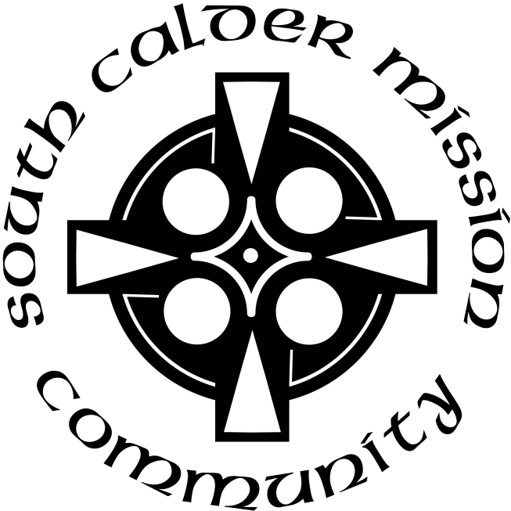

A Service of the Word
for
Sunday 10 May 2026
Sixth of Easter.

A Service of the Word for Sunday morning

This service is taken from A Service of the Word,
Morning and Evening Prayer, Night Prayer,
which is copyright (c) The Archbishops' Council, 2000,
with permitted variations.

INTRODUCTION

“‘If you love me, you will keep my commandments.”
Acts 17:22.
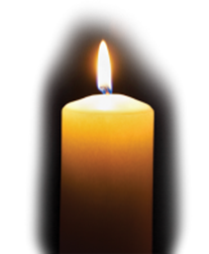

THE CONFESSION
The grace of God has dawned upon the world with healing for all. Though we have grieved him, yet he will heal us if we confess our sins in penitence and faith.

Almighty God,
I confess that I have sinned against you
in thought, word and deed;
I have not loved you with all my heart;
I have not loved my neighbours as myself.
Have mercy upon me,
cleanse me from my sins,
and help me to overcome my faults,
through Jesus Christ our Lord. Amen.

Receive God’s forgiveness
May the Father forgive us
By the death of His Son
And strengthen us
To live in the power of the Spirit
All our days. Amen.

PRAISE
O Lord, open my lips...
and my mouth shall proclaim your praise.
Give me the joy of your saving help...
and sustain me with your life-giving Spirit.

THE COLLECT
Risen Christ, by the lakeside you renewed your call to your disciples:
help your Church to obey your command and draw the nations to the fire of your love, to the glory of God the Father.

Amen.

Suggested hymn to sing or read Lord of creation, to you be all praise.

THE WORD OF GOD.
Acts 17:22-31.

Then Paul stood in front of the Areopagus and said, ‘Athenians, I see how extremely religious you are in every way. For as I went through the city and looked carefully at the objects of your worship, I found among them an altar with the inscription, “To an unknown god.” What therefore you worship as unknown, this I proclaim to you. The God who made the world and everything in it, he who is Lord of heaven and earth, does not live in shrines made by human hands, nor is he served by human hands, as though he needed anything, since he himself gives to all mortals life and breath and all things. From one ancestor he made all nations to inhabit the whole earth, and he allotted the times of their existence and the boundaries of the places where they would live, so that they would search for God and perhaps grope for him and find him—though indeed he is not far from each one of us. For “In him we live and move and have our being”; as even some of your own poets have said,
“For we too are his offspring.”
Since we are God’s offspring, we ought not to think that the deity is like gold, or silver, or stone, an image formed by the art and imagination of mortals. While God has overlooked the times of human ignorance, now he commands all people everywhere to repent, because he has fixed a day on which he will have the world judged in righteousness by a man whom he has appointed, and of this he has given assurance to all by raising him from the dead.’

Psalm 66:7-end.

7 Bless our God, O you peoples; ♦︎
make the voice of his praise to be heard,
8 Who holds our souls in life ♦︎
and suffers not our feet to slip.
9 For you, O God, have proved us; ♦︎
you have tried us as silver is tried.
10 You brought us into the snare; ♦︎
you laid heavy burdens upon our backs.
11 You let enemies ride over our heads;
we went through fire and water; ♦︎
but you brought us out into a place of liberty.
12 I will come into your house with burnt offerings
and will pay you my vows, ♦︎
which my lips uttered
and my mouth promised when I was in trouble.
13 I will offer you fat burnt sacrifices
with the smoke of rams; ♦︎
I will sacrifice oxen and goats.
14 Come and listen, all you who fear God, ♦︎
and I will tell you what he has done for my soul.
15 I called out to him with my mouth ♦︎
and his praise was on my tongue.
16 If I had nursed evil in my heart, ♦︎
the Lord would not have heard me,
17 But in truth God has heard me; ♦︎
he has heeded the voice of my prayer.
18 Blessed be God, who has not rejected my prayer, ♦︎
nor withheld his loving mercy from me.

1 Peter 3:13-end.

Now who will harm you if you are eager to do what is good? But even if you do suffer for doing what is right, you are blessed. Do not fear what they fear, and do not be intimidated, but in your hearts sanctify Christ as Lord. Always be ready to make your defence to anyone who demands from you an account of the hope that is in you; yet do it with gentleness and reverence. Keep your conscience clear, so that, when you are maligned, those who abuse you for your good conduct in Christ may be put to shame. For it is better to suffer for doing good, if suffering should be God’s will, than to suffer for doing evil. For Christ also suffered for sins once for all, the righteous for the unrighteous, in order to bring you to God. He was put to death in the flesh, but made alive in the spirit, in which also he went and made a proclamation to the spirits in prison, who in former times did not obey, when God waited patiently in the days of Noah, during the building of the ark, in which a few, that is, eight people, were saved through water. And baptism, which this prefigured, now saves you—not as a removal of dirt from the body, but as an appeal to God for a good conscience, through the resurrection of Jesus Christ, who has gone into heaven and is at the right hand of God, with angels, authorities, and powers made subject to him.

Suggested hymn to sing or read Breathe on me, breath of God.

GOSPEL
John 14:15-21.

‘If you love me, you will keep my commandments. And I will ask the Father, and he will give you another Advocate, to be with you for ever. This is the Spirit of truth, whom the world cannot receive, because it neither sees him nor knows him. You know him, because he abides with you, and he will be in you.

‘I will not leave you orphaned; I am coming to you. In a little while the world will no longer see me, but you will see me; because I live, you also will live. On that day you will know that I am in my Father, and you in me, and I in you. They who have my commandments and keep them are those who love me; and those who love me will be loved by my Father, and I will love them and reveal myself to them.’

REFLECTION – Paul in Athens.

Today’s gospel reading looks ahead to the Ascension of Jesus and the coming of the Holy Spirit at Pentecost. As (I presume) these subjects will be well covered on the next two Sundays, I shall focus today on the passage from Acts and Paul’s visit to the city of Athens. First a bit of background:

Although Rome had become the centre of power, and the location of the Emperor, Athens remained a centre of learning and culture. At the time of the New Testament, Greek was still the language of most of the empire, and Latin was mainly confined to the area around Rome. The Areopagus was a rocky hill in the centre of Athens, near the Acropolis. On this hill, in ancient times, the highest court in Athens would be held (in both senses of highest), trying cases of murder and settling disputes between rival religions (of which there were many – religions and disputes).

As time went on, the location of the court moved to another part of the city, but it was still generally known as the Court of the Areopagus, and its activities broadened to include philosophical debate as well as legal matters. When Paul was brought there to speak, it is not clear whether he was simply invited to a debate, or required to attend the court to give an account of his teaching.

Arriving in Athens was a great moment for Paul. Paul’s first missionary journey had been from Antioch to Cyprus, and then a loop around Galatia, in what is now southern Turkey. On his second journey he re-visited some of those places, but went on to cross from Turkey into Macedonia, part of Greece, founding churches in Philippi and Thessalonica. He would later write to both those churches: the letters to them which we have in the New Testament (Philippians and 1 and 2 Thessalonians). He then travelled south to Athens, a great moment for Paul, arriving in this renowned city of culture and learning.

Unfortunately, he also changed his technique to suit these august surroundings. In other places he had visited, he had first sought out the synagogue, or other meeting place of the Jews in that town. He proclaimed the good news about Jesus, and if it was not received, he would feel free to go on to the Gentiles in that place. One important group which we have come across before were those known as ‘God-fearers.’ There were Gentiles who were dissatisfied by the moral emptiness of the pagan religions and were attracted by Judaism, with its One God and its moral law, but had not yet actually converted to the Jewish faith. It was among this group that Paul often had his first and greatest success, forming the basis of a church in that place, to which other converts could be added.

In Athens, it would seem, he began with this same technique, but being distressed by the number of idols of different religions in the city, he began to argue with the followers of some of these faiths and philosophies. When he was brought before the Court of Areopagus, he referred to an altar he had noticed with the inscription ‘To an Unknown God.’ We do not know whether this meant that the altar had been there so long that people had forgotten to which god it was dedicated, or if they were just ‘playing safe’ in case there was yet one more god than all those with shrines or temples of their own. Paul chooses to interpret it that way, and explains that this ‘Unknown God’ is the one he actually serves. He explains that the worship of idols is pointless, and that his God is the one who created all things, and will one day judge the world. The proof of this, he says, is that God has raised a man from the dead, and through this man the judgement will take place. The reaction to all this is underwhelming, though he does win a few converts.

Rather disenchanted, Paul moves on to Corinth – a very different city, commercial, cosmopolitan, a bustling sea-port. And here he reverts to his usual technique, telling us in his first letter to the Corinthians:

‘When I came to you, I did not come with eloquence and human wisdom…..I resolved to know nothing while I was with you except Jesus Christ and him crucified…..My message and my preaching were not with wise and persuasive words, but with a demonstration of the Spirit’s power.’
(1 Corinthians 2:2-4)
What a difference! And how much more did people respond! The church in Corinth was one with which Paul kept in regular contact. They sometimes infuriated or exasperated him, and he had to write to them to correct error, but his affection for them remained constant. In summary, we might say that in Athens Paul tried to play them at their own game, with only limited success, whereas when he proclaimed Jesus, and followed the leading of the Spirit, the results were vastly different.

I find all this background fascinating, and could stop there. But that was then – what about now? What does this little piece of Christian history say to us as Christians, or to our church?
Are there shrines to various deities scattered around our villages? No.
Do we have philosophical discussions with people we meet in the street? Seldom.
But do people today set up idols? Yes. Perhaps not the statues of silver or gold of ancient times, yet there are things which people today might hold in that kind of esteem and honour. It might be a film- or pop-star; it might be a new car; it might well be that greatest idol of all, Self. I don’t need to watch many TV adverts to learn that the most important thing there is, is me. Whatever matters to me, or to my close family, this I must have, or must do. You only have to look at the recent election results to see that the majority of people seem to vote out of self-interest. What’s in it for me?

The traditional approach of many churches – perhaps especially in the Church of England – has been to come alongside people, to work for the good of the community, to make people welcome. These things are all worthwhile in themselves, but if we omit the name of Jesus, or play down the importance of faith in him, we are failing in our main task. And actually by not making him the centre of the message, we are letting people down. This is the crunch. We in church today, or using this written liturgy and reading this reflection, believe that salvation only comes through faith in Jesus, crucified and risen. If we disguise this truth, it might make us more acceptable to our neighbours, but in fact we are failing to give them the best gift, the best opportunity.

Like Paul in Corinth, after his visit to Athens, we need to remember that the heart of our message is ‘Jesus Christ, and him crucified.’ So returning briefly to today’s gospel reading from John chapter 14, we hear Jesus saying that if we love him we shall obey him. But he adds the reassurance that we shall not be struggling on our own: we shall have another counsellor, another helper, the Holy Spirit, who will be with us and in us.

So let us prepare over the next two weeks to acknowledge Jesus as our Lord, crucified, risen and ascended, and to be ready to receive into our lives once again the promised Holy Spirit.

Jonathan Falkner.

Suggested hymn to sing or read Lord, make me a mountain.

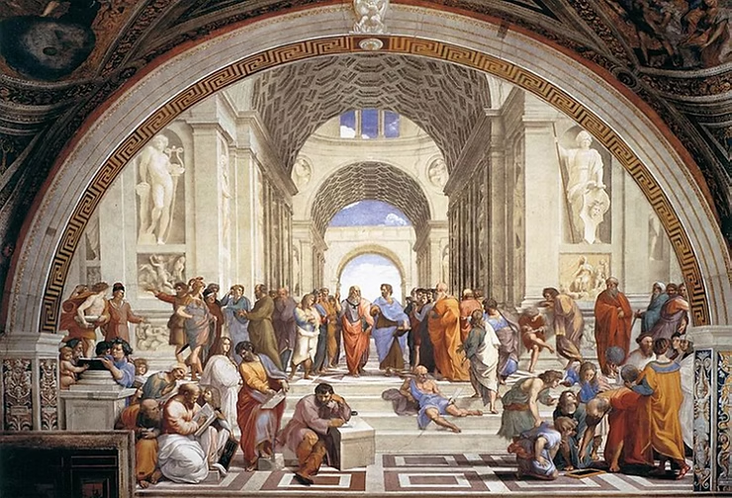
The School of Athens – Raphael.

THE CREED
All I believe in God the Father,
whose loving care is the pattern for family life.

I believe in Jesus, the Son of God,
who lives in my heart through faith,
and fills me with his love.

I believe in God the Holy Spirit,
who strengthens me with power from on high.

I believe in one God;
Father, Son and Holy Spirit. Amen.

THE PRAYERS
A time of quiet prayer for
• The universal Church - Bishops, synods and all leaders church
• The leaders of the nations
• The natural world and the resources of the earth

Lord Jesus, you are the Prince of Peace. Look upon our divided world to be with those who are victims of violence.
We pray for the people of Ukraine and the Middle East
and all who have been subjected to the cruelty of others.
Help us to know the gift of your peace
in the power of your Spirit and
we ask you to soften the hearts
of those who can stop the fighting.
Creator God, we ask for your aid as your children of light
living in the darkness of our world.
Amen.
Cumbria Ecumenical Spirituality Group.
Finishing with the South Calder Mission Community prayer...
Heavenly Father we thank you for the life of your Church
in this place, and in all the villages of the South Calder Mission Community;
for all who have served and worshipped you in years gone by,
for all who make up your family in our churches today,
for the faith we have in common, and for the people and traditions which make each church unique.
By your Spirit, guide and equip us,
that together we might find new ways
to reach out to our local community,
to show your love to our neighbours,
and to encourage them
to follow the Lord Jesus in their lives.
Father, we offer ourselves to your service,
In the unity of the Holy Spirit,
And in the name of Jesus Christ our Lord. Amen

and the Lord’s prayer...
Our Father, who art in heaven,
hallowed be thy name; thy kingdom come;
thy will be done; on earth as it is in heaven.
Give us this day our daily bread.
And forgive us our trespasses,
as we forgive those who trespass against us.
And lead us not into temptation;
but deliver us from evil.
For thine is the kingdom,
the power and the glory,
for ever and ever. Amen

THE CONCLUSION

Suggested hymn to sing or read Come people of the risen King.

The following prayer is said
Be with me, Lord, as I finish my prayer today.
May my lips always speak the truth;
may my eyes which have read your word
see only what is good;
and may my life as well as my worship
be always pleasing in your sight,
for the glory of your name. Amen.

And now may the Lord who brought us to birth by his Spirit,
strengthen us for the Christian life.
May the Lord who provides for all our needs
sustain us day by day.
May the Lord whose steadfast love is constant as a mother's care,
send us out to live and work for others.
And the blessing of God Almighty.
the Father, the Son, and the Holy Spirit,
be with us and remain with us always.
Amen.

So now may I go in peace to love and serve the Lord.
In the name of Christ. Amen.

Links for the hymns

Lord of creation, to you be all praise.

https://youtu.be/Z3jh7sEFHvo

Breathe on me, breath of God

https://youtu.be/92vT62xEV34

Lord, make me a mountain.

https://youtu.be/NN_OYOHbafs

Come people of the risen King.

https://youtu.be/azEWoyjj4LI

