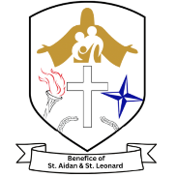
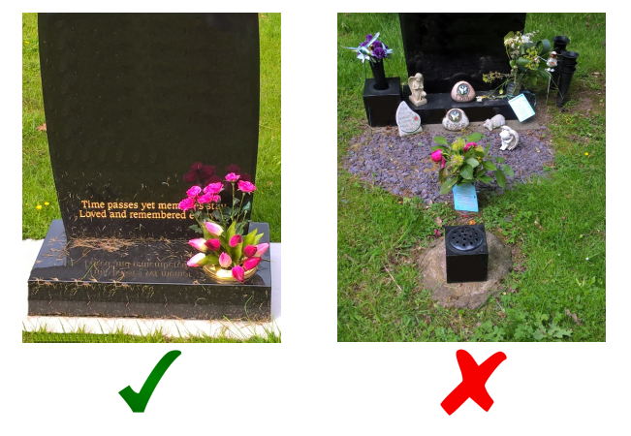
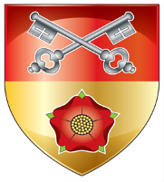

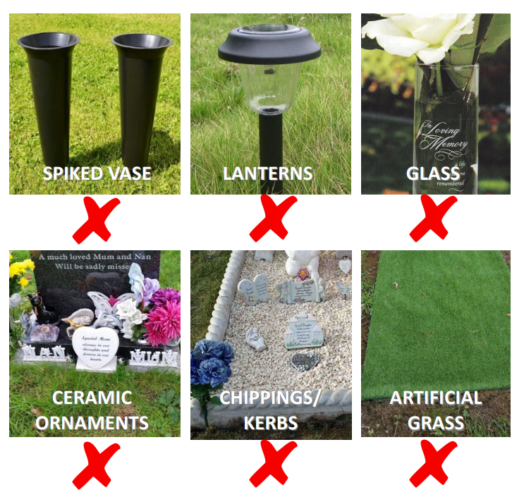
Information for Visitors to our Churchyard
Unauthorised items will be removed and sensitively disposed of. To avoid any distress please do not place items on a grave which are not allowed.
For more information please contact our Church directly: 01772 335310
Our Churchyard Regulations can be found on ‘A Church Near You’ Walton le Dale, St Leonard or a copy can be obtained in church.
Graves are laid to lawn, and plants and shrubs must not be planted within the grave scape. To allow for grass cutting and safety reasons, it is important that nothing is put on the grass than can make it difficult to maintain the Churchyard effectively.
It is our intention to make the Churchyard a beautiful, natural and safe environment. We can only do that with your help, which is why we ask that your do not place certain items on the grave.
Below are some items which are not allowed unless written approval has been given.

