THE BRIXHAM MISSION COMMUNITY
Summer Wanderings and Wonderings: Welcome!

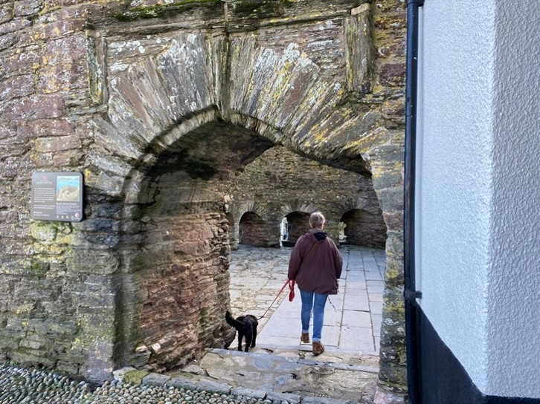

When we walk away from something, what are we walking towards? Who trod this path before us?

Moving Forward Together
Issue 33 June 2026

Magazine free to take Suggested donation £1
Brixham Mission Community Services June 2026
2026 | Week 1 | Week 2 | Week 3 | Week 4 | Week 5
Sunday | Trinity 1 Proper 5 | Trinity 2 Proper 6 | Trinity 3 Proper 7 | Trinity 4 Proper 8
June | 7th | 14th | 21st | 28th
All Saints'  Lower Brixham | 09:30  Eucharist | 09:30  Eucharist | 09:30  Worship for All | 09:30  Eucharist with baptism
St Mary’s  Brixham | 08:45  No service | 08:45  Eucharist | 08:45  No service | 08:45  Eucharist
 | 11:00  Eucharist | 11:00  W.A.L.K* | 11:00  Eucharist | 11:00  Morning worship
SMVC  Churston | 10.00  Morning worship | 10:00  Eucharist with baptism | 10:00 Eucharist | 10:00  Galmpton School
STCK  Kingswear | 10:30  Morning worship | 10:30  Eucharist | 10:30  Morning worship | 10:30  Eucharist
CGSG  Galmpton | 08:45  Eucharist | 08:45  Morning worship | 08:45  Morning worship | 08:45  Eucharist
Mid-week | CORPUS CHRISTI | Thursday  4 June | BMC service | St Mary’s Brixham
All Saints'  Lower Brixham 10.00 | 2nd  Communion by ext. | 9th  Eucharist | 16th  Communion by ext. | 23rd  Eucharist with baptism | 30th Eucharist Peter & Paul
St Mary’s  Brixham 10.30 | Thurs 4th  Eucharist CORPUS CHRIST | 10th  Eucharist St Barnabas | 17th  Eucharist | 24th Eucharist  John the Baptist
* W.A.L.K Worship, Ask, Love, Know: a fresh expression of worship Brixham Mission Community Churches welcome you!
Welcome to the month of June
Dear Friends,
As the summer begins and we begin to make a bit more of the great outdoors, I have been reflecting on how we may often feel closer to God out in nature than anywhere else. The Church has just celebrated Pentecost, the third of the three major Christian festivals. This is a time when we reflect on the Holy Spirit in our lives and communities. She inspires us with God’s love, challenges us to join in where God is already at work, sustains us and pours out God’s grace to make us holy. We understand the Holy Spirit as the energy of God, the Advocate or helper. We represent the Holy Spirit with powerful images such as fire or wind, and the peaceful image of the dove.
I often notice the Holy Spirit most when out walking on the moors or the coast; the image of the Holy Spirit in the powerful wind and the gentle breeze. I’ve included some pictures of my local wanderings with some wonderings to share some moments of pilgrimage with you.
Happy reading!
Philippa Bellows

Wonderings while wandering
With the recent Pilgrimage series on BBC 2, it is becoming clear how people of all faiths and none gain deeper spiritual understanding, and greater awareness of self and others through a physical journey to a holy place.

We probably don’t need to go very far. Brixham Mission Community spans the edge of Torbay to the South Hams along the South West coast path. Zip the dog and I went out to bring a piece of pilgrimage to your home.
Here are some wonderings for you from my local wanderings.
The Daymark at Brownstone
Wondering: How might we use landmarks in everyday life to help us navigate our way home. Who might be the landmarks in our life?
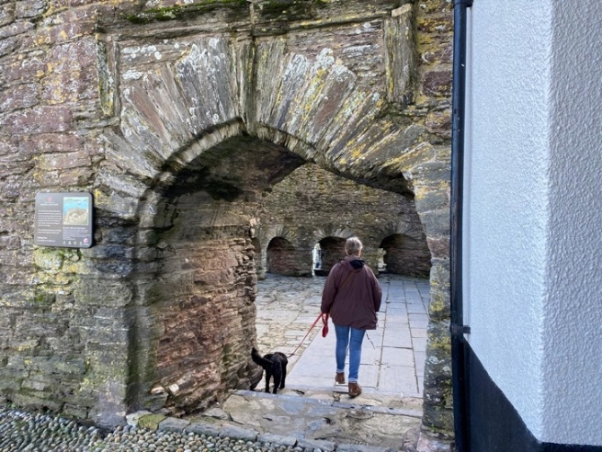
Wondering: When we walk away from something, what are we walking towards? Who trod this path before us?
Bayard’s Cove Fort, Dartmouth

Kingswear Castle
Wondering: What hidden treasures are there to surprise you when you are walking?
This is a defensive structure. What might we defend that we might do better to let go?

The Dart Estuary
Wondering: What happens when you look at the big picture of your life?
What might be the main features you want to thank God for?

Paws for thought
Wondering: What gives you energy and what leaves you feeling dog tired?
How might the Holy Spirit inspire you to make the next journey?
Philippa Bellows
Pilgrimage to the Holy Island of Lindisfarne
Pilgrimage is in the news at the moment: Archbishop Sarah's before her installation at Canterbury, the Devon Pilgrim project and our own Deb Avery's BMC pilgrimage initiative (MFT May page 13).
On 1 May I joined a group of Friends of Southwark Cathedral, gently guided by the Sub-Dean, Rev'd Canon Michael Rawson, on a pilgrimage to the Holy Island of Lindisfarne. ('Farne', also in 'Farne Islands' where Cuthbert died, has a meaning of 'retreat'.)
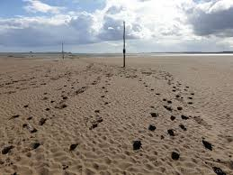
Sadly I opted to join two others to drive across the causeway, but the other 14 Friends walked the three miles across the uncovering sand, mostly barefoot though some in boots.

They began with the prayer:
O God of the rising sun, you who called Aidan, Cuthbert and the saints of Lindisfarne, guide our feet as we journey towards Holy Island.
Let the rhythm of the tides teach us trust.
Let the winds across the sands carry our prayers.
Let the cry of the seabirds remind us of your freedom.
As the causeway appears and disappears,
show us the paths you reveal in your time.
May we walk gently, receive gratefully and return changed.
The minibus group reached the end of the causeway in time to pick up the rest of the party once they had dried their feet.

Holy Island is totally controlled by the tides, and most of the people who work in the castle, shops and cafes travel from the mainland, so everything closes at a different time each day and the island becomes, for about six hours, a haven of peace. Our trip had been planned so that the tides allowed us to stay all day and have our evening meal before returning when the causeway re-opened.
On the next day we spent two hours in a boat viewing, at very close quarters, the wonderful wildlife on the Farne Islands: Atlantic grey seals with pups, eider ducks, guillemots, shags.....and hundreds of puffins swimming. Although I had visited puffin areas frequently in the past I had never seen one – they really are tiny, although they always look huge in pictures.
Each evening our minibus, parked outside our hotel in Berwick, became the chapel for compline: on Friday for Boisil, prior of Melrose Abbey and teacher of Cuthbert (d.661) and on Saturday for Patrick (389-461).
On Sunday we returned to Holy Island, all together in the minibus this time, for Eucharist in the parish church of St Mary the Virgin. As the congregation included people from many far-flung places, the celebrant began by inviting us all to introduce ourselves to the people next to us.
The church has a Fishermen's Chapel, modern stained-glass windows depicting Aidan and Cuthbert and a sculpture in elm showing six monks taking Cuthbert's body on a long journey to protect it from the Viking raids. continued
St Aidan, Bp of Lindisfarne 635-651, feast day 31 August:
Everlasting God, you sent the gentle bishop Aidan to proclaim the gospel in this land; grant us to live as he taught in simplicity, humility and love for the poor; through Jesus Christ our Lord.
St Cuthbert, Bp of Lindisfarne from 685, feast day 20 March:
Almighty God, who called your servant Cuthbert from following his flock to following your Son and to be a shepherd of your people: mercifully grant that we, following his example, may bring those who are lost home to your fold. AR

Coming to pray in your Mission Community
Bishop James’ pilgrimage

Wednesday 3rd June
8.30–9.45am Visit to South Devon College
Walk 1 mile
10.15–10.45am Prayer at St Mary, Churston Ferrers
Walk 2 miles
11.45–12.15pm Prayer at All Saints’, Lower Brixham
Walk 7 miles
4.00–4.30pm Prayer at St Thomas of Canterbury, Kingswear
Walk 0.5 miles
5.15–5.45pm Prayer at St Saviour’s, Dartmouth
Walk 1 mile
6.15–6.45pm Prayer at St Petrox, Dartmouth
National Fishermen’s Remembrance Day
Sunday 10th May was National Fishermen’s Remembrance Day. An outdoor service was held at the port, led by Helen Lovell-Smith (Fishermen’s Mission) with Anne Donnelly (Stella Maris) and Rev’d Dr Philippa Bellows (Brixham Mission Community).
Many attended to remember the lives of loved ones lost at sea. Torbay and Exmouth lifeboats moored at the port for their crews to collect fresh flowers from bereaved families. These were laid out at sea after the service.
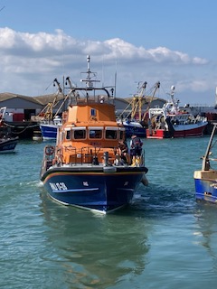
A new recording of the Fishermen’s Mission song Lost and Found, sung by children from Brixham Church of England Primary School, was played, and other songs performed by Missin’ Tackle.
As you read this article, have a moment to reflect on the centrality of the fishing community to Brixham; do take a moment to be mindful of those who have lost their lives at sea and their families.
May they rest in peace and rise in glory.
Philippa Bellows

"You shall love your neighbour as yourself"
One of the marked impressions I get from the case studies we are given for safeguarding training is how much harm is done to vulnerable and easily-led people by those in a position of power in the Church, who ought to know better.
As one who grew up in the 1950s, I am used to a culture where we assume that our leaders have integrity and that they are trustworthy. It was the last age of the 'gentleman' and the 'lady'. Parliament itself is built on a system that relies on honesty and trustworthiness. In recent times we have come to discover that simply trusting someone to behave with probity is not enough. There have been far too many instances of lack of accountability leading to abuse of power. In the eighteenth-century Jonathan Edwards observed, ‘hell is full of Christians’.
These are the days of safeguarding. We have safeguarding training at various levels. We have Safeguarding Officers. We have safeguarding guidelines to show us how to deal with any problems that arise. Each parish must display a safeguarding policy. It has gradually become a significant extra administrative task for every parish. But never think of safeguarding as a burden. It is easy to think it is just a bore and a lot of extra tick-boxes to be filled.
I believe that safeguarding is an intrinsic part of a responsible Christian life.
Jesus said that, if we cause a stumbling block for those people for whom we are called to care, ‘it would be better for you if a millstone were hung round your neck and you were thrown into the sea’.
For whom are we called to care? We are called to care for everyone. We are called to look out for the welfare of everyone. The people most responsible for looking out for others are church leaders, but it is also the calling of us all. All of us are called to look out for everyone.
We have come to a time when it is not enough to comply with all the regulations and tick-boxes. It is now essential that we look at safeguarding of the vulnerable and those at risk and draw it into our normal Christian culture. Looking out for our brothers and sisters should be a Christian reflex based on the calling we have to love.
Jesus said, ‘This is my commandment, that you love one another’.
There is no love in abuse and there is no love in trying to ignore abuse when it is happening. So here I am planting a standard for us all to pick up and walk with every day.
Take safeguarding seriously as an intrinsic part of your walk in faith with Jesus.
M Pickthorne LLM

BOOTED INTO THE KINGDOM: Part 2 by Rev’d John Calvert
In April I wrote about the beginnings of my journey as a Christian. But that was many years ago. So what happened next and, for that matter, what happened in the next 58 years?
I attended the London College of Divinity and was ordained in Southwark Cathedral as a priest in October 1968. I married Gill the following week. Unusually, I served three curacies: Kennington, near the Oval Cricket Ground, followed by Southborough, near Tunbridge Wells, then, finally, Barton Seagrave in Northamptonshire. Canon Michel Farrer, an ex-theological college lecturer and an insightful preacher, had heard I was good with children and collared me to work with him. After three years it was time to move on and he suggested that I needed to acquire a teaching qualification in order to further my ministry. There followed a very happy but impecunious two years at Salisbury College of Education. Did I study Religious Studies? No, definitely not! Music was my subject. Part time teaching at Guys Marsh Borstal to help ‘balance the books’ was less enjoyable!
Michael was right, because my teaching qualification definitely led to the post as Gloucester Diocesan Children’s Officer in 1975. This was a great job - touring the diocese, giving advice to clergy, being a visiting preacher and running training courses for Sunday School teachers and junior youth club leaders… plus organising annual children’s events such as Christingle services, cathedral services for church schools, and festival services for Sunday Schools. One of these we called ‘Fish and Ships’, which really confused some parents! The cathedral verger even made me an enormous collapsible screen for overhead projector and slide presentations (video was almost unheard of). We also hired a small prep. school over several seasons for Breakaway holidays for 7-11 year olds. Exciting as all this was, after eight years I felt God was calling me back into parish ministry again. More about that in the final instalment in July. Rev’d John Calvert
Between a rock and a hard place
Between a rock and a hard place; we don’t want to be in that sort of situation. But maybe we do. If the rock is God the Father and the hard place is a step on the path of our Christian pilgrimage in this life, should we not welcome it?
The writer of the letter to the Romans [5 vv 3-5] says:
‘…we should also rejoice in our sufferings, because we know that suffering produces perseverance; perseverance, character; and character, hope. And hope does not disappoint us because God has poured out his love into our hearts through his Holy Spirit, whom he has given us.’
When you read this, we shall just have celebrated Pentecost. The gift of the Holy Spirit will be fresh in our minds and, please God, bubbling out of our hearts and overflowing into every step of our Christian journey through this life and into the life to come. Alison Crozier
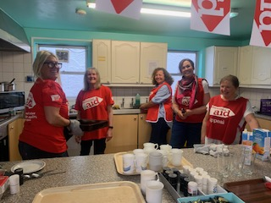
We believe in life before death
Big Brekkie Kitchen!
We had a wonderful start to Christian Aid Week in the Christian Community Centre, with a coffee morning followed by a delicious lunch, with Marge's home cooked ham and a huge variety of salads, followed by desserts to die for, organised by Lindsay.
We had a very successful cake sale and our gardens will be looking good and producing well after our plant sale. Many, many thanks to all who helped to make it a marvellous morning with their generous donations and giving.
In the middle of the week we had a most enjoyable Big Brekkie at Judy's raising £208.00. Then came the second Saturday with Marie and Kim cooking breakfast and what a breakfast it was! The waitress service was first class with many waitresses smiling and eager to serve. Alison and Cindy took over the kitchen at 10.00am to get our coffee morning in swing. Judy and Barbara ran another great cake stall including vegan and gluten free buns. Jo replaced Alison at the plant stall where many more plants were for sale as always. We even had Jane, a gorgeous young waitress from London, who had come specially for our Saturday event. Fiona ran from pillar to post seeing everything was in order and our very faithful Jane and Ian were making sure we knew where everything was. It is just wonderful to see all the churches working joyfully together. We raised an amazing £1,534 over the two Saturdays.
Praying comes first with us. We had special Sunday services in the Baptist Church, St Mary's and All Saints’, ending the week in the Christian Community Centre in true Christian Aid style with tea and buns and a service led by the Rev’d Andy Chislett-McDonald.
Where hardship means hunger urban farmers can grow hope. In the crowded and bustling settlements of Nairobi, most parents wake every single day knowing that they must go and earn money, otherwise their children won’t eat that evening. It’s a precarious and frightening daily struggle that no family should have to face. Rev’d Andy told us the stories of two resilient women, Fridah and Belinda, who with tools and training from our partner, Beacon of Hope, are farming vegetables in their small city backyards and feeding their families and earning an income. Together, we have helped support some families escape the cruel grip of urban poverty.
And the acting and giving carries on. Our next big occasion is our annual garden party in Roger and Lindsay's beautiful garden on Saturday 13 June 2pm-4pm.
Lord, you have promised to hear us when we call on you. Bless those who are battling hunger and hardship. Open our eyes to the challenges our global neighbours face each day. Amen
Marie, Lindsay and Mary
Leprosy – treating the current pains of an ancient disease
Few diseases have left as great a cultural mark on humanity as leprosy (also known as Hansen’s disease). The disease, caused by long-term infection of body cells by a bacterial parasite, most often affects the skin and nerves; but infection can also spread to the eyes, bones, lungs and reproductive organs. The most serious of these health effects can be life-changing, with permanent disfigurement, blindness and disability occurring in untreated cases.
A consistent companion of the disease throughout history has been the fear and stigma of those affected. This stigma contributes to the difficulty of monitoring and combatting outbreaks.
Leprosy cases have fallen dramatically worldwide in the last 40 years since effective drug therapies have enabled patients to be treated and even cured. However, the disease remains present worldwide, with highest case numbers in Brazil, India and Indonesia.
Support from charities and non-governmental organisations (NGOs) is essential to maintain progress towards global zero leprosy. Charity organisations such as LEPRA and The Leprosy Mission work together to coordinate projects targeting leprosy transmission and treatment.
A significant barrier to leprosy research is the difficulty of growing the bacteria under laboratory conditions. My work at the University of Exeter hopes to address this by improving understanding of the unique metabolism of the leprosy bacteria. This may allow for future culturing of the bacteria within the laboratory. Laboratory cultures may allow for the testing of new treatments, or even the development of a vaccine to prevent further transmission of the disease. It is my hope that with renewed scientific focus, and the efforts of international health organisations and charities, leprosy may finally be consigned to history within this century.
Michael Perret
PhD Student, Department of Biosciences, University of Exeter
The Cake of Kindness by Gill Calvert
When my husband (Rev’d John) was training for teaching in Salisbury, we rented a house in a lane on the edge of Shaftesbury. Shaftesbury is an attractive small town (remember the Gold Hill Hovis advert?) but initially I saw little of it as I was experiencing a very difficult second pregnancy. Living across the road was a local French teacher called Jaqueline. We had not spoken many times, but she had heard I was unwell and one day she appeared at our door with a lovely tray of cake slices. The memory of this simple act of kindness has remained with me for fifty years and the recipe became a family favourite. Matrimonial cakes like this are not uncommon – after all, marriage is often a mix of the rough, the smooth and the sweet but the derivation of Harradence remains a mystery.
Harradence Matrimonial cake
Ingredients:
Crumble base and topping:
125g each of butter, light brown sugar and oats; 175g plain flour; 1 tsp baking powder plus pinch salt
Filling
250g chopped dates; 175ml orange juice or water; 160g light brown sugar
Method:
Preheat oven to 190C or fan 170C. Well grease a small tray-bake tin approx. 30cm x 20cm. Simmer the filling ingredients until a soft, thick paste and then cool. Roughly mix the crumble ingredients together and firmly press approximately two thirds onto the base of the tin. Cover with the cooled filling and sprinkle the remaining rubble-like crumble over the top. Bake for 30-35 mins, until topping is lightly browned. Mark out the slices (14 if you want generous helpings) while hot, but leave until cold before lifting out of the tin. This makes an ideal sweet treat for picnics.
Torbay Galliard Recorder Consort
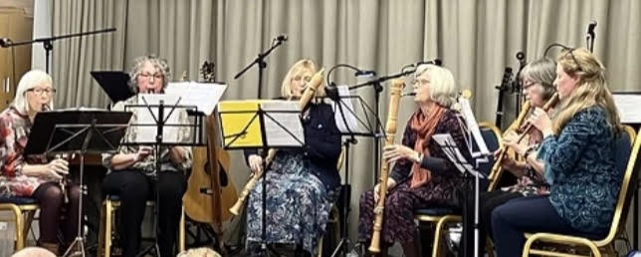
The Torbay Galliard Recorder Consort is a Brixham-based group of enthusiastic instrumentalists. Members play a wide range of recorders, descant, treble, tenor and bass, and are enthusiastic to share the music performed on this combination of instruments. Their repertoire covers music from the Baroque and Renaissance period up to present day compositions including folk music.
The Consort are very grateful to Churston church for letting them rehearse there every Tuesday morning. In 2025 they performed on numerous occasions at Churston church, including the Quay Harmony Choir concert, during Agatha Christie week and at the poinsettia remembrance morning.
They have also performed at Brixham Folk Club and have performed on two occasions for the children of Furzeham Primary school. They would love to perform for other schools in the area. Their time is given freely. Recently they played at a fund-raising event at the Galmpton Institute for Dart Sailability and entertained members of the Good Companions Club at the United Reformed Church Brixham.
The Consort will be playing at the Galmpton Open Gardens on 14 June. J B

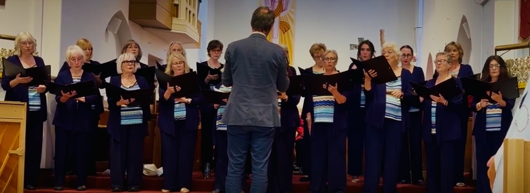
Quay Harmony Ladies Choir
Quay Harmony is a Brixham-based social ladies choir who recently delighted an appreciative audience as guests of the Brixham Orpheus Male Voice choir at a spring concert held at St George’s church, Goodrington, in aid of Children’s Hospice South. Conducted by their very talented musical director, Jeremy, and accompanied by an accomplished pianist, Karen White, they performed a varied repertoire including May It Be from Lord of the Rings, Fix You by Cold Play and Anthem from Chess.
They hope to hold their Summer Concert this year on Tuesday 16 June 7pm - 9.30pm (tbc - please look out for further details). Guest performers will be the Galliard Recorder Trio and the very talented folk group, the Sea Hounds. Refreshments will be provided by the church community members. Proceeds from the concert will be split equally between the church and the choir. Please support us.
The cost of entrance to the concert is £8 payable on the evening. Jan B
Churston News
It was the feast of the Good Shepherd on 26 April - very appropriate for the Barn Chapel. Please pray for the Barn and for the congregation who attend very faithfully and regularly. Also pray for the users of the Chapel and Hall during the week - the children who attend Breakfast Club, the artists, the school, the yoga group and Pilates people, dancers, singers and of course our Stay and Play group. There are also others such as party goers. We are fortunate to have such a lovely facility right in the heart of Galmpton and, now it is looking so good and feeling so much warmer and brighter, we can be very pleased with what we have achieved. Special thanks to Jonathan Bye who has put in such a lot of effort, not just with the Barn Hall project but also continuing to look after the Barn Chapel and Hall, along with Lynn Milner. Lynn is hanging up her dusters after thirty years of hard work, and we thank her so much for her diligence over such a long period. Lynn will still be taking bookings for the Barn Hall, and keeping an eye on things. We welcome Yuliia who is taking over the cleaning on Friday afternoons.
Back to shepherding and I am sure you are familiar with this lovely poem by William Blake:
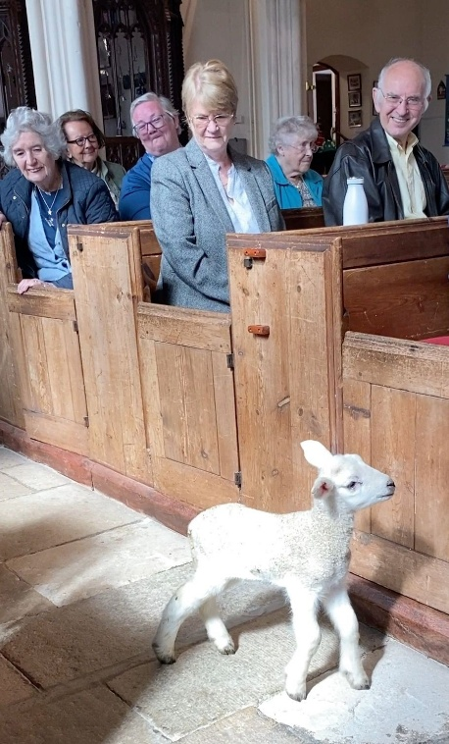
Little lamb, who made thee?
Dost thou know who made thee,
Gave thee life, and bade thee feed
By the stream and o'er the mead:
Gave thee clothing of delight,
Softest clothing, woolly, bright:
Gave thee such a tender voice,
Making all the vales rejoice?
Little lamb, who made thee?
Dost thou know who made thee?
Little lamb, I'll tell thee;
Little lamb, I'll tell thee;
He is calléd by thy name
For he calls himself a lamb,

He is meek and he is mild,
He became a little child;
I a child, and thou a lamb.
We are calléd by his name.
Little lamb, God bless thee!
Little lamb, God bless thee!

Jane Washington

St Mary’s, Brixham
With an early Easter this year the Easter season was well and truly underway when May began, and it culminated in the Ascension Day BMC service at Kingswear, celebrated with a choir of twenty, mostly from the BMC churches. A lovely service.
Our APCM at the end of April resulted in new churchwardens, a new secretary, and a light lunch and presentations for Roger, our outgoing churchwarden, and Alison, our treasurer, both of whom had seen us through Covid, two vacancies and the sad death of our beloved sister Susan (churchwarden) RIP. Thanks to them for their faithful service to a church they love.
As usual we supported Christian Aid Week by supplying delicious salads and desserts for the lunch in the Community Centre in Fore Street at the start of the week. A great feast was enjoyed by all (see Christian Aid report page 14).
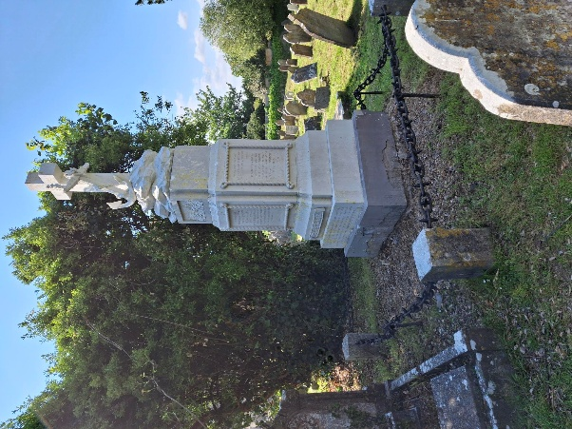
The following day saw the Fishermen’s Remembrance service (see report page 9). In remembrance of a family member who died in the Great Gale 160 years ago, Julian Lane has very kindly offered to clean the monument to the seamen lost that day which stands in our churchyard.

Members of our choir joined with other BMC choristers at All Saints’ for the wedding of two of their parishioners, taken by Rev’d Angela Sumner.
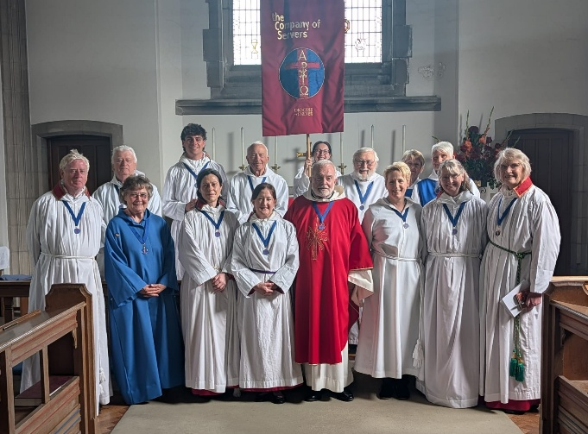
Our servers went to St James’ church in Exeter the following week for the annual service for the Exeter Chapter of the Company of Servers.
From Ascension Day we moved to Pentecost, and with Hilary LLM’s lead we well and truly celebrated the coming of the Holy Spirit, with many of the congregation turning out in red/orange/yellow.
Our retired clergy and LLMs work very hard to ensure the continuity of worship throughout the BMC. We are particularly excited by the W-A-L-K service on the second Sunday of each month at St Mary’s: W – Worship/A – Ask/L – Love/K – Know. Children from Brixham C/E Primary School have helped enhance this service with their participation in leading prayers and singing, and they particularly enjoyed May’s W-A-L-K service where waffles were cooked and served before the service. Yum!
From Pentecost we move to Trinity Sunday and a joint BMC service at St Mary’s to celebrate the three-in-one: Holy, Holy, Holy, Lord God Almighty....God in three persons, blessed Trinity.
Onward into Ordinary Time, which we know is anything but ordinary, and the SUMMER. LW

Messy Church St Mary’s, Brixham: May 2026
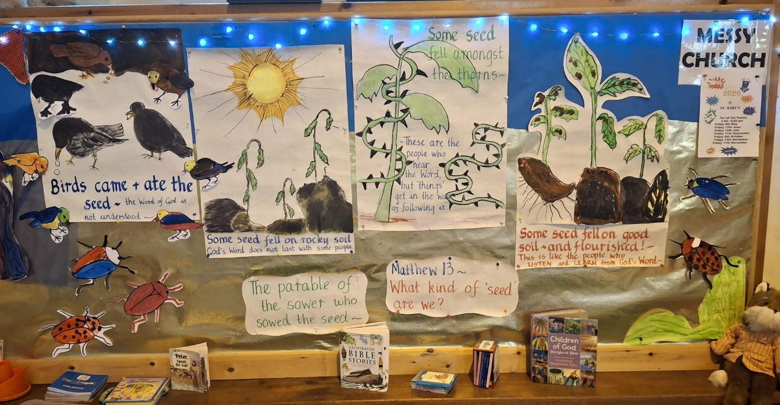
Jesus said, ‘I am the Bread of Life….’ This led us to consider the sowing of the wheat to make the bread, and thence to the Parable of the Sower. We had great fun painting the pictures to illustrate the parable and then thinking about the meaning behind the story.
After a game, story and singing, great fun was had making sandwiches with different fillings, in a variety of shapes. And…….’Dampers’, which were fun to make and were cooked as we ate supper and then taken home to enjoy with a small pot of jam.

Everyone also made
- a ‘Bread of Life’ card as a reminder
- an illustrated card of the Parable of the Sower
- a summer-opening flower with a prayer
- a promise to look after their pot of seeds.
Thanks as always go to all who help giving the Messy-Churchers a good time, with the message from the story to remember in a variety of ways, and a splendid supper afterwards.
Our next Messy Church is on Friday 12th June after school and is open to all under 12 (children please bring an adult).
For further details please contact Lindsay 07813 311613 or Lesley 01803 854036. LW

All Saints’, Lower Brixham
Easter at All Saints:

This special time in our church year always includes our Stations of the Cross service. Fourteen wooden depictions of our Saviour’s final earthly journey, which normally adorn St Peter’s Chapel, are mounted around the main body of the church. LLM Martyn Hodge then leads us on a journey of pathos as each stage of the Crucifixion is remembered by appropriate readings at each Station. Occasional recorded music from Sacred Weave adds to the solemnity of the service. Almost twenty worshippers took the journey before quietly and thoughtfully taking their leave of the church.
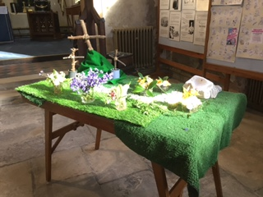
Our Garden of Gethsemane is also a reminder of that fateful, yet in many ways glorious, three days and we thank Phyllis for once again creating that place within All Saints’.
Peter

LYTE FINGERS – DOWN ON THE FARM!
A recent sermon by Rev’d Angela inspired her to ask Lyte Fingers to make a flock of sheep. (John 10 v.1-14)
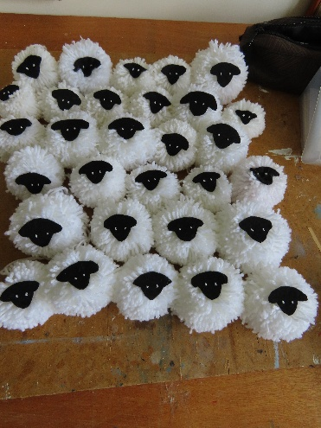
The thoughts of many at All Saints’ church now are focused on ways to raise much needed funds. Rev’d Angela’s intention and hope is that we can sell sheep to members of our congregation, and maybe the wider public, not only to raise money, but to remind them of Jesus, the Lamb of God, but also the Shepherd of his sheep. Since then, a great effort has been put in to make fifty sheep and Rev’d Angela talked more about her project at the Pentecost service on Sunday 24 May.
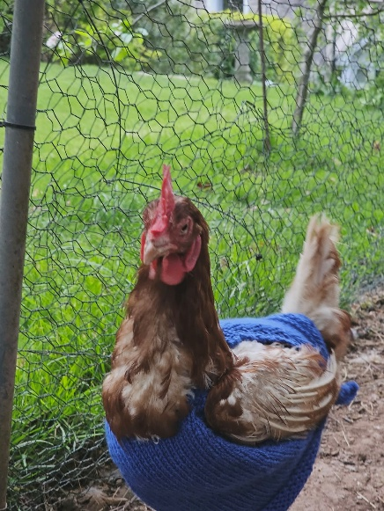
Meanwhile, Rosemary has been knitting jumpers for rescued battery chickens. These poor creatures have been plucking out their own feathers through stress and boredom, and it is hoped the jumpers will not only provide them with some warmth, but will give them something else to pluck, rather than themselves.
We have accumulated a good stock of goodies for the Quayside Market, and knitted squares for blankets are continuing. Margaret has been in touch with Jonathan Parr, who, together with his wife Wendy, is in liaison with several other groups sending goods to Ukraine, not only blankets but medical equipment, clothing for children etc. Margaret has delivered another five blankets to him (see following report).
Marion Turner
Blankets for Ukraine
There are currently three major charities in South Devon/North Cornwall actively supporting charities and military units in Ukraine, with the supply of vehicles, medical equipment, food, clothing and blankets. They are CR2EE in Exmouth, Ukrainian Action Devon based in Stoke Gabriel and Sending Love to Ukraine, based in Callington.
The blankets which you supplied recently, and the blankets and aid you supplied previously through Brixham Future went directly to Ukraine. The latest batch of blankets will be delivered to CR2EE with other aid that I have collected from other sources. These vehicles go out monthly.
As to Ukraine now, a lot of countries like Norway, UK, the Netherlands, Germany and mainly other European countries and Canada are supplying vehicles to the front line. On average due to FPV drones these have limited lifetimes, between six and twelve weeks. Currently Ukraine is winning the drone war and has recently taken back over 412km of invaded land, causing major loss of life to the Russian invaders. In April this number was approximately 34,000 men/women, and the figure for May is likely to be higher. The Russians are actively targeting the civilian population, which means that blankets and other items are always required, whether for the civilian or military hospitals.
My wife and her friends are actively knitting baby clothes for maternity wards and collecting soft toys.
from Jonathan Parr, our contact for despatch, submitted by Margaret Dyer
The Custom of the Sea
The laws of England are constantly evolving. Prior to this case coming before the courts ‘the custom of the sea’ was a get-out-of-jail-free card for all sorts of shenanigans on the high seas.
Pear Tree Church is the oldest Anglican Church in the world, its building being commissioned just after the formation of the Church of England.
On 19 May 1884 the Mignonette set sail from Southampton, bound for Australia. Damaged in a storm in the Southern Ocean, she subsequently sank. The four survivors took to a lifeboat: Richard Parker, the 17-year-old cabin boy, and three older able-bodied seamen.
There is a memorial plaque to Richard in the burial ground at Pear Tree Church, Southampton. continued

The Custom of the Sea
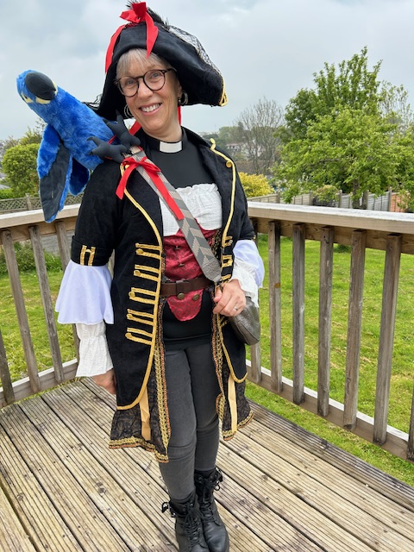
It has been ruled that
The Custom of the Sea
Is no longer acceptable
And can have no part

In debates in this
Courtroom.
Murder, in extremis, is murder
Regardless that the evidence

Has been eaten. Our favourite pirate
Richard Parker, a young man and her friend during
Came on board, a cabin boy Brixham Pirate
Expecting to serve, not be served Festival!

Sliced and diced
His heart and liver
The first to go
Skull and bones chucked
Into the Southern Ocean.

One man acquitted
He’d eaten but not killed
The others on a boat
Back to Botany Bay.
Stephen Bellows


Alex Rehaag, Affordable Housing Manager at Torbay Council, has kindly approached our Rector, to ensure that our Brixham Mission Community is aware of the new St Kilda’s housing scheme in Brixham.
CONTRIBUTIONS FOR JULY MOVING FORWARD TOGETHER:
I would be grateful if you could send contributions
by Sunday 21st June, to Debbie Perret, BMC Administrator, at debbie.brixhammc@gmail.com

Dates for your diary
JUNE
Wednesday 3rd 9.15am St Mary’s hall
Men’s breakfast
3rd Bp James pilgrimage
Thursday 4th 10.30am St Mary’s Corpus Christi
Eucharist
Friday 12th St Mary’s Messy Church
Saturday 13th Hunters’ Moon, Horsepool Street
Christian Aid Garden Party
FORTNIGHTLY
Friday 7.00-9.00pm in term time
St Mary’s Youth Group 11 -18s
WEEKLY
Thursday 9.30-11.30am St Mary’s church hall
Mummy & me
Friday 9.15-11.15am Barn Chapel Stay & play


Coming soon…to
Brixham Does Care Café
(A.K.A. The Function Room in
Brixham Town Hall)

Monday 29th June 2026
1.15-3.15pm

Sunshine Singalong

Don’t sit at home.
Enjoy an afternoon of fun and entertainment.
Dig out your summer shirts and dresses.
Come along and sing along with Martyn.
Sit back and enjoy yourself
With new-found friends.
Donated raffle prizes would be appreciated.

WHO WE ARE
Revd Dr Philippa Bellows, Team Rector rectorbrixhammc@gmail.com 01803 927797
Revd Angela Sumner, Associate Priest (SSM) 01803 853959
Debbie Perret, Administrator debbie.brixhammc@gmail.com 07790 104293
LICENSED LAY MINISTERS (LLMS)
Wendy Emlyn 07785 573145 Margaret Pickthorne 07969 474613
Martyn Hodge 01803 851302 Elaine Vestey 07930 815155
Hilary Hyde 01803 852323
-------------------------------------------------------------------------------------------------------------------------------
PARISH OFFICERS
ALL SAINTS', LOWER BRIXHAM
Warden: vacant
PCC Secretary: vacant
Organist: Mr R Thomas 01803 850125
Choir Director: Jean Aird (Mrs Jean Holman) jeanaird@aol.com 01803 858235
Treasurer: Mr I A Webb ianw@iawaccountancy.co.uk 01803 845961 Safeguarding: Martyn Hodge martynhodge47@gmail.com 01803 851302
-------------------------------------------------------------------------------------------------------------------------------------------
ST MARY'S, BRIXHAM
Wardens: Nichola Aldridge nicholawinstanley@live.com
Lindsay Williams ra_lawilliams@hotmail.com 07813 311613
PCC Secretary: David Roberts david@slatecottage.org.uk 01803 854036
Acting Organist/Dir. of Music: Michael Hackeson
Treasurer: vacant
Safeguarding: Ferne Raybould ferne.rogers@nhs.net
-------------------------------------------------------------------------------------------------------------------------------------------
ST MARY THE VIRGIN, CHURSTON
Warden: vacant
Safeguarding: Philip Mantell philip.81mantell@btinternet.com 01803 844128
PCC Secretary: Debbie Perret deb.perrethome@gmail.com 07790 104293 Treasurer: Mr I A Webb ianw@iawaccountancy.co.uk 01803 845961
-------------------------------------------------------------------------------------------------------------------------------------------
ST THOMAS OF CANTERBURY, KINGSWEAR
Warden: Gary Lewis Gary.Lewis@a1plc.co.uk 07940 734721 contact via Carmen Lewis 07957 432993
PCC Secretary: vacant
Safeguarding: Sandra Barton Jayne sbartonjayne@outlook.com 07341 845462
Treasurer: Carolyn Williams carolynwilliams351@gmail.com 07801 847248
-------------------------------------------------------------------------------------------------------------------------------------------
CHURCH HALL BOOKINGS
St Mary’s Church hall Mrs M Seffert 01803 853525
Barn hall, Galmpton Lynn Milner 07305 788503
------------------------------------------------------------------------------------------------------------------------------------------
OTHER CONTACT DETAILS
BMC Treasurer: Mr I A Webb ianw@iawaccountancy.co.uk 01803 845961
Funerals: The Team Rector
Baptisms: The Team Rector/Administrator
Weddings: Rachel Fox rachelpaul2506@outlook.com 07359 1432571

REMEMBER …….

ALL SAINTS’

SEA WEEK

12-19 JULY 2026

