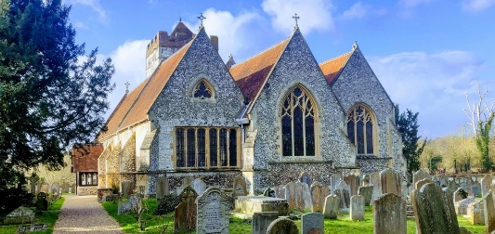
BISHAM TOGETHER
The Monthly Newsletter
from All Saints Bisham
May 2026

As we step into May, there’s a noticeable shift in the rhythm of things. The days feel longer, the evenings lighter, and there’s a growing sense that summer is beginning to edge its way closer. Gardens are coming into their own, the sound of lawnmowers is never far away, and the grass seems to grow faster than we can keep up with — a sure sign that the season is turning!
With the promise of warmer days, and time spent outdoors, comes that first hint of barbecues and shared meals with friends. It’s a season that invites us to gather, to relax a little more, and to enjoy the simple pleasures that come with lighter, brighter days.
As a church and community, May offers us an opportunity to lean into that spirit — to spend time together, to notice one another, and to make the most of the life around us. Whether it’s stopping for a chat, lending a hand, or simply taking a moment to appreciate things, there is much to be thankful for.
May this month bring a sense of warmth, connection, and quiet joy to us all — and perhaps just enough sunshine to make keeping on top of the grass feel (almost!) worthwhile.
Carol
Team Vicar

🕍 Church Life
Worship & Events:
• Every Sunday: 9.30am Holy Communion at All Saints Bisham
• First Sunday of every month: 8am Book of Common Prayer Service
- Next BCP service: 7th June

Sundays at All Saints…
As we continue our sermon series through to Pentecost (the moment God’s Holy Spirit came to the first followers of Jesus), our focus turns to the risen Jesus sending his people into the world with the good news of the gospel. In these final weeks we will be exploring the call to mission, the empowering presence of the Holy Spirit, and what it means for the Church to live as witnesses to Christ today. At Pentecost we celebrate God’s gift of the Spirit, who equips and transforms ordinary people for extraordinary service in God’s kingdom.
Then in June we begin a new series in the story of Joseph — a story full of family drama, jealousy, betrayal, reconciliation, and God’s surprising grace at work through it all. If we ever think our own families are complicated, Joseph’s family certainly gives them a run for their money! Yet through all the messiness, we see God faithfully working out his purposes and bringing hope and restoration.
We’d love you to join us as we explore this remarkable story together and discover what it has to say to our own lives and families today.

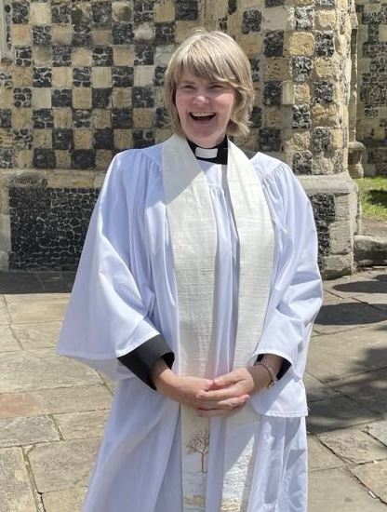
…And in other news this month:
🌱 Continuing the Journey Together
I am delighted to share that, following an interview and presentation to a panel including the Archdeacon, Rev Sam Follett our Team Rector, Rev Fiona Ellingham and Claire Wheeler, I have been appointed as Team Vicar for Bisham Church. This means that my role is now permanent rather than interim, and I am very grateful for the opportunity to continue serving the church and wider community.
I would also like to thank the church family, the clergy team, and BCF for all the encouragement, support, and prayers over the past year. It has been a real privilege to journey together, and I look forward to continuing to work alongside you all as we seek to grow in faith, fellowship, and service in the months and years ahead.

🕯️ From Darkness to Light – Easter Services across the Benefice
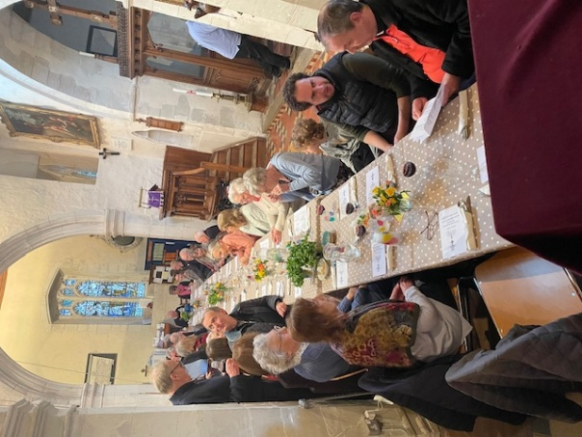
Our Easter celebrations this year took us on a moving journey from the solemnity of Holy Week to the joy of Easter morning.
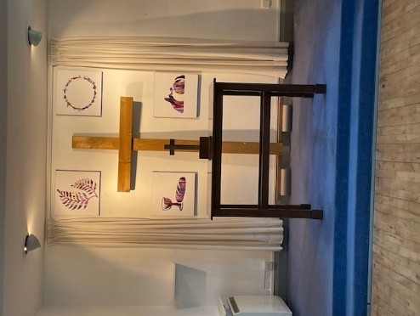
On Maundy Thursday, around 35 people gathered at St John the Baptist for a Seder Meal of roast lamb as we reflected on Jesus’ last meal with his disciples. As we shared the meal together, the Jewish traditions and symbolism that Jesus himself would have known were carefully explained to us along the way, helping bring the events of the Last Supper vividly to life.
On Good Friday, many gathered at the Lantern Church for the three-hour Service, where our very own Tim Linacre gave one of the reflections as we spent time prayerfully considering the events of the cross.
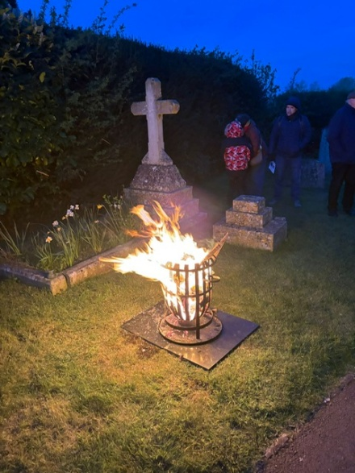
Then, before dawn on Easter Sunday, around 30 hardy early risers gathered by the river at All Saints Bisham, for our 6am Sunrise Service. In the stillness of the morning, with the warmth of a blazing brazier and the sound of the river nearby, we marked the Pascal candle together before processing into church to celebrate Holy Communion. It was a deeply atmospheric and moving service, and special thanks go to Simon and Mark for lighting the brazier and for all their help with setting everything up.
Later that morning we celebrated Easter again with a joyful All Age Service, retelling the story of the “Easter surprise” by opening a series of boxes together. Inside we found seeds to remind us of new life, plasters to remind us of the healing Christ brings, and finally — most surprising of all — an empty box, reminding us that the tomb is empty because Jesus is alive!
It was a wonderful way to celebrate the hope and joy of Easter together.

💍 Wedding Bells at Bisham
It was a real joy to celebrate the wedding of Harry and Phoebe at Bisham recently. Having worshipped with us for the past couple of years, it was especially lovely to share this special day with them and their family and friends.
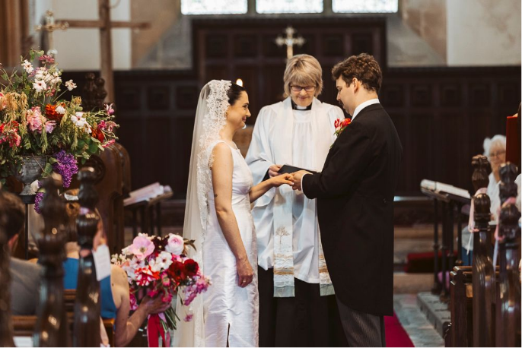
Blessed with warm sunshine and a wonderful atmosphere of joy and celebration, it was a beautiful occasion as Harry and Phoebe made their vows before God and began married life together. We continue to hold them in our prayers as they start this new chapter together.



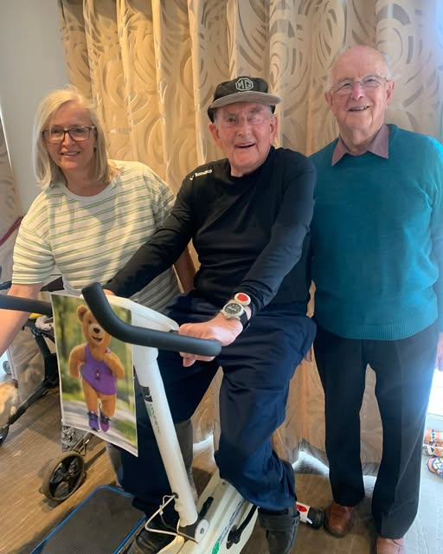
🏮Project Shine at The Lantern, Marlow Bottom
At 93 years young, one of our wonderful parishioners, Graham Cooper, proved that every effort counts by taking part in The Lantern’s Marathon Challenge.
Determined to support Project Shine, he completed 26 minutes on his exercise bike and inspired us all with his dedication and enthusiasm. We are so grateful for his fantastic contribution and the encouragement he has given to our whole church community.
….. And a message from Rev Graham Watts at The Lantern Church
Thank you so much from The Lantern Church to everyone who supported our Lantern Marathon Challenge over the last few weeks. The challenge finished with a wonderful Family Fun Day at church last Saturday, featuring Charlie Bear.
Fifteen individuals and groups took on their own “Marathon Challenge” of completing 26 different tasks and gaining sponsorship. Donations are still coming in, but around £16,000 has already been raised for Project Shine, while also helping to raise its profile across Marlow Bottom.
On a personal note, thank you to everyone who sponsored my 26-mile run to Henley and back. Despite the hot weather, with wonderful companions joining me along the way, I was delighted to complete it.
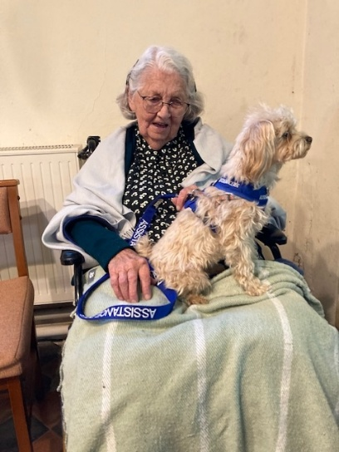
🫶 Bisham Church Friends
Our recent History Coffee Morning was one of our most popular yet, with around 50 people gathering to enjoy coffee, cake, conversation, and a fascinating talk from Sheila on the Vansittarts and their connections with India and “Indian money”.
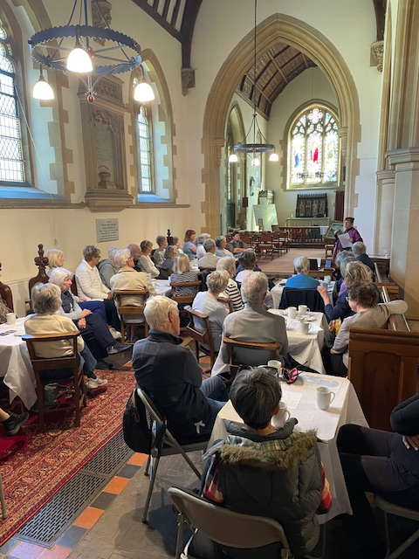
There was a wonderful atmosphere throughout the morning as people listened, chatted, and caught up together — including one very well-behaved assistance dog who also joined us for the occasion! Huge thanks go to Gina and the fantastic team of volunteers who baked cakes, served refreshments, and helped everything run so smoothly. Our History Coffee Mornings take place every month, and whether you come for the history, the homemade cake, or simply the company, you would be very warmly welcome to join us next time.
Our next coffee morning is Friday 29th May.
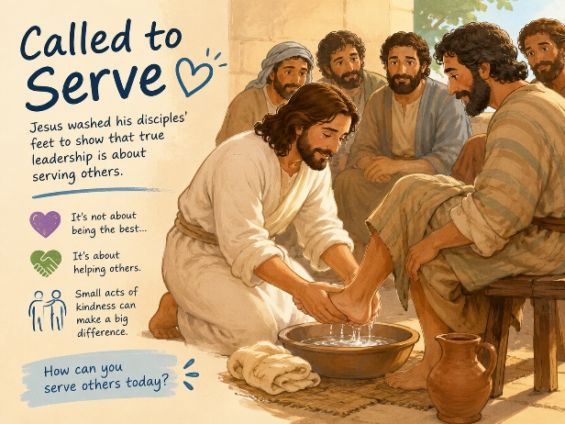
🏫 Bisham CofE Academy
It was lovely to spend time at Bisham Academy recently leading assemblies on the theme of service.
We thought together about the story of Jesus washing his disciples’ feet — a surprising example of humility and kindness, showing that true leadership is about serving others rather than putting ourselves first.
We chatted about the many simple ways we can all help and encourage one another in everyday life, whether at school, at home, or in the wider community. It was great to see the pupils engaging so thoughtfully with the theme and sharing their own ideas about what it means to serve others well.

Community Notices

Upcoming Dates:
- 29th May Coffee Morning 10am
- 30th May Marlow Riders

Contact us:

Parish Office (Marlow) | 01628 481806 | parish.office@4u-team.org
Rev Carol Cooper | 07774 061944 | carol.cooper@4u-team.org
Mark Garrad (Churchwarden) | 07738 029086 | garrad.mark@gmail.com
Daphne Dru (Safeguarding) | 07717 441437 | Daphne.dru@4u-team.org

📸 Community Gallery
A few moments from the life of our church and community this month…..
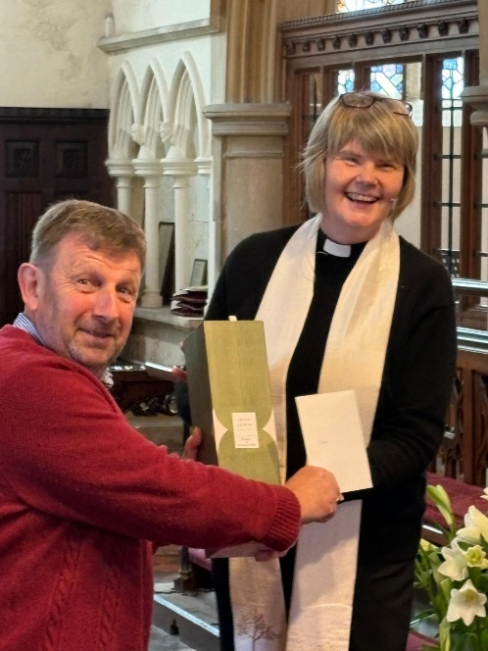
Easter Sunday – also Carol’s birthday!
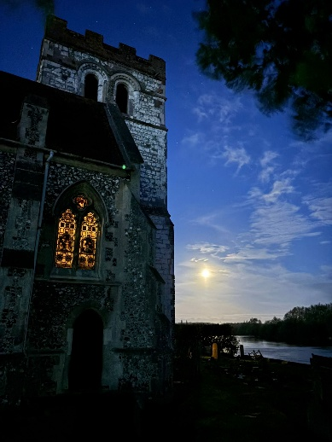
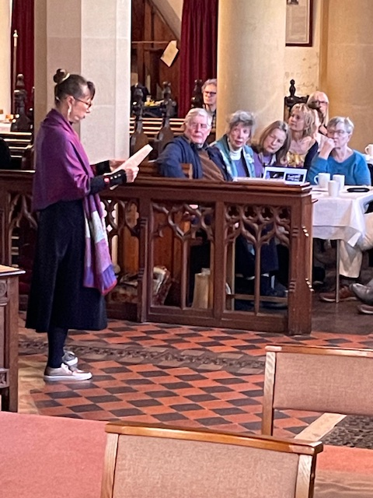
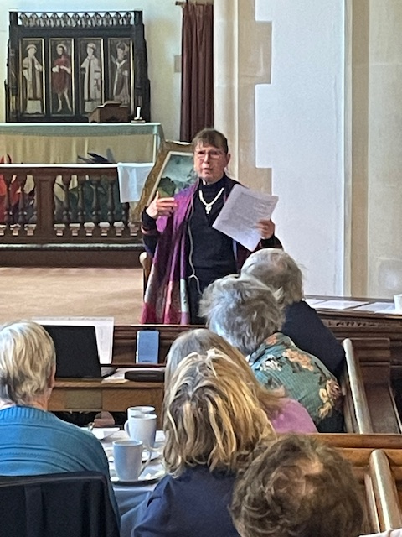
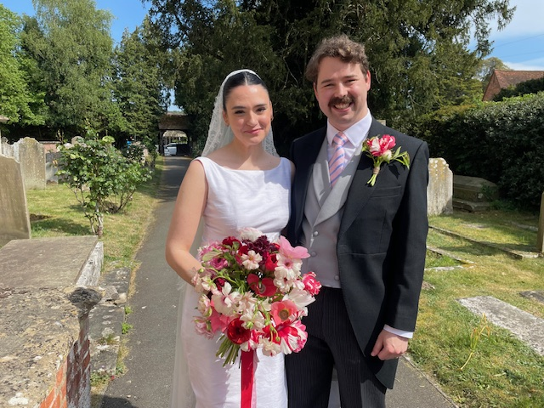
Coffee morning

