CHURCH SERVICES IN CLIFTON, THE SHELSLEYS AND LOWER SAPEY (HARPLEY)
May 2026
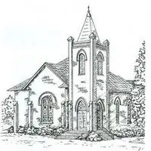

Sunday 3rd May
9.30am: Morning Praise, St Bartholomew, Harpley
10.30am: Holy Communion Service, St Kenelm’s, Clifton

Sunday 10th May
10.30am: Rogation Service, New House Farm,
Clifton Upon Teme
10.30am: ‘The Melville Service’ All Saints, Shelsley Beauchamp

Wednesday 13th May
10.30am: Holy Communion, St Andrews, Shelsley Walsh

Sunday 17th May
10.00am: Praise 4 All, St Kenelm’s Clifton
5.00pm: Afternoon Tea Celebration for Pat Snelling
6.30pm: Evensong, St Kenelm’s, Clifton

Saturday 23rd May
4.00pm: Welly Church, St Kenelm’s Clifton

Sunday 24th May
10.30am: Circle Service St Bartholomew, Harpley

Sunday 31st May
3.00pm: Outdoor Service, St Bartholomew, Harpley

