Coffee Break Praise is Back!

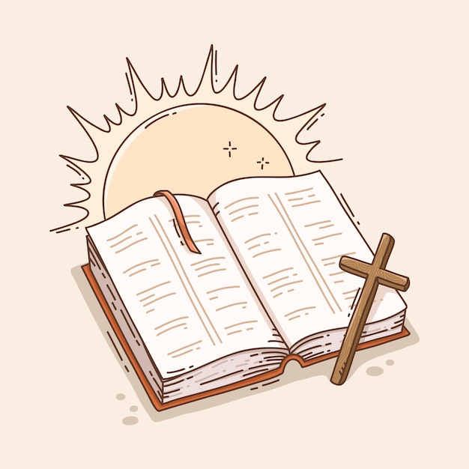

At St Helena’s Church, Kirmington
on the first Tuesday of each month at 10:30am.
Starting from 2nd June 2026

Join us for a more informal act of worship, followed by coffee, cake and chat after the service.
You are very welcome.

Let everything that has breath praise the Lord! Praise the Lord!
Psalm 150:6

