Visit us at
affinitywater.co.uk
 | Project number P023458
 | Letter date 4th June 2026

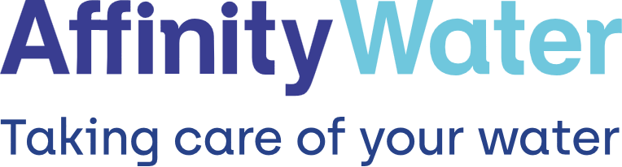

Keep up to date
We want to make sure we can keep you updated of any works in your area.
Please register for My Account or log in to check your mobile number and email address are the best ones to reach you on at affinitywater.co.uk/myaccount

Let us know if you need
a hand
If you’re clinically vulnerable, have sight, hearing impairments, or additional health needs, you can tell us by joining our free Priority Service Register. It helps us to be aware of your needs and know how to support you better.
For more information and to register visit affinitywater.co.uk/priorityservices

Hello,

We’re starting work to improve our pipes in your area
We’ll soon be starting work to carry out essential network improvements to the water mains along Stone Street, Stanford (CT21) and the surrounding area.
We’re sorry, we know it’s inconvenient for us to work near your home. These new water pipes are essential for reducing disruption from leaks and bursts, leaving more water in our precious environment, and helping us continue supplying you and the local community with high-quality drinking water long into the future.

Working in partnership
We’ve been in contact with your local Highway Authority and transport teams at Kent County Council to minimise the impact of these works on you.

When we’ll be working
- Working hours: Monday - Friday 8am – 6pm, Saturday 8am – 4pm.
- Working dates: Monday 29th June – Friday 27th November 2026

How does this affect you?
- Traffic Management: To undertake this work safely the works will be carried out under a rolling road closure. The works will be carried out in 3 phases.
Phase 1 will take place 29th June – 21st August. We will be working from the junction with Kennett Lane to the junction with B2068 Stone Street.
Phase 2 will take place 28th September – 30th October. We will be working from the junction at Stone Street, Stanford (village) to the junction with Blind House Lane.
Phase 3 will take place 2nd November – 27th November. We will be working from the junction with Blind House Lane to the junction with Pilgrims Way.
- Your water supply: Your water supply may potentially need to be turned off on one day for a few hours, whilst we connect to the new pipe. We’ll notify you well in advance. If you are water dependant or require additional assistance, do let us know or sign up to our Priority Services Register.
Access: Access to your property will be maintained during these works. We’ll keep you updated if we need to restrict access to a particular area.
Noise: To minimise noise during working hours, we have a ‘non-idle’ policy where plant and machinery won’t be left running for extended periods unless they’re actively working.

Thank you for your patience while we carry out this important work. If you'd like more information, you can get in touch with us at affinitywater.co.uk/feedback, listing the project code at the top of this letter.
For any updates, please visit affinitywater.co.uk/alerts, where you can find this location on our interactive map.

Kind regards,
The Affinity Water Team

