The Seven Sacraments Project for St Martin’s Church
After the Advent Stations were installed in December 2025 Rick, Pansy and Mark started thinking about a different creative intervention with the liturgical year and how to inspire a deeper faith conversation within our congregation. We wanted to interact with the architectural space in a more dynamic manner and tackle a less obvious aspect of the practiced faith of the people. Strangely we don’t speak about the Sacraments of the Christian tradition much, yet they play a huge role in our lives. Traditionally these rituals mark each of the major events of a believer’s life. The Sacraments are understood as outward visible signs of inward and invisible transformations made possible through God’s grace or divine love. Some are obvious; the symbol of the swapping of rings at the marriage ceremony others are private or singular such as reconciliation or anointing of the sick.
There is a wider understanding of sacramental thinking, going beyond these set rites and embracing/shaping every event in our days. If we try to live in the light of God’s Grace, then each of our actions or intentions could be considered sacramental. Unseen by others even the humblest act of service or gesture towards a stranger can be in fact an outward sign of transformative faith practice.

The sacraments are grouped into three categories;
Initiation - Baptism, Confirmation and Eucharist
Healing – Reconciliation, Anointing of the sick
Service – Matrimony, Holy Orders

Through Rick’s words, Pansy’s calligraphy and Mark’s visuals the artists want to suggest that the seven sacraments are a single interconnected root network of belief practice. A continual gentle transformation of each person. God’s loving presence in every action or act of self-control. Hope and Love bookend justice and service, in turn springing from faith and kindness. At the centre is the commemoration of the ultimate gift Christ’s self-sacrificing, the gift of God made human and poured out to redeem us. The artists also suggest that all seven are interconnected and can become interwoven in our lives, so that we embody the words drawn from Rick’s poems, rendered in Pansy’s calligraphy and delicately illustrated through Mark’s backgrounds, all of which is characterised by the congregation coming together to lift these words in songs of praise.
The linen is semi-transparent, the double layer of colours and marks will come and go depending on the sun’s backlighting, much like our shifting awareness of the sacramental lives we are called to. But often the light will shine through and lift us, renewing our potential to experience a fuller tranquil grounded life in Jesus. The individual and the community are one.

This project has been generously assisted by the encouragement of Fr Graham, St Martin’s PCC and the following participants who gave their time and energy for free. We are most grateful and hope this will inspire new works to come from others!
Calligraphy: Pansy Campbell.
Backgrounds: Mark Cazalet.
Haikus/ Lyrics: Richard Leaf.
Banner Construction: Sandra Gerrard.
Music composed by: Juliet Bowerman.
Choir arranged, conducted, recorded and mixed by: Sam West
The Choir sang numbers 1,2 and 4.
The Choir is: Jane Ali, Juliet Bowerman, Marcia Burke, Louise Williamson, Tom Doyle, Deb Penny, Sandra Sappleton, Barbara Robinson and Mary Lambert
Leandros Taliotis sang numbers 3, 6 and 7
William Longhurst played Trumpet on number 7.
Jane Ali and Matthew Longhurst sang number 5.
Clare Palmer played flute on number 5.
Numbers 3, 5, 6 and 7 recorded and mixed by Ben Miles.
To listen to each of the poems sung please use the QR code below to access the audio files on our website –
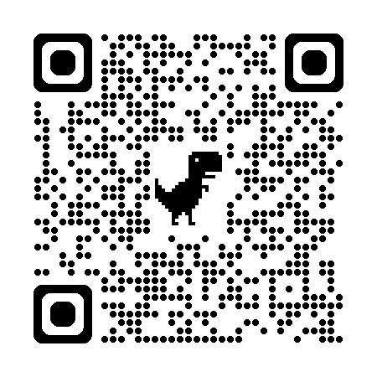
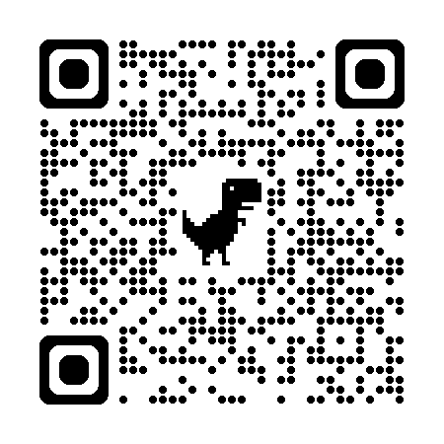

1Baptism
2Confirmation
3Confession
4Holy Communion
5Marriage
6Holy Orders
7Last Rites

