SUNDAY MORNING READING SHEET 24th May 2026 PENTECOST

A reading from the Acts of the Apostles

When the day of Pentecost had come, they were all together in one place. And suddenly from heaven there came a sound like the rush of a violent wind, and it filled the entire house where they were sitting. Divided tongues, as of fire, appeared among them, and a tongue rested on each of them. All of them were filled with the Holy Spirit and began to speak in other languages, as the Spirit gave them ability.
Now there were devout Jews from every nation under heaven living in Jerusalem. And at this sound the crowd gathered and was bewildered, because each one heard them speaking in the native language of each. Amazed and astonished, they asked, ‘Are not all these who are speaking Galileans? And how is it that we hear, each of us, in our own native language? Parthians, Medes, Elamites, and residents of Mesopotamia, Judea and Cappadocia, Pontus and Asia, Phrygia and Pamphylia, Egypt and the parts of Libya belonging to Cyrene, and visitors from Rome, both Jews and proselytes, Cretans and Arabs—in our own languages we hear them speaking about God’s deeds of power.’ All were amazed and perplexed, saying to one another, ‘What does this mean?’ But others sneered and said, ‘They are filled with new wine.’ Acts 2:1-13

Gospel
When it was evening on that day, the first day of the week, and the doors of the house where the disciples had met were locked for fear of the Jews, Jesus came and stood among them and said, ‘Peace be with you.’ After he said this, he showed them his hands and his side. Then the disciples rejoiced when they saw the Lord. Jesus said to them again, ‘Peace be with you. As the Father has sent me, so I send you.’ When he had said this, he breathed on them and said to them, ‘Receive the Holy Spirit. If you forgive the sins of any, they are forgiven them; if you retain the sins of any, they are retained.’ John 20:19-23

Events coming up:
19th June 7.30 pm - Hymns and PIMM’ s
20th June 7.30 pm - An evening with Faversham Musical Theatre Choir
21st June 10.30 am - Patronal Festival Service with the Bishop of Hertford
21st June 5 pm - Come and Sing Vivaldi’s Gloria
With a rehearsal for those who wish to sing from 2.30 pm


If you wish to make a donation to the church, then please hold Your phone’s camera over this image then touch the link that appears:

Royston Parish Church
Where all are welcome and God’s love is shared
Sunday 24th May - 6th PENTECOST

If you would like regular copies of the Notice Sheet emailed to you please email the
Parish Office at admin@roystonparishchurch.org.uk

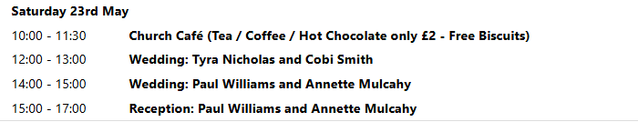
PENTECOST
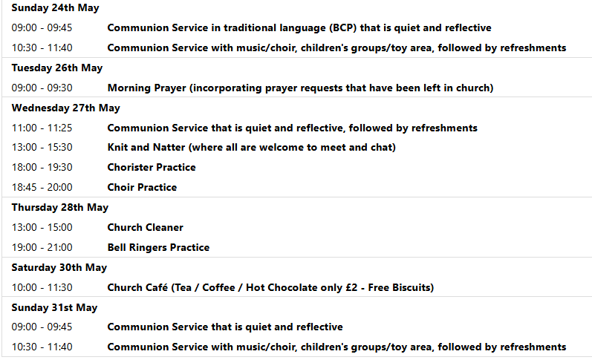
TRINTY SUNDAY

We pray for all Christians worldwide:
For all Christians in Indian Ocean Islands
For all who worship at Therfield Chapel: Paul Dutton
For the work of our mission partners: Royston Home Start

Pray for the community of Royston:
For our local health centres
For all who work on our local farms and land workers
For all our young people revising for exams at this present time

We pray for our world and ECO projects:
We pray for people encouraging their children and grandchildren to participate in gardening during National Children's Gardening Week (24-31st May 2026).

We pray for the sick and suffering:
3rd May | 10th May | 17th May | 24/31 May
Emma Thompson | Ted Rayment | Val Brown | Peter Coates
Jackson Herbert | Pat Tidey | Angie & Ken Rushall | Margaret Green
Marion | Mike Brown | Paula Walker | Peter Foster
Peggy Dawes | Cobi Smith | Laura O’nyamul  (On-Ya-Mul) | Keith & Elaine Edwards
George N | Max Elliott | William, Ruth & baby | Susan Bowles
Katie | William |  | Mike Askew

We pray for those who have died in the faith of Christ:
Deceased Bereaved
Wendy Smith Sue Canon, family and friends
We pray for those whose anniversaries fall at this time:
Jean Rice, Pauline Gates

NOTICES

JAIME’S ORDINATION: We are offering a coach to take people to Jaime’s Ordination on Saturday 4th July in St. Alban’s Abbey. To help towards the cost a charge of £10 will be made. Please sign up on the list at the back of church, and pay either Kay or Richard.

BAGS FOR LIFE: We are planning to store books left from the Book Fayre in the attic above the vestry. To make this a simple process, we are asking if anyone can spare at least 1 Bag for Life? If so, please bring and give to either Kay, Richard or Joanne. Thank you.

CONFIRMATION: Bishop Jane will be leading our Patronal Festival at 10.30 am on Sunday 21st June. If you are interested in being confirmed or to receive communion for the first time please speak to Steven.

PATRONAL FESTIVAL RAFFLE: Raffle tickets are now on sale at £1 each, they are available at the back of church. Please take some extras to sell to family, friends, neighbours and work colleagues if you are able.
We are also seeking donations of luxury food items for the 2nd prize hamper. Please leave items in the kitchen or with Joanne in the vestry. Please note, the hamper will be put together during Church Cafe on Saturday 13th June so we will need the items before then! Thank you from the Events Committee.

REMINDER We are having a tidy up of the churchyard around the head stones and tombs, on Saturday 30th May. Richard and Kay will be there at 10-30 but if others are going to Saturday coffee, they can join us afterwards. We request that they bring some gardening tools with them such as strimmers, shears, secateurs and definitely gloves.
We would like to remove the Ivy growing around the stones and remove invasive weeds.

WEDDING INVITATION. Two members of our Church, Annette and Paul, are getting married here at 2pm on Saturday 23rd May. They would really like it if members of the Church could join in their celebration and stay for refreshments before they go off to their reception.

WE HAVE A NEW BATCH OF CHURCH MUGS FOR SALE, at £10 each, sales go towards church funds. Available at Saturday coffee, or after church services.

