SUNDAY MORNING READING SHEET 31st May 2026 TRINITY SUNDAY

A reading of Psalm 8

O Lord, our Sovereign, how majestic is your name in all the earth!
You have set your glory above the heavens. Out of the mouths of babes and infants
you have founded a bulwark because of your foes, to silence the enemy and the avenger.
When I look at your heavens, the work of your fingers, the moon and the stars that you have established;
what are human beings that you are mindful of them, mortals that you care for them?
Yet you have made them a little lower than God, and crowned them with glory and honour.
You have given them dominion over the works of your hands; you have put all things under their feet,
all sheep and oxen, and also the beasts of the field, the birds of the air, and the fish of the sea,
whatever passes along the paths of the seas. O Lord, our Sovereign,
how majestic is your name in all the earth! Psalm 8

GOSPEL

Now the eleven disciples went to Galilee, to the mountain to which Jesus had directed them. When they saw him, they worshipped him; but some doubted. And Jesus came and said to them, ‘All authority in heaven and on earth has been given to me. Go therefore and make disciples of all nations, baptizing them in the name of the Father and of the Son and of the Holy Spirit, and teaching them to obey everything that I have commanded you. And remember, I am with you always, to the end of the age.’
Matthew 28:16-20

Events coming up:
Thursday 18th June 7 pm - Julian Prayer meeting 11 Middle Drift.
19th June 7.30 pm - Hymns and PIMM’ s
20th June 7.30 pm - An evening with Faversham Musical Theatre Choir
21st June 10.30 am - Patronal Festival Service with the Bishop of Hertford
21st June 5 pm - Come and Sing Vivaldi’s Gloria
With a rehearsal for those who wish to sing from 2.30 pm


If you wish to make a donation to the church, then please hold Your phone’s camera over this image then touch the link that appears:

Royston Parish Church
Where all are welcome and God’s love is shared
Sunday 31st May TRINITY SUNDAY

If you would like regular copies of the Notice Sheet emailed to you please email the
Parish Office at admin@roystonparishchurch.org.uk

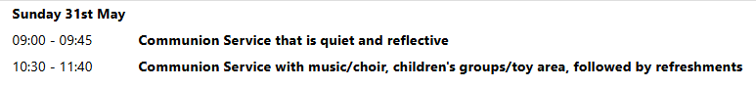
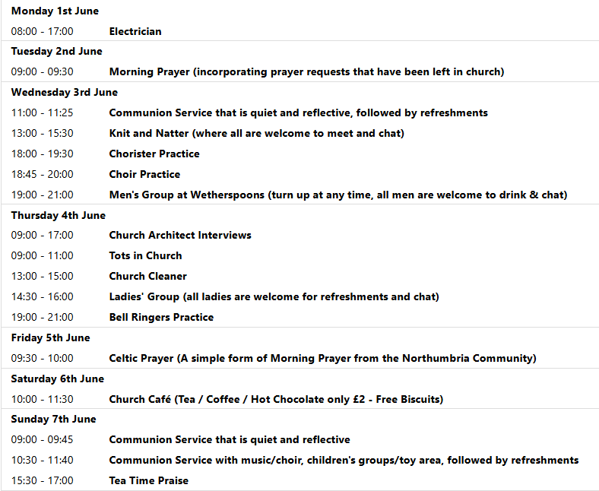

We pray for all Christians worldwide:
For all Christians in Angola, Mozambique
For all who worship at
For the work of our mission partners: Royston Home Start

Pray for the community of Royston:
For our local health centres
For all who work on our local farms and land workers
For all our young people revising for exams at this present time

We pray for our world and ECO projects:
We pray for World Environment Day - held annually on 5 June to encourage awareness and action for the protection of the environment

We pray for the sick and suffering:
3rd May | 10th May | 17th May | 24/31 May
Emma Thompson | Ted Rayment | Val Brown | Peter Coates
Jackson Herbert | Pat Tidey | Angie & Ken Rushall | Margaret Green
Marion | Mike Brown | Paula Walker | Peter Foster
Peggy Dawes | Cobi Smith | Laura O’nyamul  (On-Ya-Mul) | Keith & Elaine Edwards
George N | Max Elliott | William, Ruth & baby | Susan Bowles
Katie | William |  | Mike Askew

We pray for those who have died in the faith of Christ:
Deceased Bereaved
Wendy Smith Sue Canon, family and friends
We pray for those whose anniversaries fall at this time:
Jean Rice, Pauline Gates

NOTICES

CLIMATE EMERGENCY BRIEFING & DISCUSSION: You are warmly invited to an important and thought-provoking evening on Tuesday 7th July at 7:30pm, as Royston St John the Baptist Parish Church Sustainable Living Committee joins with the Royston Environmental Group to host a screening of the National Climate Emergency Briefing.
This event is an opportunity to come together as a community to better understand the challenges facing our world today, and to reflect on what they mean for us locally and personally. The briefing will be followed by an open, friendly discussion, where everyone is welcome to share thoughts, ask questions, and listen to different perspectives. Whether climate change is something you feel strongly about, are curious to learn more about, or are still forming your views on, we encourage you to come with an open mind. These conversations matter not just globally, but for how we care for our neighbours, our environment, and future generations. By coming along, you’ll be part of a supportive space where we can explore how faith, community, and practical action can come together in response to one of the most pressing issues of our time.
All are welcome, please invite friends, family, and neighbours.

JAIME’S ORDINATION: We are offering a coach to take people to Jaime’s Ordination on Saturday 4th July in St. Alban’s Abbey. To help towards the cost a charge of £10 will be made. Please sign up on the list at the back of church, and pay either Kay or Richard.

BAGS FOR LIFE: We are planning to store books left from the Book Fayre in the attic above the vestry. To make this a simple process, we are asking if anyone can spare at least 1 Bag for Life? If so, please bring and give to either Kay, Richard or Joanne. Thank you.

CONFIRMATION: Bishop Jane will be leading our Patronal Festival at 10.30 am on Sunday 21st June. If you are interested in being confirmed or to receive communion for the first time please speak to Steven.

PATRONAL FESTIVAL RAFFLE: Raffle tickets are now on sale at £1 each, they are available at the back of church. Please take some extras to sell to family, friends, neighbours and work colleagues if you are able.
We are also seeking donations of luxury food items for the 2nd prize hamper. Please leave items in the kitchen or with Joanne in the vestry. Please note, the hamper will be put together during Church Cafe on Saturday 13th June so we will need the items before then! Thank you from the Events Committee.

REMINDER We are having a tidy up of the churchyard around the head stones and tombs, on Saturday 30th May. Richard and Kay will be there at 10-30 but if others are going to Saturday coffee, they can join us afterwards. We request that they bring some gardening tools with them such as strimmers, shears, secateurs and definitely gloves.
We would like to remove the Ivy growing around the stones and remove invasive weeds.

WEDDING INVITATION. Two members of our Church, Annette and Paul, are getting married here at 2pm on Saturday 23rd May. They would really like it if members of the Church could join in their celebration and stay for refreshments before they go off to their reception.

WE HAVE A NEW BATCH OF CHURCH MUGS FOR SALE, at £10 each, sales go towards church funds. Available at Saturday coffee, or after church services.

