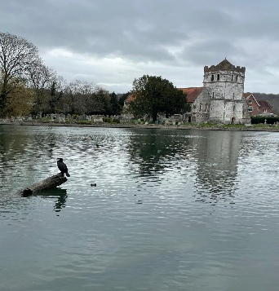
BISHAM TOGETHER
The Monthly Newsletter
from All Saints Bisham
April 2026

As we head into April and start to notice that it’s no longer dark at teatime (always a victory!), there’s a definite feeling that things are beginning to wake up again. The daffodils are out, the weather can’t quite make up its mind, and there’s a general sense that spring is on its way — even if we’re still keeping a coat handy, just in case!
Alongside all that, we’ve also made our way through Lent and into the celebrations of Easter — a season that, at its heart, is all about hope, fresh starts, and new life. Whether that’s been something you’ve fully taken part in, or simply something in the background of the season, it’s hard not to notice the theme of “new beginnings” popping up everywhere — in gardens, in longer days, and perhaps even in ourselves.
So, as we pack away the last of the chocolate eggs (or stubbornly keep them going a bit longer!), my hope is that we can hold on to that sense of renewal — take time to enjoy the lighter days, look out for one another, and maybe even try something new as a community in the weeks ahead.
Carol
Interim Team Vicar

🕍 Church Life
Worship & Events:
• Every Sunday: 9.30am Holy Communion at All Saints Bisham
• First Sunday of every month: 8am Book of Common Prayer Service

Sundays at All Saints…
Over the coming weeks, we’ll be exploring a new sermon series called Resurrection People – Disciples of the Risen Christ, inspired by the Book of Acts.
It’s easy to think of Easter as a single day, but the story doesn’t end there. Acts shows us what happens next—how ordinary people, still figuring things out, are changed by the discovery that Jesus is alive, and begin to live differently because of it. Their lives become marked by hope, courage, generosity, and a deep sense that they are part of something bigger than themselves.
This series invites us to consider what that might look like today. What does it mean to live as “resurrection people” in our own communities—in our workplaces, homes, and everyday encounters? Whether you’ve been part of church for years or are simply curious about faith, this is a chance to explore a story that is both ancient and surprisingly relevant.
Together we’ll look at how people learned to pray, to belong, to care for one another, and to step out in faith—and perhaps discover how those same patterns might shape our lives too.

…And in other news this month:
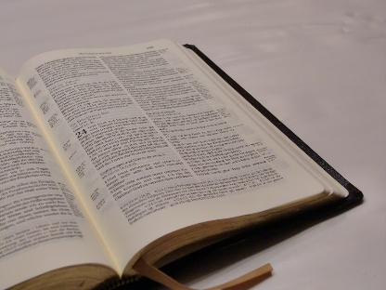
📖✨ Lent Bible Course!
Bisham Church had the majority of attendees at Cliveden Manor Care Home as we journeyed through our Lent course, together with St John the Baptist church and Rev. Fiona Ellingham.
It was a good reminder for all of us, of the importance and significance of reading the bible, sharing communion together, being mindful of the needs of others and sharing the Good News of Jesus with others too. We ended the course with a short reflective service, which affirmed the Christian Way, and pulled everything together in a friendly act of worship. A fitting end to an interesting and thought-provoking time together.

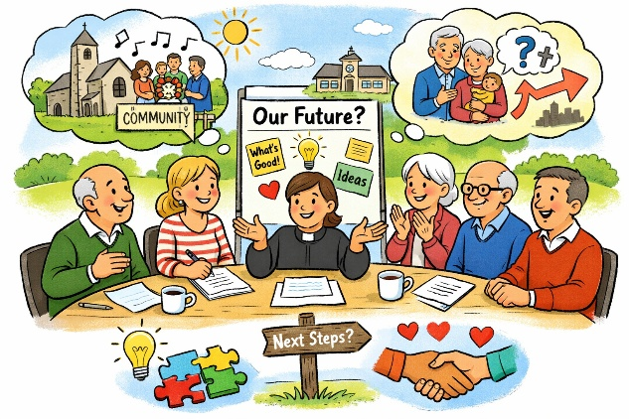
🌱 Looking Ahead Together
At our recent Bisham Church Council meeting, we began an important and hopeful conversation about the future of our church.
Using a simple approach called Appreciative Inquiry, we spent time noticing what’s already good, life-giving, and worth celebrating in our community—and there is much to be thankful for.
It was a positive and even enjoyable afternoon, as we shared stories of where we see kindness, connection, and purpose. At the same time, we’re aware of the challenges we face, particularly around the number of people who join us on Sundays and the age profile of our congregation.
This was just the first step, and we’re looking forward to the next stage, where we’ll begin to imagine what the future might look like and how we can take practical steps towards it—joining in with the good that is already happening around us.
And we’d love to hear from you, too—what do you value most about our church, and what would you like to see it offering to the wider community in the future?

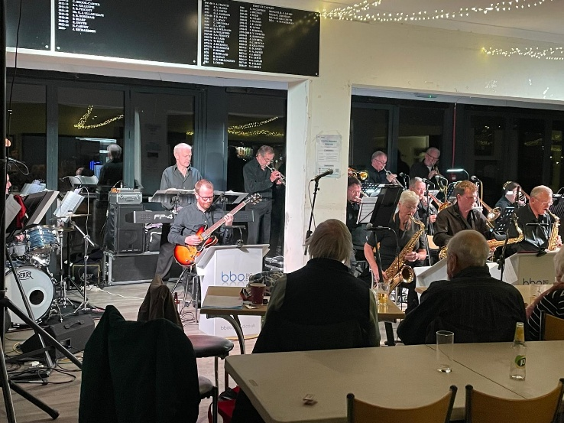
🫶 Bisham Church Friends
🎷 A Swinging Evening at Marlow Rugby Club
We had a fantastic evening recently at Marlow Rugby Club, where the brilliant BBO Big Band treated us to a wonderful concert in support of the church. With classic big band sounds, two superb jazz singers, and a room full of great company, it was a truly enjoyable night from start to finish.
Huge thanks go to the BBO for their generosity in giving their time and talent, and to Sean for organising the raffle prizes and managing the door.
Thanks also to everyone who came along and supported the event—we’re delighted that the evening raised an amazing £480 for the church!
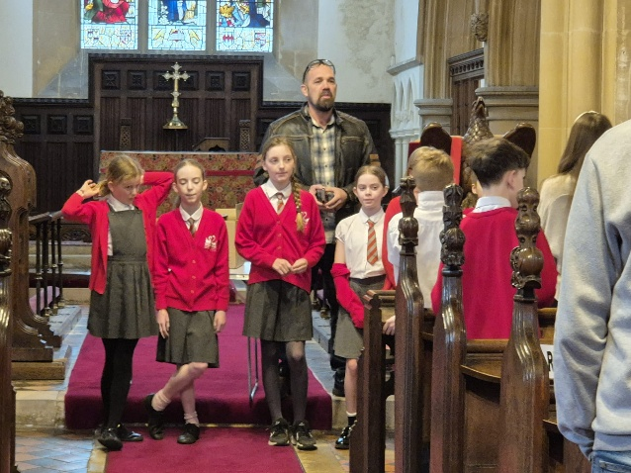
🏫 Bisham CofE Academy
🐣 Easter Surprises at Church
It was a joy to welcome our local school into church for their Easter Service, as we explored together the theme of surprise at the heart of the Easter story.
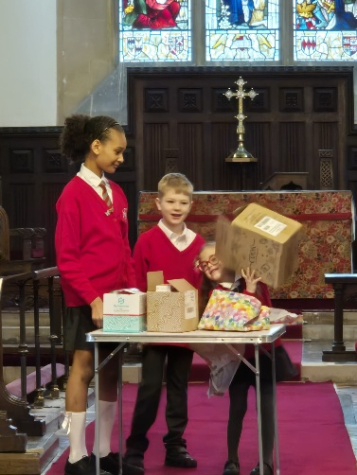
Three pupils helped bring this to life by opening three boxes: one filled with seeds, reminding us of new life; one with plasters, symbolising healing; and, most powerfully, an empty box, representing Jesus rising from the dead.
The children sang beautifully, filling the church with energy and enthusiasm, and pupils also led us thoughtfully in prayer. It was a lively, meaningful service and a wonderful way to share the Easter story together.

Community Notices

Upcoming Dates:

- 30th April - Coffee Morning: The Vansittarts

Contact us:

Parish Office (Marlow) | 01628 481806 | parish.office@4u-team.org
Rev Carol Cooper | 07774 061944 | carol.cooper@4u-team.org
Mark Garrad (Churchwarden) | 07738 029086 | garrad.mark@gmail.com
Daphne Dru (Safeguarding) | 07717 441437 | Daphne.dru@4u-team.org

📸 Community Gallery
A few moments from the life of our church and community this month…..
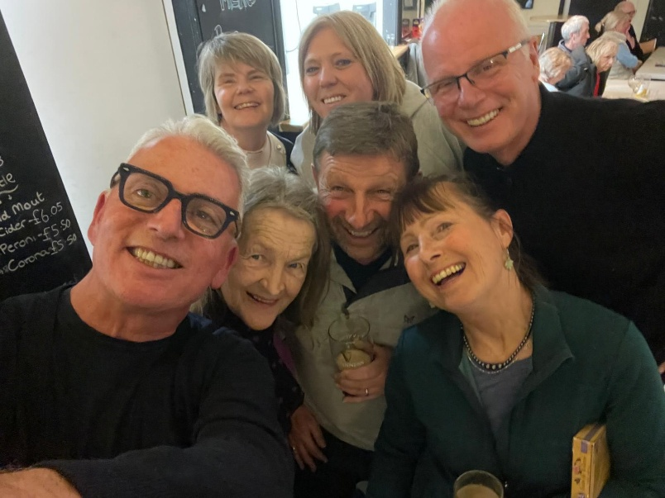
Easter School Service
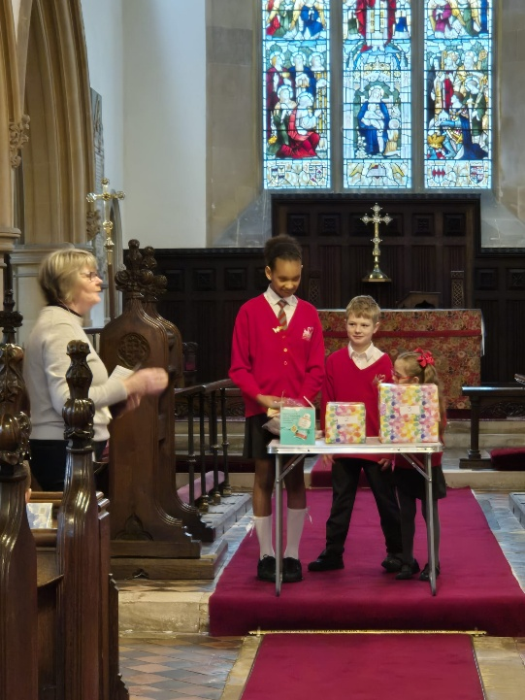
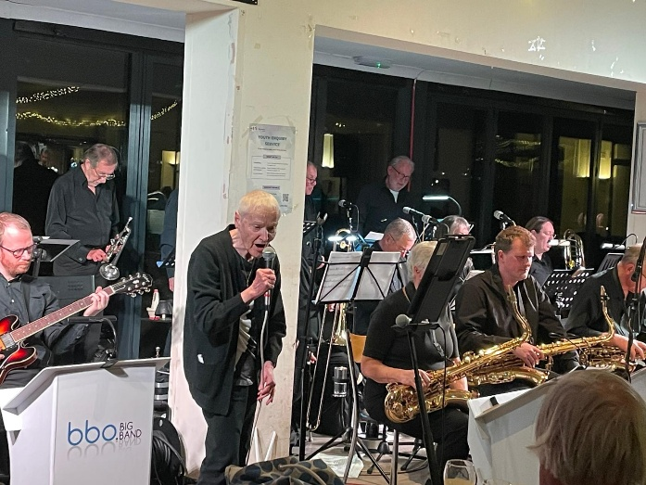
BBO Fun!!

