Into his Courts
with Praise...



A Service of the Word
for
Sunday 5 April 2026
Easter Day.

A Service of the Word for Sunday morning

This service is taken from A Service of the Word,
Morning and Evening Prayer, Night Prayer,
which is copyright (c) The Archbishops' Council, 2000,
with permitted variations.

INTRODUCTION

“He is not here; for he has been raised, as he said. Come, see the place where he lay.”
Matthew 28:6.


THE CONFESSION
The grace of God has dawned upon the world with healing for all. Though we have grieved him, yet he will heal us if we confess our sins in penitence and faith.

Almighty God,
I confess that I have sinned against you
in thought, word and deed;
I have not loved you with all my heart;
I have not loved my neighbours as myself.
Have mercy upon me,
cleanse me from my sins,
and help me to overcome my faults,
through Jesus Christ our Lord. Amen.

Receive God’s forgiveness
May the Father forgive us
By the death of His Son
And strengthen us
To live in the power of the Spirit
All our days. Amen.

PRAISE
O Lord, open my lips...
and my mouth shall proclaim your praise.
Give me the joy of your saving help...
and sustain me with your life-giving Spirit.

THE COLLECT
God of glory, by the raising of your Son
you have broken the chains of death and hell:
fill your Church with faith and hope; for a new day has dawned and the way to life stands open in our Saviour Jesus Christ.

Amen.

Suggested hymn to sing or read Jesus Christ is risen today.

THE WORD OF GOD.
Colossians 3:1-4.

So if you have been raised with Christ, seek the things that are above, where Christ is, seated at the right hand of God. Set your minds on things that are above, not on things that are on earth, for you have died, and your life is hidden with Christ in God. When Christ who is your life is revealed, then you also will be revealed with him in glory.

Psalm 118:1-2, 14-24.

O give thanks to the Lord, for he is good; ♦︎
his mercy endures for ever.
Let Israel now proclaim, ♦︎
‘His mercy endures for ever.’
The Lord is my strength and my song, ♦︎
and he has become my salvation.
Joyful shouts of salvation ♦︎
sound from the tents of the righteous:
‘The right hand of the Lord does mighty deeds;
the right hand of the Lord raises up; ♦︎
the right hand of the Lord does mighty deeds.’
I shall not die, but live ♦︎
and declare the works of the Lord.
The Lord has punished me sorely, ♦︎
but he has not given me over to death.
Open to me the gates of righteousness, ♦︎
that I may enter and give thanks to the Lord.
This is the gate of the Lord; ♦︎
the righteous shall enter through it.
I will give thanks to you, for you have answered me ♦︎
and have become my salvation.
The stone which the builders rejected ♦︎
has become the chief cornerstone.
This is the Lord’s doing, ♦︎
and it is marvellous in our eyes.
This is the day that the Lord has made; ♦︎
we will rejoice and be glad in it.

Acts 10:34-43.

Then Peter began to speak to them: ‘I truly understand that God shows no partiality, but in every nation anyone who fears him and does what is right is acceptable to him. You know the message he sent to the people of Israel, preaching peace by Jesus Christ—he is Lord of all. That message spread throughout Judea, beginning in Galilee after the baptism that John announced: how God anointed Jesus of Nazareth with the Holy Spirit and with power; how he went about doing good and healing all who were oppressed by the devil, for God was with him. We are witnesses to all that he did both in Judea and in Jerusalem. They put him to death by hanging him on a tree; but God raised him on the third day and allowed him to appear, not to all the people but to us who were chosen by God as witnesses, and who ate and drank with him after he rose from the dead. He commanded us to preach to the people and to testify that he is the one ordained by God as judge of the living and the dead.
All the prophets testify about him that everyone who believes in him receives forgiveness of sins through his name.’

Suggested hymn to sing or read Now the green blade rises.

GOSPEL
John 20:1-18.

Early on the first day of the week, while it was still dark, Mary Magdalene came to the tomb and saw that the stone had been removed from the tomb. So she ran and went to Simon Peter and the other disciple, the one whom Jesus loved, and said to them, ‘They have taken the Lord out of the tomb, and we do not know where they have laid him.’ Then Peter and the other disciple set out and went towards the tomb. The two were running together, but the other disciple outran Peter and reached the tomb first. He bent down to look in and saw the linen wrappings lying there, but he did not go in. Then Simon Peter came, following him, and went into the tomb. He saw the linen wrappings lying there, and the cloth that had been on Jesus’ head, not lying with the linen wrappings but rolled up in a place by itself. Then the other disciple, who reached the tomb first, also went in, and he saw and believed; for as yet they did not understand the scripture, that he must rise from the dead. Then the disciples returned to their homes.

But Mary stood weeping outside the tomb. As she wept, she bent over to look into the tomb; and she saw two angels in white, sitting where the body of Jesus had been lying, one at the head and the other at the feet. They said to her, ‘Woman, why are you weeping?’ She said to them, ‘They have taken away my Lord, and I do not know where they have laid him.’ When she had said this, she turned round and saw Jesus standing there, but she did not know that it was Jesus. Jesus said to her, ‘Woman, why are you weeping? For whom are you looking?’ Supposing him to be the gardener, she said to him, ‘Sir, if you have carried him away, tell me where you have laid him, and I will take him away.’ Jesus said to her, ‘Mary!’ She turned and said to him in Hebrew, ‘Rabbouni!’ (which means Teacher). Jesus said to her, ‘Do not hold on to me, because I have not yet ascended to the Father. But go to my brothers and say to them, “I am ascending to my Father and your Father, to my God and your God.” ’ Mary Magdalene went and announced to the disciples, ‘I have seen the Lord’; and she told them that he had said these things to her.
REFLECTION – You will be my witnesses.

Peter said, ‘We are witnesses of everything Jesus did in the country of the Jews and in Jerusalem: they killed him by hanging him on a cross, but God raised him from the dead on the third day.’

(Acts 10: 39, 40)

I want to think this morning about witnesses. We sometimes hear about the police appealing for witnesses after a road accident, or if someone has gone missing. We probably associate the word ‘witness’ with seeing. But simply seeing is not enough: it is important that a witness tells what they have seen. And witnesses, in this sense, are an important part of the Easter story.

Incidentally, the word used for witnesses in the Greek language of the New Testament is what gives us our word martyr. We think of a martyr as someone put to death for their faith, but the important thing about martyrs is that they would not stay silent: they spoke about their faith in Jesus, they ‘bore witness’ and were killed as a result.

So when we think about the Easter story, we need to think about the importance of those who witnessed the death of Jesus on the cross, and his rising from death on the third day, and in particular that faithful group of women disciples who saw Jesus’ die, and were the first to see and hear of his resurrection. (It is ironic that at that time women could not be called as witnesses in a court of law, yet God entrusted them with the most important act of witness in history.) The gospels give us some of their names: Mary Magdalene, Mary the mother of James, Salome and Joanna.

We’ll come back to them in a minute, but of course witnesses were important throughout the gospel story. There were the early disciples, people like James and John the sons of Zebedee, Peter and his brother Andrew, Matthew the tax collector and Jesus’ own mother, Mary. These all heard Jesus teaching, saw him heal people, heard him argue with Pharisees and synagogue officials. The witness of these people was passed on until it came to be written down by the gospel writers. If it had not been, we would not have these stories today.

In the account of Palm Sunday quite a number of disciples were on the road with Jesus as he entered Jerusalem shortly before his death; the inner group of twelve, plus perhaps some of the women, were at the Last Supper as Jesus shared the Passover meal with them; and some of these were also in the Garden of Gethsemane when he was arrested. How do we know? Because they told what had happened and it was remembered and passed on. Peter and probably John were outside the council chamber when Jesus was tried by the Jewish Council, and others heard him sentenced to death by Pontius Pilate. Then on Friday that group of faithful women I have already mentioned saw him die, followed Joseph of Arimathea who took Jesus for burial, and saw the stone rolled across the entrance to the tomb. Full Stop - The End - but it wasn't!

Do notice at this point that none of these disciples were expecting the resurrection. Jesus had said that he would ‘rise again’ but they had not understood, had not taken it in. The crucifixion was on Friday; Saturday was the Sabbath, the day of rest: no work, no trading, no travel. So at the first chance, early on Sunday morning, the same women came with spices to anoint the body of Jesus: a last loving act of service to their dead leader. But the tomb is empty and Jesus is gone! And now the news of the resurrection begins to spread.

Peter goes to check the tomb and comes away puzzled, but by the end of the day he and several others have actually seen Jesus alive. Thomas doubts their story, but by the end of the week he too has seen Jesus for himself. Paul tells us in his first letter to the church in Corinth (chapter 15) that in the course of the next six weeks or so, over 500 of his followers have seen Jesus alive. At the time Paul is writing, perhaps some 20 or 25 years afterwards, he says some of these people have died – but some have not. The implication is clearly, ‘If you don’t believe me, go and ask them. They will bear witness to the truth of the story.’

The story spreads, and those early Christians stake everything, even their lives, upon its being true. At the start I quoted a couple of verses from the Acts of the Apostles, chapter 10. Some time had passed since the resurrection, and Peter was speaking to the household of Cornelius, a Roman officer – the first time Peter had preached to non-Jews.
‘We are witnesses….’ he says. Other disciples suffered for speaking out: Stephen, and James the brother of John, were both killed, as were many others as the years went on. They must have been absolutely convinced of the truth of the message to be willing to die for it.

I have rather laboured this point about witnesses telling what they know, because without them we would not be gathering in church (or reading this) today. We would not have the opportunity to put our trust in Jesus.
I have heard historians say that many stories from Greek and Roman times are accepted as historical on much less evidence than we have for the life of Jesus. In comparison, the weight of evidence we have for the life, death and resurrection of Jesus is huge.

We have every reason to believe that Jesus was raised from the dead. If that is so, how can we be witnesses today? Can we, in fact, be witnesses nearly 2,000 years after the event? Yes, we can. I am going to suggest two ways:

1. The time between the events of Jesus’ life and our own time has not been a vacuum. There have been 2,000 years of Christians passing on the story, building their lives upon its truth, and in many cases facing death rather than deny their faith in Jesus. Generation by generation, the story has been tested and found convincing. As I have been saying, the evidence for the resurrection is massive, and if anyone is in doubt we can tell them so.

2. And then, just as convincing, we can tell them about our own experience of living as followers, as disciples of Jesus today - of the difference it makes to our lives to know that we have a Saviour who has experienced human life with all its joys and sorrows, pains and consolations – of the extra dimension added to life in knowing that Jesus is there with us.

In other years around Easter time I have quoted a little saying which means a lot to me:

‘Christians do not follow the teaching of a dead leader, they share their lives with a living Lord.’ To this truth, we can ourselves bear witness. So I shall end with a verse from the (New Testament) Letter to the Hebrews:
‘Jesus Christ, the same yesterday, today and for ever.’ (Hebrews 13: 8)

Jonathan Falkner.

Suggested hymn to sing or read Jesus, Prince and Saviour.

THE CREED
All I believe in God the Father,
whose loving care is the pattern for family life.

I believe in Jesus, the Son of God,
who lives in my heart through faith,
and fills me with his love.

I believe in God the Holy Spirit,
who strengthens me with power from on high.

I believe in one God;
Father, Son and Holy Spirit. Amen.

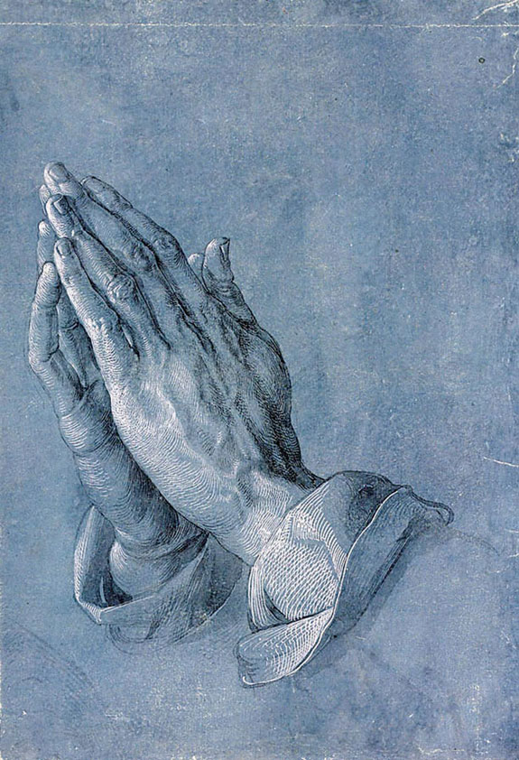

THE PRAYERS
A time of quiet prayer for
• The universal Church - Bishops, synods and all leaders church
• The leaders of the nations
• The natural world and the resources of the earth

Lord Jesus, you are the Prince of Peace.
Look upon our divided world
to be with those who are victims of violence.
We pray for the people of Ukraine
and all who have been subjected to the cruelty of others.
Help us to know the gift of your peace
in the power of your Spirit and
we ask you to soften the hearts
of those who can stop the fighting.
Creator God, we ask for your aid as your children of light
living in the darkness of our world.
Amen.

Cumbria Ecumenical Spirituality Group.

Finishing with the South Calder Mission Community prayer...

Heavenly Father we thank you for the life of your Church
in this place, and in all the villages of the South Calder Mission Community;
for all who have served and worshipped you in years gone by,
for all who make up your family in our churches today,
for the faith we have in common, and for the people and traditions which make each church unique.
By your Spirit, guide and equip us,
that together we might find new ways
to reach out to our local community,
to show your love to our neighbours,
and to encourage them
to follow the Lord Jesus in their lives.
Father, we offer ourselves to your service,
In the unity of the Holy Spirit,
And in the name of Jesus Christ our Lord. Amen

and the Lord’s prayer...
Our Father, who art in heaven,
hallowed be thy name; thy kingdom come;
thy will be done; on earth as it is in heaven.
Give us this day our daily bread.
And forgive us our trespasses,
as we forgive those who trespass against us.
And lead us not into temptation;
but deliver us from evil.
For thine is the kingdom,
the power and the glory,
for ever and ever. Amen.

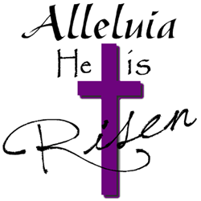

THE CONCLUSION

Suggested hymn to sing or read Come people of the risen King.

The following prayer is said
Be with me, Lord, as I finish my prayer today.
May my lips always speak the truth;
may my eyes which have read your word
see only what is good;
and may my life as well as my worship
be always pleasing in your sight,
for the glory of your name. Amen.

And now may the Lord who brought us to birth by his Spirit,
strengthen us for the Christian life.
May the Lord who provides for all our needs
sustain us day by day.
May the Lord whose steadfast love is constant as a mother's care,
send us out to live and work for others.
And the blessing of God Almighty.
the Father, the Son, and the Holy Spirit,
be with us and remain with us always.
Amen.

So now may I go in peace to love and serve the Lord.
In the name of Christ. Amen.

Links for the hymns

Jesus Christ is risen today.

https://youtu.be/Mv169n74fwQ

Now the green blade rises.

https://youtu.be/En28Je8ehDs

Jesus, Prince and Saviour.

https://youtu.be/mgD47Np2BqA

Come people of the risen King.

https://youtu.be/azEWoyjj4LI

Now the green blade rises (alternative version).

https://youtu.be/vpU01KQIUJM

