


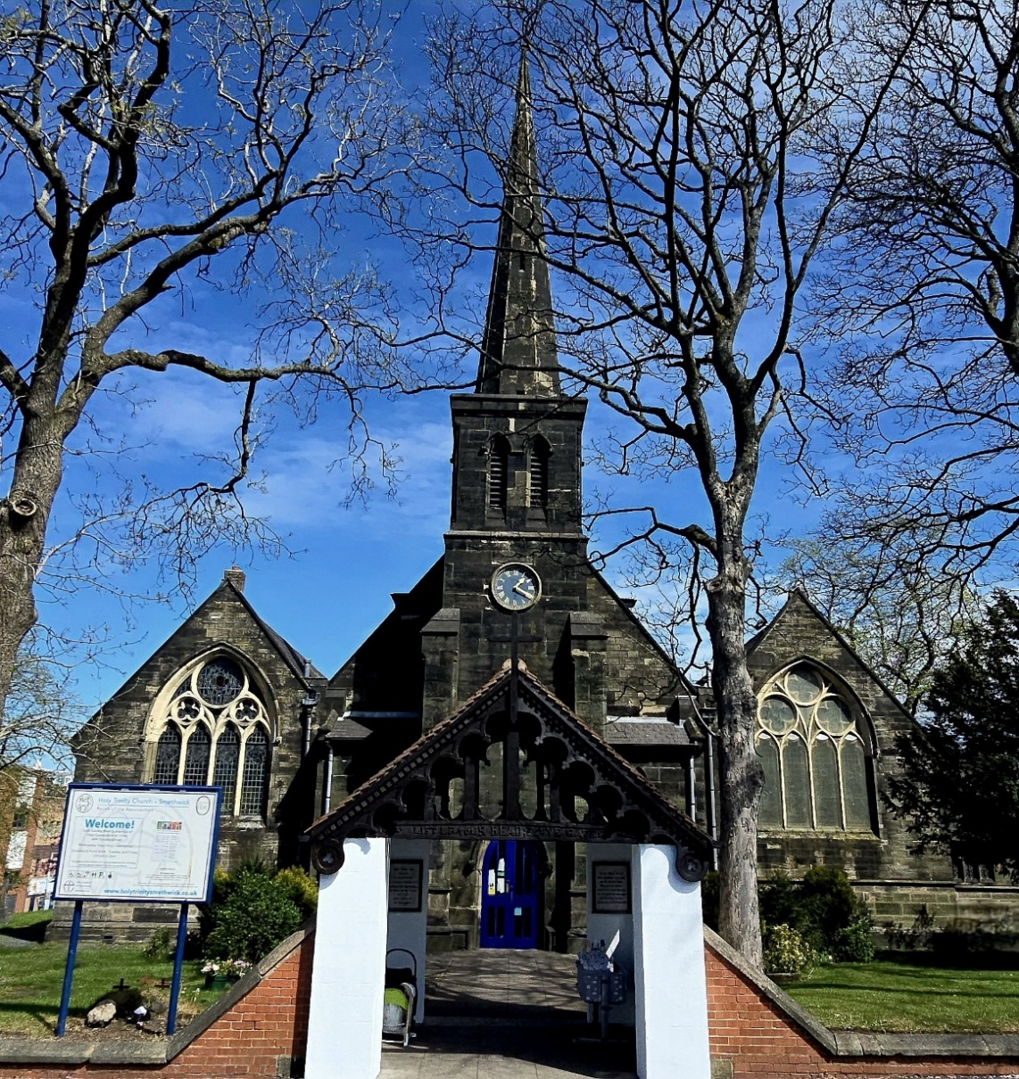
Parish Profile
This rather grey Victorian exterior shows the grime
of Smethwick’s industrial heritage, but inside is
a modern, flexible and comfortable interior. What it
can’t hide is our diverse and vibrant congregation.
Step inside…

Index
Introduction 3
Our Vision and Aims for the future. 4
Ministering to the Parish 6
Sharing the load of lay leadership during the interregnum 7
Safeguarding 8
Anglican Liturgy is our common ground 8
All are welcome in this place 9
A working church building, fit for present purpose 10
and adaptable for the future.
Our buildings speak to the history of Christianity in Smethwick 11
A financially secure church 12
Being the ‘Civic Church’ + being the Church of England 13
Schools 14
Together for Hope: our interfaith work 15
Social Events 16
The Vicarage 17
Summary: What Holy Trinity offers 18
What we are looking for in our new vicar 18

Website
https://www.achurchnearyou.com/Holy-Trinity-Smethwick
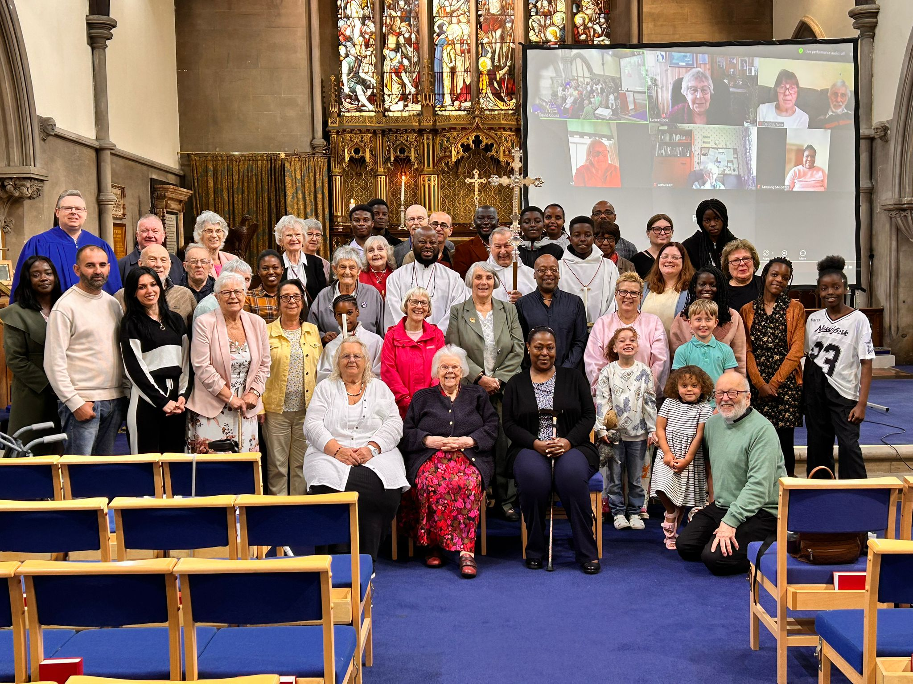
Introduction:
Smethwick is an extraordinary place. In census terms it may be a place of multiple deprivation, but in the lived reality it is a place of great richness. Cultures and faiths meet and greet and work together rather than living in silos. As a place of first settling for many asylum seekers and immigrants, it is home to countless nationalities and languages. This is a faith-filled parish. Across gurdwaras, mosques and churches, it may well have the highest regular faith attendance in the region. Holy Trinity reflects the diversity and warmth of this community both in its congregation and its relations with the other faiths in the parish.
Our congregation is always being refreshed as we welcome new families from around the world, so our numbers have remained stable despite the deaths and departures. As a consequence, we are now a much younger congregation than we were ten years ago. We wrote the following prayer for use in our monthly inter-generational services…
Loving God, we have come to worship you.
All We come from many places:
Places of security and places of insecurity,
Places of wealth and places of poverty.
We were born here
and we have arrived here from far away.
We are young and we are old.
We have come together as one in your name ©
We are moving forward with exciting plans to further the interfaith work, which has long been a particular charism of Holy Trinity, in ways that recognise the particular status of the Church of England in this setting and our responsibility towards enabling and maintaining community cohesion.
Smethwick has a great deal to offer quite apart from its rich multicultural heritage. It is surprisingly green - There are numerous parks and the canal side paths. It has excellent state primary and secondary schools – We welcome our three diverse primary schools into church every Christmas and we are always warmly welcomed at the schools for assemblies and other events. Smethwick is very well connected - Birmingham city centre is only six minutes away by train from Rolfe Street, there are excellent bus services, and the M5 and M6 are
close by.

Vision and Aims
See the following page…but before you turn over…
We have been on a significant journey over the last decade, steered in part by the vision and aims that were developed by the PCC at that time. The direction of travel set out by those aims has challenged and engaged the congregation and has yielded good fruit. Having reviewed and refreshed the vision of ‘Living God’s Love for All’ and the aims that arise from it, we believe that they still provide a proper compass bearing for the present. The PCC looks forward to undertaking a wider review and revisioning for this church in conjunction with our new incumbent.

Our vision and aims for the future
vision & aims 2025
Living God’s Love for One and All
Maintaining a welcoming, supportive and inspiring presence
for the congregation and the wider community

To share the Good News for everyone that is in Jesus Christ
…by enabling members of the congregation to confidently and clearly
express the promise of Jesus and the vision of the Kingdom
…by living in a way that speaks of the Gospel to all they meet
To welcome and nurture alike the lost, the explorers, and the believers
…by meeting them where they are and being prepared to go to new
places together
…by offering patterns of welcome and worship that encourage all to
belong, and do not frighten or exclude
To respond to the needs of the wider community by providing loving
service alongside others
…by working with Smethwick Church Action Network and other faith
groups and agencies including Sandwell MBC, to ensure that loving
service is directed towards greatest need
To seek to transform unjust and disabling structures of society
and to pursue peace and reconciliation in our community and beyond
…by fulfilling our responsibility to speak out with integrity
…by working with those who live with injustice and struggle to be heard
…by engaging more people with our interfaith work
To strive to safeguard the integrity of creation, to work for the healing of
the earth, and to pursue the greening of our post-industrial townscape
…by maintaining and improving the church’s own green space
…by working for the protection of public green space and creative
repurposing of local brown field space.
…by actively participating in the Deanery’s environmental group,
in Eco-church, and in other green initiatives.
Responding to the World’s needs
with Kingdom service

Ministering to the Parish
Holy Trinity has an enthusiastic team of people engaged in Sunday ministry. There are three ordained clergy with permission to officiate including the Associate Minister, who works part time in the church during the week as well as on Sundays. In addition there are a small number of lay people who preach on occasion, and a larger group…including some of our young people…who lead the service of the word and intercessions and read the Old and New Testament lessons. And that is before we get to our crucifers and acolytes, the leaders of Sunday School and Ascenders, our welcomers and our coffee makers…and the pastoral ministry of caring for one another which involves everyone.
We regularly run ‘seasonal’ courses, including most recently an Advent course developed ‘in house’ exploring Mark’s Gospel. A number of congregation members have done CofE Birmingham courses (3D and Growing Gifts)
We are all called to recognise and encourage the gifts of others as well as recognising and being willing to offer our own gifts. Over a third of the congregation are on one or more rotas. The encouragement to serve is an integral part of the church conversation, but this is not something we can be complacent about. In a fluid congregation, new people always need to be brought in to take up roles that have been vacated. We find particular difficulty in encouraging more people to take up the roles of teaching Sunday School and Ascenders, which take them out of worship, and to engage more people with activities and roles outside the Sunday morning slot. We are therefore focused on doing what we do as well as we can, without exhausting the resources of any individual. We need new ideas for activities aiming to reach the parts of the community that the traditional idea of church doesn’t necessarily attract, but along with the new ideas we need someone who will bring a new energy and forward momentum.
Taking ministry in its broader sense, the role of Church Wardens is vital and never more so than in the interregnum. As we only have one church warden at the moment, we are experimenting with a pattern of Associate Wardens (see following page) so that specific roles and responsibilities are delegated and the Warden provides oversight and coordination. It may well be that this is seen as offering continuing benefit beyond the interregnum and whether or not we have two wardens.

Sharing the load of lay leadership
during the interregnum
Note: We have a meeting to elect a second
warden on Sunday 21st December
Warden
Afia Owusu
Secretary to PCC
Christine Price
A.W. Buildings
David Dyke &
Anthony Marshall
A.W. Safeguarding
Nicky Edwards
A.W. Finance
Jayne Dean
A.W. Clergy Booking
Jenny Cannings
A.W. Sunday School
Lorna Peters
A.W. Sacristy
Ngozi Ugwu
A.W. Liturgy
Nick Ross
Verger
Kes Peniket
PCC
The Warden retains overall responsibility during the interregnum,
but Associate Wardens take primary responsibility for their area
and are the first point of contact for any issues / concerns.
All responsibilities are held jointly with and by the PCC as a whole

Safeguarding
Safeguarding is a primary concern and a vital part of the management of the church and the safety of the congregation…both in church and in their lives beyond church. As a church, we have taken a proactive approach to raising awareness of what we mean by safeguarding amongst the congregation. We have clear processes in place to identify any concerns, with clear lines of responsibility and prompt responses to any concerns, which has allowed us to deal appropriately with the issues that have arisen.
We have adopted the Birmingham Diocese Safeguarding, Domestic Abuse and Safer Recruitment policies which were last reviewed in February 2025 by the Parish Safeguarding Co-ordinator.
Safeguarding is a permanent item on the PCC agenda where we discuss processes and practice as well as any concerns that have arisen. We go through the Safeguarding Dashboard as a committee on a quarterly basis.

Anglican liturgy is our common ground
The liturgy is a vital anchor for our congregation, gathered as it is from across the Anglican Communion…something recognisable in an unfamiliar place. We come together on Sunday mornings for a eucharistic service using Common Worship and the set lectionary readings. Weekly or monthly service books allow us to vary our eucharistic prayers, creed etc. Once a month the liturgy is adapted for our intergenerational service where we are joined and in part led by the children and young people. On other Sundays we run Sunday School for children of primary school age/ability and Ascenders for young people of secondary school age/ability. Being liturgically driven, there is a certain formality to the service, but it is never stuffy and only sombre when it needs to be. The congregation expects clergy to robe (just as the wider community – of all faiths - expects to be able to recognise clergy by their collar when they are out and about on duty). The service of the word is led by lay people, as are the intercessory prayers. Our music is mainly traditional hymnody which, like the liturgy, is familiar to most of our congregation wherever they come from. We have a paid organist, but no choir. We are exploring ways to make more of a place in our main service for what our diverse congregation members bring from their own particular cultures, so that our worship is more reflective of all our traditions.
The Sunday service is always livestreamed on Zoom…using experience from necessity that was one of very few boons of Covid lockdown. This allows all those joining us on line to feel fully engaged with the congregation in church and the reality of the service.
All our other regular services are on Zoom only. We have midweek communion service on Wednesday and Sunday evensong, both of which use the Book of Common Prayer (BCP). Morning and Evening Prayer from Monday to Friday uses Daily Prayer App. In addition to prayer services a weekly prayer sheet is circulated on line.

All are welcome in this place
Our welcomers on the rota for Sunday mornings give out service books as necessary, but that is secondary to ensuring that everyone coming in to church…wherever and whatever circumstances they come from is made to feel at home. We are above all a welcoming church. One of our longstanding members saw a mum who was new to the church with her four young children listening to the service in the foyer. He said: “You should be in church. I was made welcome when my boys were little and everybody should be made welcome in the same way.” Sometimes we need a reminder that welcoming doesn’t stop when the service starts. We have come a long way, but we know that we still have a way to go. Baptisms are performed as part of our regular Sunday morning worship for both the current community and those who are not (yet!) part of the congregation, as a symbol of the welcome of the whole church. All are welcomed for Baptism without any qualifying period or record of church attendance and we recognise a need to improve follow-up of non-congregation baptism families as a matter of pastoral care as well as encouragement to engage more fully with church.
We are a liberal church and there is no pretence of us having a single theological stance. We welcome all to join its fellowship and joyfully share our communion while recognising and valuing our differences. As such, it is to be expected that, as on many issues, the whole spectrum of views on LLF are represented in the congregation. The PCC therefore welcomed the Bishops’ invitation to consider Living in Love and Faith prayerfully together. In light of both current patterns of authorisation for PLF and the important role of the incumbent in determining whether and how the prayers are used in practice, wider discussion of these matters will be delayed until an appointment is made.
A working church building, fit for present purpose and adaptable for the future.

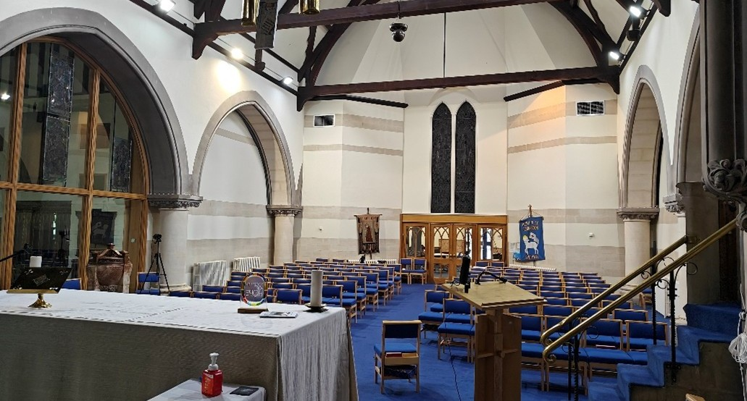

Reordering and repurposing
The church underwent major reordering in the 1970s and 90s. The two aisles were separated off from the nave to form the Lady Chapel on one side (plus vestry, kitchen and toilet facilities) and, on the other side, a church hall (plus offices). The rear of the worship space was cut off and a floor put in to create storage space above a foyer. Pews were removed and replaced with chairs. In its current form the church can seat up to two hundred with comfort (and considerably more when we have the primary schools in. The worship space is capable of being used in a number of different arrangements which allows us to alter the whole orientation for Lent and Advent, as well as allowing use for non- church / social events. The church hall is now the warehouse for the Smethwick Church Action Network foodbank which runs in the foyer twice a week. Foodbank staff occupy some of the offices on the same side of the building.

As it stands
The church is in good order, with quinquennial work up to date. It is well heated with separate boilers for each of the main areas.

For the Future?
Any further change to the building needs to be considered in the context of managing change in a grade II listed building of interest to the Victorian Society, the 20th Century Society (our dormer windows!) that sits within a council designated conservation area. We have had detailed discussions with an architectural practice about the possible development of the area above the foyer and foodbank warehouse as offices / community facilities. These have not been taken beyond the drawing stage, but the potential is clearly there to be pursued. We have had discussions with Sandwell MBC and made faculty applications about fitting photovoltaic panels to the main roof of the church. We have not had approval but the project remains on the PCC agenda as part of a longer-term plan to move from gas to electric heating.
Grounds
The church sits on Church Hill Street in a grassed plot sloping towards the High Street. The graveyard is closed. Our caretaker mows the area to the front and sides of the church while the council is responsible for mowing the longer stretch from the east end of the church to the High Street. There are a number of ideas for how we might make it a better used space, including an area of wild flower meadow.

Our buildings speak to the history of Christianity in Smethwick

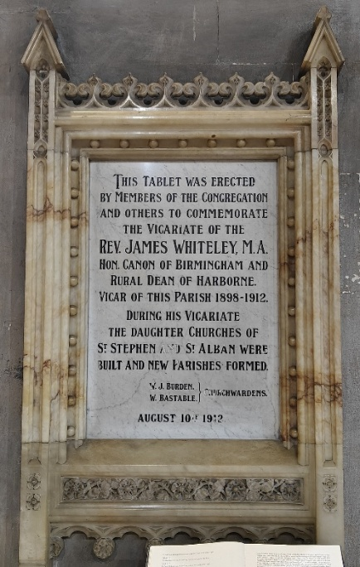
The church was originally built in 1838 as Smethwick expanded rapidly to house the population needed by new heavy industries. Only the spire and front remain from the original building. The rest was rebuilt on a grander scale in 1887 and at that point could seat 800 people. Still, the need was greater. A plaque on the wall commemorates the development of daughter churches / new parishes within the expanding town in the early 20th Century.
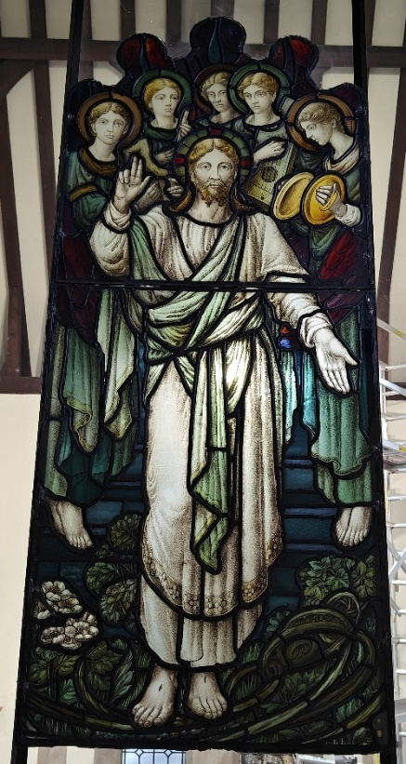
The faith demographics of Smethwick…the arrival of Sikhs and later Muslims…mean that the Christian population is significantly less than it once was. Right beside the plaque, the glass screen between the main worship space and the Lady Chapel contains stained glass from those daughter churches and others when five parishes (including Holy Trinity) were reformed into the Parish of the Resurrection: Smethwick. The range of churchmanship across those five parishes helped to create a sense of give and take which continues to serve the church well in changing times.
Smethwick used to be a major centre for the glass industry and for stained glass making. Much of the stained glass in Holy Trinity and that gathered in from the other parish churches is locally designed and made, including windows by Camm (the Annunciation Window) and Evans (the east window)

A financially secure church
As a result of the combination of parishes, the Parish of the Resurrection inherited two buildings. One of which was sold as a community centre and the money invested to supplement congregational giving. The second building…an ex-church hall…is rented out as a nursery and brings in a monthly income.
We draw down money as necessary from our investments, recognising that
the gospel calls on us to spend wisely and trust in God, rather than to bury
the ‘talents’ we have been given.
We run stewardship campaigns to try to boost congregational giving but recognising the difficult financial situation of a number of our congregation (including asylum seekers who are not allowed to work) this has to be managed with great sensitivity.

Being the ‘Civic Church’ + being the CofE
Holy Trinity is the de facto civic church for Sandwell and the Sandwell MBC. This role is partly historical but is also a measure of the facilities the church offers and of the significant (and successful) efforts made to engage with the Sandwell MBC and encourage them to see the benefits of working with the faith communities. In the past few years we have hosted Sandwell MBC services for royal occasions and the Lord Lieutenant’s Carol Service. On both occasions the services have been attended by representatives of the other faiths…something which is possible because of the civic role we fulfil. As the established church, we have a wider responsibility to all the other faiths to ensure that, as much as is possible, the council engages with them and listens to them just as it engages with and listens to the church. Although now a much smaller constituency than either Sikhs or Muslims in Smethwick, we are still looked to by the other faiths to provide that gateway and make sure that it stays open.
It's not just our work with the council and schools. We are embedded in our diverse community at all levels including those most in need through our housing and support for Smethwick Foodbank and Smethwick Pantry. These are run by Smethwick Chiurch Action Network. We are actively engaged at Trustee level but need to find ways to encourage greater volunteering from the congregation. Those who were founder volunteers for the foodbank are no longer able and we need to find new ways to present volunteering (at the foodbank or elsewhere) as part of our faith commitment.
The vicar of Holy Trinity also leads the Remembrance Sunday commemoration at the Smethwick cenotaph. In recent years, the parade to the cenotaph has been proudly led by our Crucifer carrying the cross and a Sikh from Guru Nanak Gurdwara carrying the Sikh flag walking side by side. The event is always well attended by dignitaries and by the people of the town, for some of whom this is their only contact with the church.

Schools
There are no church schools within the parish, but there are three state primary schools and one secondary school. All four schools are rated good or excellent by Ofsted. As you would expect from the demographics of the area, most of the pupils are Sikh or Muslim. We have excellent relations with the schools and we are trusted to speak the Christian message in a way that is appropriate to the multifaith community as well as to the age group and the school setting. We regularly take assemblies in the primary schools and lead the remembrance event at the secondary school every November. The trust in which we are held is reflected both in the welcome we receive and in the willingness of pupils of all faiths (and lots of their parents) to come to the church for their Christmas events.

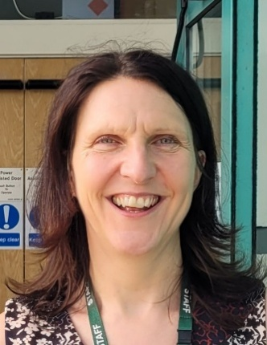
“Holy Trinity is a trusted and valued partner to many local schools, working sensitively and inclusively with children of all faiths and none. The parish actively supports schools through regular assemblies, contributions to Religious Education sessions, and by warmly welcoming pupils and staff for visits to the church. Holy Trinity is also a hub for wider community engagement, offering space for school and community events and playing a key role in initiatives such as the local food bank. This work has been vital in supporting the diverse community of Smethwick and reflects the deep commitment to compassionate, outward-facing ministry. Strong relationships with schools and local organisations are well established, offering a rich opportunity to build on a foundation of trust, collaboration, and service.”
Mrs Lynne Paino: Headteacher,
Crocketts Community Primary School

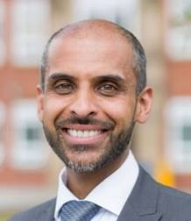
“At Holly Lodge High School, we believe that community is the cornerstone of our educational ethos. Our close partnership with Holy Trinity Church exemplifies this commitment, as we work together to foster a supportive environment that nurtures our students' personal and spiritual growth. Through shared values of respect, kindness, and responsibility, we strive to empower our students to become active, engaged members of both our school and the wider community.”

Mr Imran Iqbal: Headteacher,
Holly Lodge High School
Together for Hope
Interfaith working has been an important part of the charism of Holy Trinity for many decades. The Revd Roger Hooker fostered closer relationships with the Sikh community who had started to arrive here in significant numbers in the 1950’s. In recent years, Revd David Gould was instrumental in broadening this interfaith working by forming Faithful Friends…a group of faith leaders. Meeting regularly over food, firm friendships were formed which were only deepened by the opportunity to travel to each other’s special spiritual places, sending back regular videos to our primary schools. Alongside members of its sister group, Women First, Faithful Friends have made journeys to Israel/Palestine and to meet with those trying to develop similar initiatives in Scandinavia.
The group’s readiness for cooperative action has allowed us to respond to local interfaith tensions and flare ups and to offer Sandwell Public Health team a means of talking to harder to reach communities during Covid, dispelling myths and encouraging vaccination.

Along with Sandwell Council, Faithful Friends and Women First were given Coventry Cathedral’s first ‘Together for Hope’ award in recognition of our contribution to interfaith reconciliation. We have also received the Police and Crime Commissioner’s Community Thank You Award and were recognised by the Outstanding Active Citizens Fund Project.

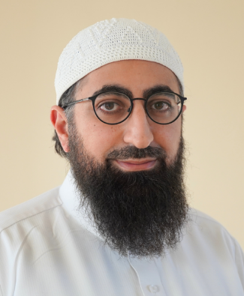
“Since its establishment in Smethwick, the Abrahamic Foundation has enjoyed a strong relationship with Holy Trinity Church. What began as sincere well-wishing for one another has grown into a well-established partnership marked by genuine friendships between our congregations, collaboration on community development programmes, and sharing of experience and best practices. We see Holy Trinity as an integral part of our organisation’s efforts to serve the communities in which we live.”
Imam Nasir Zameer: Abrahamic Foundation


Guru Nanak Gurdwara Smethwick and Holy Trinity Smethwick share a unique and growing interfaith partnership that beautifully weaves together Sikh and Christian values. In November 2019, the Bishop of Birmingham joined leaders of the Gurdwara, clergy of Holy Trinity, and other members of Faithful Friends network to plant a tree in the church grounds to mark the 550th birth anniversary Of Sri Guru Nanak Dev Ji symbolising unity, mutual respect, and hope for future generations. The Gurdwara and Church communities regularly collaborate on community events, fostering deeper understanding across faiths and offering a model of peaceful coexistence and active solidarity.
Jatinder Singh: President of Guru Nanak Gurdwara

Where next for interfaith work?
The world changes and people move on. Networks of individuals are bound to wax and wane, but they are a starting point for building real collaboration between institutions that can be ongoing. We are currently looking at the idea of how we might hold each other to account for what we say and do; don’t say and don’t do, and how that impacts other faiths and communities. We continue to work with the Bishop’s Advisor for Interfaith matters.

Social Events
Events include an annual barbeque, a Christmas party after nine lessons and carols; Passover Meal in Holy Week; St Andrew’s Supper (Fish and Chips); Fireworks, sausage and mash; and Picnic in the Park with our children and young people We have also arranged visits to St Albans, Wells, Lichfield and Durham and Oxford.

A well-appointed modern vicarage
A modern, spacious vicarage with four bedrooms, a triple aspect lounge, a substantial dining room and an office. Well maintained and decorated throughout. There is a well-appointed kitchen with an informal dining area and
a rear lobby / utility area
There is a garage plus ample parking on the driveway and a large easily maintained rear garden surrounded by mature trees.
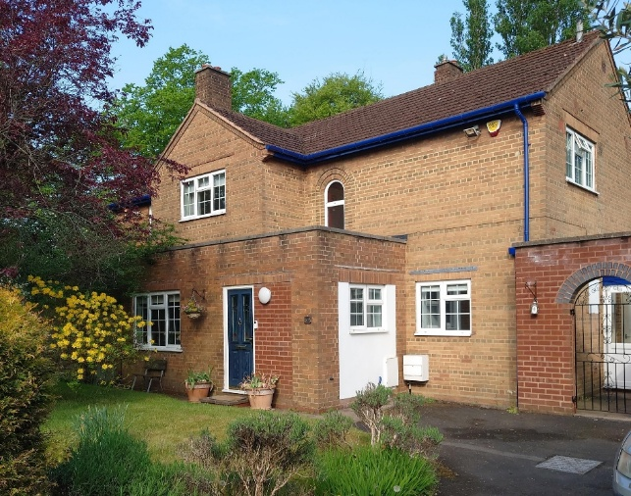
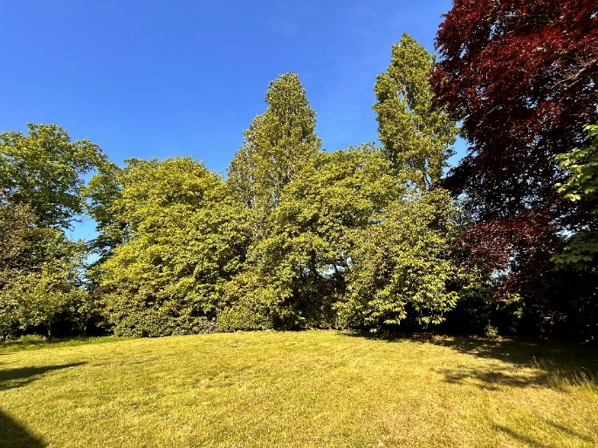 | 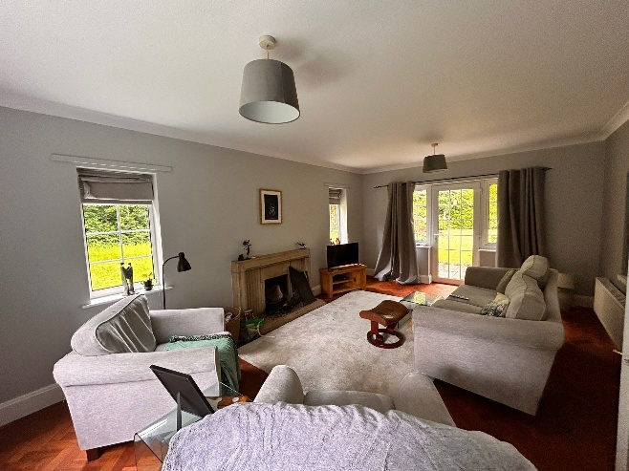

In Summary
Holy Trinity offers…
- A thriving and diverse congregation of all ages, many of whom are
active in the ministry of the church.
- A broad church which also welcomes and works with a diversity of theological understanding.
- A well-maintained Grade II listed church building that is fit for the
present and ready for the future, situated in a closed graveyard
- Established relationships with local schools and an active interfaith ministry built on mutual respect and friendship.
- A firm foundation on which to build, with huge opportunity and a congregation prepared for the challenge and change that the future
will bring.

What we are looking for in our new vicar
- Somone with real heart for this congregation, and for Smethwick in all its richness and deprivation.
- A ‘people’ person with the communication skills to reach out to the whole breadth of the congregation, to speak and listen to our diverse parish, and to be the lynch pin in our conversations with the church hierarchy.
- A collaborative leader who will further the ministry of all the people: an encourager and enabler who can recognise gifts amongst the congregation and help to bring them to fruition.
- A vision as to how our diversity of background, culture, traditions of worship and theological understanding can be held together, nurtured, grown, and used to the glory of God.
- A theology and background which readies them to work collaboratively and sensitively with other faiths in our diverse, multicultural context.
- Willingness to work with others to ensure governance and finance processes are in place and adhered to.
- Someone who is willing to take up those mantles of responsibility in the town and borough that lie beyond the congregation but are expected of the Vicar of Holy Trinity.
- Someone with the capacity and the new vision to build creatively on the foundations that are already in place so that this church may grow in grace,
in wellbeing and in numbers.

