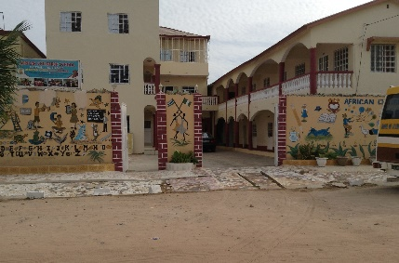 |  | Email: revdjohn60@gmail.com  BACSECT Newsletter No 14 March 2026  Hi to all our BACSECT supporters. On behalf of the school we wish you all a very Happy and Peaceful Easter.  We were able to visit our school again this month after not getting out to The Gambia for nearly a year because of some medical issues that I have had. Finally, we were able to get travel insurance so have been able to spend a week with the school. It was wonderful to see everyone. Whilst all our prayer and financial support is invaluable, visiting the school and actually meeting the staff and children and the local community is so important both for us and for them.  On our arrival the whole school greeted us with a song of welcome and the waving of handheld flags they had made in the classrooms showing both the Union Jack and the Gambian flag. We visited every classroom and were most impressed with the standard of teaching, something that has always been commented upon by the Education officer during his inspections.  Whilst we were there, we were able to visit the shop where we always purchase stationary material to restock the school and help it over the busy months ahead. After the normal “discussions “ about costs and discounts we got a good deal again.  The headmaster, Richard, sent thanks on behalf of all the teachers for the help the school receives from its supporters in the UK. Sadly, his deputy head had a motor accident when he was knocked off his motorbike and had to give up teaching. He will be sorely missed.  The students are preparing for their national assessment tests next term using old test papers for revision.  Richard has created a new school report form as per attached pictures. We visited the firm doing the printing for the school and, after some discussion, settled the account for the printing. The reports are expensive but show a good picture of the school to the parents so are very worthwhile .  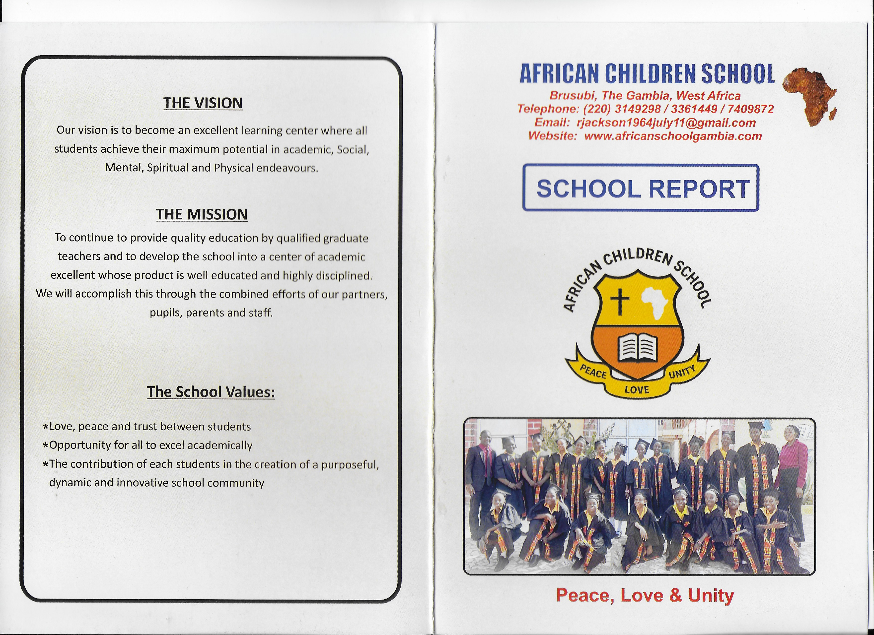  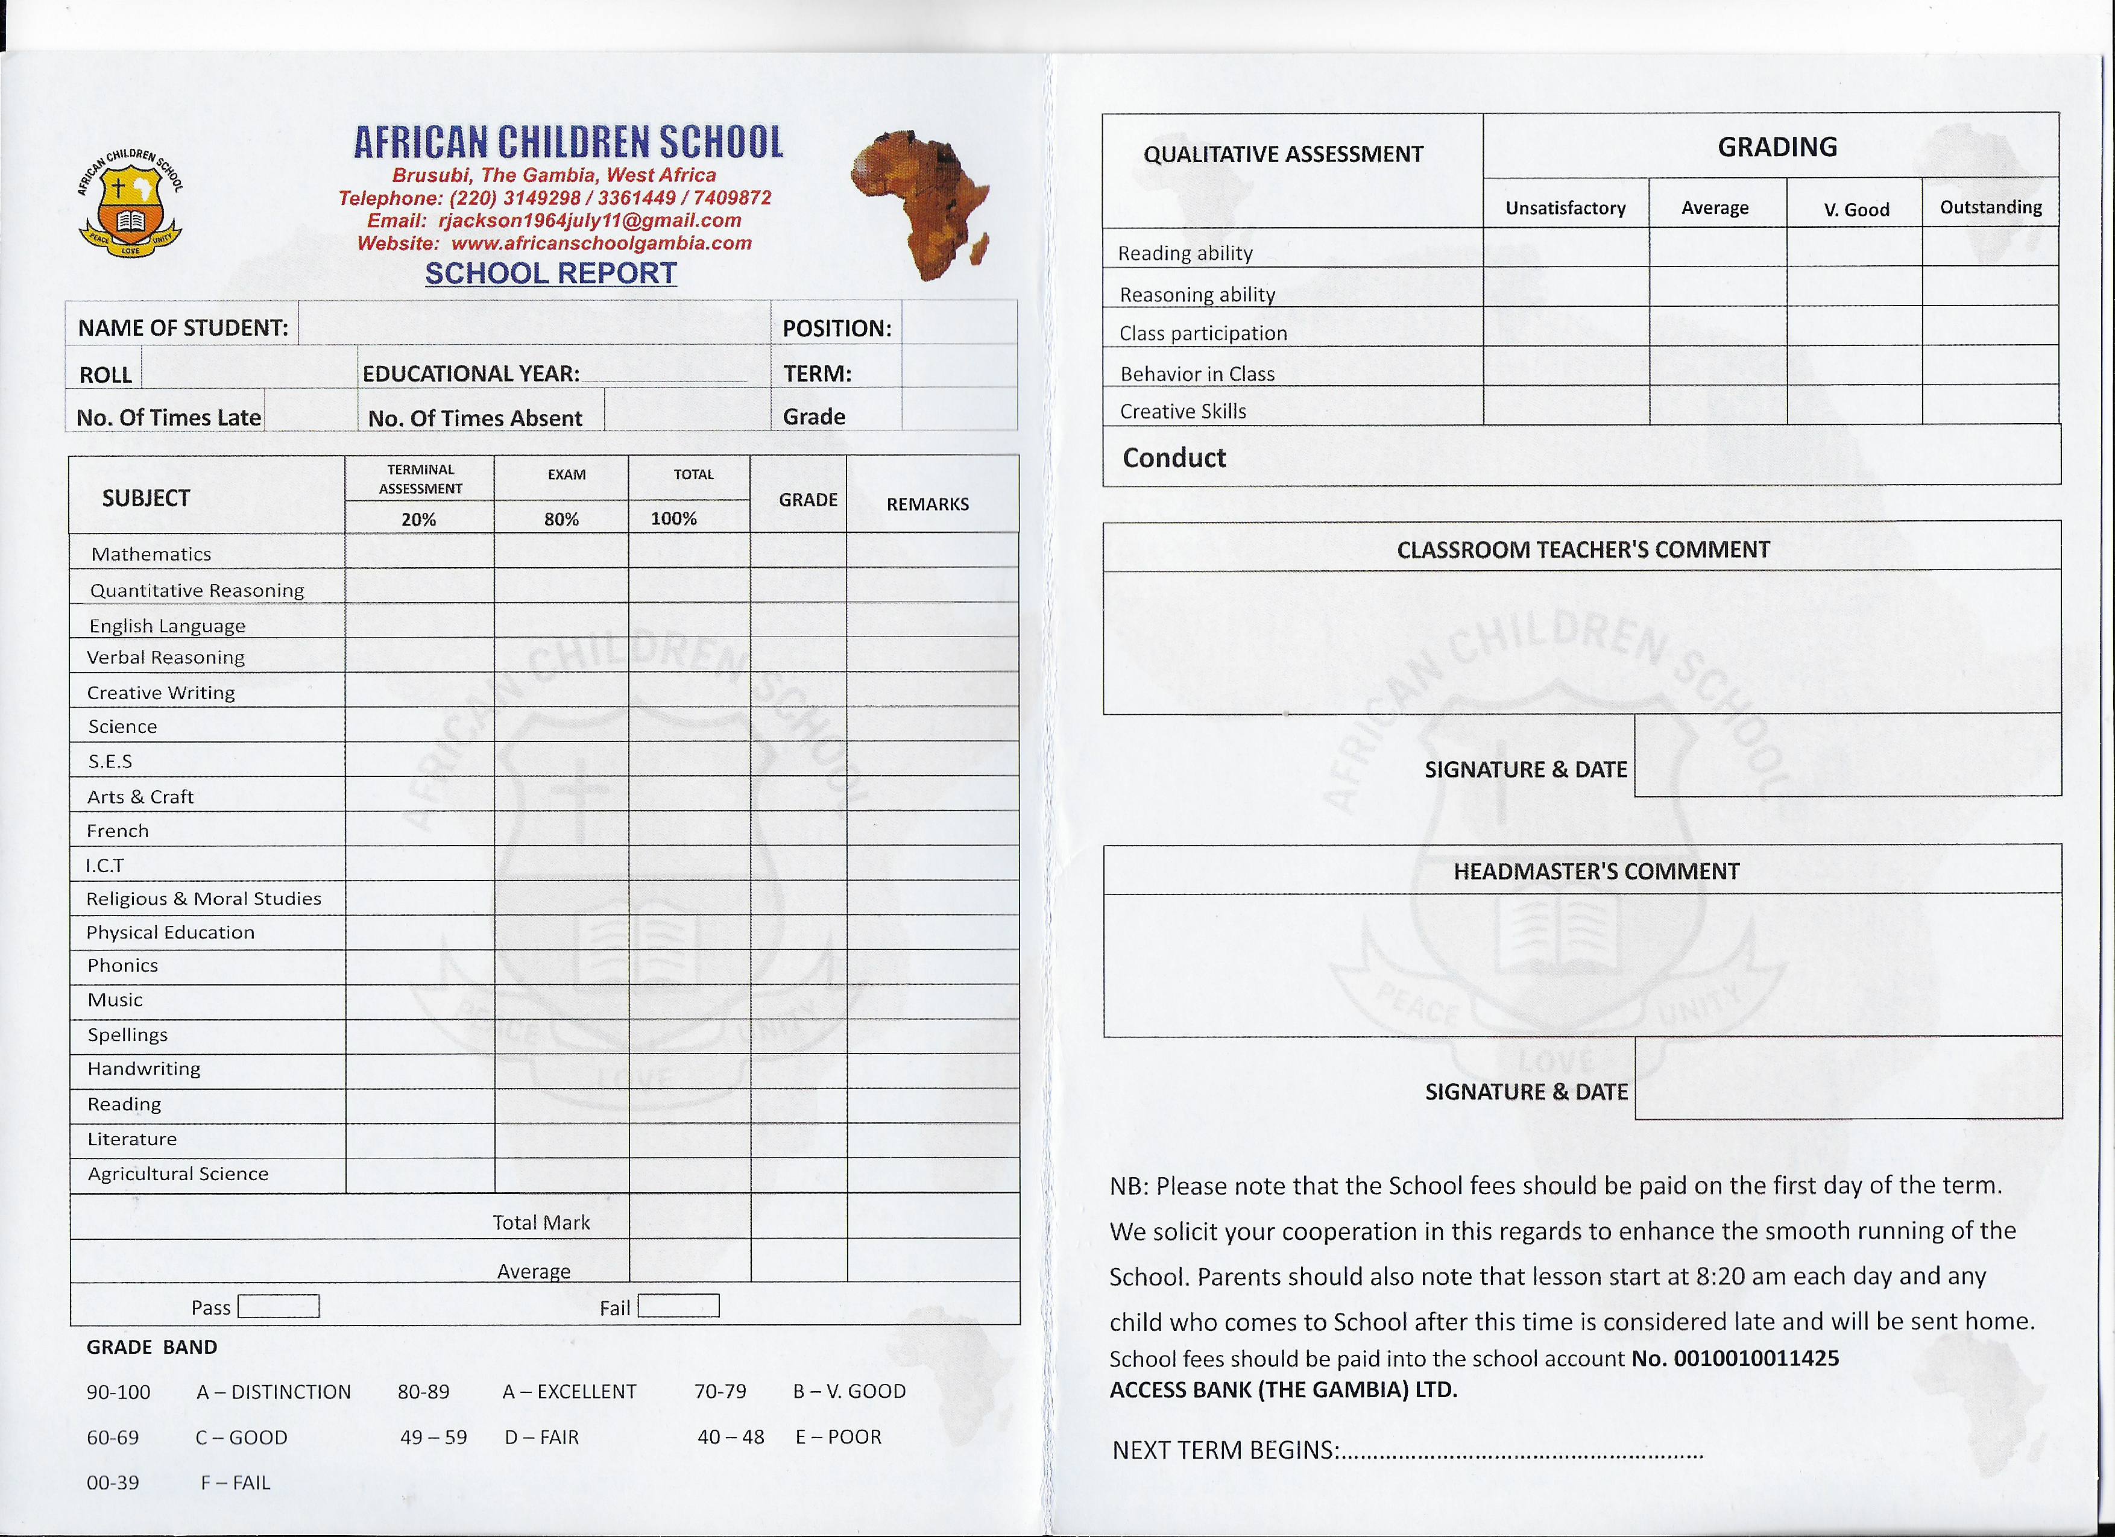  We are hoping to visit again in November when we will be able to meet some of the new children and continue to progress the work of the school.  God Bless  Revd John Baxter  Chair of Trustees

B
A
C
S
E
C
T
Registered charity number: 1187921

