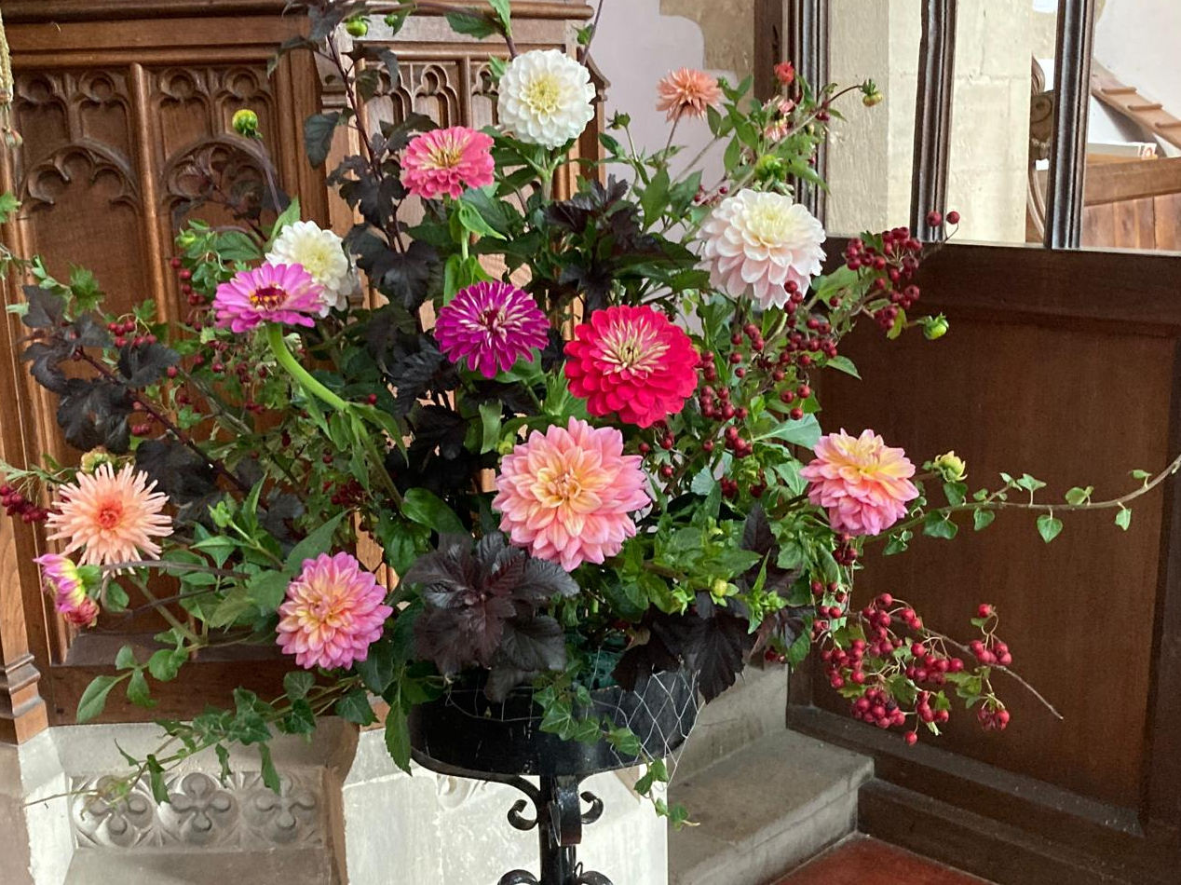
Harvest
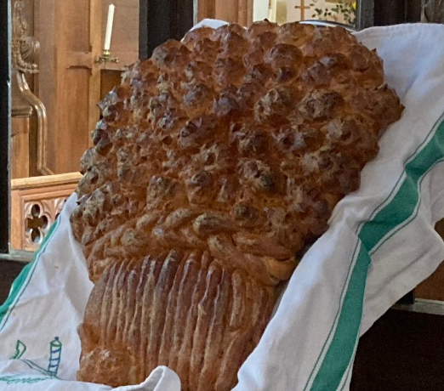

Lower Heyford Parochial Church Council
Report and Accounts Year ended 31 December 2025

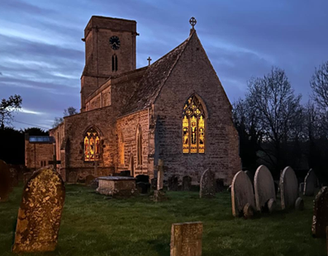
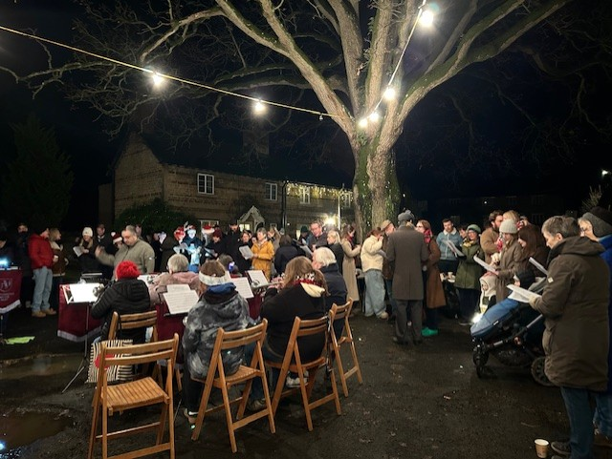
Many artists have been inspired by flowers, “Flowers inspired by Art” explored the creative process from the other direction. The arrangement pictured alongside embodied the painting “Vase of Flowers” by Odilon Redon. This event ran alongside several Arts Week displays held in Lower Heyford. Over 100 visitors visited the church over the late May bank holiday with the option to enjoy a homemade cream tea.

“Carols in the Square” with the Bletchington Silver band was attended by 130 people.

Review of year
St Mary’s future as a living village church is dependent on our connection, service and witness to those around us. The weekly services, underpinned by rhythms of the church year and work of ministry across all the churches in the Benefice, provide welcome and fellowship to all in the village. The church is nearly always left open during the day. There were just over 1,000 church service attendances in the year and over 600 further footfall from other visitors and activities in the church. It is estimated that around 800 different individuals used the church at least once during 2025.
In February the Rev. Helen Barnes’ farewell benefice service was held at Lower Heyford, wishing her well as she moved on to take up her new post in Wales. During the year there was a funeral, a wedding and a blessing at St Mary’s. Special seasons of the church year were duly celebrated. On Mothering Sunday passers-by were encouraged to “pick up a posy and take a prayer”. We welcomed Bishop Gavin to preside at Easter Communion, had a beautifully decorated church for Harvest Festival, raised £82 for the Children’s Society at a well-attended Christingle service and also welcomed large Christmas congregations. The combined Souldern/Lower Heyford choir enhanced the music at the Carol Service, as well as Helen’s farewell Service and Easter Sunday. The bells were rung for the 80th Anniversary of VE day. During July and August a Saturday a morning prayer service of prayer and reflection provided a “15 minute vacation”.
Fundraising this year focused on music, with two concerts raising just over £1,000 after costs. At the end of January, the early music ensemble “Sounds Historical” took us on a musical journey of 600 years from Hildegarde to Haydn and demonstrated not only a wide range of music but also a fascinating range of instruments, from flutes and recorders to viols, lutes and crumhorns. In May an equally accomplished trio of oboe, cello and harp brought together by oboist and village resident Maddy Aldis-Evans led us on a folk music journey around the British Isles. Complementing “Art Week” activities elsewhere in the village, “Flowers inspired by Art” explored the creative process from the other direction. A small team decorated the church with floral arrangements which had their basis in a painting or a style of painting and provided cream teas on the day. The “carols in the square” with the Bletchington Silver Band is a regular village event sponsored by the church and was very well attended.
We gratefully acknowledge the Parish Council’s ongoing financial support in its grant of £500 in 2025. Our thanks also go to all those who give their time to clean, maintain and decorate the church and also help in the churchyard maintenance. An electrical inspection in the late Autumn revealed that there is some remedial work to be done in 2026 before the church can be issued with the five-yearly certificate.
For the longer term we must, at least, maintain funds for investment in the future and as insurance against emergencies of the kind that inevitably arise in the fabric of old buildings. The restricted funds, relating to monies raised for specific purposes such as building maintenance and restoration and religious education provide some resilience, but only 10% of our reserves are available without restriction. However, we have succeeded in maintaining the general reserve at more than £6,000 (3 months running costs), which has been the PCC policy since 2011.

Statistics for 2025
The Electoral Roll membership is fully renewed each 6 years, this renewal fell due most recently in April 2025. Current membership stands at 19.
Administrative Information
St Mary’s, of the parish of Lower Heyford & Caulcott, is situated in Church Lane, Lower Heyford. It is part of the Benefice of Cherwell Valley which consists of the parishes of Ardley with Fewcott, Fritwell, Upper Heyford, Heyford Park, Somerton, Souldern and Lower Heyford & Caulcott. The Benefice is part of the Diocese of Oxford within the Church of England.
The Parochial Church Council (PCC) is a charity for the purposes of the Charities Act 2011.

PCC members who have served from 1 January 2025 until the date this report was approved are:-
Rev. Helen Barnes Team Rector & Chair (left February 2025)
Rev. Kath Cooke
Denise Ball
Philip Boxall (Churchwarden)
JJ Macnamara (Diocesan and Deanery Synod representative)
Diana Boxall (Treasurer)
Tom Corrie
Chris Daly (Lay Chairman and Secretary)

Structure, governance and management
The method of appointment of PCC members is set out in the Church Representation Rules. All Church attendees are encouraged to register on the Electoral Roll and stand for election to the PCC. There is a Standing Committee, consisting of the Team Rector, the Churchwarden, the PCC Secretary and the Treasurer which meets as necessary between PCC meetings to deal with emergency decisions that cannot await the next PCC.
Objectives
St Mary’s PCC supports and aids the Team Clergy in promoting in the parish the whole mission of the Church – pastoral, evangelistic, social and ecumenical. It cares for, maintains and finances the running of the church and churchyard. Through the Parish Share (ministry costs) it helps pay for the funding of the diocese, including clergy costs.
Safeguarding and promoting a safer church
The care and protection of children, young people and adults involved in Church activities is the responsibility of everyone who participates in the life of the church. The PCC of Lower Heyford is committed to the safeguarding of children, young people and adults. We follow the House of Bishops guidance and policies and have our own Benefice Safeguarding Officer. All members of the PCC complete training in Safeguarding awareness (using materials provided by the Diocese).
Finance review
Overall income was £2,215 more than expenses this year (2024: surplus £1,529). On the income side, the income from the CCLA investments is a substantial contribution, although slightly decreased from the previous year as interest rates fell a little. On the other hand, funds raised at services by cash collections and online giving increased when compared to 2024.
Two fundraising concerts in the church raised over £1,000, the “Inspired by Art” event £104, and participation in the annual Ride & Stride Event raised £100. The carols in the Square, a community event rather than a fund raiser, nevertheless also made a positive contribution rather than being a net cost. Overall fundraising efforts brought in around £1,325 during 2025. Income from Gift Aided giving and collections, after a number of years of downward trends, recovered somewhat this year (partly due to some once-off events, but also strong attendances at Christmas and Easter).
In terms of expenditure, church running expenditure costs were fairly similar to the previous year, albeit with upward inflationary creep in most categories. Increased fundraising costs reflected the participation of professional musicians but, as mentioned above, this was in the context of solid net fundraising results. It should be noted that the mowing costs were not invoiced this year (or in 2024).
At 31 December 2025 our reserves amounted to £78,090 (2024:£75,875). The unrestricted element of this, the General Fund, increased to £8,106 in the year and represents 10.4% of the total.

Reserves at 31 December 2025: £78,090

The notes of pages 5 and 6 form part of these accounts

In addition (not included above), the assets for the Village Hall Fund which is in the beneficial ownership of the churchwarden and incumbent, and derives from a sale of land in 1969, are held by the Diocesan Trustee (Oxford) Limited. The accumulated capital is invested in the CBF Investment fund and the CBF CofE Deposit Fund and was valued at £619 on the 31 December 2025 (2024: £605).

Approved by the PCC on 11 March 2026 and signed on their behalf by Rev. Kath Cooke and Mrs Diana Boxall.

Kath Cooke Diana Boxall

Kath Cooke Diana Boxall
Team Vicar PCC Treasurer
